|  |  |  |  |
| --- | --- | --- | --- |
|  | United Nations | ECE/TRANS/WP.29/GRSP/2021/19 | |
| _unlogo | **Economic and Social Council** | | Distr.: General  21 September 2021  Original: English |

**Economic Commission for Europe**

Inland Transport Committee

**World Forum for Harmonization of Vehicle Regulations**

**Working Party on Passive Safety**

**Seventieth session**

Geneva, 6–10 December 2021

Item 6 of the provisional agenda

**UN Regulation No. 16 (Safety-belts)**

Proposal for the 09 series of amendments to UN Regulation No. 16 (Safety-belts)

Submitted by the experts from Japan[[1]](#footnote-2)\*

The text reproduced below was prepared by the expert from Japan. It describes the new requirements concerning the safety-belts of seat positions equipped with the lower ISOFIX anchorage. It is based on informal document GRSP-69-23 distributed during the sixty-ninth session of the Working Party on Passive Safety (GRSP). The modifications to the current text of the UN Regulation are marked in bold for new characters.

**I. Proposal**

*Insert new paragraphs 2.48. and 2.49*., to read:

"**2.48. "*Effective belt anchorage*" means the point used to determine conventionally, as specified in paragraph 5.4 of UN regulation No. 14, the angle of each part of the safety-belt in relation to the wearer, that is, the point to which a strap would need to be attached to provide the same lie as the intended lie of the belt when worn, and which may or may not be the actual belt anchorage depending on the configuration of the safety-belt hardware at its attachment to the belt anchorage.**"

"**2.49. "*BP point for the buckle strap*" means the point as specified in paragraph 3.2. of Annex 17 Appendix 1**."

*Paragraph 5.3.2*., amend to read:

"5.3.2. An approval number shall be assigned to each type approved. Its first two digits (at present 0**9** corresponding to the 0**9** series of amendments) shall indicate the series ..."

*Insert new paragraphs 8.2.3. to 8.2.3.3*., to read:

"**8.2.3. The requirement of the strap between the buckle and effective belt anchorage at seats equipped with ISOFIX lower anchorages."**

**8.2.3.1. The difference between the actual strap length and the straight line distance between the effective belt anchorage and BP point for the buckle strap, according to paragraph 3.2. of Annex 17 Appendix 1, should be [50] mm or less."**

**8.2.3.2. In the case that the path of the strap between the buckle and effective belt anchorage is defined by a rigid part whose shape is not deformed during the dynamic test specified in UN Regulation No. 94 or No. 137, and the manufacturer shows those data and the technical service confirms those data, paragraph 8.2.3.1. does not apply."**

**8.2.3.3. In the case that the path of the strap between the buckle and effective belt anchorage is not straight during the dynamic test specified in UN Regulation No. 94 or No. 137, and the manufacturer shows the length of the strap between the buckle and effective belt anchorage during the dynamic test and technical service confirms that length, the difference between the actual strap length and the path length during the dynamic test between the effective belt anchorage and BP point for the buckle strap, according to paragraph 3.2. of Annex 17 Appendix 1, should be [50] mm or less.**"

*Insert new paragraphs 15.6. to 15.14.,* to read:

"**15.6. As from the official date of entry into force of the 09 series of amendments, no Contracting Party applying this UN Regulation shall refuse to grant or refuse to accept type approvals under this Regulation as amended by the 09 series of amendments.**

**15.7. As from [1 September 2024], Contracting Parties applying this UN Regulation shall not be obliged to accept type approvals to the preceding series of amendments, first issued after [1 September 2024].**

**15.8. Until [1 September 2026], Contracting Parties applying this UN Regulation shall accept type approvals to the preceding series of amendments, first issued before [1 September 2024].**

**15.9. As from [1 September 2026], Contracting Parties applying this UN Regulation shall not be obliged to accept type approvals issued to the preceding series of amendments to this UN Regulation.**

**15.10. Notwithstanding the transitional provisions above, Contracting Parties who start to apply this UN Regulation after the date of entry into force of the most recent series of amendments are not obliged to accept type approvals which were granted in accordance with any of the preceding series of amendments to this Regulation / are only obliged to accept type approvals granted in accordance with the 09 series of amendments.**

**15.11. Notwithstanding paragraph 15.9., Contracting Parties applying this Regulation shall continue to accept type approvals issued according to the preceding series of amendments to this UN Regulation, for vehicles that are not affected by the changes introduced by the 09 series of amendments.**

**15.12. Notwithstanding paragraph 15.9., Contracting Parties applying this UN Regulation shall continue to accept type approvals of safety-belts and restraint systems to the preceding series of amendments to the UN Regulation.**

**15.13. Contracting Parties applying this UN Regulation may grant type approvals according to any preceding series of amendments to this UN Regulation.**

**15.14. Contracting Parties applying this UN Regulation shall continue to grant extensions of existing approvals to any preceding series of amendments to this UN Regulation.**"

*Annex 2,* amend to read:

"Annex 2

Arrangements of the approval marks

1. Arrangements of the vehicle approval marks concerning the installation of safety-belts

# Model A

(See paragraph 5.2.4. of this Regulation)

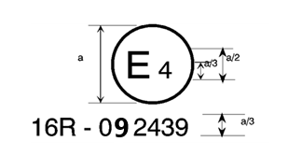

a = 8 mm

The above approval mark affixed to a vehicle shows that the vehicle type concerned has, with regard to safety-belts, been approved in the Netherlands (E 4) pursuant to UN Regulation No. 16. The approval number indicates that the approval was granted according to the requirements of UN Regulation No. 16 as amended by the 0~~8~~**9** series of amendments.

# Model B

(See paragraph 5.2.5. of this Regulation)

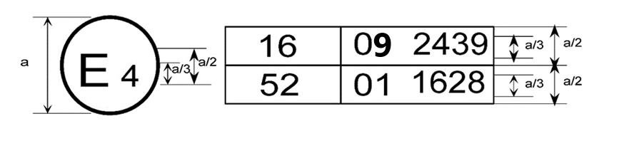

a = 8 mm min.

The above approval mark affixed to a vehicle shows that the vehicle type concerned has been approved in the Netherlands (E 4) pursuant to UN Regulations Nos. 16 and 52[[2]](#footnote-3)F The approval numbers indicate that, at the dates when the respective approvals were given, UN Regulation No. 16 included the 0~~8~~**9** series of amendments and UN Regulation No. 52 the 01 series of amendments.

2. Arrangements of the safety-belt approval marks (see paragraph 5.3.5. of this Regulation)



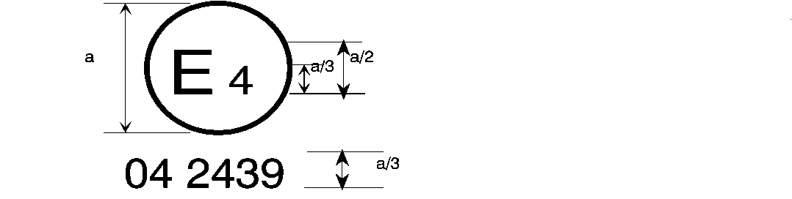

0**9** 2439

a = 8

mm min.

The belt bearing the above approval mark is a three-point belt ("A"), fitted with an energy absorber ("e") and approved in the Netherlands (E 4) under the number 0~~8~~**9**2439, this Regulation already incorporating the 06, 07**,** ~~or~~ 08  or **09** series of amendments at the time of approval.

B → 4 m



0**9** 2489

The belt bearing the above approval mark is a lap belt ("B"), fitted with a retractor, type 4, with multiple sensitivity (m) and approved in the Netherlands (E 4) under the number 0~~8~~**9**2489, this Regulation already incorporating the 06, 07**,** ~~or~~ 08  or **09** series of amendments at the time of approval.

*Note:* The approval number and additional symbol(s) shall be placed close to the circle and either above or below the "E" or to left or right of that letter. The digits of the approval number shall be on the same side of the "E" and orientated in the same direction. The additional symbol(s) shall be diametrically opposite the approval number. The use of roman numerals as approval numbers should be avoided so as to prevent any confusion with other symbols.

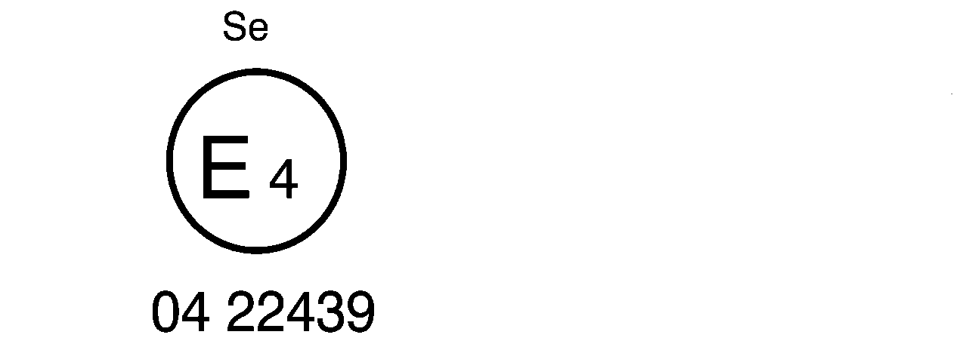

0**9** 22439

The belt bearing the above approval mark is a special type belt ("S"), fitted with an energy absorber ("e") and approved in the Netherlands (E 4) under the number 0~~8~~**9**22439, this Regulation already incorporating the 06, 07**,** ~~or~~ 08  or **09** series of amendments at the time of approval.

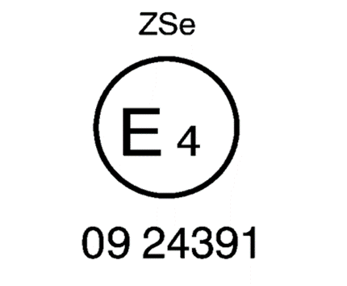

The belt bearing the above approval mark is part of a restraint system ("Z"), it is a special type belt ("S") fitted with an energy absorber ("e"). It has been approved in the Netherlands (E 4) under the number 0~~8~~**9**24391, this Regulation already incorporating the 06, 07**,** ~~or~~ 08  or **09** series of amendments at the time of approval.



a ≥ 8 mm

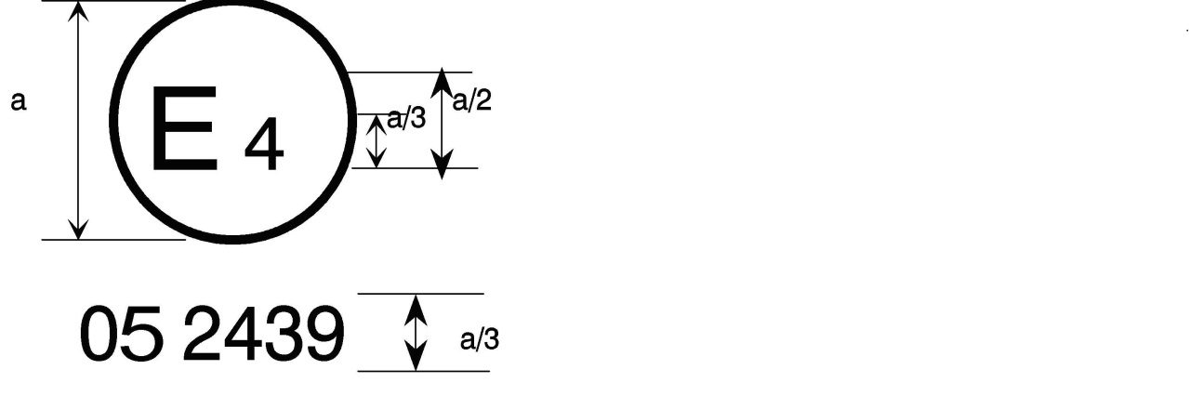

0**9** 2439

a = 8 mm min.



The belt bearing this type approval mark is a three-point belt ("A") with a multiple-sensitivity ("m") type 4N ("r4N") retractor, in respect of which type approval was granted in the Netherlands ("E 4") under number 0~~8~~**9**2439, this Regulation already incorporating the 06, 07**,** ~~or~~ 08  or **09** series of amendments at the time of approval. This belt shall not be fitted to vehicles of category M1.

**Aer4m**

**E4**

**092439**

**AIRBAG**

The safety-belt bearing this type approval mark is a three-point belt ("A") fitted with an energy absorber ("e"), approved as meeting the specific requirements of paragraph 6.4.1.3.3. or 6.4.1.3.4. of this Regulation, and with a multiple-sensitivity ("m") type 4 ("r4") retractor, in respect of which type approval was granted in the Netherlands ("E 4") under the approval number 0~~8~~**9**2439. The first two digits indicate that the Regulation already incorporated the 06, 07, 08 or **09** series of amendments at the time of the approval. This safety-belt has to be fitted to a vehicle equipped with an airbag in the given seating position."

*Annex 17 Appendix 1, paragraph 1.1.,* amend to read:

"1.1. The test procedure and the requirements in this appendix shall be used to determine the suitability of seating positions for the installation of child restraints of the "universal" category**, and to measure the length of the strap between the effective belt anchorage and BP point for the buckle strap at seat positions equipped with ISOFIX lower anchorages.**"

*Annex 17 Appendix 1, paragraph 2.7.,* amend to read:

"2.7. Ensure that the fixture is located with its vertical plane of symmetry within ±25 mm of the vertical plane of symmetry of the seating position **for determining the suitability of seating positions for the installation of child restraints of the "universal" category.** **Ensure that the fixture is located with its vertical plane of symmetry within ±12.5 mm of the vertical plane of symmetry of the ISOFIX lower anchorages for measuring the length of the strap between the effective belt anchorage and BP point for the buckle strap.**"

*Annex 17 Appendix 1, paragraph 3.2.,* amend to read:

"3.2. The lap portion of the belt shall touch the fixture on both sides at the rear of the lap belt path (see Figure 3). The seatbelt webbing shall always cover the points BP on the left and right ends of the curved edge; the exact position of point BP on the curved edge is indicated in detail W of Figure 1. **"BP point for the buckle strap" is the point BP on the curved edge is indicated in detail W of Figure 1 when the fixture is located with its vertical plane of symmetry within ±12.5 mm of the vertical plane of symmetry of the ISOFIX lower anchorages**."

**II. Justification**

1. The strap’s paths between the effective belt anchorage and the buckle are normally straight like the test bench specified in UN Regulation No. 129 (Figure 1). However, the strap’s paths between the effective belt anchorage and the buckle of some vehicles in the market are not straight, and are curved along the cushion (Figure 2).

Figure 1.   
**Photo of the buckle strap path of the UN Regulation No. 129 test bench**



Figure 2.   
**Photo of the buckle strap path when not straight**



2. When the strap’s paths between the effective belt anchorage and the buckle are not straight, the occupants may move significantly forward during a frontal impact accident. If an occupant is seated in the booster seat attached by ISOFIX, there are cases in which the seatbelt slips up to the neck and in which submarining occurs (referred to in GRSP-69-24). These phenomena would increase the risk to the neck and abdomen of a child occupant. In addition, the dummy chest injury increases. Figure 3 shows the relation between the amount of slack of the buckle strap and dummy 3ms chest maximum acceleration for two types of CRS. When the slack of the buckle belt was over [50] mm, the chest maximum acceleration approached UN Regulation No. 129 criteria in one CRS. When the slack of the buckle belt was over [80] mm, the chest maximum acceleration exceeded the R129 criteria.

Figure 3.   
**Relation between amount of slack of the buckle strap and dummy 3ms chest maximum acceleration**



3. The slack of the buckle belt makes the pedestrian’s excursion larger, so it is not good for the safety of the passenger.

4. Therefore, we propose to limit the slack of the buckle belt in seats equipped with ISOFIX lower anchorages.

5. These amendments prevent the phenomena of the seatbelt slipping up to the neck and of submarining.

1. \* In accordance with the programme of work of the Inland Transport Committee for 2021 as outlined in proposed programme budget for 2021 (A/75/6 (Sect.20), para 20.51), the World Forum will develop, harmonize and update UN Regulations in order to enhance the performance of vehicles. The present document is submitted in conformity with that mandate. [↑](#footnote-ref-2)
2. The second number is given merely as an example. [↑](#footnote-ref-3)