E/ECE/324/Rev.1/Add.40/Rev.2/Amend.8−E/ECE/TRANS/505/Rev.1/Add.40/Rev.2/Amend.8
2 February 2021
Agreement
Concerning the Adoption of Harmonized Technical United Nations Regulations for Wheeled Vehicles, Equipment and Parts which can be Fitted and/or be Used on Wheeled Vehicles and the Conditions for Reciprocal Recognition of Approvals Granted on the Basis of these United Nations Regulations*
(Revision 3, including the amendments which entered into force on 14 September 2017)
_________
Addendum 40 – UN Regulation No. 41
Revision 2 - Amendment 8
Supplement 8 to the 04 series of amendments – Date of entry into force: 3 January 2021
Uniform provisions concerning the approval of motor cycles with regard to noise
This document is meant purely as documentation tool. The authentic and legal binding text is: ECE/TRANS/WP.29/2020/70.
_________
UNITED NATIONS
Paragraph 2., amend to read:
"2. …
2.1. "Approval of a motorcycle" means the approval of a motorcycle type with regard to noise;
2.2. "Type of motorcycle as regards its sound level" means motorcycles which do not differ in such essential respects as the following:
2.2.1. The type of engine (two-stroke or four-stroke, reciprocating piston engine or rotary-piston engine, number and capacity of cylinders or rotors, number and type of carburettors or injection systems, arrangement of valves, rated maximum net power and corresponding engine speed). For rotary-piston engines the cubic capacity should be taken to be double of the volume of the chamber;
2.2.2. Transmission system, in particular the number and ratios of the gears and the overall gear ratio taking into account the rear wheel circumference.
2.2.3. Configurations and arrangements of exhaust or silencing systems.
2.3. "Exhaust or silencing system" means a complete set of components necessary to limit the noise caused by a motorcycle engine and its exhaust.
2.3.1. "Original exhaust or silencing system" means a system of a type fitted to the vehicle at the time of type approval or extension of type approval. It may also be the vehicle manufacturer's replacement part.
2.3.2. "Non-Original Replacement Exhaust or Silencing System (NORESS)" means a system of a type other than that fitted to the vehicle at the time of type approval or extension of type approval.
2.4. "Exhaust or silencing systems of differing configurations" means systems which are fundamentally different in one of the following ways:
2.4.1. Systems comprising components bearing different factory or trademarks;
2.4.2. Systems comprising any component made of materials of different characteristics or comprising components which are of a different shape or size;
2.4.3. Systems in which the operating principles of at least one component are different;
2.4.4. Systems comprising components in different combinations.
2.5. …"
Insert a new paragraph 3.3. to read:
"3.3. Respective documents mentioned in paragraph 3.2 above shall be prepared for each exhaust or silencing system configuration, if multiple configurations are applicable to the motorcycle type to be approved."
Paragraph 3.3. (former), renumber to 3.4. and amend to read:
"3.4. At the request of the technical service responsible for conducting approval tests in agreement with the type approval authorities, the motorcycle manufacturer shall, in addition, submit a sample of the exhaust or silencing system(s)."
Paragraph 3.4. (former), renumber to 3.5. and amend to read:
"3.5. All motorcycle(s) representative of the same type with all possible exhaust or silencing system configurations to be approved shall be submitted to the technical service responsible for conducting approval tests in agreement with the type approval authorities."
Paragraph 3.5. (former), renumber to 3.6.
Paragraph 5.2., renumber to 5.2.1. and amend to read:
"5.2.1. An approval number shall be assigned to each type approved. Its first two digits indicate the series of amendments incorporating the most recent major technical amendments made to the Regulation at the time of issue of the approval. The same Contracting Party may not assign the same number to another motorcycle type."
Insert a new paragraph 5.2.2. to read:
"5.2.2. Multiple exhaust or silencing system configurations shall be explicitly listed under the same approval of a type of motorcycle with their respective test results."
Paragraph 5.3., amend to read:
"5.3. Notice of approval or of refusal of approval of a motorcycle type pursuant to this Regulation shall be communicated to the Parties to the Agreement which apply this Regulation, by means of a form conforming to the model in Annex 1 to this Regulation and of drawings of the exhaust or silencing system, supplied by the applicant for approval in a format not exceeding A4 (210 × 297 mm) or folded to that format and on an appropriate scale."
Insert a new paragraph 5.4. to read:
"5.4. The respective information for multiple exhaust or silencing system configurations mentioned in paragraph 5.2.2. above shall be provided for in Annex 1 to this Regulation."
Paragraphs. 5.4. to 5.8. (former), renumber as 5.5. to 5.9., respectively.
Annex 3
Paragraph 1.3.2.1., amend to read:
"1.3.2.1. General conditions
The vehicle(s) tested shall be representative of vehicles to be put on the market under the vehicle type to be approved and selected by the manufacturer in agreement with the Type Approval Authority, to comply with the requirements of this Regulation.
…"
Paragraph 2.4.1., amend to read:
"2.4.1 Positioning of the microphone (see Appendix 2)
...
If a vehicle has two or more exhaust outlets spaced less than or equal to 0.3 m apart and connected to a single silencer, only one measurement shall be made. The microphone shall be located relative to the outlet furthest from the vehicle's longitudinal centreline, or, when such outlet does not exist, to the outlet that is highest above the ground. The 0.3 m measurement is to be made along a single plane perpendicular to the flow axis of the exhaust gases.
If a vehicle has two or more exhaust outlets spaced less than or equal to 0.3 m apart and connected to separate silencers, only one measurement shall be made. The microphone shall be located relative to the outlet furthest from the vehicle's longitudinal centreline, or, when such outlet does not exist, to the outlet that is highest above the ground.
For vehicles having an exhaust provided with outlets spaced more than 0.3 m apart, one measurement is made for each outlet as if it were the only one, and the highest sound pressure level shall be noted. For the purpose of roadside checking, the reference point may be moved to the outer side of the body."
Appendix 2, amend to read:
"Positioning of the microphones for the stationary noise test:

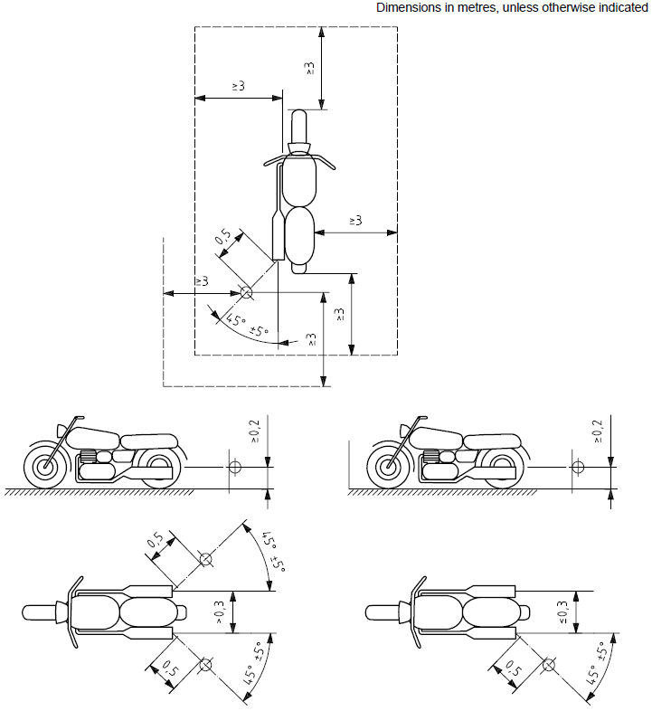

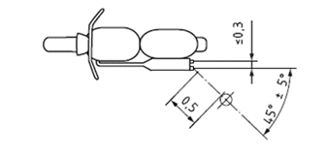
"
Annex 5
Figure 1, note 3, amend to read:
"3. Compensating reservoir with a maximum capacity of 40 litres and a filling time of not less than 1 second."

* Former titles of the Agreement: Agreement concerning the Adoption of Uniform Conditions of Approval and Reciprocal Recognition of Approval for Motor Vehicle Equipment and Parts, done at Geneva on 20 March 1958 (original version); Agreement concerning the Adoption of Uniform Technical Prescriptions for Wheeled Vehicles, Equipment and Parts which can be Fitted and/or be Used on Wheeled Vehicles and the Conditions for Reciprocal Recognition of Approvals Granted on the Basis of these Prescriptions, done at Geneva on 5 October 1995 (Revision 2).

