Submitted by SIG on UN-R 157 | Informal document GRVA-11-33  11th GRVA, 24 September – 01 October 2021  Provisional agenda item 4 (d)

Proposal to amend ECE/TRANS/WP.29/GRVA/2021/31
The text reproduced below reflects the discussion state of play of the Special Interest Group on Regulation No. 157 (Automated Lane Keeping System) up to its eight meeting, on raising the specified maximum speed of Automated Lane Keeping System (ALKS) up to 130 km/h. It is based on ECE/TRANS/WP.29/GRVA/2020/32 (submitted by Germany) and subsequent proposals for amendments received on this proposal.
ECE/TRANS/WP.29/GRVA/2021/31: Modifications to the existing text of UN Regulation No. 157 (incl. Supplement 2) are marked in black bold for new or strikethrough for deleted characters. Open issues are marked in square brackets.
GRVA-11-33: The entire text of ECE/TRANS/WP.29/GRVA/2021/31 is reproduced below. Modifications to this document are marked in green bold for new or green strikethrough for deleted characters.

I. Proposal
Paragraph 2.1., amend to read:
“2.1. “Automated Lane Keeping System (ALKS)” for low speed application is a system which is activated by the driver and which keeps the vehicle within its lane for travelling speed of 60 130 km/h or less by controlling the lateral and longitudinal movements of the vehicle for extended periods without the need for further driver input.
Within this Regulation, ALKS is also referred to as “the system”.”
Paragraphs 2.21. and 2.22, insert to read:
“[2.21. “Stability of vehicle and driver system” is the ability of the system composed by the vehicle and the driver, either human or non-human, to recover the initial safe motion after a disturbance.
2.22. “String stability” is the capability of the ALKS vehicle to react to a perturbation in the speed profile of the vehicle in front, whose speed profile directly affects the speed profile of the ALKS vehicle, with a perturbation in its speed profile of lower or equal absolute magnitude.]
2.21. “String instability” is when a disturbance in the speed profile of the vehicle in front is amplified by the following vehicle.”
Paragraph 5.1.1.1, insert to read:
“5.1.1.1. The system shall demonstrate anticipatory behavior in interaction with other road user(s), in order to ensure stable, low-dynamic, longitudinal behavior and risk minimizing behavior when critical situations could become imminent, e.g. with pedestrians or cutting-in vehicles.”
Paragraph 5.2.1., amend to read:
“[5.2.1. The activated system shall keep the vehicle inside its lane of travel and ensure that the vehicle does not cross any lane marking (outer edge of the front tyre to outer edge of the lane marking). The system shall [drive smoothly], aiming to keep the vehicle in a stable lateral [and longitudinal] position motion inside the lane of travel to avoid confusing other road users [or requiring them to take unnecessary avoiding action.]
The system shall aim to recover the initial original safe state of motion after disturbances not requiring an emergency manoeuvre.”
Paragraph 5.2.3.1., amend to read:
“5.2.3.1. Speed
The manufacturer shall declare the specified maximum speed based on the forward detection range of the system as described in paragraph 7.1.1.
The maximum speed up to which the system is permitted to operate is 60 130 km/h.
Specified maximum speeds of more than 60km/h shall only be permissible if the ALKS is capable of bringing the vehicle to standstill on the hard shoulder during an MRM according to paragraph [x].
[Operational speeds of more than [60 km/h] are permitted either
- Up to [90]km/h exclusively in the slowest lane of travel, provided there is surrounding traffic travelling at a similar speed (e.g. dense traffic or following a lead vehicle) or
- In all lanes of travel, if the ALKS is capable of changing lanes to bring the vehicle to a standstill outside of the regular lanes of travel during an MRM according to paragraph [X]
Systems that operate above 60 km/h up to [90]km/h without lane change capability shall implement strategies to minimize the risk of stopping in lane to the vehicle occupants and other road users, e.g. adapted deceleration strategy, operation only under good visibility.]”
Paragraph 5.2.3.3., amend to read:
“5.2.3.3. The activated system shall detect the distance to the next vehicle in front as defined in paragraph 7.1.1. and shall adapt the vehicle speed to adjust a safe following distance in order to avoid a collision.
While the ALKS vehicle is not at standstill and operating in speed range up to 60 km/h, the system shall adapt the speed to adjust the distance to a vehicle in front in the same lane to be equal or greater than the minimum following distance according to the table below.
For speeds above 60 km/h the activated system shall comply with minimum following distances in the country of operation as defined in paragraph 5.1.2.
In case the minimum time gap cannot be respected temporarily because of other road users this following distance to a vehicle in front is temporarily disrupted (e.g. vehicle is cutting in, decelerating lead vehicle, etc.), the vehicle shall readjust the minimum following distance at the next available opportunity without any harsh braking implementing strategies aiming to address significant string instability in order to not disrupt traffic flow, unless an emergency manoeuvre would become necessary.
For speeds up to 60 km/h Tthe minimum following distance shall be calculated using the formula:
d_{min} = v_{ALKS}* t_{front}
Where:
d_{min} = the minimum following distance
v_{ALKS} = the present speed of the ALKS vehicle in m/s
t_{front} = minimum time gap in seconds between the ALKS vehicle and a leading vehicle in front as per the table below:
Present speed  of the ALKS vehicle |  | Minimum time gap | Minimum following distance
(km/h) | (m/s) | (s) | (m)
7.2 | 2.0 | 1.0 | 2.0
10 | 2.78 | 1.1 | 3.1
20 | 5.56 | 1.2 | 6.7
30 | 8.33 | 1.3 | 10.8
40 | 11.11 | 1.4 | 15.6
50 | 13.89 | 1.5 | 20.8
60 | 16.67 | 1.6 | 26.7
For speed values up to 60 km/h which are not mentioned in the table, linear interpolation shall be applied.
Notwithstanding the result of the formula above for present speeds below 2 m/s the minimum following distance shall never be less than 2 m.
The requirements of this paragraph are without prejudice to other requirements in this Regulation, most notably paragraphs 5.2.4. and 5.2.5. with subparagraphs.”
Insert new paragraph 5.2.8., to read:
“[5.2.8. In the situation where a vehicle is proceeding in the opposite direction in the ALKS vehicle’s lane of travel, the ALKS shall implement strategies to react to the vehicle with the aim of mitigating the effects of a potential collision.]”
Paragraph 5.2.5.3., amend to read:
“5.2.5.3. The activated system shall avoid a collision with an unobstructed crossing pedestrian in front of the vehicle.
In a scenario with an unobstructed pedestrian crossing with a lateral speed component of not more than 5 km/h where the anticipated impact point is displaced by not more than 0.2 m compared to the vehicle longitudinal center plane, the activated ALKS shall avoid a collision up to the maximum operational speed of the system 60 km/h.
[At higher speeds, upon detection of pedestrians crossing the carriageway the ALKS shall implement strategies to reduce the potential for a collision.]”
Paragraph 5.2.7., amend to read:
“5.2.7. For conditions not specified in paragraphs 5.2.4., 5.2.5. or its subparagraphs, the performance of the system shall be ensured at least to the level at which a competent and careful human driver could minimize the risks. The attentive human driver performance models and related parameters in the traffic critical disturbance scenarios from in Annex 3 may be taken as guidance. The capabilities of the system shall be demonstrated in the assessment carried out under Annex 4.”
Paragraph 5.2.9., insert to read:
“[5.2.9. The stability of the vehicle and driver system is a necessary condition that must be always met, provided that effects of unplanned events disturbing the safe motion are within reasonable limits. This shall be demonstrated in the assessment of the tests carried out in accordance with Annex 4 and 5 of this Regulation]”
Paragraph 5.2.10., insert to read:
“[5.2.10. While following another vehicle the ALKS vehicle shall aim to be string stable.
In particular, when following another vehicle at constant speed and at a distance such that the speed profile of the ALKS vehicle is influenced by the speed profile of the vehicle in front, the ALKS vehicle shall aim to respond to a perturbation in the speed of the vehicle in front with a perturbation in its speed profile by at most a 5% increase in the maximum difference in speed compared to the vehicle in front before reaching a new equilibrium velocity following the visual examples reported in the following figures.
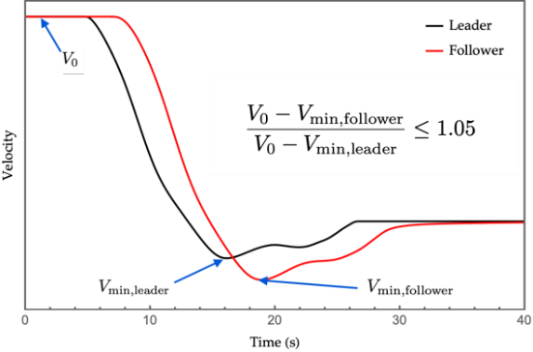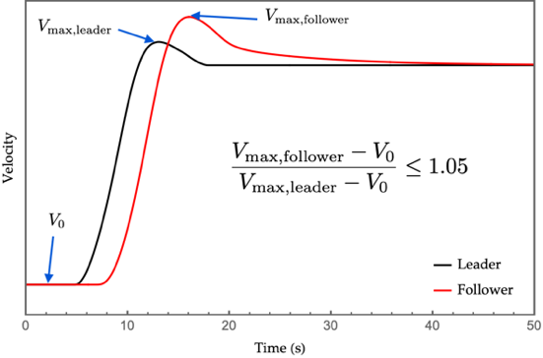
In addition, in the case when there is more than one ALKS vehicle in a chain following a vehicle under the conditions described in the previous paragraph, they shall aim to avoid further amplifying the perturbation caused by the lead vehicle from one vehicle to the next. The provisions included in this paragraph shall be demonstrated in accordance with Annex 4 of this Regulation.]”
Paragraph 5.3.2., amend to read:
“5.3.2. This manoeuvre shall decelerate the vehicle up to its full braking performance if necessary and/or may perform an automatic evasive manoeuvre, when appropriate.
If failures are affecting the braking or steering performance of the system, the manoeuvre shall be carried out with consideration for the remaining performance.
During the evasive manoeuvre the ALKS vehicle shall not cross the lane marking (outer edge of the front tyre to outer edge of the lane marking).
After the evasive manoeuvre the vehicle shall aim at resuming a stable position motion.”
Paragraph 5.4.2.3., amend to read:
“5.4.2.3 In case of any failure affecting the operation of the system ability of the system to meet the requirements of this regulation, the system shall immediately initiate a transition demand upon detection.”
Paragraph 6.4.1., amend to read:
“6.4.1. The following information shall be indicated to the driver:
(a) The system status as defined in paragraph 6.4.2.
(b) Any failure affecting the operation of the system ability of the system to meet the requirements of this regulation with at least an optical signal unless the system is deactivated (off mode),
(c) Transition demand by at least an optical and in addition an acoustic and/or haptic warning signal.
At the latest 4 s after the initiation of the transition demand, the transition demand shall:
(i) Contain a constant or intermittent haptic warning unless the vehicle is at standstill; and
(ii) Be escalated and remain escalated until the transition demand ends.
(d) Minimum risk manoeuvre by at least an optical signal and in addition an acoustic and/or a haptic warning signal and
(e) Emergency manoeuvre by an optical signal
The optical signals above shall be adequate in size and contrast. The acoustic signals above shall be loud and clear.”
“Paragraph 7.1.1., amend to read:
7.1.1. Forward detection range
The manufacturer shall declare the forward detection range measured from the forward most point of the vehicle. This declared value shall be at least 46 metres for a specified maximum speed of 60 km/h.
A specified maximum speed above 60 km/h shall only be declared by the manufacturer, if the declared forward detection range fulfils the corresponding minimum value according the following table based on deceleration of 5m/s²:
Specified maximum speed /  km/h | Minimum forward detection range /  m
0…60 | 46
70 | 50
80 | 60
90 | 75
100 | 90
110 | 110
120 | 130
130 | 150
For values not mentioned in the table, linear interpolation shall be applied.
It is recognized that the minimum forward detection range and vehicle deceleration of 5m/s² cannot be achieved under all conditions (e.g. on slippery roads). Nevertheless, The system shall implement appropriate strategies in order to ensure safe operation at all times control strategies to adapt its maximum speed due the actual detection range and the actual deceleration capability to comply with paragraph 5.2.4. Those strategies shall be demonstrated and approved by the Technical Service.
The Technical Service shall verify that the distance at which the vehicle sensing system detects a road user during the relevant test in Annex 5 is equal or greater than the declared value.”

Annex 3, amend to read:
“[1. General
1. This document clarifies derivation process to define conditions under which Automated Lane Keeping Systems (the ALKS) vehicle shall avoid a collision. Conditions under which ALKS shall avoid a collision are determined by a general simulation program with following attentive human driver two possible performance models and related parameters in the traffic critical disturbance scenarios.
2. Traffic critical scenarios
2.1. Traffic disturbance critical scenarios are those which have conditions under which the ALKS vehicle may not be able to avoid a collision.
2.2. Following three are traffic critical scenario:
(a) Cut-in: the ‘other vehicle’ suddenly merges in front of the ‘ego ALKS vehicle’
(b) Cut-out: the ‘other vehicle’ suddenly exits the lane of the ALKS vehicle ‘ego vehicle’
(c) Deceleration: the ‘other vehicle’ suddenly decelerates in front of the ALKS vehicle ‘ego vehicle’
2.3. Each of these traffic critical scenarios can be created using the following parameters/elements:
(a) Road geometry
(b) Other vehicles’ behavior/maneuver
3. Performance models of ALKS
3.1. Traffic critical scenarios of ALKS are divided into preventable and unpreventable scenarios. The threshold for preventable/unpreventable is based on the simulated performance of a skilled careful competent and competent careful attentive human driver. It is expected that some of the "unpreventable" scenarios by human standards may actually be preventable by the ALKS system.
3.2. For the purpose of determining whether a traffic critical scenario is preventable or unpreventable, guidance can be taken from the following two performance models below can be used.
3.3. “Performance model 1”
3.3.1. In the first performance model, the avoidance capability of the driver model is assumed to be only by braking. The driver model is separated into the following three segments: "Perception"; "Decision"; and, "Reaction". The following diagram in Figure 1 is a visual representation of these segments.:
3.3.1.1. To determine conditions under which Automated Lane Keeping Systems (ALKS) shall avoid a collision, performance model factors for these three segments in the following Table 1 table should be used as the performance model of ALKS considering attentive human drivers’ behavior with ADAS.

Figure 1
Skilled Careful Competent and competent careful human performance model 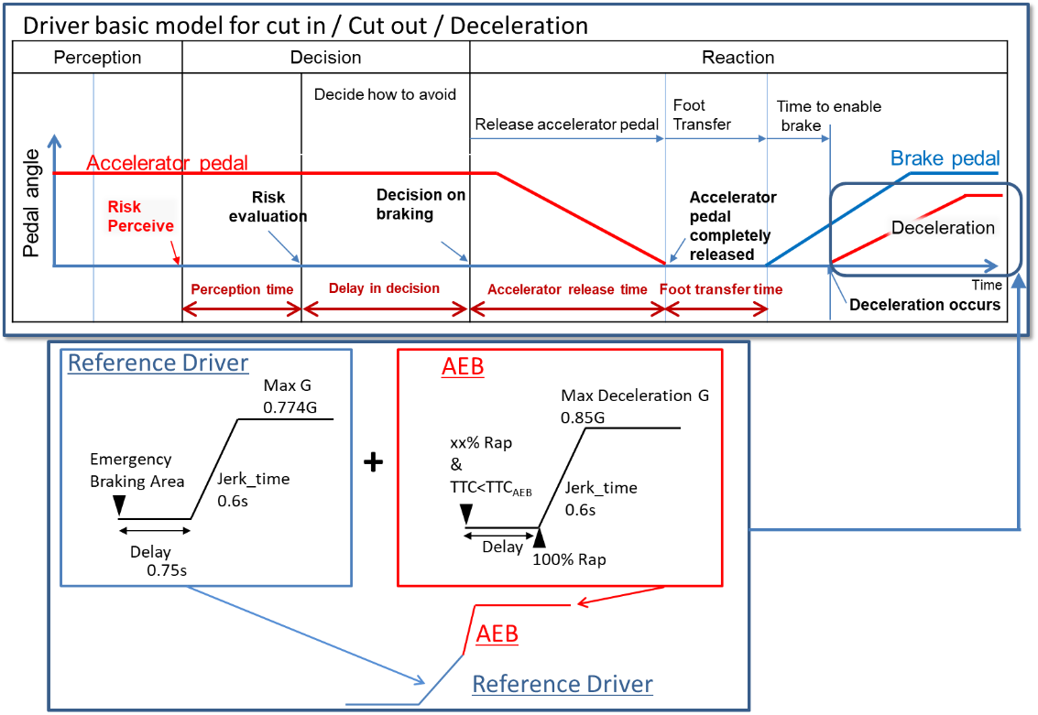

Table 1
Performance model factors for vehicles
 |  | Factors
Risk perception point | Lane change (cutting in, cutting out) | Deviation of the center of a vehicle over 0.375m from the center of the driving lane  (derived from research by Japan)
 | Deceleration | Deceleration ratio of preceding vehicle and following distance of ego vehicle
Risk evaluation time |  | 0.4 seconds  (from research by Japan)
Time duration from having finished perception until starting deceleration |  | 0.75 seconds  (common data in Japan)
Jerking time to full deceleration (road friction 1.0) |  | 0.6 seconds to 0.774Gg  (from experiments by NHTSA and Japan)
Jerking time to full deceleration (after full wrap of ego vehicle and cut-in vehicle, road friction 1.0) |  | 0.6 seconds to 0.85Gg  (derived from UN Regulation No. 152 on AEBS)
3.3.2. Driver model for the three ALKS scenarios:
3.3.2.1. For Cut in scenario:
The lateral wandering distance the vehicle will normally wander within the lane is 0.375m.
The perceived boundary for cut-in occurs when the vehicle exceeds the normal lateral wandering distance (possibly prior to actual lane change)
The distance a. is the perception distance based on the perception time [a]. It defines the lateral distance required to perceive that a vehicle is executing a cut-in manoeuvre a. is obtained from the following formula;
a.= lateral movement speed x Risk perception time [a] (0.4sec)
The risk perception time begins when the leading vehicle exceeds the cut-in boundary threshold.
Max lateral movement speed is real world data in Japan.
Risk perception time [a] is driving simulator data in Japan.
2sec* is specified as the maximum Time To Collision (TTC) below which it was concluded that there is a danger of collision in the longitudinal direction.
Note: TTC = 2.0sec is chosen based on the UN Regulation guidelines on warning signals.
Figure 2
Driver model for the cut-in scenario
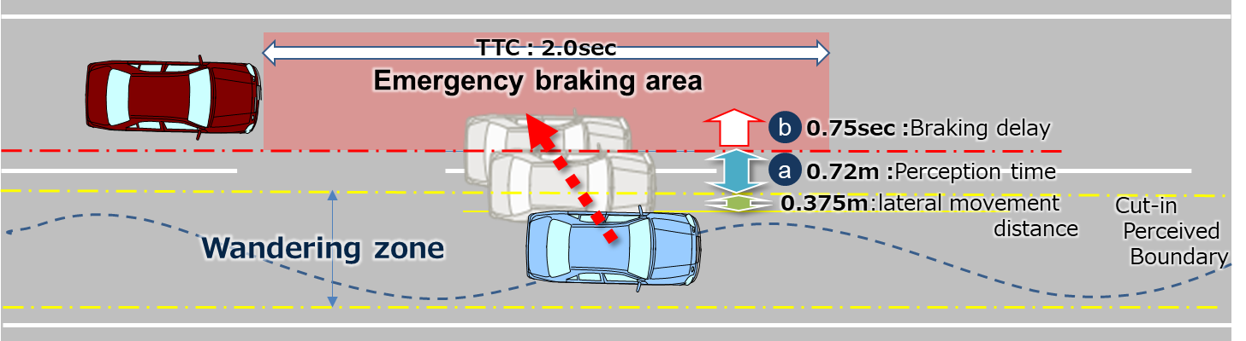
3.3.2.2. For Cut out scenario:
The lateral wandering distance the vehicle will normally wander within the lane is 0.375m.
The perceived boundary for cut-out occurs when the vehicle exceeds the normal lateral wandering distance (possibly prior to actual lane change)
The risk perception time [a] is 0.4 seconds #and begins when the leading vehicle exceeds the cut-out boundary threshold.
The time 2 sec is specified as the maximum Time Head Way (THW) for which it was concluded that there is a danger in longitudinal direction.
Note: THW = 2.0sec is chosen according to other countries’ regulations and guidelines.
Figure 3
Cut in scenario
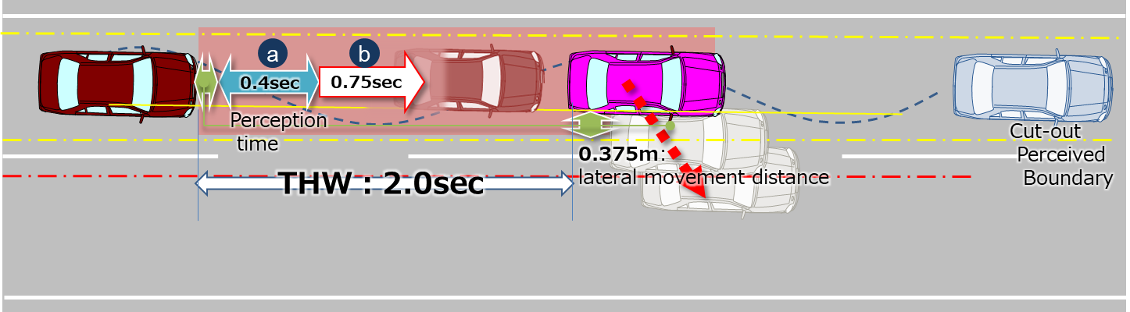

3.3.2.3. For Deceleration scenario:
The risk perception time [a] is 0.4 seconds. The risk perception time [a] begins when the leading vehicle exceeds a deceleration threshold 5m/s².
Figure 4
Deceleration scenario
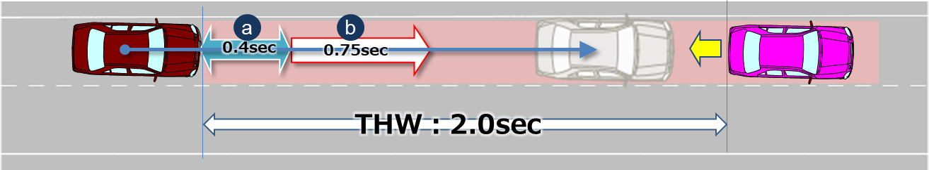
4. Parameters
3.3.3. Parameters
3.3.3.1. Parameters below are essential when describing the pattern of the traffic critical scenarios in section 2.1.
3.3.3.2. Additional parameters could be added according to the operating environment (e.g. friction rate of the road, road curvature, lighting conditions).
Table 2
Additional parameters
- Operating conditions | - Roadway | - Number of lanes = The number of parallel and adjacent lanes in the same direction of travel  - Lane Width = The width of each lane  - Roadway grade = The grade of the roadway in the area of test  - Roadway condition = the condition of the roadway (dry, wet, icy, snow, new, worn) including coefficient of friction  - Lane markings = the type, colour, width, visibility of lane markings
 | - Environmental conditions | - Lighting conditions = The amount of light and direction (i.e., day, night, sunny, cloudy)  - Weather conditions = The amount, type and intensity of wind, rain, snow etc.
- Initial condition | - Initial velocity | - Ve0 = Ego vehicle
 |  | - Vo0 = Leading vehicle in lane or in adjacent lane
 |  | - Vf0 = Vehicle in front of leading vehicle in lane
 | - Initial distance | - dx0 = Distance in Longitudinal direction between the front end of the ego vehicle and the rear end of the leading vehicle in ego vehicle’s lane or in adjacent lane
 |  | - dy0 = Inside Lateral distance between outside edge line of ego vehicle in parallel to the vehicle's median longitudinal plane within lanes and outside edge line of leading vehicle in parallel to the vehicle's median longitudinal plane in adjacent lines.
 |  | - dy0_f = Inside Lateral distance between outside edge line of leading vehicle in parallel to the vehicle's median longitudinal plane within lanes and outside edge line of vehicle in front of the leading vehicle in parallel to the vehicle's median longitudinal plane in adjacent lines.
 |  | - dx0_f = Distance in longitudinal direction between front end of leading vehicle and rear end of vehicle in front of leading vehicle
 |  | - dfy = Width of vehicle in front of leading vehicle
 |  | - doy = Width of leading vehicle
 |  | - dox = Length of the leading vehicle
- Vehicle motion | - Lateral motion | - Vy =Leading vehicle lateral velocity
 | - Deceleration | - Gx_max = Maximum deceleration of the leading vehicle in G
 |  | - dG/dt = Deceleration rate (Jerk) of the leading vehicle
3.3.3.3. Following are visual representations of parameters for the three types of scenarios
Figure 5
Visualisation
Cut in | 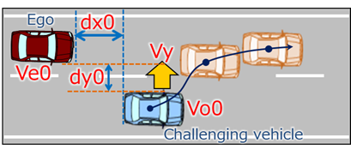
Cut out | 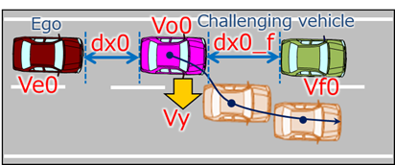
Deceleration | 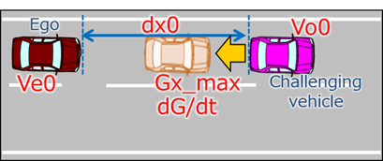

5.3.3.4. Reference
Following data sheets are pictorial examples of simulations which determines conditions under which ALKS travelling at a speed up to 60 km/h shall avoid a collision, taking into account the combination of every parameter, at and below the maximum permitted ALKS vehicle speed.
5.1. 3.3.4.1. Cut in
Figure 6
Parameters
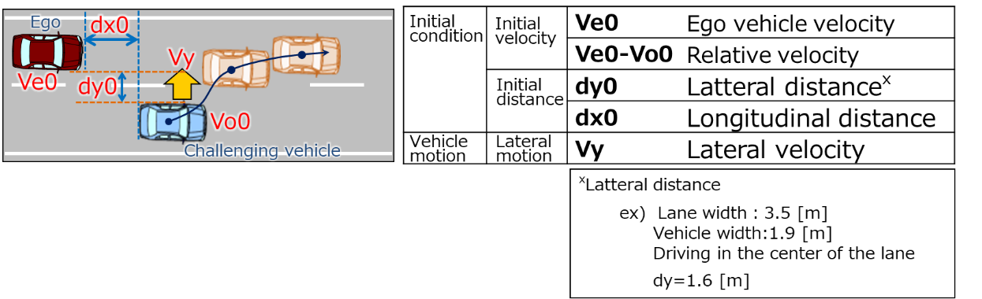
(Data sheets image)
Figure 7
Overview
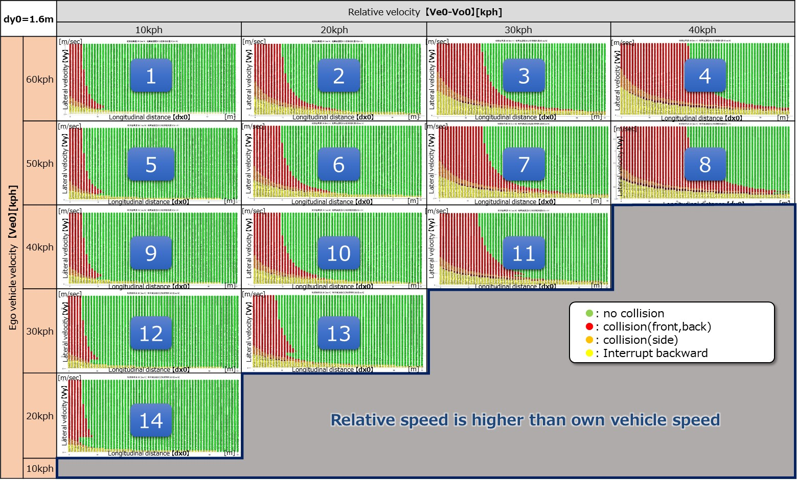

Figure 8
For Ve0 = 60 kph
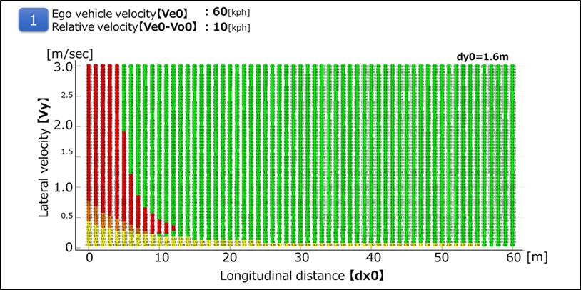

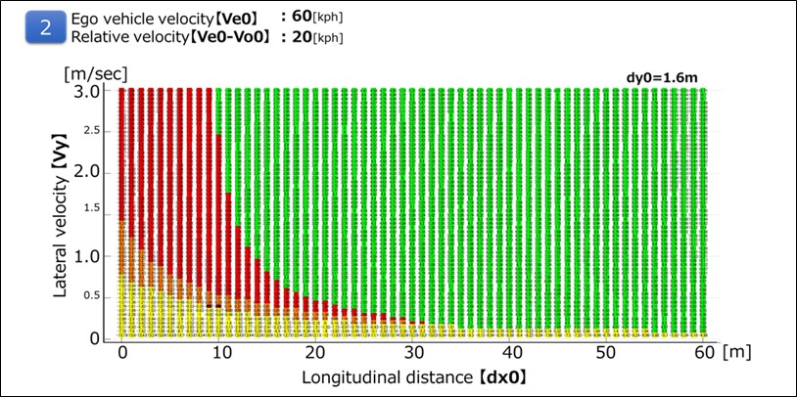
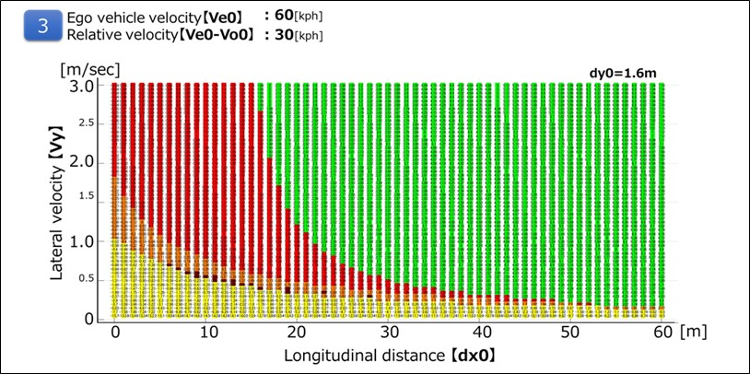

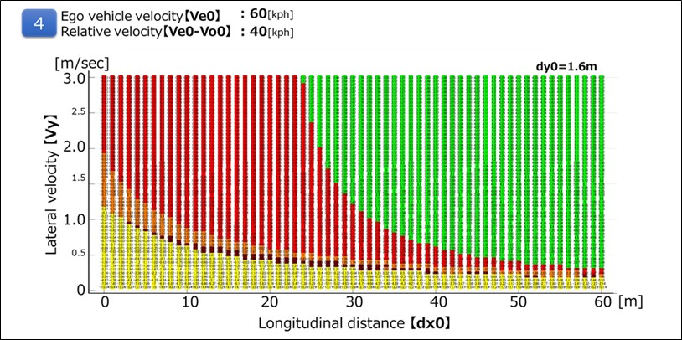

Figure 9
For Ve0 = 50 kph
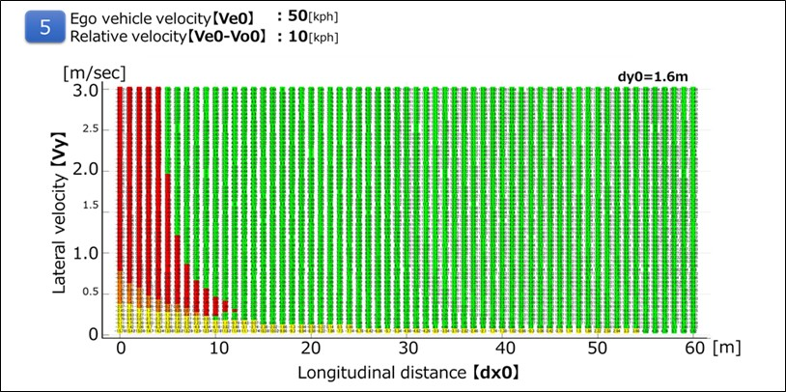

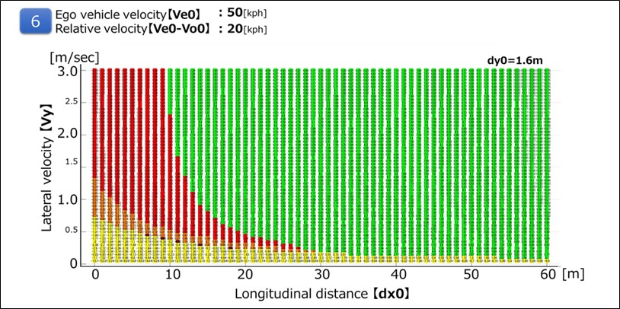

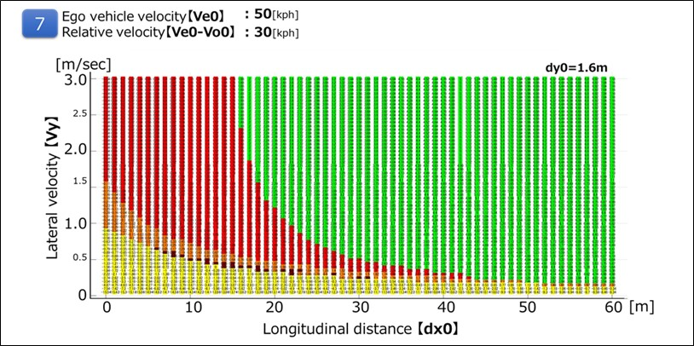

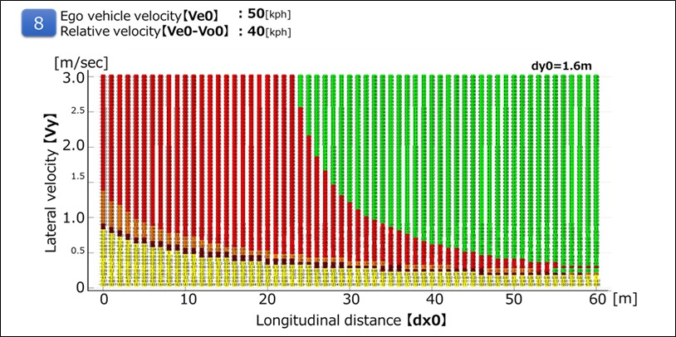

Figure 10
For Ve0 = 40 kph
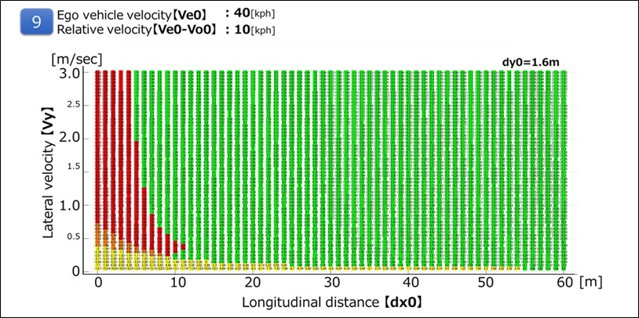

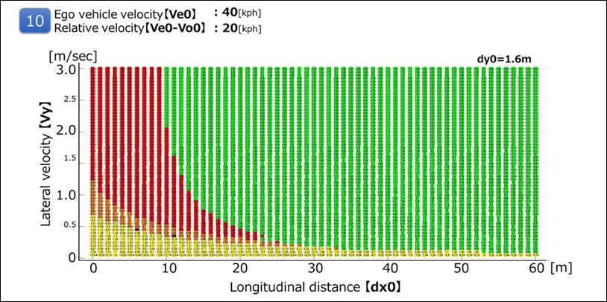

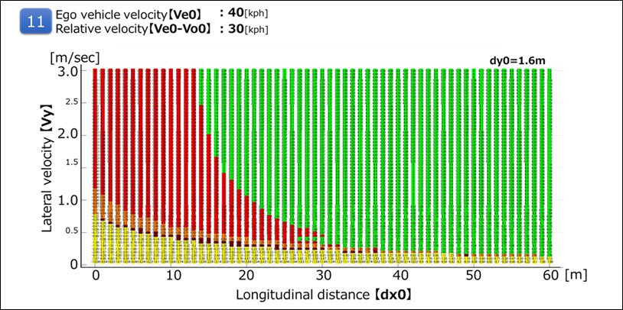
Figure 11
For Ve0 = 30 kph
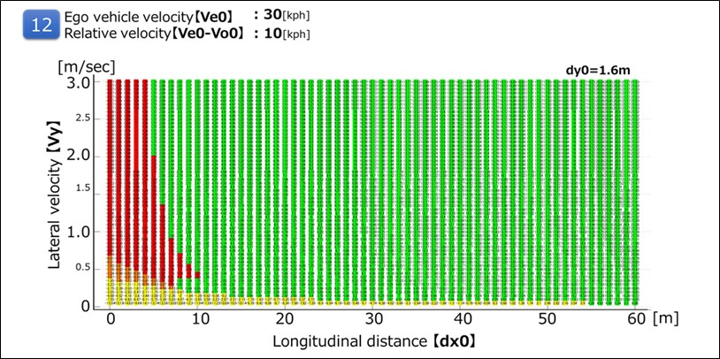

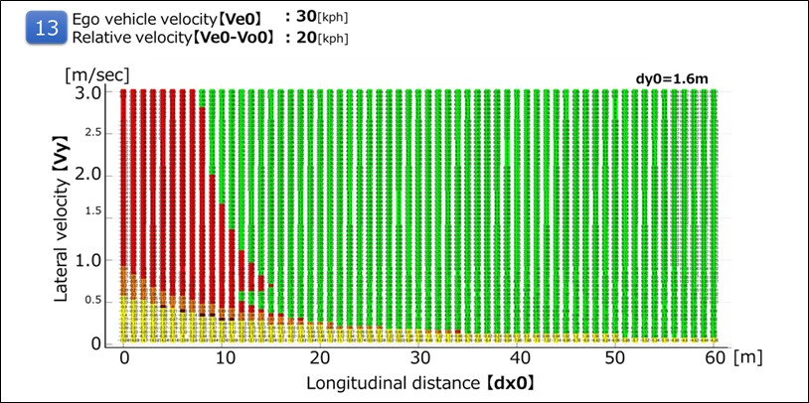
Figure 12
For Ve0 =20 kph
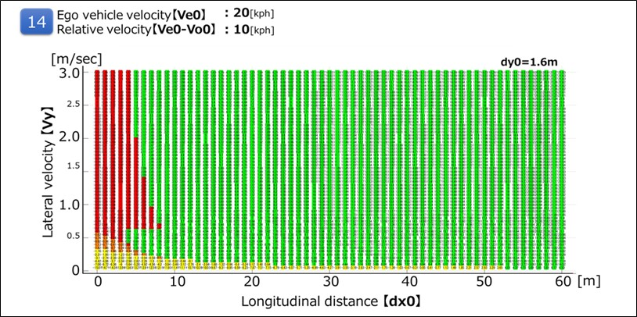

5.2. 3.3.4.2. Cut out
It is possible to avoid all the deceleration (stop) vehicles ahead of the preceding vehicle cut-out in the following running condition at THW 2.0 sec.
Figure 12
Parameters
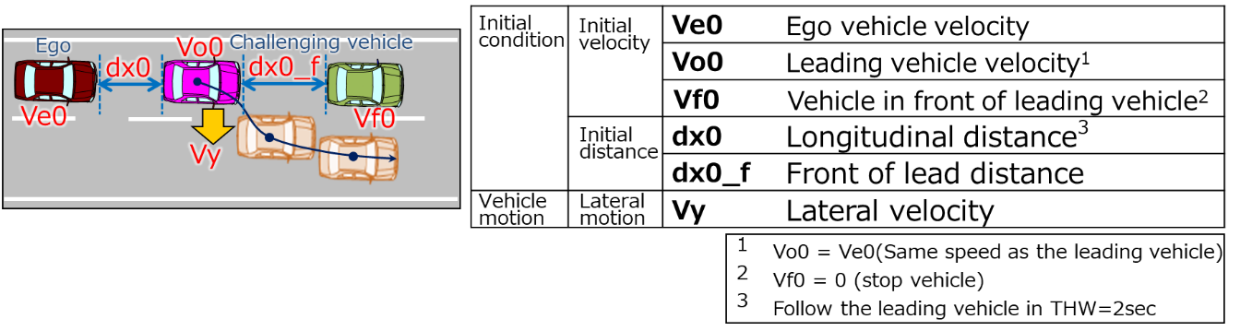
(Data sheets image)
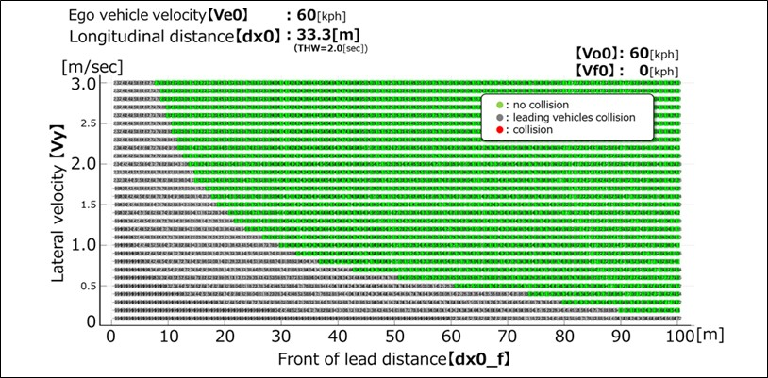
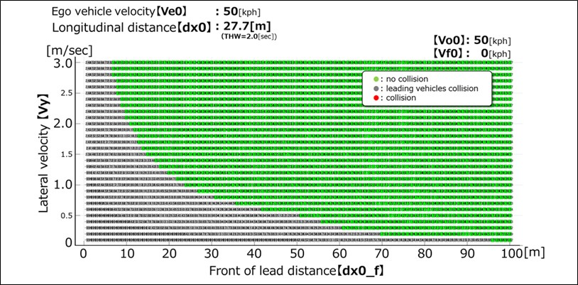
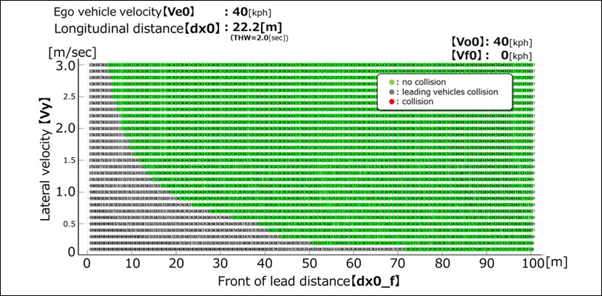

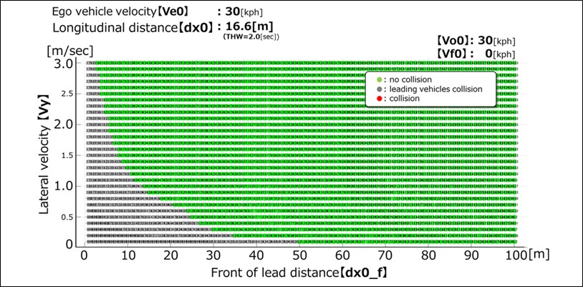

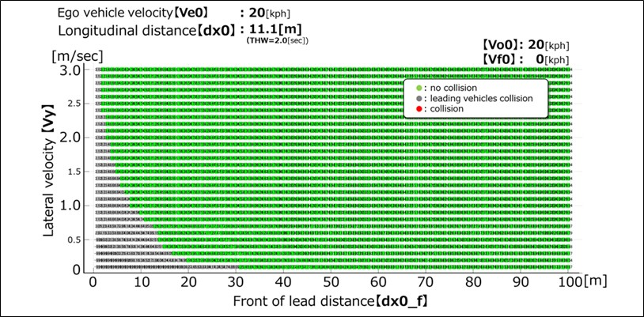
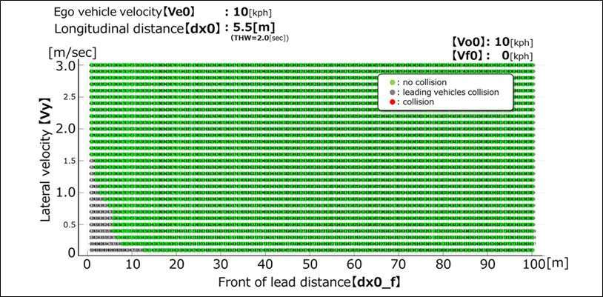

5.4. 3.3.4.3. Deceleration
It is possible to avoid sudden deceleration of -1.0G or less in the follow-up driving situation at THW 2.0sec.
(Data sheet image)
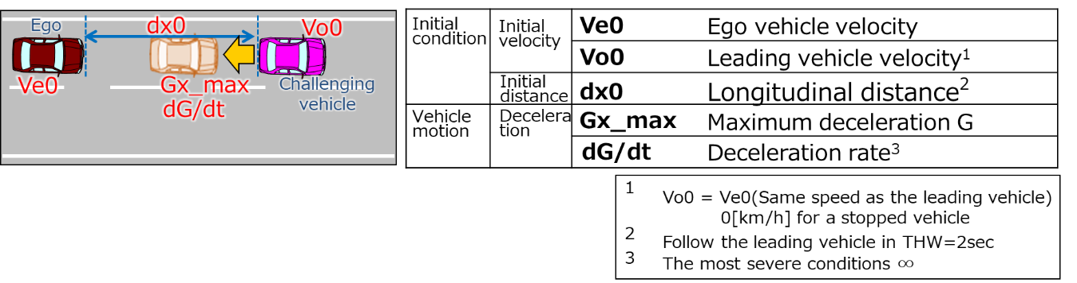
(Data sheets image)
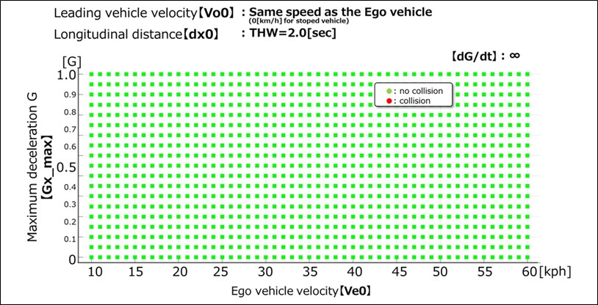

3.4. “Performance model 2”
3.4.1. In the second performance model, it is assumed that the driver can anticipate the risk of a collision and apply proportionate braking. apply proportionate braking actions in order to anticipate the risk of collision. In this case, the performance model considers the following three actions performed by the competent and careful human driver: "Lateral Safety Check"; "Longitudinal Safety Check"; and, "Reaction". A Reaction is implemented only if the Lateral and Longitudinal Safety Checks identify a risk of imminent collision. The diagram reported in Figure 2 provides a visual representation of the decision flow followed by the driver in the second performance model for the case of the cut-in traffic critical scenario.

Figure 6
Flow-chart of the second ALKS performance model for the case of the cut in traffic critical scenario

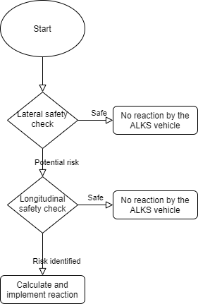

3.4.2. Cut-in traffic critical scenario.
3.4.2.1. The Lateral Safety Check identifies a potential risk of collision if the following conditions hold true:
a) the rear of the ‘other vehicle’ is ahead of the front of the ALKS vehicle along the longitudinal direction of motion;
b) the ‘other vehicle’ is moving towards the ALKS vehicle
c) the longitudinal speed of the ALKS vehicle is greater than the longitudinal speed of the ‘other vehicle’
d) the following equation is satisfied
$\frac{dist_{lat}}{u_{cut-in,lat}}<\frac{dist_{lon}+length_{ego}+length_{cut-in}}{u_{ego,lon}-u_{cut-in,lon}}+0.1$
Where
$dist_{lat}$ instantaneous lateral distance between the two vehicles
$dist_{lon}$ instantaneous longitudinal distance between the two vehicles
$length_{ego}$ length of the ALKS vehicle
$length_{cut-in}$ length of the ‘other vehicle’
$u_{cut-in,lat}$ instantaneous lateral speed of the ‘other vehicle’
$u_{ego,lon}$ instantaneous longitudinal speed of the ALKS vehicle
$u_{cut-in,lon}$ instantaneous longitudinal speed of the ‘other’ vehicle.
3.4.2.2. The Longitudinal Safety Check requires the assessment of two Fuzzy Surrogate Safety Metrics, the Proactive Fuzzy Surrogate Safety Metric (PFS), and the Critical Fuzzy Surrogate Safety Metric (CFS).
3.4.2.2.1. The PFS is defined by the following equation:
$PFS\left(dist_{lon}\right)= \left\{\begin{aligned}1 \\ 0 \\ \frac{dist_{lon}-d_{safe}-d_{1}}{d_{unsafe}-d_{safe}}\end{aligned} \begin{matrix}if 0<dist_{lon}<d_{unsafe} \\ if dist_{lon}>d_{safe} \\ if d_{unsafe}<dist_{lon}<d_{safe}\end{matrix}\right.$
where
$d_{1}$ is the safety distance when the two vehicles reach complete stop
$$d_{safe}=u_{ego,lon}τ+\frac{u_{ego,lon}^{2}}{2b_{ego,comf}}- \frac{u_{cut-in,lon}^{2}}{2b_{ego,max}}+d_{1}$$
$$d_{unsafe}= u_{ego,lon}τ+\frac{u_{ego,lon}^{2}}{2b_{ego,max}}- \frac{u_{cut-in,lon}^{2}}{2b_{cut-in,max}}$$
with
$τ$ the reaction time of the ALKS vehicle defined as the total time from the moment in which the need for a reaction is identified until it starts to be implemented
$b_{ego,comf}$ the comfortable deceleration of the ALKS vehicle
$b_{ego,max}$ the maximum deceleration of the ALKS vehicle
$b_{cut-in,max}$ the maximum deceleration of the ‘other vehicle’
3.4.2.2.2. The CFS is defined by the following equation:
$CFS\left(dist_{lon}\right)= \left\{\begin{aligned}1 \\ 0 \\ \frac{dist_{lon}-d_{safe}}{d_{unsafe}-d_{safe}}\end{aligned}\right. \begin{matrix}if 0<dist_{lon}<d_{unsafe} \\ if dist_{lon}≥d_{safe} \\ if d_{unsafe}≤dist_{lon}<d_{safe}\end{matrix}$
Where
$d_{safe}=\left\{\begin{matrix}\frac{{\left(u_{ego,lon}- u_{cut-in,lon}\right)}^{2}}{2a_{ego}^{'}} \\ d_{new}+\frac{{\left(u_{ego,lon,ΝΕΧΤ}-u_{cut-in,lon} \right)}^{2}}{2b_{ego,comf}}\end{matrix}\right. \begin{matrix}\begin{matrix}if u_{ego,lon,ΝΕΧΤ}≤u_{cut-in,lon} \\ \end{matrix} \\ if u_{ego,lon,ΝΕΧΤ}>u_{cut-in,lon}\end{matrix}$
$d_{unsafe}=\left\{\begin{matrix}\frac{{\left(u_{ego,lon}- u_{cut-in,lon}\right)}^{2}}{2a_{ego}^{'}} \\ d_{new}+\frac{{\left(u_{ego,lon,ΝΕΧΤ}-u_{cut-in,lon} \right)}^{2}}{2b_{ego,max}}\end{matrix}\right. \begin{matrix}\begin{matrix}if u_{ego,lon,ΝΕΧΤ}≤u_{cut-in,lon} \\ \end{matrix} \\ if u_{ego,lon,ΝΕΧΤ}>u_{cut-in,lon}\end{matrix}$
in which
$a_{ego}^{'}=max⁡(a_{ego}, {-b}_{ego,comf})$
$u_{ego,lon,ΝΕΧΤ}=u_{ego,lon}+a_{ego}^{'}τ$
$d_{new}=\left(\frac{{(u}_{ego,lon}+u_{ego,lon,ΝΕΧΤ})}{2}- u_{cut-in,lon}\right)τ$
where
$a_{ego}$ the instantaneous longitudinal acceleration of the ALKS vehicle
$a_{ego}^{'}$ a modified instantaneous acceleration which assume that ALKS vehicle cannot decelerate by more than $b_{ego,comf}$
$u_{ego,lon,ΝΕΧΤ}$ the expected longitudinal speed of the ALKS vehicle after the reaction time assuming constant acceleration
$d_{new}$ the expected longitudinal change in distance between the ALKS vehicle and the ‘other vehicle’ after the reaction time
3.4.2.2.3. The Longitudinal Safety Check identifies a potential risk if either PFS or CFS are greater than 0.
3.4.2.3. If a risk is identified the ALKS vehicle is assumed to plan and implement a reaction by decelerating according to the following equation:
$b_{reaction}=\left\{\begin{matrix}CFS∙\left(b_{ego,max}- b_{ego,comf}\right)+b_{ego,comf} \\ PFS∙b_{ego,comf}\end{matrix}\right. \begin{matrix}if CFS>0 \\ if CFS=0\end{matrix}$
3.4.2.3.1 The deceleration is implemented after a time equal to $τ$ when it starts to increase with a constant rate equal to the maximum jerk.
3.4.2.4. In the case the reaction is not able to prevent the vehicle to collide with the cutting-in vehicle, the scenario is classified as unpreventable, otherwise it is classified as preventable.
3.4.3. Cut-out traffic critical scenario.
In case of a cut-out, the model follows the same flow chart described in 3.2.2.1. for the cut-in scenario, with three changes:
(a) The Lateral Safety check is ignored, as the ALKS vehicle and the static object are already in the same lane.
(b) The Longitudinal Safety check is evaluated as in paragraph 3.2.2.1.2. with the state parameters being calculated for the static object instead of the cutting in vehicle.
(c) The ALKS vehicle is assumed not to be able to start the reaction time before the cutting out vehicle’s centre is outside the wandering zone of 0.375 m from the centre of the lane.
3.4.4. Deceleration traffic critical scenario
In case of a sudden deceleration of the preceding vehicle, the model follows the same flow chart described in 3.2.2.1. for the cut-in scenario, with two changes:
(a) The Lateral Safety check is ignored, as the ALKS vehicle and the preceding vehicle are already in the same lane.
(b) The Longitudinal Safety check is evaluated as in 3.2.2.1.2. with the state parameters being calculated for the preceding vehicle instead of the cutting in vehicle.
3.4.5. A software implementation of the second performance model to derive the scenario classification from simulation applied to the three traffic critical scenarios described in paragraph 2.2. of the present appendix is openly available. at the following url: [link to be provided as soon as the software is published]. For any request of support to its use the following email address can be used: JRC-SMART-MOBILITY@ec.europa.eu
3.4.6. To determine conditions under which the ALKS vehicle shall avoid a collision, the following performance model factors shall be used.

Table 3
Performance model factors for vehicles
 | Factor
Risk perception point | The time when either PFS or CFS value is not any longer 0
 | In the case of cut-out the ALKS vehicle reaction time cannot start before the cutting out vehicle’s centre is outside the wandering zone of 0.375 m from the centre of the lane
Reaction time of the ALKS vehicle | $τ$ = 0.75 seconds
Jerking (road friction 1.0) | 12.65 m/s³
Safety distance when the two vehicles reach complete stop | $d_{1}$ = 2 meters
Comfortable deceleration of the ALKS vehicle | $b_{ego,comf}=$4 m/s²
Maximum deceleration of the ALKS vehicle | ${ b}_{ego,max}=$6 m/s²
Maximum deceleration of the ‘other vehicle’ | ${ b}_{cut-in,max}=$7 m/s²
]
Annex 5, paragraphs 4.7. and 4.8., insert to read:
[4.7. Detect and response to traffic rules and road furniture
4.7.1. These tests shall ensure that the ALKS respects traffic rules, detects and adapts to a variation of permanent and temporary road furniture.
4.7.2. The test shall be executed at least with the list of scenarios below, but based on the ODD of the given system:
(a) Different speed limit signs, so that the ALKS vehicle has to change its speed according to the indicated values;
(b) Signal lights of an ending lane. The signal lights are set above the belonging lanes, and the signal lights of adjacent lanes are kept in green state, while the one of the current lane for the ALKS vehicle is kept red.;
(c) Driving through a tunnel: at least [X]m long section of the road with no sunlight and availability of the positioning system.
(d) Toll station: a section of the motorway with toll station-, speed limit signs and buildings (ticket machines, barriers, etc.).
(e) Temporary modifications: e.g., road maintenance operations indicated by traffic signs, cones and other modifications.
4.7.3. Each test shall be executed at least:
(a) Without a lead vehicle;
(b) With a passenger car target as well as a PTW target as the lead vehicle / other vehicle.
4.8. Avoid braking before a passable object in the lane
4.8.1. The test shall demonstrate that the ALKS vehicle is not braking without a reason before a passable object in the lane (e.g., a manhole lid or a small branch).
4.8.2. The test shall be executed at least:
(a) Without a lead vehicle;
(b) With a passenger car target as well as a PTW target as the lead vehicle / other vehicle.]
Annex 5, paragraph 4.9., insert to read:
[4.9. Oncoming traffic / Wrong way driver
4.9.1. The test shall demonstrate that ALKS is capable of detecting and reacting to oncoming traffic in an adjacent lane.
4.9.2. The test for oncoming vehicle shall be executed at least:
(a) Without a lead vehicle;
(b) With a passenger car target as well as a PTW target as the lead vehicle / other vehicle]
II. Justification
1. This proposal aims at increasing the specified maximum speed of ALKS up to 130 km/h. . It is based on ECE/TRANS/WP.29/GRVA/2020/32 presented to GRVA at its September 2020 session by the expert from Germany as well as subsequent proposals for amendments received so far.
2. An informal document from group is expected before the next GRVA session to close the open issues. Here below is summarized the SIG 157 state of play of discussion for each paragraph:
(a) Group conclusion on 2.1: agreed.
(b) Group conclusion Point of discussion on 2.21.: agreed to include defintion for string instability. and 2.22: Stability and string stability definitions (As proposed by the Joint Research Center/European Commission in working paper
UNR157-03-06), to be confirmed together with string stability requirements.
(c) Group conclusion on 5.1.1.1: agreed.
(d) Group conclusion on 5.2.1: Proposal (change ‘position’ into ‘motion’) an simplification in line with new definition for string instability in para. 2.21. agreed. Point of discussion: Introducing provisions by the leadership of “smooth driving” and “string stability” from JRC/EC proposal (working paper UNR157-03-06, new para. 5.2.7. and 5.2.8.) which are detailed further below. Are they appropriately worded by leadership (green text) and well-placed?
(e) Point of discussion on 5.2.3.1.: The group agreed the max speed of 60 km/h instead of originally proposed 100 km/h by industry for systems with no lane change capability during MRM. New text in square brackets proposed by industry to allow systems to operate at higher speeds without lane change capability during MRM in very limited circumstances.
(f) Group conclusion on 5.2.3.3: Agreed to keep table only up to 60 km/h. Values based on braking capabilities. For speeds above 60 km/h, the text refers to traffic rules. Addional amendment in line with string instability definition para. 2.21. and requirement in para. 5.2.1.
(g) Group conclusion: New text in bold in 5.2.5. on a vehicle proceeding in opposite direction agreed and moved to 5.2.8. by the leadership. The Group needs to confirm that new location of para. 5.2.8. is OK (reworded slightly to fit with existing text).
(h) Point of discussion on 5.2.5.3: Tentative group conclusion to agree on proposal for para. 5.2.5.3.
(i) Points of discussion for 5.2.7: Group tentatively agreed at its seventh meeting to include JRC/EC fuzzy logic model in UN Regulation No. 157, Annex 3 in addition to existing model. Group to confirm that the text..
(j) Group conclusion Point of discussion on 5.2.9. and 5.2.10: deleted without replacment (not needed due to other aforementioned amendments) Agreement to include some aspects of proposals from JRC/EC (working paper UNR157-03-06) on “string stability” as general requirements. Leadership to prepare proposal. → Group needs to review proposal by leadership.
(k) Group conclusion for 5.3.2: Proposal agreed.
(new) Group conclusion for 5.4.2.3. and 6.4.1.: Proposal agreed.
(l) Group conclusion on 7.1.1: Proposal agreed (based on 5 m/s² deceleration), but with added (strengethend) requirement reagrding control strategies of the system.
(m) Points of discussion for Annex 3: Proposal by leadership to implement the tentative group decision at the seventh meeting to embrace the JRC/EC model in Annex 3 as guidance (largely transferred from JRC/EC proposal in working paper UNR157-03-06)). Group needs to confirm, if this proposal is acceptable.
(n) Points of discussion for Annex 5: Group agreement needed how to deal with the following two new on-road tests proposed by JRC/EC (working paper UNR157-03-06). Open question: Can the three tests be added to UN Regulation No. 157?

