|  |  |
| --- | --- |
| Transmitted by the experts of the  Informal Working Group on  Measurement Uncertainties (IWG MU) | Informal document **GRBP-74-13e**  (74rd GRBP, 15-17 September 2021,  agenda item 3) |

**Proposal to Introduce a Temperature Correction for the Tyre Rolling Sound Component of Pass-by Tests according UN Regulation No. 51.03 Annex 3**

The text below has been prepared by the experts of the Informal Working group on Measurement Uncertainties (IWB MU) in order to introduce measures to reduce variability. The modifications to the existing text of the UN regulation are marked in **bold** for new or ~~strikethrough~~ for deleted characters. Some modifications include moving existing provisions to other places.

Only for the informal document these modifications of moved existing content are additionally marked in **green color** for easier reading.

1. **Proposal**

*Annex 3, paragraph 3.1.3., amend to read*

“3.1.3. Interpretation of results

~~For vehicles of categories M~~~~1~~ ~~and M~~~~2~~ ~~having a maximum authorized mass not exceeding 3,500 kg, and category N~~~~1~~ ~~the maximum A-weighted sound pressure level indicated during each passage of the vehicle according to paragraphs 3.1.2.1.5. and 3.1.2.1.6. shall be rounded to the first significant digit after the decimal place (e.g. XX,X).~~

~~For vehicles of category M~~~~2~~ ~~having a maximum authorized mass exceeding 3,500 kg and categories M~~~~3~~~~, N~~~~2~~~~, and N~~~~3~~ ~~the maximum A-weighted sound pressure level indicated during each passage of the reference point of the vehicle between line AA’ and line BB’ + 5 m shall be rounded, to the first significant digit after the decimal place (e.g. XX,X).~~

~~For indoor testing, pass-by sound is simulated by measurement of power train sound on the dynamometer and energetical addition of the tyre/road sound (measured separately on an outdoor test track) according to Annex 8, paragraph 2 of this Regulation.~~

~~If a sound peak obviously out of character with the general sound pressure level is observed, the measurement shall be discarded. At least four measurements for each test condition shall be made on each side of the vehicle and for each gear ratio. Left and right side may be measured simultaneously or sequentially. The first four valid consecutive measurement results, within 2 dB(A), allowing for the deletion of non-valid results (see paragraph 2.1.), shall be used for the calculation of the final result for the given side of the vehicle.~~

~~The results of each side shall be averaged separately and rounded to the first decimal place. All further calculations to derive L~~~~urban~~ ~~shall be done separately for the left and right vehicle side. The final value to be reported as the test result mathematically rounded to the nearest integer shall be the higher value of the two sides.~~

~~The speed measurements at AA', BB', and PP' shall be noted and used in calculations to the first significant digit after the decimal place.~~

~~The calculated acceleration a~~~~wot test~~ ~~shall be noted to the second digit after the decimal place.~~

3.1.3.1. **Measurement readings for outdoor tests** ~~Vehicles of categories M~~~~1~~~~, N~~~~1~~ ~~and M~~~~2~~ ~~≤ 3,500 kg technically permissible maximum laden mass~~

**For vehicles of categories M1 and M2 having a maximum authorized mass not exceeding 3,500 kg, and category N1 the maximum A-weighted sound pressure level indicated during each passage of the vehicle according to paragraphs 3.1.2.1.5. and 3.1.2.1.6. shall be rounded to the first significant digit after the decimal place (e.g. XX.X).**

**For vehicles of category M2 having a maximum authorized mass exceeding 3,500 kg and categories M3, N2, and N3 the maximum A-weighted sound pressure level indicated during each passage of the reference point of the vehicle between line AA’ and line BB’ + 5 m shall be rounded, to the first significant digit after the decimal place (e.g. XX.X).**

~~The calculated values for the acceleration test and the constant speed test are given by:~~

~~L~~~~wot rep~~ ~~= L~~~~wot (i+1)~~ ~~+ k * (L~~~~wot(i)~~ ~~– L~~~~wot (i+1)~~~~)~~

~~L~~~~crs rep~~ ~~= L~~~~crs(i+1)~~ ~~+ k * (L~~~~crs (i)~~ ~~– L~~~~crs (i+1)~~~~)~~

~~Where k = (a~~~~wot ref~~ ~~– a~~~~wot (i+1)~~~~)/(a~~~~wot (i)~~ ~~– a~~~~wot (i+1)~~~~)~~

~~In the case of a single gear ratio test the values are the test result of each test.~~

~~The final result is calculated by combining L~~~~wot rep~~ ~~and L~~~~crs rep~~~~. The equation is:~~

~~L~~~~urban~~ ~~= L~~~~wot rep~~ ~~– k~~~~P~~ ~~* (L~~~~wot rep~~ ~~– L~~~~crs rep~~~~)~~

~~The weighting factor k~~~~P~~ ~~gives the part power factor for urban driving. In cases other than a single gear test, k~~~~P~~ ~~is calculated by:~~

~~k~~~~P~~ ~~= 1 – (a~~~~urban~~ ~~/ a~~~~wot ref~~~~)~~

~~If only one gear was specified for the test, k~~~~P~~ ~~is given by:~~

~~k~~~~P~~ ~~= 1 – (a~~~~urban~~ ~~/ a~~~~wot test~~~~)~~

~~In cases where a~~~~wot test~~ ~~is less than a~~~~urban~~~~:~~

~~k~~~~P~~ ~~= 0~~

**3.1.3.2. Measurement readings for indoor tests** ~~Vehicles of categories M~~~~2~~ ~~> 3,500 kg technically permissible maximum laden mass, M~~~~3~~~~, N~~~~2~~~~, N~~~~3~~

**For indoor testing, pass-by sound is simulated by measurement of power train sound on the dynamometer and energetical addition of the tyre/road sound (measured separately on an outdoor test track) according to Annex 8, paragraph 2 of this Regulation.**

~~When the result of one test condition is used the final result L~~~~urban~~ ~~is equal to the intermediate result.~~

~~When the results of two test conditions are used the arithmetic mean of the intermediate results of the two averages for each side of the two conditions shall be calculated. The final result L~~~~urban~~ ~~is the higher value of the two calculated averages.~~

**3.1.3.3. Validation of individual test runs**

**If a sound peak obviously out of character with the general sound pressure level is observed, the measurement shall be discarded. At least four measurements for each test condition shall be made on each side of the vehicle and for each gear ratio. Left and right side may be measured simultaneously or sequentially. The first four valid consecutive measurement results, within 2 dB(A), allowing for the deletion of non-valid results (see paragraph 2.1.), shall be used for the calculation of the final result for the given side of the vehicle.**

**3.1.3.4. Calculation of results**

**3.1.3.4.1. Calculation for vehicles of category M1 and N1, and for vehicles of category M2 having a maximum authorized mass not exceeding 3,500 kg**

**Each valid test run of the acceleration and – if applicable – of the constant speed tests per vehicle side and per gear ratio shall be subjected a temperature correction according to Appendix 2 to Annex 3.**

**All further calculations to derive *Lurban* shall be done separately for the left and right vehicle side. The final value *Lurban* to be reported as the test result mathematically rounded to the nearest integer shall be the higher value of the two sides.**

**The speed measurements at AA', BB', and PP' shall be noted and used in calculations to the first significant digit after the decimal place.**

**The calculated acceleration aacc test shall be noted to the second digit after the decimal place.**

**The calculated and temperature corrected values for the acceleration test and the constant speed test are given by:**

***Lacc rep = Lacc (i+1) + k * (Lacc(i) – Lacc (i+1))***

***Lcrs rep = Lcrs(i+1) + k * (Lcrs (i) – Lcrs (i+1))***

**where *k = (aacc ref – aacc (i+1))/(aacc (i) – aacc (i+1))***

**In the case of a single gear ratio test the values are the test result of each test.**

**The final result is calculated by combining *Lacc rep* and *Lcrs rep*. The equation is:**

***Lurban = Lacc rep – kP * (Lacc rep – Lcrs rep)***

**The weighting factor *kP* gives the part power factor for urban driving. In cases other than a single gear test, *kP* is calculated by:**

***kP = 1 – (aurban / aacc ref)***

**If only one gear was specified for the test, *kP* is given by:**

***kP = 1 – (aurban / aacc test)***

**In cases where *aacc test* is less than aurban:**

***kP = 0***

**3.1.3.4.2. Calculation for vehicles of category M2 having a maximum authorized mass exceeding 3,500 kg and categories M3, N2, and N3**

**Each valid test run shall be averaged separately, rounded to the first decimal place and be reported as interim results.**

**All further calculations to derive *Lurban* shall be done separately for the left and right vehicle side. The final value *Lurban* to be reported as the test result mathematically rounded to the nearest integer shall be the higher value of the two sides.**

**The speed measurements at line BB' shall be noted and used in calculations to the first significant digit after the decimal place.**

**The engine speed measurements (if applicable) at line BB' shall be noted and used in calculations to the full integer.**

**When the result of one test condition is used the final result *Lurban* is equal to the intermediate result.**

**When the results of two test conditions are used the arithmetic mean of the intermediate results of the two averages for each side of the two conditions shall be calculated. The final result *Lurban* is the higher value of the two calculated averages.**

**”**

*Annex 3, add new Appendix 2*

“**Annex 3** **– Appendix 2**

**Correction for the tyre rolling sound component of pass-by sound measurements of Annex 3 for vehicles of category M1 and N1, and for vehicles of category M2 having a maximum authorized mass not exceeding 3,500 kg**

1. **General (see the flowchart in Appendix 3, Figure 5a to Figure 5d)**

**This Appendix provides correction for temperature and test track dependent on the tyre category and purpose.**

**For the correction, tyre rolling sound reference values are needed. Tyre rolling sound measurements shall be carried out according to the test procedure of Appendix 3 to Annex 3 of this regulation.**

**These measurements might be carried out during the type approval of a vehicle type (CASE 1 described in paragraph 2. of this appendix) or be performed as an independent test to be used for type approval tests of different vehicle types (CASE 2 described in paragraph 3. of this appendix).**

**For the further processing of data, the following tyre rolling sound reference information shall be available from the test according to Appendix 3 to Annex 3:**

* **The tyre rolling sound *LTR,ϑREF* separately for the left and the right side of the vehicle**
* **The slope of the tyre rolling sound *aREF* separately for the left and for the right side of the vehicle**
* **The reference speed *vREF* to which these sound levels are assigned. If tyre rolling sound measurements are directly carried out in junction with the pass-by measurements, the reference speed *vREF* shall be determined in a way to be equal to the vehicle test speed *vTEST*.**

**The interim results *Lacc(i)*, and *Lcrs(i)*, for gear i and - if applicable - *Lacc(i+1)* and *Lcrs(i+1)* per vehicle side are subject to the temperature correction.**

**For simplicity, the formula below uses the index *x* as place holder for the gear ratio i or i+1. No index is introduced for left and right side, but all calculations shall be done separately for left and right side of the vehicle.**

**The formula for temperature correction is applicable to C1 tyres only. In case a vehicle is equipped with C2 tyres, the temperature correction is not applied (CASE 3 described in paragraph 4. of this appendix).**

**If tests are carried at air temperatures below 5°C according to paragraph out according to paragraph 2.1.3 of Annex 3, the temperature correction is applicable down to an air temperature of 0°C. For any tests carried out at air temperatures below 0°C, the temperature correction shall be calculated with 0°C, regardless of the measured air temperature.**

1. **CASE 1:   
   The temperature correction is based on tyre rolling sound measurements carried in junction with pass-by tests according to Annex 3.**
   1. **The rolling sound of the tyre *LTR,ϑTR* shall be determined for a reference speed according to Appendix 3 to Annex 3.**
      1. **The reported values are the tyre rolling sound *LTR,ϑTR* at the reference speed *vTR,REF*, tyre sound level slope *slpREF*and the air temperature *ϑTR* at which these tests have been performed.   
           
         The reference speed shall be identical to the reference test speed of the constant speed test *vtest* determined in Annex 3. In most cases this will be 50 km/h. if the tyre reference speed *vTR,REF*, differs from *vtest*, adjust the tyre rolling sound to the test speed vtest by:**

* + 1. **For each individual pass-by measurement run j under constant speed the following values per gear are available:   
       the reported sound levels *LCRS,j*, the vehicle speed *vCRS,PP’,j* and the air temperature *ϑCRS,j.***

**For each individual pass-by measurement under acceleration the following values per gear are available:   
the reported sound levels *LACC,j*, the vehicle speeds *vACC,PP’,j*and *vACC,BB’,j* and the air temperature *ϑACC,j*.**

* + 1. **If the temperature *ϑTR* of the tyre rolling sound reference differs by more than 3 °C from the reported temperature of an individual run, adjust at first the tyre rolling sound to the applicable air temperature *ϑCRS,j*or *ϑACC,j* of the individual run. For simplicity these individual temperatures per test run are named ϑTEST in all subsequent calculation formula.**

* 1. **Temperature correction for constant speed test results**
     1. **For each gear and each run under constant speed extract the power train component *LPT,CRS,j* from the test result *LCRS,j*, by calculation.**

$$L_{PT,CRS,j}=10×\log\left({10}^{0,1×L_{CRS,j}}-{10}^{0,1×L_{TR,ϑTEST}}\right)$$

**In case that $L_{TR,ϑTEST}$ is greater than $L_{CRS,j}$ the power train component *LPT,CRS,j* is determined by**

* + 1. **Calculate per gear and per run the air temperature adjusted constant speed test result *LCRS,j,ϑREF* using the temperature normalized tyre rolling sound *LTR,ϑREF* calculated by**

**with**

* 1. **Temperature correction for acceleration test results**
     1. **For each gear and per run, adjust the tyre rolling sound *LTR,ϑTEST* to the speed condition of the acceleration test**

* + 1. **For each gear and each run extract the power train component *LPT,ACC,j* from the reported acceleration test *LACC,j*, by calculation.**

$$L_{PT,ACC,j}=10×\log\left({10}^{0,1×L_{ACC,j}}-{10}^{0,1×L_{TR,ACC,j,ϑTEST}}\right)$$

**In case that $L_{TR,ACC,j,ϑTEST}$ is greater than $L_{ACC,j}$ the power train component *LPT,ACC,j* is determined by**

* + 1. **Adjust the tyre rolling sound component of the acceleration test *LTR,ACC,j,ϑTEST* to the reference temperature *ϑREF***

**where:**

***=* 20 °C**

* + 1. **Calculate per gear the acceleration test result *LACC,j,ϑREF***
    2. **Proceed to calculate LURBAN using the temperature normalized sound pressure levels LCRS,j,ϑREF and LACC,j,ϑREF according to the procedure of Annex 3.**

1. **CASE 2:   
   The temperature correction based on tyre rolling sound measurements that have been performed independent from the pass-by tests subject to the temperature correction.**

**Case 2 is applicable, when pass-by tests carried out according to Annex 3 shall be compared with already existing results – e.g. from type approval , that have been performed under a different temperature condition and on a different test track.**

* 1. **The necessary information on tyre rolling sound representative for the tyre used on the vehicle are available from former tests. The necessary information are the tyre rolling sound *LTR,DB,ϑREF* at the reference temperature *ϑREF*, for the reference vehicle speed *vTR,DB,REF* and the tyre rolling sound slope *slpDB,REF*.**
     1. **The reference speed shall be identical to the reference test speed of the constant speed test *vtest* determined in Annex 3. In most cases this will be 50 km/h. If the tyre reference speed *vTR,DB,REF*, differs from *vtest*, adjust the tyre rolling sound to the test speed *vtest* by:**
  2. **Determine the tyre rolling sound for the vehicle according to CASE 1 above and extract the power train relevant components *LPT,CRS,j* and *LPT,ACC,j* for each gear and run accordingly.**
  3. **Temperature correction for constant speed test results** 
     1. **Calculate per gear and run the air temperature and test track adjusted constant speed test results *LCRS,j,ϑREF* using the air temperature and test track normalized tyre rolling sound LTR,DB,ϑREF calculated by**

* 1. **Temperature correction for acceleration test results**
     1. **For each gear and run, adjust the tyre rolling sound LTR,DB,ϑTEST to the speed condition of the acceleration test**

* + 1. **Calculate per gear the acceleration test result *LACC,j,ϑREF***

* + 1. **Proceed to calculate LURBAN using the temperature normalized sound pressure levels *LCRS,j,ϑREF* and *LACC,j,ϑREF* according to the procedure of Annex 3.**

1. **CASE 3:   
   Case 3 is applicable for C2 tyres only and provides a correction for different test tracks without any temperature correction applied.**
   * 1. **The necessary information on tyre rolling sound representative for the tyre used on the vehicle are available from former tests. The necessary information are the tyre rolling sound *LTR,DB* for the reference vehicle speed *vTR,DB,REF* and the tyre rolling sound slope *slpDB,REF*.**
     2. **The reference speed shall be identical to the reference test speed of the constant speed test *vtest* determined in Annex 3. In most cases this will be 50 km/h. If the tyre reference speed *vTR,DB,REF*, differs from *vtest*, adjust the tyre rolling sound to the test speed *vtest* by:**
   1. **Determine the tyre rolling sound for the vehicle according to CASE 1 above and extract the power train relevant components *LPT,CRS,j* and *LPT,ACC,j* for each gear and run accordingly.   
         
      A temperature correction is not applicable, but scheme to determine the tyre rolling sound in combination with Annex 3 tests and the extraction of the power train sound components remains valid.**
   2. **Correction for constant speed test results** 
      1. **Calculate per gear and run the test track adjusted constant speed test results *LCRS,j,ϑREF* using test track normalized tyre rolling sound *LTR,DB* calculated by**

* 1. **Correction for acceleration test results**
     1. **For each gear and run, adjust the tyre rolling sound *LTR,DB* to the speed condition of the acceleration test**

* + 1. **Calculate per gear the acceleration test result *LACC,j***

* + 1. **Proceed to calculate *LURBAN* using the temperature normalized sound pressure levels *LCRS,j,ϑREF*and *LACC,j,ϑREF* according to the procedure of Annex 3.**

**Figure 5a Flowchart for vehicles tested according to paragraph 3.1.2.1. of Annex 3 to this Regulation –   
Correction of pass-by measurements for temperature and if applicable for test track differences**

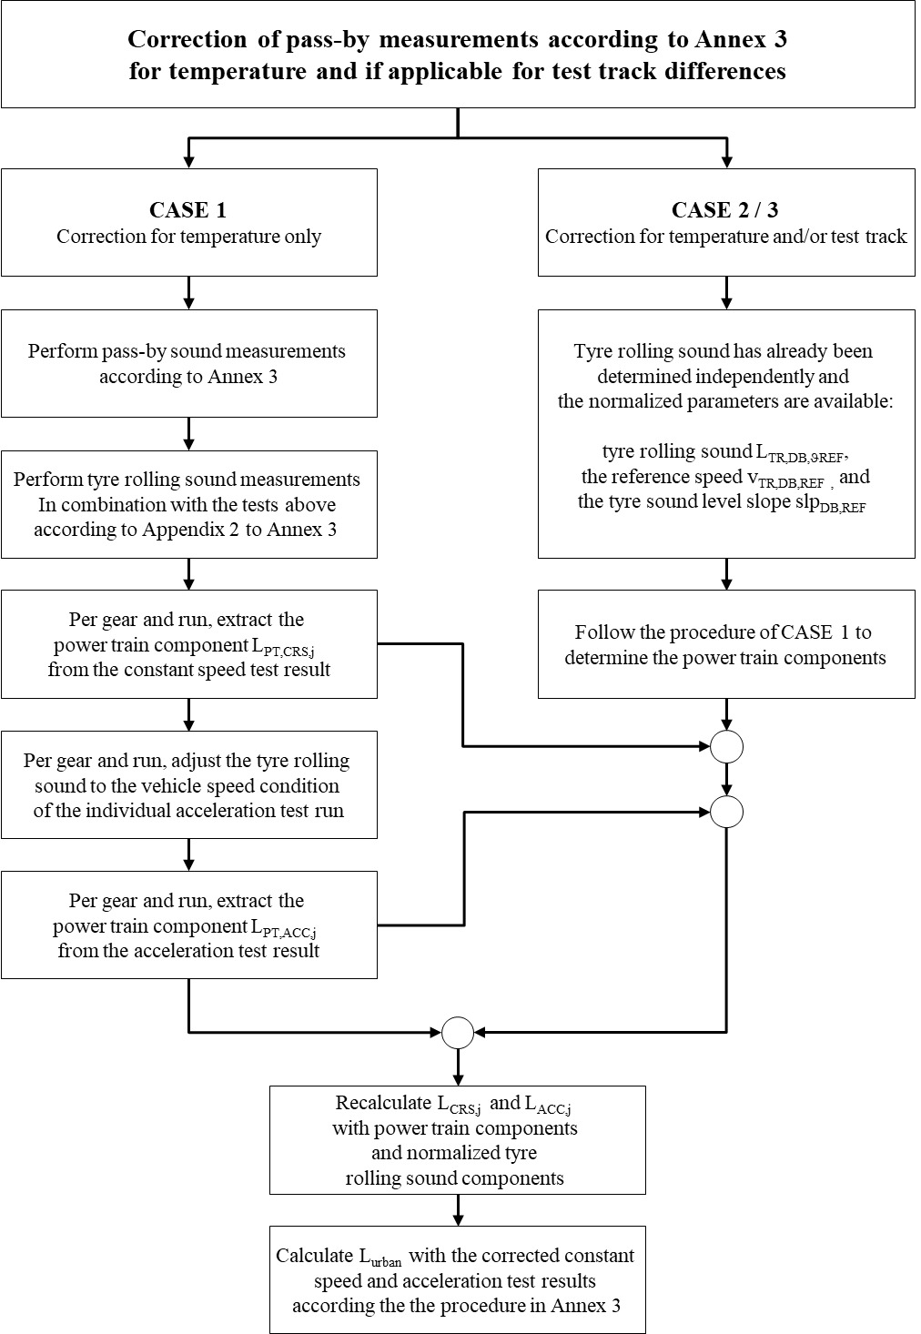

**Figure 5b Flowchart for vehicles tested according to paragraph 3.1.2.1. of Annex 3 to this Regulation –   
Temperature Correction for Tyre Rolling Sound Components CASE 1**

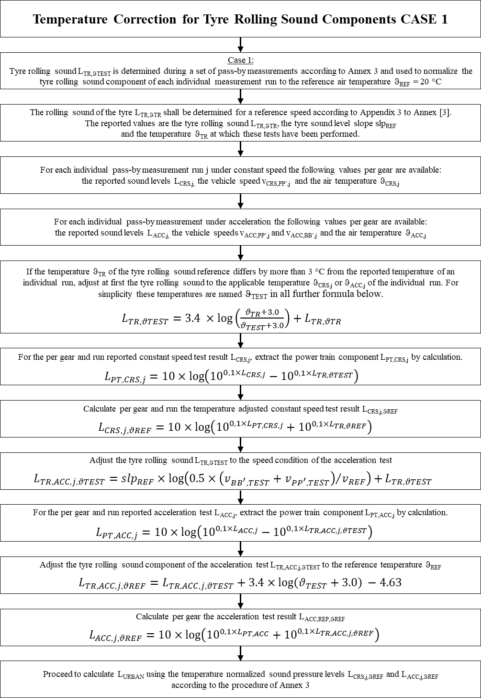

**Figure 5c Flowchart for vehicles tested according to paragraph 3.1.2.1. of Annex 3 to this Regulation –   
Temperature Correction for Tyre Rolling Sound Components CASE 2**

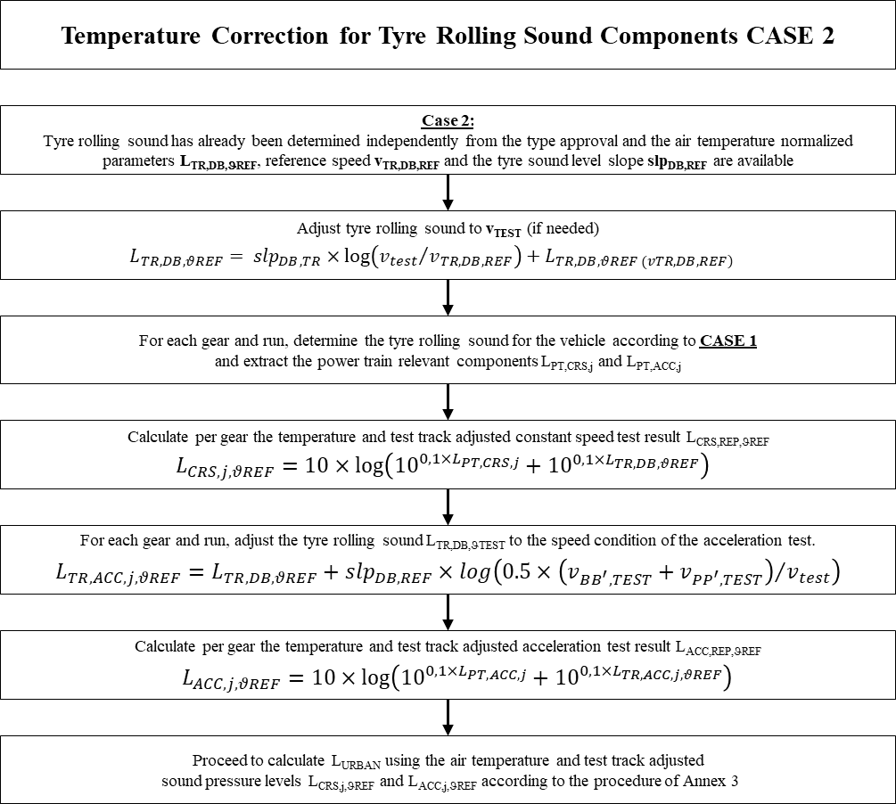

**Figure 5d Flowchart for vehicles tested according to paragraph 3.1.2.1. of Annex 3 to this Regulation –   
Test Track Correction for Tyre Rolling Sound Components CASE 3**

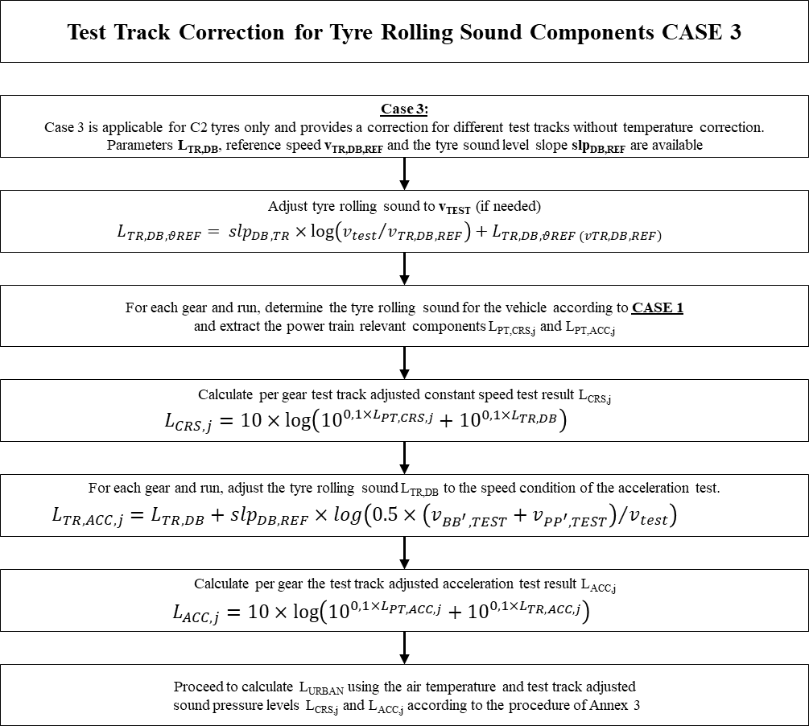

“

*Annex 3, add new Appendix 3*

“**Annex 3 – Appendix 3:**

**Coast-by test method for measuring tyre-rolling sound emission**

1. **Measuring instruments**

**Unless otherwise specified, the measuring instruments shall comply with the provisions of Annex 3 of this UN Regulation**

**1.1. Test surface temperature**

**The temperature sensor is to be positioned in a location where the temperature measured is representative of the temperature in the wheel tracks, without interfering with the sound measurement.**

**If an instrument with a contact temperature sensor is used, heat-conductive paste shall be applied between the surface and the sensor to ensure adequate thermal contact.**

**If a radiation thermometer (pyrometer) is used, the height should be chosen to ensure that a measuring spot with a diameter of ≥ 0.1 m is covered.**

**2. Conditions of measurement**

**2.1. Test site**

**The test site shall comply with the provisions of Annex 3 of this UN Regulation.**

**2.2. Meteorological conditions**

**Measurements shall not be made under poor atmospheric conditions. It shall be ensured that the results are not affected by gusts of wind. Testing shall not be performed if the wind speed at the microphone height exceeds 5 m/s.**

**Measurements shall not be made if the air temperature is below 5 °C or above 40 °C or the test surface temperature is below 5 °C or above 60 °C. Tests carried out on request of the manufacturer at temperatures below 5° C shall be accepted as well, however temperature correction to be applied is limited to a minimum air temperature of 0 °C. See paragraph 1 of Appendix 2 to Annex 3 of this Regulation as well.**

**2.3. Ambient noise**

**2.3.1. The background noise provisions shall be in line with Annex 3 of this UN Regulation.**

**2.4. Test vehicle requirements**

**2.4.1. General**

**The test vehicle shall be either**

* **the vehicle directly used for tests according Annex 3 of this UN Regulation. In this case, the requirements of paragraphs 2.4.2 to 2.4.4. inclusive the subparagraphs do not apply. The vehicle shall comply with the specifications of Annex 3 of this UN Regulation.**
* **a motor vehicle compliant with the provisions of paragraphs 2.4.2 to 2.4.4. inclusive the subparagraphs and be fitted with four single tyres on just two axles.**

**2.4.2. Vehicle load**

**The vehicle shall be loaded such as to comply with the test tyre loads as specified in paragraph 2.5.2. below.**

**2.4.3. Wheelbase**

**The wheelbase between the two axles fitted with the test tyres shall for Class C1 be less than 3.50 m.**

**2.4.4. Measures to minimize vehicle influence on sound level measurements**

**The test vehicle shall be suitable for vehicles to which this tyre will be fitted, especially with regard to the design criteria below:**

**2.4.4.1. Requirements:**

**(a) Spray suppression flaps or another extra device to suppress spray;**

**(b) Retention of elements in the immediate vicinity of the rims and tyres, which may screen the emitted sound;**

**(c) Wheel alignment (toe in, camber and caster) shall be in full accordance with the vehicle manufacturer's recommendations;**

**(d) Sound absorbing material in the wheel housings or under the underbody;**

**(e) Suspension shall be in such a condition that it does not result in an abnormal reduction in ground clearance when the vehicle is loaded in accordance with the testing requirement. If available, body level Regulation systems shall be adjusted to give a ground clearance during testing which is normal for unladen condition.**

**2.4.4.2. Recommendations to avoid parasitic noise:**

**(a) Removal or modification on the vehicle that may contribute to the background noise of the vehicle is recommended. Any removals or modifications shall be recorded in the test report;**

**(b) During testing it should be ascertained that brakes are not poorly released, causing brake noise;**

**(c) It should be ascertained that electric cooling fans are not operating;**

**(d) Windows and sliding roof of the vehicle shall be closed during testing.**

**2.5. Tyres**

**2.5.1. General**

**Four tyres shall be fitted on the test vehicle to be representative for the tyre configuration as it will be used for the type approval of a vehicle. Tyres with special fitting requirements shall be tested in accordance with these requirements (e.g. rotation direction). The tyres shall have a minimum tread depth of 80%.**

**New tyres shall be "run-in" prior to testing to remove compound nodules or other tyre pattern characteristics resulting from the moulding process. This will normally require the equivalent of about 100 km of normal use on the road.**

**Tyres are to be tested on rims specified by the vehicle manufacturer.**

**2.5.2. Tyre loads**

**If the test vehicle is a vehicle subject to tests according to Annex 3 according to this UN Regulation, the provisions on the tyre loads do not apply.**

**2.5.2.2. In other cases the loads on the tyres shall be representative for the vehicle to which these tyres are dedicated with a tolerance +/- 20% not exceeding 90% of the maximum tyre load.**

**2.5.3. Tyre inflation pressure**

**If the test vehicle is a vehicle subject to type approval according to this Regulation, the tyre inflation pressure shall be according to paragraph 2.2.2. of Annex 3.**

**2.5.4. Preparations prior to testing**

**Prior to testing tyres shall be warmed up by running under test conditions for at least 10 min to allow the rubber compound to warm-up.**

**3. Method of testing**

**3.1. General conditions**

**For all measurements the vehicle shall be driven in a straight line over the measuring section (AA' to BB') in such a way that the median longitudinal plane of the vehicle is as close as possible to the line CC'.**

**When the front end of the test vehicle has reached the line AA' the vehicle shall be brought to coast-down by full release of the acceleration pedal. If applicable, the influence of the power train noise shall be minimized, e.g. the driver shall have put the gear selector to neutral position and switched off the engine. If abnormal noise (e.g. ventilator, self-ignition) is emitted by the test vehicle during the measurement, the test shall be disregarded.**

**As an alternative test method, the acceleration pedal may be positioned such to maintain a constant speed between line AA’ with an accuracy of +/- 1 km/h. The procedure is recommended especially for electric vehicles when a release of the acceleration pedal would result is a forced deceleration with higher negative torque on the tyre.**

**3.2. Nature and number of measurements**

**The maximum sound level expressed in A-weighted decibels (dB(A)) shall be measured simultaneously for the left and ride side of the vehicle and be reported to the first decimal place as the vehicle is coasting between lines AA' and BB' (front end of the vehicle on line AA', rear end of the vehicle on line BB').**

**For each pass-by measurement *n* the vehicle speeds *vPP’,n* shall be reported, when the front end of the vehicle passes the lines PP’. The vehicles speeds shall be reported to the first decimal place.**

**At least six measurements shall be made on each side of the test vehicle approximately equally spaced over the speed range specified in paragraph 3.3. below.**

**3.3. Test speed range**

**The test vehicle speeds shall be within the range from 40 km/h to 60 km/h.**

**4. Interpretation of results**

**The measurement shall be invalid if an abnormal discrepancy between the values is recorded (see background noise and measurement reading provisions of annex 3).**

**4.1. Determination of test result**

**Reference speed *vref* used to determine the final result will be 50 km/h, unless the reference speed is reduced during the type approval test according to the provisions of paragraph 3.1.2.1.4.1. (d) of Annex 3 of this UN Regulation.**

**4.2. Temperature correction**

**Each test result *LTR,n*shall be normalized to the air temperature *ref* by applying a temperature correction, according to the following:**

$$L_{TR,n,ϑREF}= L_{TR,n}+ K_{1}× \log_{10}\left(\frac{ϑ_{air,n}+K_{2}}{ϑ_{REF}+K_{2}}\right)$$

$$=L_{TR,n}+ K_{1}× \log_{10}\left(ϑ_{air,n}+K_{2}\right)+K_{3}$$

**where:**

***ϑair,n* = the measured air temperature per run n**

***K1 =* 3.4**

***K2 =* 3.0**

***K3 =* -4.63**

***=* 20 °C**

**If the measured air temperature does not change by more than 3 °C within all measurements necessary for the determination of the sound level of one set of tyres, the temperature correction may be made only on the final reported tyre rolling sound level as indicated above, utilizing the arithmetic mean value of the measured temperatures.**

**4.3** **Regression analysis of rolling sound measurements**

**The tyre-road rolling sound level LTR,ϑREF is determined by a regression analysis for each vehicle side separately according to:**

|  |  |  |
| --- | --- | --- |
| **  **  **  **  *a*  *L*  *L*  ***TR,ϑREF***  **Where:** | | |
| *L* |  | **is the mean value of the rolling sound levels Li, measured in dB(A):** |
|  |  | $$\overset{_}{L}=\frac{1}{n}\sum_{i = 1}^{n}{L_{i}}$$ |
| **n** |  | **is the measurement number (n ≥ 6),** |
| ****** |  | **is the mean value of logarithms of speeds *Vi*:** |
|  |  | **with**    ******    ******    ****    ****    ****    **1**    **1**    **n**      ***i***    **i**    **n**        ******    ****    ***V***  ***V***    ***i***  ***ref***      ***i***    **log (**  **/**    **)** |
| **a** |  | **is the slope of the regression line in dB(A):** |
|  |  |  |

* 1. **The final result *LTR,REF* for the reference speed *vREF* and the slope *slpREF* of the regression line shall be reported per vehicle side to the first decimal place.**

1. **Test report**
   1. **Part 1 - Report**
      1. **Type Approval Authority or Technical Service:**
      2. **Name and address of applicant:**
      3. **Test report No.:**
      4. **Manufacturer and Brand Name or Trade description:**
      5. **Tyre Class:**
      6. **Category of use: (M1 or N1)**
      7. **Reported values**
         1. **Sound level left side: dB(A)   
            Sound level right side: dB(A)**
         2. **Reference speed vref according to paragraph 4.1: km/h**
         3. **Regression slopes slpREF left side of the vehicle: dB(A)/log(v)  
            Regression slopes slpREF right side of the vehicle: dB(A)/log(v)**
      8. **Comments (if any):**
      9. **Date:**
      10. **Signature:**
   2. **Part 2 - Test data**
      1. **Date of test:**
      2. **Test vehicle** 
         1. **Make, model, year, modifications, etc.:**
         2. **Test vehicle wheelbase: mm**
      3. **Location of test track:**
      4. **Date of track certification to ISO 10844:2014:**
      5. **Issued by:**
      6. **Method of certification:**
      7. **Tyre test details:** 
         1. **Tyre size designation:**
         2. **Tyre service description:**
         3. **Reference inflation pressure: kPa**

“

*Annex 6, paragraph 2.1., amend to read*

“2.1. The vehicle(s) under test shall be subjected to the test for measurement of sound of vehicle in motion as described in paragraph 3.1. of Annex 3.

For vehicles of category M1 and N1**, and for vehicles of category** M2 **having a maximum authorized mass not exceeding** ~~≤~~ 3,500 kg ~~technically permissible maximum laden mass~~,

- the same mode, gear(s)/gear ratio(s), gear weighting factor k and partial power factor kP as determined during the type approval process may be used, provided ~~these~~ **this** information ~~are~~ **is** available from the type approval test report for the applicable vehicle variant of the family. If not, ~~these~~ **this** information shall be determined anew. The test report shall document which way of data processing was selected.

- the test mass mt of the vehicle shall be between 0.90 mro ≤ mt ≤ 1.20 mro

**Notwithstanding the provisions of paragraph 2.2.3.4.2 on tyre conditioning for testing, manufacturer may use a simplified conditioning according to the vehicle manufacturers specification to avoid excessive use of the tyres during the conditioning.**

“

*Annex 7, paragraph 1., amend to read*

“1. General (see the flowchart in Appendix 2, Figure 1)

This annex describes a measurement method to evaluate compliance of the vehicle with the additional sound emission provisions (ASEP) conforming to paragraph 6.2.3. of this Regulation.

It is not mandatory to perform actual tests when applying for type-approval. The manufacturer shall sign the declaration of compliance set out in Appendix 1. The approval authority may ask for additional information about the declaration of compliance and carry out the tests described below.

The procedure set out in this annex requires the performance of a test in accordance with Annex 3.

If the tests according to Annex 7 are carried out in the course of type approval, all tests either for Annex 3 and for Annex 7 shall be carried out on the same test track and under similar environmental conditions.**[1]**

If Annex 7 tests are carried out when type approval has already been granted, e.g. during tests for conformity of production or for in-use compliance, the tests in motion specified in Annex 3 shall be carried out with the same mode, gear(s)/gear ratio(s), gear weighting factor k and partial power factor kP as determined during the type approval process.

**The test results of Annex 3 shall be used within Annex 7 without any temperature correction.**

“

1. **Justification:**

*General*

1. The Internal Working Group on Measurement Uncertainties (IWG MU) identified the temperature behaviour of tyre rolling sound component as a contributor to the measurement uncertainty of pass-by noise tests.
2. Since in UN Reg. No.117 a temperature correction of tyre rolling sound is already established the group investigated an adoption of the existing calculation procedure. Due to the different testing conditions in UN Reg. No.117, new scientific investigations and industry data in pass-by testing the group worked out a temperature correction, which is adopted to the requirements of UN Reg. No.51.

*Annex 3, Paragraph 3.1.3.*

1. Chapter 3.1.3. for interpretation of results has been completely restructured for more clarity. Additional subchapters have been introduced to describe measurement readings for outdoor tests, measurement readings for indoor tests, the validation of individual test runs and the calculation of results.
2. The old subchapters 3.1.3.1 and 3.1.3.2 have been integrated in the new subchapter 3.1.3.4 Calculation of Results.
3. In the subchapter Calculation of Results the wording of the definition vehicle categories was optimized for more clarity. The accuracy of engine speed measurements has also been added.

*Annex 3, new Appendix 2*

1. Addition of new appendix to describe the correction for temperature and test track dependent on the tyre category and purpose. Therefore, three different cases are described:
   * + - 1. Tyre rolling sound measurements carried in junction with pass-by tests according to Annex 3
         2. Tyre rolling sound measurements that have been performed independent from the pass-by tests subject to the temperature correction
         3. Tyre rolling sound measurements for C2 tyres only for correction of different test tracks without temperature correction.
2. Since air temperature is more stable than track temperature due to weather conditions the correction is based on air temperature.

Figure 6a: Measurements of air and track surface temperature   
(about 700 measurement points under various ambient conditions (summer, winter, cloudy, sunny, etc…))

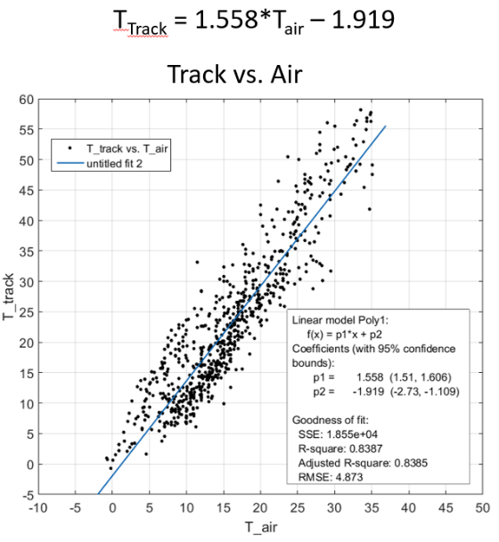

Source: BMW Group, 2021

1. The tyre rolling sound component will be corrected to a reference air temperature. Thus, the temperature range is less critical as today.
2. Background Information according to the last paragraph of chapter 1.:

Tests at temperatures below 5°C should normally be avoided, but sometimes it is unavoidable due to practical considerations. Therefore, manufacturer could on request carry out tests at lower temperatures.

The UN Reg. No. 51.03 temperature correction is a logarithmic function to address the extreme temperature situations at very low and very high temperatures WITHIN THE SPECIFIED TEMPERATURE RANGE more adequate relative to linear functions (In the diagram below the CNOSSOS applied correction is shown).

However, at air temperatures below 5°C, the correction is very much based on the chosen logarithmic function. Especially normal (summer) tyres change their rolling sound performance very fast (becoming louder) due to the change of the physical behaviour of the rubber compound. This effect starts typically below 7°C. Therefore, in many countries it is suggested to not use summer tyres at cold temperatures. After a tyre has changed its compound properties, the characteristics become stable again, so that the tyre does not become significant more loud at further reduced temperatures.

It is suggested to limit the correction function to an air temperature of 0 °C. This means, when tests are carried out at air temperatures below 0°C, the correction is based on 0°C.

The maximum applicable correction is limited to 3 dB(A). This is in line with typical observation on tyre rolling sound for tyres at very cold temperatures.

Figure 6b: Temperature Correction for Tyre Rolling Sound Component

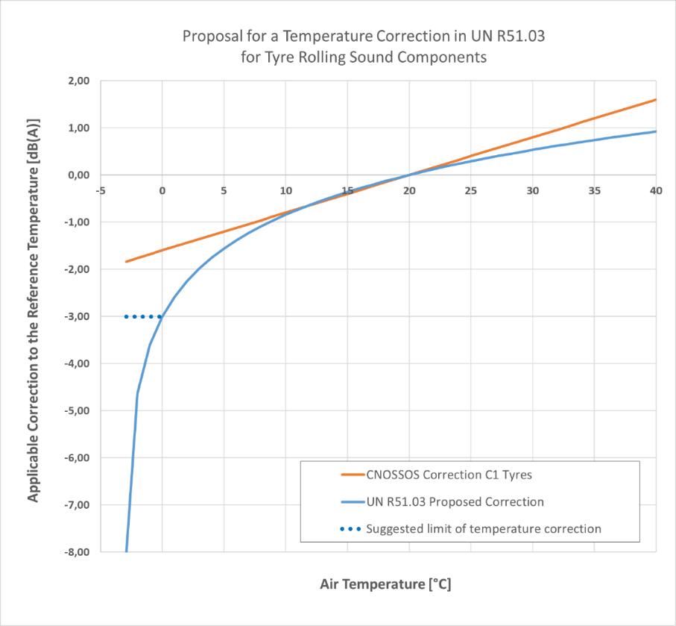

*Source: OICA calculation scheme; 2021*

1. Background Information according to paragraph 2.1.3. in chapter 2:

In the situation that you carry out a tyre rolling sound reference measurement at the beginning of your testing of the vehicle. Due to the weather situation, the afterwards carried out cruise and acceleration tests might have a drift in temperature (e.g. sun is shining very much). In this case the temperature of tyre reference is too much differing from the measurement subject for correction. Before you can extract the power train sound, the tyre reference measurement needs to be adjusted to the temperature condition of the test.

*Annex 3, new Appendix 3*

1. Addition of new appendix to describe the related coast-by test method for measuring tyre rolling sound emission that matches to the requirements UN Reg. No. 51 Annex 3. The measurement results of this method are the base for the calculation of the temperature correction described in appendix 2 of this Annex 3.

*Annex 6, Paragraph 2.1.*

1. The possibility of a simplified conditioning of the tyres in COP-tests has been added to avoid excessive use of tyres before delivery to customer.

*Annex 7, Paragraph 1.*

1. Since the Annex 7 needs no temperature compensation (relative judgement) the anchor point must be based on the test results of Annex 3 without any temperature correction. Usually Annex 7 test are performed in junction with Annex 3 tests.
2. All text in this proposal is produced by IWG MU by amending the 03 series of amendments to UN Regulation No. 51.

1. Measurements for Annex 7 for a particular vehicle type may be carried out on ~~a~~ different test tracks or under different environmental conditions, each according to the provisions of this Regulation, if the test results ~~L~~~~woti~~ ~~and L~~~~crsi~~ ~~for the gear~~~~i~~~~,~~ **of the lower gear used for the calculation of Lurban in Annex 3 and** representing the anchor point, do not differ by more the +/- 1.0 dB from the test results at the time when the tests according to Annex 3 have been carried out.