|  |  |  |  |
| --- | --- | --- | --- |
|  | United Nations | ECE/TRANS/WP.29/2021/121 | |
| _unlogo | **Economic and Social Council** | | Distr.: General  1 September 2021  Original: English |

**Economic Commission for Europe**

Inland Transport Committee

**World Forum for Harmonization of Vehicle Regulations**

**185th session**

Geneva, 23-25 November 2021

Item 4.8.13. of the provisional agenda

**1958 Agreement:  
Consideration of draft amendments to existing   
UN Regulations submitted by GRSP**

Proposal for Supplement 7 to the 02 series of amendments to Regulation No. 129 (Enhanced Child Restraint Systems)

Submitted by the Working Party on Passive Safety [[1]](#footnote-2)\*

The text reproduced below was adopted by the Working Party on Passive Safety (GRSP) at its sixty-ninth session (ECE/TRANS/WP.29/GRSP/69, para. 22). It is based on ECE/TRANS/WP.29/GRSP/2021/5 not amended. It is submitted to the World Forum for Harmonization of Vehicle Regulations (WP.29) and to the Administrative Committee (AC.1) for consideration at their November 2021 sessions.

*Paragraph 7.1.3.,* amend to read:

"7.1.3. Dynamic Testing for Frontal, Rear and Lateral Impact:

(a) Frontal impact test shall be performed on all Enhanced Child Restraint Systems within the scope of this Regulation.

(b) Lateral impact tests shall be performed on all Enhanced Child Restraint Systems within the scope of this Regulation, except for built in enhanced child restraint systems.

(c) Rear impact tests shall be performed on all rearward and lateral facing Enhanced Child Restraint Systems within the scope of this Regulation.

(d) The frontal and rear impacts shall be performed on the test bench (trolley plus standard seat) or in the vehicle bodyshell, according to paragraph 6.6.4.1. Table 4, or in a complete vehicle according to paragraph 7.1.3.3. The lateral impact tests shall be performed on the test bench only, according to paragraph 6.6.4.1. Table 4.

(e) For lateral impacts tests the Enhanced Child Restraint Systems shall be tested in its most upright used position. If this upright position falls outside the Vehicle Seat Fixture, this position shall still be chosen.

For Enhanced Child Restraint Systems that fit into any of the vehicle seat fixtures where the lateral shock absorbers can be adjusted outside the Vehicle Seat Fixture, the width position of the lateral shock absorbers that still fit in the Vehicle Seat Fixture shall be chosen;

For Enhanced Child Restraint Systems that do not fit into any of the vehicle seat fixtures, a lateral test shall be performed for each listed vehicle.

For each test, the initial position of the side impact door panel relative to the bench shall be adjusted according to the minimum distance between the vehicle's door panel and the centre of the seating position as shown in Figure 3.

Figure 3  
**Minimum distance for lateral impact**

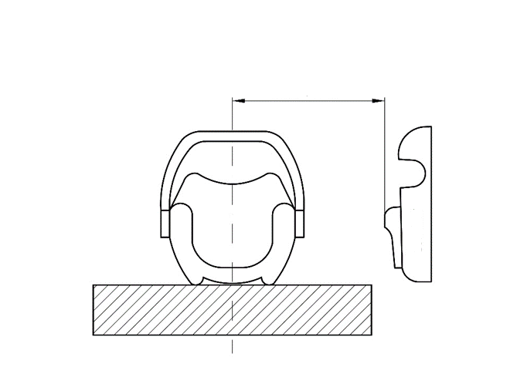

Door Panel

Minimum distance

(f) For frontal and rear impacts, the tests shall be performed with the Enhanced Child Restraint System adjusted to the size of the dummy (ies) selected to cover the entire size range, in the child seating position representing the most upright position and the most reclined position for each dummy and impact orientation.

If not yet covered by the previous configurations, the Technical Service may test the Enhanced Child Restraint Systems in a position defined by the Technical Service that it fits in the Vehicle Seat Fixture.

(g) For frontal, rear and lateral tests an anti rebound device acting on the vehicle seatback shall stay inside the seat fixture in one position, but may protrude beyond the Vehicle Seat Fixture in its adjusted position according to the user manual."

*Paragraph 7.2.8.,* amend to read:

7.2.8. The complete seat, or the component fitted with ISOFIX attachments (e.g. ISOFIX base) if it has a release button, is attached rigidly to a test rig in such a way that ISOFIX connectors are vertically aligned as shown in Figure 4. A 6 mm diameter bar, 350 mm long, shall be attached to the ISOFIX connectors. A mass of 5 kg shall be attached to the extremities of the bar."

*Paragraph 7.2.8.5., Figure 3 (former),* renumber as Figure 4.

1. \* In accordance with the programme of work of the Inland Transport Committee for 2021 as outlined in proposed programme budget for 2021 (A/75/6 (part V sect. 20) para 20.51), the World Forum will develop, harmonize and update UN Regulations in order to enhance the performance of vehicles. The present document is submitted in conformity with that mandate. [↑](#footnote-ref-2)