|  |  |  |  |
| --- | --- | --- | --- |
|  | United Nations | ECE/TRANS/WP.29/GRE/2021/24 | |
| _unlogo | **Economic and Social Council** | | Distr.: General  10 August 2021  Original: English |

**Economic Commission for Europe**

Inland Transport Committee

**World Forum for Harmonization of Vehicle Regulations**

**Working Party on Lighting and Light-Signalling**

**Eighty-fifth session**

Geneva, 26–29 October 2021

Item 5 of the provisional agenda

**Regulations Nos. 37 (****Filament light sources), 99 (Gas discharge light sources), 128 (Light emitting diodes light sources) and the Consolidated Resolution on the common specification of light source categories**

Proposal for an amendment to the original version of the Consolidated Resolution on the common specification of light source categories

Submitted by the expert from the International Automotive Lighting and Light-Signalling Expert Group (GTB)[[1]](#footnote-2)\*

The text reproduced below was prepared by the expert from the International Automotive Lighting and Light-Signalling Expert Group (GTB) with the aim to amend the Consolidated Resolution on the common specification of light source categories (R.E.5) (ECE/TRANS/WP.29/1127). There are no associated amendments to UN Regulations Nos. 37, 99 or 128. The modifications to the existing text of the Resolution are marked in bold for new or strikethrough for deleted characters.

**I. Proposal**

*The Status table*, amendto read:

"**Status table**

This consolidated version of this Resolution contains all provisions and amendments adopted so far by the World Forum for Harmonization of Vehicle Regulations (WP.29) and is valid from the date as indicated in the following table until the date on which the next revision of this Resolution becomes valid:

|  |  |  |  |  |
| --- | --- | --- | --- | --- |
| *Version of the Resolution* | *Date \* as from which the version is valid* | *Adopted by WP.29* | | *Clarification* |
| *Session No.* | *Amendment document No.* |
| 1 **(**Original**)** | 22.06.2017 | 170 | ECE/TRANS/WP.29/2016/111 | Based upon Annexes 1 of Regulations:   * No. 37, up to and including Supplement 44 * No. 99, up to and including Supplement 11 * No. 128, up to and including Supplement 5 |
| … | … | … | … | … |
| **[8]** | **[xx.xx.2022]** | **[….]** | **[ECE/TRANS/WP.29/2022/xx]** | **Amended detail in filament light source sheets:**  **H8/3, H9/3, H11/3, H16/3, and T4W/1**  **Amended detail in LED light source sheets:**  **L1/2, Lx3/2, LR4/2, and Lx5/2**  **Introduction of new LED light source categories LR6A and LR6B** |

\* This date is the date of adoption of the amendment to the Resolution by WP.29 or the date of entering into force of an amendment to UN Regulation No. 37, 99 or 128 adopted by AC.1 as a package with the amendment to the Resolution in the same session of WP.29.

”

*Paragraph 3.3.,*

*Group 2,* amend to read:

"

| *Group 2* | | | | |
| --- | --- | --- | --- | --- |
| *LED light source categories only for use in signalling lamps, cornering lamps, reversing lamps and rear registration plate lamps:* | | | | |
|  | *Category* |  | *Sheet number(s)* |  |
|  | LR1 |  | LR1/1 to 5 |  |
|  | LW2 | 2 | LW2/1 to 5 |  |
|  | LR3A |  | Lx3/1 to 6 |  |
|  | LR3B |  | Lx3/1 to 6 |  |
|  | LW3A | 2 | Lx3/1 to 6 |  |
|  | LW3B | 2 | Lx3/1 to 6 |  |
|  | LY3A |  | Lx3/1 to 6 |  |
|  | LY3B |  | Lx3/1 to 6 |  |
|  | LR4A |  | LR4/1 to 5 |  |
|  | LR4B |  | LR4/1 to 5 |  |
|  | LR5A |  | Lx5/1 to 6 |  |
|  | LR5B |  | Lx5/1 to 6 |  |
|  | LW5A | 2 | Lx5/1 to 6 |  |
|  | LW5B | 2 | Lx5/1 to 6 |  |
|  | LY5A |  | Lx5/1 to 6 |  |
|  | LY5B |  | Lx5/1 to 6 |  |
|  | **LR6A** |  | **Lx6/1 to 6** |  |
|  | **LR6B** |  | **Lx6/1 to 6** |  |

1 Not for use in conformity of production control of lamps.

2 Not for use behind red and amber lenses"

*Annex 1,*

*Sheet H8/3, table,* amend to read:

(update the cap sheet number)

"…

|  |  |  |
| --- | --- | --- |
| Cap: | H8: PGJ19-1  H8B: PGJY19-1 | in accordance with IEC Publication 60061 (sheet 7004-110-~~2~~ **3**)  in accordance with IEC Publication 60061 (sheet 7004-146-1) |

…"

*Sheet H9/3, table,* amend to read:

(update the cap sheet number)

"…

|  |  |  |
| --- | --- | --- |
| Cap: | H9: PGJ19-5  H9B: PGJY19-5 | in accordance with IEC Publication 60061 (sheet 7004-110-~~2~~ **3**)  in accordance with IEC Publication 60061 (sheet 7004-146-1) |

…"

*Sheet H11/3, table,* amend to read:

(update the cap sheet number)

"…

|  |  |  |
| --- | --- | --- |
| Cap: | H11: PGJ19-2  H11B: PGJY19-2 | in accordance with IEC Publication 60061 (sheet 7004-110-~~2~~ **3**)  in accordance with IEC Publication 60061 (sheet 7004-146-1) |

…"

*Sheet H16/3, table,* amend to read:

(update the cap sheet number)

"…

|  |  |  |
| --- | --- | --- |
| Cap: | H16: PGJ19-3  H16B: PGJY19-3 | in accordance with IEC Publication 60061 (sheet 7004-110-~~2~~ **3**)  in accordance with IEC Publication 60061 (sheet 7004-146-1) |

…"

*Sheet T4W/1, table,* amend to read:

(update the cap sheet number)

"…

|  |
| --- |
| Cap BA9s in accordance with IEC Publication 60061 (sheet 7004-14-~~9~~ **10**) |

…"

*Annex 3,*

*List of sheets for LED light sources and their sequence,* amend to read:

"

|  | *Sheet number(s)* |  |
| --- | --- | --- |
|  | C5W/LED/1 to 4  H11/LED/1 to 7  L1/1 to 5 |  |
|  | LR1/1 to 5 |  |
|  | LW2/1 to 5 |  |
|  | Lx3/1 to 6 |  |
|  | LR4/1 to 5 |  |
|  | Lx5/1 to 6 |  |
|  | **Lx6/1 to 6** |  |
|  | PY21W/LED/1 to 4  R5W/LED/1 to 4  W5W/LED/1 to 4 |  |

"

*Sheet L1/2, Table 1,* amend to read:

(update the cap sheet number)

"…

|  |
| --- |
| Cap PGJ18.5d-29 in accordance with IEC Publication 60061 (sheet 7004-185-~~2~~ **3**) 10 |

…"

*Sheet Lx3/2, Table 1,* amend to read:

(update the cap sheet number)

"…

|  |  |  |  |
| --- | --- | --- | --- |
| Cap | LR3A, LR3B  LW3A, LW3B  LY3A, LY3B | PGJ18**.**5d-1  PGJ18.5d-24 PGJ18.5d-15 | in accordance with IEC Publication 60061 (sheet 7004-185-~~2~~ **3**) |

…"

*Sheet Lx3/2, Table 1,* *footnote 13*, amend to read:

"

13/ Light centre length**, for the method of measurement, see Annex K of IEC Publication 60809, Edition 4.**

"

*Sheet LR4/2, Table 1,* amend to read:

(update the cap sheet number)

"…

|  |
| --- |
| Cap PGJ18.5t-5 in accordance with IEC Publication 60061 (sheet 7004-185-~~2~~ **3**) |

…"

*Sheet Lx5/2, Table 1,* amend to read (update the cap sheet number):

"…

|  |  |  |  |
| --- | --- | --- | --- |
| Cap | LR5A, LR5B  LW5A, LW5B  LY5A, LY5B | PGJ18.5d-10  PGJ18.5d-28  PGJ18.5d-19 | in accordance with IEC Publication 60061 (sheet 7004-185-~~2~~ **3**) |

…"

*Sheet Lx5/2, Table 1,* *footnote 11*, amend to read:

"

11/ Light centre length**, for the method of measurement, see Annex K of IEC Publication 60809, Edition 4.**

"

*After sheet Lx5/6*, insert new sheets Lx6/1 to 6, to read

(see following pages; one page per sheet):

" **Categories LR6A, LR6B Sheet Lx6/1**

The drawings are intended only to illustrate the essential dimensions of the LED light source.

Figure 1\*

**Main Drawing**

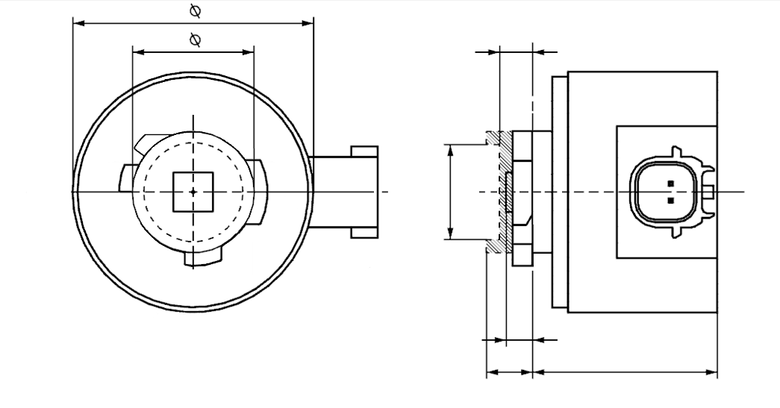

b

c

m

e

a

d

4

Light emitting area3

Reference axis2

V+

Ground

Reference plane1

ø k

**LR6A**

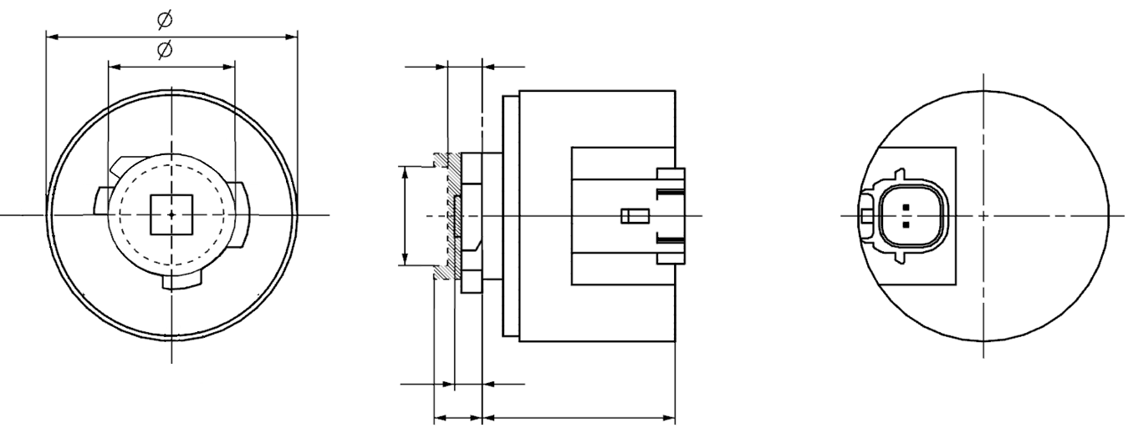

a

e

m

b

c

ø k

d

Reference axis2

Light emitting area3

Reference plane1

4

Ground

V+

**LR6B**

\* Projection method:

For the notes see sheet Lx6/2  
 **Categories LR6A, LR6B Sheet Lx6/2**

Table 1

**Essential dimensional, electrical and photometric characteristics of the LED light source**

|  |  |  |  |  |  |  |  |
| --- | --- | --- | --- | --- | --- | --- | --- |
| *Dimensions* | | | | | | *Production LED light sources* | *Standard LED light sources* |
| a | | | | | mm | 6.0 max. | |
| b | | | | | mm | c + 10.0 min.  38.0 max. | |
| c | | | | | mm | 18.5 ± 0.1 | |
| d | | | | | mm | 28.0 max. | |
| e 8/ | | | | | mm | 3.0 ± 0.30 | 3.0 ± 0.15 |
| k 9/ | | | | | mm | 7.5 min. | |
| m 9/ | | | | | mm | 4.0 max. | |
| Cap | LR6A, LR6B | | PGJ18.5d-33 | | in accordance with IEC Publication 60061 (sheet 7004-185-3) | | |
| *Electrical and photometric characteristics* | | | | | | | |
| Rated values | | Volts | |  | | 12 | |
| Watts | |  | | 7 | |
| Test voltage | | Volts (DC) | |  | | 13.5 | |
| Objective Values 6 | | Watts (at test voltage) | | | | 8 max. | |
| Luminous flux (in lm at test voltage) 5 | | | | 180 ± 15% | 180 ± 10 % 7 |
| Luminous flux (in lm at 9 V DC) 5 | | | | 40 min. | |

1/ The reference plane is the plane defined by the contact points of the cap-holder fit.

2/ The reference axis is perpendicular to the reference plane and passing through the centre of the bayonet core.

3/ Light emitting area: to be checked by means of the box system in Figure 2

4/ A minimum free air space of 5 mm around the light source shall be respected for convection; the connector interface can be neglected.

5/ The emitted light shall be red.

6/ After continuous operation for 30 minutes at 23 ± 2.5° C.

7/ The measured value shall be in between 105 per cent and 90 per cent of the value measured after 1 minute.

8/ Light centre length; for the method of measurement, see Annex K of IEC 60809, Edition 4.

9/ The bounded area defined with the dimensions c, k and m defines the maximum outline in relation to the reference system

Electrical characteristics

In case of LED light source failure (no light emitted) the max. electrical current draw, when operated between 12 V and 14 V, shall be less than 20 mA (open circuit condition).

**Categories LR6A, LR6B Sheet Lx6/3**

Screen projection requirements

The following test is intended to define the requirements for the light emitting area of the LED light source and to determine whether the light emitting area is correctly positioned relative to the reference axis and reference plane in order to check compliance with the requirements.

The position of the light emitting area is checked by the box system defined in Figure 2, which is aligned to the planes C90 and C180 and shows the projection when viewing along direction γ = 0º at e = 3.0 mm (C, γ as defined in Figure 3).

The luminous flux Φ emitted into the viewing direction shall be calculated as given below:

$$Φ=L⋅S⋅Ω$$

with

*S* = area to be considered

*L* = luminance average of area *S*

Ω = solid angle defined by the entrance aperture of the measurement system

The distribution of luminous flux originating from the LEA as shown in Figure 2 shall fulfil the requirements given in Table 3. All numbers shall be given in % of the total luminous flux emitted into the viewing direction from the bayonet core area, i.e. a circular area with diameter c = 18.5 mm (see Figure 1).

*Note: When evaluating the luminous flux distribution emitted from the LEA, reflections and stray light within the measurement equipment shall be reduced as much as possible and if necessary, corrected. More details regarding measurement of light-emitting areas can be found in the publication describing general photometry accuracy guidelines currently prepared by CIE TC2-67*

Figure 2

**Box definition of the light emitting area with dimensions as specified in Table 2**

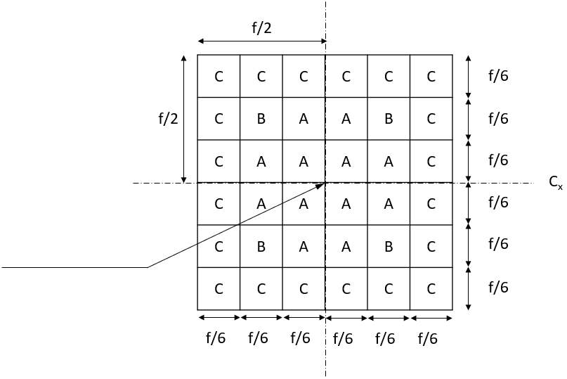

Reference axis perpendicular in

the centre of the light-emitting area

C270

C180

C90

C0

Table 2

**Dimensions of the box system in Figure 2**

|  |  |
| --- | --- |
| *Dimensions in mm* | *f* |
| LED light sources of normal production | 4.8 |
| Standard LED light sources | 4.8 |

**CATEGORIES LR6A, LR6B Sheet Lx6/4**

Table 3

**Proportion of the total luminous flux emitted into the viewing direction from the areas specified in Figure 2**

|  |  |  |
| --- | --- | --- |
| *Area(s)* | *LED light sources of normal production* | *Standard LED light sources* |
| Each A individually | > 3%  < 10 % | > 4%  < 10% |
| Each B individually | > 3%  < 10% | > 3%  < 10% |
| All A and B together | > 70% | > 75% |
| Each C individually | < 2% | < 2% |
| All A, B and C together | > 90% | > 90% |

**Categories LR6A, LR6B Sheet Lx6/5**

Normalized luminous intensity distribution

The following test is intended to determine the normalized luminous intensity distribution of the light source in an arbitrary plane containing the reference axis. The intersection of the reference axis and the parallel plane to the reference plane in distance e = 3.0 mm is used as the coordinate system origin.

The light source is mounted on a flat plate with the corresponding mounting lug features. The plate is mounted to the goniometer table by a bracket, so that the reference axis of the light source lines up with one of the rotating axes of the goniometer. The corresponding measurement set-up is described in Figure 3.

Luminous intensity data is recorded with a standard photo-goniometer. The measurement distance should be chosen appropriately, to make sure that the detector is located in the far field of the light distribution.

The measurements shall be performed in C-planes C0, C90, C180 and C270, which contain the reference axis of the light source. The test points for each plane for multiple polar angles γ are specified in Table 4.

The measured luminous intensity values, normalised to the measured luminous flux of the individual light source under test, shall be converted to normalised luminous intensity values of a 1,000 lm light source.The data shall comply with the tolerance band as defined in Table 4.

The drawings are intended only to illustrate the essential set-up for measurement of the LED light source.

Figure 3

**Set-up to measure the luminous intensity distribution**

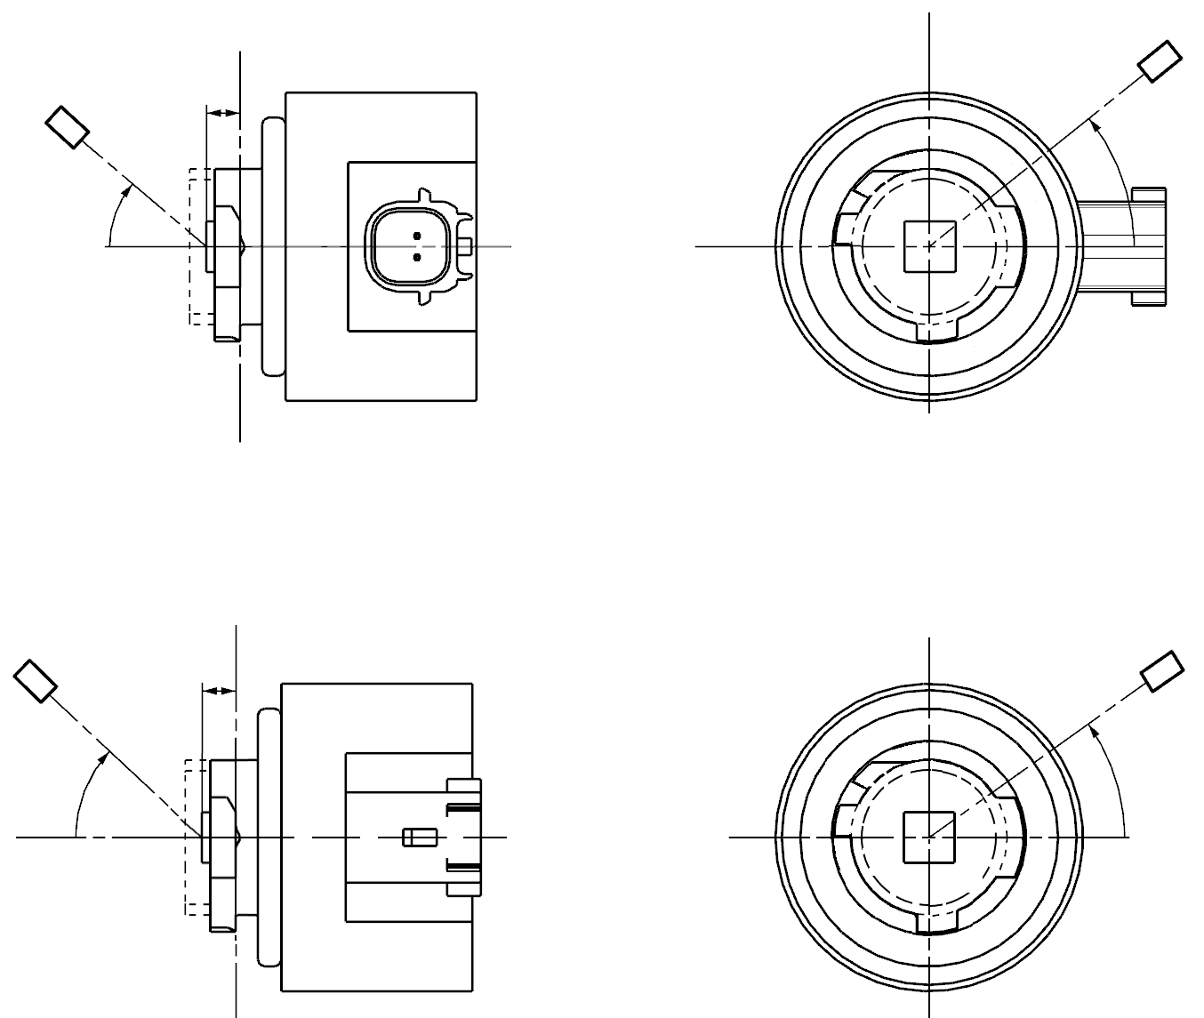

Reference axis

Reference plane

Photo-Detector or Goniometer

C-Plane definition

Viewing direction along reference axis

e

γ

C

C0

Reference axis

Reference plane

Photo-Detector or Goniometer

C-Plane definition

Viewing direction along reference axis

e

γ

C0

C

**LR6A**

**LR6B**

**Categories LR6A, LR6B Sheet Lx6/6**

The light pattern as described in Table 4 shall be substantially uniform, i.e. in between two adjacent grid points the relative luminous intensity requirement is calculated by linear interpolation using the two adjacent grid points. In case of doubt this may be checked in addition to verification of the grid points given in Table 4.

Table 4

**Test point values of normalized intensities**

|  |  |  |  |  |
| --- | --- | --- | --- | --- |
|  | *LED light sources of normal production* | | *Standard LED light sources* | |
| *Angle γ* | *Minimum Intensity  in cd /1000 lm* | *Maximum Intensity  in cd/1000 lm* | *Minimum Intensity  in cd /1000 lm* | *Maximum Intensity in cd /1000 lm* |
| 0° | 200 | 425 | 250 | 390 |
| 15° | 190 | 415 | 240 | 370 |
| 30° | 170 | 380 | 220 | 335 |
| 45° | 145 | 310 | 180 | 275 |
| 60° | 85 | 245 | 105 | 220 |
| 75° | 0 | 160 | 0 | 150 |
| 90° | 0 | 70 | 0 | 65 |

"

II. Justification

1. This document is a consolidation of amendments proposed by experts of GTB to the Consolidated Resolution on the common specification of light source categories (R.E.5) (ECE/TRANS/WP.29/1127). The amendments cover a number of topics and for clarity the justification for the document is structured to provide justifications by topic under their respective topic headers.

**2. Amendment with the aim to introduce new LED light source categories LR6A and LR6B**

2.1. This proposal introduces new light-emitting diode (LED) light source categories for signalling to accommodate an increasing market demand for LED light sources according to UN Regulation No. 128. The ongoing trend towards style-driven rear lamps requires light sources with higher luminous flux to compensate for the lower efficiency of the corresponding optical designs.

2.2. In general, standardized and replaceable UN Regulation No. 128 LED light sources can serve individual rear lamp designs with limited development efforts. The proposed categories of a high luminous flux mono-function red light source are based on an established cap concept combined with an increased and more precise light output, while a new and future-proof specification of the light emitting area (LEA) allows a more reliable description of where the light originates from.

2.3. The cap/holder system for the new red emitting light source is based on the International Electrotechnical Commission (IEC) Inter PGJ18.5d fit, a family of cap/holders that has already been successfully employed in existing LED light sources in UN Regulation No. 128. Keys from the PGJ18.5d fit that are not in use so far have been assigned to the newly proposed categories. Following established LED light source categories, the new red emitting light source is proposed with an elbow connector at the side – the A version – as well as with a straight connector at the bottom – the B version. The assigned category designations are LR6A and LR6B respectively.

**3. Amendment of the specifications for light source categories LR3A, LR3B, LW3A, LW3B, LY3A, LY3B and categories LR5A, LR5B, LW5A, LW5B, LY5A, LY5B with respect to the light centre length**

3.1. Since the adoption of UN Regulation No. 128 LED light sources experience has been gained with the measurement of such light sources. As a result of this the definition for the light centre in R.E.5 had been improved. However, it was identified that a clarification of the light centre length (LCL) requirement for the categories LR3A, LR3B, LW3A, LW3B, LY3A, LY3B and categories LR5A, LR5B, LW5A, LW5B, LY5A, LY5B was needed.

3.2. Experts from GTB propose to amend footnote 13 of categories LR3A, LR3B, LW3A, LW3B, LY3A, LY3B (sheet Lx3/2) and footnote 11 of categories LR5A, LR5B, LW5A, LW5B, LY5A, LY5B (Sheet Lx5/2) to provide a normative reference to the method of measurement of the light centre length in Annex K of IEC Publication 60809, Edition 4.

**4. Amendments to make administrative updates of IEC cap sheet references in light source category specifications**

4.1. From time to time cap sheets in IEC 60061 are updated. With each update the cap sheet version number is changed. As the cap sheet number is referenced from the category sheets in R.E.5, references in the category sheets must be updated in accordance with the latest cap sheet numbers in order to maintain the correct linkage between the Resolution and the IEC standard. As links are established, the content of R.E.5 is continually reviewed.

4.2. This proposal includes customary administrative updates of IEC cap sheet numbers in the IEC cap sheet reference for categories H8, H9, H11, H16, T4W, L1A/6, L1B/6 LR3A/B, LW3A/B, LY3A/B, LR4A/B, LR5A/B, LW5A/B, LY5A/B.

1. \* In accordance with the programme of work of the Inland Transport Committee for 2021 as outlined in proposed programme budget for 2021 (A/75/6 (Sect.20), para 20.51), the World Forum will develop, harmonize and update UN Regulations in order to enhance the performance of vehicles. The present document is submitted in conformity with that mandate. [↑](#footnote-ref-2)