|  |  |  |  |
| --- | --- | --- | --- |
|  | United Nations | ECE/TRANS/WP.29/GRE/2021/23 | |
| Description: _unlogo | **Economic and Social Council** | | Distr.: General  10 August 2021  Original: English |

**Economic Commission for Europe**

Inland Transport Committee

**World Forum for Harmonization of Vehicle Regulations**

**Working Party on Lighting and Light-Signalling**

**Eighty-fifth session**

Geneva, 26-29 October 2021

Item 7 (b) of the provisional agenda

**Other UN Regulations:**

**UN Regulation No. 53 (Installation of lighting and light-signalling devices for L3 vehicles)**

Proposal for a Supplement to the 01, 02 and 03 series of amendments to UN Regulation No. 53

Submitted by the expert from the International Motorcycle Manufacturers Association[[1]](#footnote-2)\*

The text reproduced below was prepared by the expert from the International Motorcycle Manufacturers Association (IMMA) with the aim to clarify the electrical connection requirements for a white front position lamp reciprocally incorporated with the front direction indicator, in line with the corresponding provisions in UN Regulation No. 48. The modifications to the current text of the UN Regulation are marked in bold for new or strikethrough for deleted characters.

I. Proposal

*Paragraph 6.6.7.*, amend to read:

"6.6.7. Other requirements

~~When the front position lamp is reciprocally incorporated in the front direction indicator lamp, the electrical connection shall be such that the position lamp on the same side as the direction indicator lamp is switched off when the direction indicator lamp is flashing.~~

**6.6.7.1.** **If a front position lamp is coloured amber and reciprocally incorporated with a direction indicator, the electrical connection of the front position lamp on the relevant side of the vehicle or the reciprocally incorporated part of it shall be such that it is switched OFF during the entire time (both ON and OFF cycle) of operation of the direction indicator lamp.**

**6.6.7.2. If a front position lamp is coloured white and reciprocally incorporated with a direction indicator, the electrical connection of the front position lamp on the relevant side of the vehicle or the reciprocally incorporated part of it may be such that it is switched OFF during the entire time (both ON and OFF cycle) of operation of the direction indicator lamp.**"

II. Justification

1. The objective of this proposal is to clarify the electrical connection requirements for a white front position lamp reciprocally incorporated with a direction indicator and to align the wording with those for vehicles of category M and N in UN Regulation No. 48, as they were inadvertently altered with the introduction of amber front position lamps for motorcycles.

2. When the requirements for position lamps reciprocally incorporated with other lamps were introduced by Supplement 12 to the 01 series of amendments to UN Regulation No. 53 (ECE/TRANS/WP.29/2010/98), paragraph 6.6.7. was fully aligned with UN Regulation No. 48.

3. In parallel to this amendment, another proposal to introduce amber front position lamps was discussed in the Working Party on Light and Light-Signalling (GRE) and later introduced as Supplement 13 to the 01 series of amendments to UN Regulation No. 53 (ECE/TRANS/WP.29/2011/13). In the discussion, GRE agreed to amend paragraph 6.6.7. to prevent an amber front position lamp reciprocally incorporated with a direction indicator to be lit during the operation of the direction indicator, as both lamps would have the same colour, to guarantee a clear communication towards other road users and to increase safety.

4. However, given the technological constraints at that time, the wording employed in Supplement 13 did not consider the possibility of a widespread white front position lamp that has both lateral ends partially reciprocally incorporated with direction indicators. As a result, the current text requires the entire white front position lamp to be extinguished during the operation of the direction indicator, which may reduce the motorcycle conspicuity (Figure 1). This result contradicts the requirement in the case of having two amber position lamps; in such a case, the front position lamp on the opposite side of the vehicle must be kept ON. Thus, IMMA believes this is not the intention of GRE.

**Figure 1**

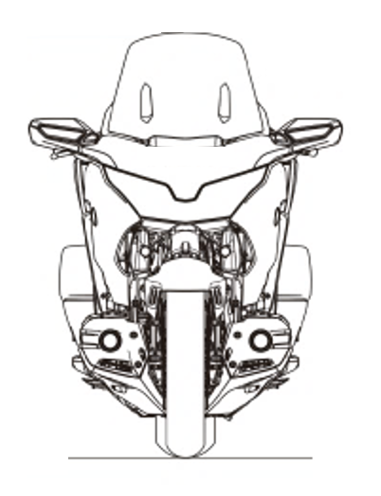

Front position lamp

During ON cycle of

DI operation

During OFF cycle of

DI operation

Illuminated white

Illuminated amber

Extinguished

Outcome of the current wording in paragraph 6.6.7.

5. To rectify the situation, IMMA proposes to fully realign the requirement for white front position lamps with UN Regulation No. 48. In the case of the abovementioned widespread white front position lamp, the remaining part of the front position lamp could be kept ON, enhancing the motorcycle conspicuity (Figure 2). On the other hand, the provisions for amber front position lamps are reworded in line with UN Regulation No. 48 and continue to require switching it OFF during the entire time of operation of a reciprocally incorporated direction indicator, with the aim to keep the intention of the past GRE discussion.

Illuminated white

Illuminated amber

Extinguished



During ON cycle of

DI operation

During OFF cycle of

DI operation

**Figure 2**

Proposed solution

1. \* In accordance with the programme of work of the Inland Transport Committee for 2021 as outlined in proposed programme budget for 2021 (A/75/6 (Sect.20), para 20.51), the World Forum will develop, harmonize and update UN Regulations in order to enhance the performance of vehicles. The present document is submitted in conformity with that mandate. [↑](#footnote-ref-2)