|  |  |  |  |
| --- | --- | --- | --- |
|  | United Nations | ECE/TRANS/WP.29/GRE/2021/11 | |
| Description: _unlogo | **Economic and Social Council** | | Distr.: General  5 August 2021  Original: English |

**Economic Commission for Europe**

Inland Transport Committee

**World Forum for Harmonization of Vehicle Regulations**

**Working Party on Lighting and Light-Signalling**

**Eighty-fifth session**

Geneva, 26–29 October 2021

Item 4 (b) of the provisional agenda

**Simplification of lighting and light-signalling UN Regulations:**

**UN Regulation No. 148 (Light-signalling devices)**

Proposal to clarify and to correct the text of the UN Regulation No. 148

Submitted by the Informal Working Group on Simplification of Lighting and Light-Signalling Regulations[[1]](#footnote-2)\*

The text reproduced below was prepared by the Informal Working Group on Simplification of Lighting and Light-Signalling Regulations (IWG SLR) with the aim to insert missing text and to correct errors inadvertently introduced in the new UN Regulation No. 148. The modifications to the existing text of UN Regulation No. 148 are marked in bold for new or strikethrough for deleted characters.

I. Proposal

*Paragraph 5.4.4.2.*, amend to read:

“5.4.4.2. In case of failure of any one light source in a single lamp containing more than one light source, one of the following provisions shall apply:

(a) The light intensity at the points of standard light distribution defined in paragraph 2.2. of Annex 3 shall be at least 80 per cent of the minimum intensity required; or

(b) The light intensity in the axis of reference shall be at least 50 per cent of the minimum intensity required, provided that a note in the communication form states that the lamp is only for use on a vehicle fitted with a~~n operating~~ tell-tale **indicating failure.**”

*Paragraph 5.11.3.,* amend to read:

“5.11.3. Photometric characteristics

**For the approval of this device, the illumination of the space to be occupied by the plate is determined. The illuminated areas are grouped in the following categories:**

**Category 1a: illuminated area of at least 340 x 240 mm (Figure A3-IX).**

**Category 1b: illuminated area of at least 520 x 120 mm (Figure A3-X).**

**Category 1c: illuminated area of at least 255 x 165 mm, for use on agricultural or forestry tractors, (Figure A3-XI).**

**Category 2a: illuminated area of at least 330 x 165 mm (Figure A3-XII).**

**Category 2b: illuminated area of at least 440 x 220 mm (Figure A3-XIII).**

**Category 1: illuminated area of at least 130 x 240 mm for use on a vehicle of category L (Figure A3-XIV).**

**Category 2: illuminated area of at least 200 x 280 mm for use on a vehicle of category L (Figure A3-XV).**

At each of the points of measurement shown in paragraph 3. of Annex 3, the luminance B shall be at least

1. For categories 1a, 1b, 1c, 2a and 2b equal to 2.5 cd/m2;
2. For categories 1 and 2 equal to 2.0 cd/m².

The gradient of the luminance between the values B1 and B2, measured at any two points 1 and 2 selected from among those mentioned above, shall not exceed 2 x Bo/cm, Bo being the minimum luminance measured at the various points, i.e.:

 **”**

*Figure A7-III and the text below,* amend to read:

“Figure A7-III

**Marking example 3**

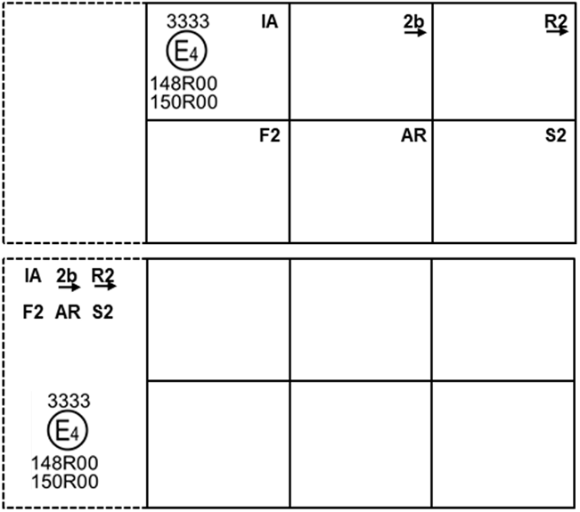

These examples of approval marks represent two possible solutions for the marking of a light signalling lamp where two or more lamps are part of the same assembly of grouped, combined or reciprocally incorporated lamps

They indicate that the lamp was approved in the Netherlands (E4) under approval number 3333 and comprises:

(a) A retro-reflector of class **IA**~~1A~~;

(b) A rear direction indicator lamp with variable luminous intensity (category 2b). The horizontal arrow shows in what position this device, which cannot be mounted on either side of the vehicle indiscriminately, is to be mounted;

(c) A rear position lamp with variable luminous intensity (R2). The horizontal arrow indicates the side on which the required photometric specifications are met up to an angle of 80° H;

(d) A rear fog lamp with variable luminous intensity (F2);

(e) A reversing lamp (AR);

(f) A stop lamp with variable luminous intensity (S2).

All these lamps (functions) are approved in accordance with the original series of amendments to this Regulation (148R) **and to UN Regulation No. 150 (150R)** as indicated by the number (00) mentioned after 148R **and 150R respectively**. ”

*Figure A7-IV,* amend to read:

“Figure A7-IV

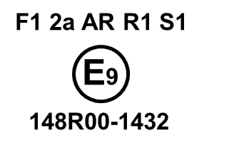

This example corresponds to the marking of a lens intended to be used in different types of light signalling lamps. The approval marks indicate that the lamp was approved in Spain (E9) under approval number 1432 and may comprise all listed different functions.

The main body of the lamp shall bear the only valid approval mark.”

II. Justification

1. For the daytime running lamps (DRL), the requirement for “operating tell-tale” has been modified to a “tell-tale indicating failure”. This modification was introduced with Supplement 18 to the original series of amendments to UN Regulation No. 87, but not in UN Regulation No. 148.

2. The explanation for the categories of the illuminated area, existing in the frozen UN Regulations Nos. 4 ("Definitions") and 50 (paragraph 1. of Annex 5), were unintentionally omitted in the original text of UN Regulation No.148. This proposal is intended to re-introduce such an explanation under paragraph 5.11.3. The missing information for the category of the illuminated area was given with reference to the relevant rear registration plate.

3. Some errors have been identified in figures A7-III and A7-IV. This proposal also corrects these figures.

1. \* In accordance with the programme of work of the Inland Transport Committee for 2021 as outlined in proposed programme budget for 2021 (A/75/6 (Sect.20), para 20.51), the World Forum will develop, harmonize and update UN Regulations in order to enhance the performance of vehicles. The present document is submitted in conformity with that mandate. [↑](#footnote-ref-2)