|  |  |  |  |
| --- | --- | --- | --- |
|  | United Nations | ECE/TRANS/WP.29/2021/130 | |
| _unlogo | **Economic and Social Council** | | Distr.: General  8 September 2021  Original: English |

**Economic Commission for Europe**

Inland Transport Committee

**World Forum for Harmonization of Vehicle Regulations**

**185th session**

Geneva, 23-25 November 2021

Item 4.9.3. of the provisional agenda

**1958 Agreement:  
Consideration of draft amendments to existing   
UN Regulations submitted by GRPE**

Proposal for Supplement 7 to the 06 series of amendments to UN Regulation No. 49 (Emissions of compression ignition and positive ignition (LPG and CNG) engines)

Submitted by the Working Party on Pollution and Energy[[1]](#footnote-2)\*

The text reproduced below was adopted by the Working Party on Pollution and Energy (GRPE) at its eighty-third session (ECE/TRANS/WP.29/GRPE/83, para. 22). It is based on ECE/TRANS/WP.29/GRPE/2021/14, as amended by Annex X of the report. It is submitted to the World Forum for Harmonization of Vehicle Regulations (WP.29) and to the Administrative Committee (AC.1) for consideration at their November 2021 sessions.

*Annex 4*

*Paragraph 8.2.,* amend to read:

"8.2. NOx correction for humidity

As the NOx emission depends on ambient air conditions, the NOx concentration shall be corrected for humidity with the factors given in paragraph 8.2.1. or 8.2.2. The intake air humidity Ha may be derived from relative humidity measurement, dew point measurement, vapour pressure measurement or dry/wet bulb measurement using generally accepted equations.

For all humidity calculations (for example Ha, Hd) using generally accepted equations the saturation vapour pressure is required. For calculating the saturation vapour pressure which is in general a function of the temperature (at the humidity measurement point) the equation D.15 specified in Annex D to ISO Standard 8178-4:2020 should be used."

*Paragraph 8.4.2.3.*, *Equation (36)*, amend to read:

"…

The following equation shall be applied:

$$m_{gas}=u_{gas}×\sum_{i=1}^{i=n}{\left(c_{gas,i}×q_{mew,i}×\frac{1}{f}\right) } in (g/test) (36)$$

Where:

…"

*Paragraph 8.4.2.4., Equation (37)*, amend to read:

"…

The following equation shall be applied:

$m_{gas}=\sum_{i=1}^{i=n}{\left({u_{gas,i}×c}_{gas,i}×q_{mew,i}×\frac{1}{f}\right)} in \left(\frac{g}{test}\right)$ (37)

Where:

…"

*Paragraph 8.5.1.4.*, *Equation (54)*, amend to read:

"…

$Q_{SSV}=\frac{A_{0}}{60}d_{V}^{2}C_{d}p_{p}\sqrt{\left[\frac{1}{T}\left(r_{p}^{1.4286}-r_{p}^{1.7143}\right)∙\left(\frac{1}{1-r_{D}^{4}r_{p}^{1.4286}}\right)\right]}$ (54)

Where:

*A*0 is 0.005692 in SI units of 

*d*V is the diameter of the SSV throat, mm

…"

*Paragraph 8.5.2.3.1.*, *Equation (57)*, amend to read:

"…

$u_{gas}=\frac{M_{gas}}{M_{d}×\left(1-\frac{1}{D}\right)+M_{e}×\left(\frac{1}{D}\right)}×\frac{1}{1000}$ (57)

…"

*Paragraph 8.6.1.,* amend to read:

"…

Depending on the measurement system and calculation method used, the uncorrected emissions results shall be calculated with equations 36, 37, 56, 58 or 62, respectively. For calculation of the corrected emissions, *c*gas in equations 36, 37, 56, 58 or 62, respectively, shall be replaced with *c*cor of equation 66. If instantaneous concentration values *c*gas,i are used in the respective equation, the corrected value shall also be applied as instantaneous value *c*cor,i. In equation**s** 58 and 62, the correction shall be applied to both the measured and the background concentration.

…"

*Paragraph 9.2., Table 7,* amend to read:

"Table 7

**Linearity requirements of instruments and measurement systems**

|  |  |  |  |  |
| --- | --- | --- | --- | --- |
| *Measurement system* | ꭓ*min* X (*a1* - 1*)+ a0\* | *Slope a1* | *Standard error SEE* | *Coefficient of*  *Determination r2* |
| Engine speed | ≤ 0.05 % max | 0.98 - 1.02 | ≤ 2 % max | ≥ 0.990 |
| Engine torque | ≤ 1 % max | 0.98 - 1.02 | ≤ 2 % max | ≥ 0.990 |
| Fuel flow | ≤ 1 % max | 0.98 - 1.02 | ≤ 2 % max | ≥ 0.990 |
| Airflow | ≤ 1 % max | 0.98 - 1.02 | ≤ 2 % max | ≥ 0.990 |
| Exhaust gas flow | ≤ 1 % max | 0.98 - 1.02 | ≤ 2 % max | ≥ 0.990 |
| Diluent flow | ≤ 1 % max | 0.98 - 1.02 | ≤ 2 % max | ≥ 0.990 |
| Diluted exhaust gas flow | ≤ 1 % max | 0.98 - 1.02 | ≤ 2 % max | ≥ 0.990 |
| Sample flow | ≤ 1 % max | 0.98 - 1.02 | ≤ 2 % max | ≥ 0.990 |
| Gas analyzers | ≤ 0.5 % max | 0.99 - 1.01 | ≤ 1 % max | ≥ 0.998 |
| Gas dividers | ≤ 0.5 % max | 0.98 - 1.02 | ≤ 2 % max | ≥ 0.990 |
| Temperatures | ≤ 1 % max | 0.99 - 1.01 | ≤ 1 % max | ≥ 0.998 |
| Pressures | ≤ 1 % max | 0.99 - 1.01 | ≤ 1 % max | ≥ 0.998 |
| PM balance | ≤ 1 % max | 0.99 - 1.01 | ≤ 1 % max | ≥ 0.998 |
| Humidity measurement device | ≤ 2 % max. | 0.98 – 1.02 | ≤ 2 % | ≥ 0.95 |

"

*Paragraph 9.3.3.1.,* amend to read:

"9.3.3.1. Pure gas

…

Hydrogen mixture (FID burner fuel)

(40 ± 1 per cent hydrogen, balance helium or alternatively nitrogen)

(Contamination ≤1 ppm C1, ≤400 ppm CO2)"

*Paragraph 9.3.6.2.,* amend to read:

"9.3.6.2. Calibration

The CLD and the HCLD shall be calibrated in the most common operating range following the manufacturer's specifications using zero and span gas (the NO content of which shall amount to about 80 per cent of the operating range and the NO2 concentration of the gas mixture to less than 5 per cent of the NO concentration). With the ozonator deactivated, the NOx analyzer shall be in the NO mode so that the span gas does not pass through the converter. The indicated concentration has to be recorded."

*Paragraph 9.3.6.8.,* amend to read:

"9.3.6.8. NOx mode

Keeping NO**x** mode with the ozonator deactivated, the flow of oxygen or synthetic air shall be shut off. The NOx reading of the analyzer shall not deviate by more than ±5 per cent from the value measured according to paragraph 9.3.6.2. (the analyzer is in the NOx mode)."

*Paragraph 9.5.4.1.*, amend to read:

"9.5.4.1. Data analysis

…

$C_{d}=\frac{Q_{ssv}}{\frac{A_{0}}{60}×d_{V}^{2}×p_{p}×\sqrt{\left[\frac{1}{T}×\left(r_{p}^{1.4286}-r_{p}^{1.7143}\right)×\left(\frac{1}{1-r_{D}^{4}×r_{p}^{1.4286}}\right)\right]}} (89)$

Where:

*Q*SSV is the *airflow* rate at standard conditions (101.3 kPa, 273 K), m3/s

*T* is the temperature at the venturi inlet, K

*d*V is the diameter of the SSV throat, mm

…

$Re=A_{1}×60×\frac{Q_{SSV}}{d_{V}×μ}$ (90)

With

 (91)

Where:

A1 is 27.43831 in SI units of $\left(\frac{kg}{m^{3}}\right)\left(\frac{min}{s}\right)\left(\frac{mm}{m}\right)$

*Q*SSV is the airflow *rate* at standard conditions (101.3 kPa, 273 K), m3/s

*d*V is the *diameter* of the SSV throat, mm

…"

*Annex 4, Appendix 2*

*Paragraph A.2.1.3.*, amend to read:

"A.2.1.3. Components of Figures 9 and 10

EP Exhaust pipe

SP1 Raw exhaust gas sampling probe (Figure 9 only)

…"

*Paragraph A.2.2.1.*, amend to read:

"…

# Figure 12

# **Scheme of partial flow dilution system (total sampling type)**

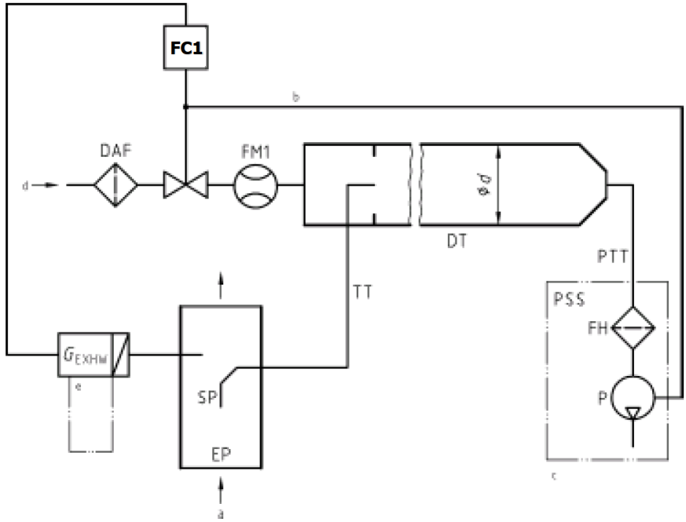

a = exhaust b = optional c = details see Figure 16

…"

*Paragraph A.2.2.5.*, amend to read:

"…

For a partial flow dilution system, a sample of the diluted exhaust gas is taken from the dilution tunnel DT through the particulate sampling probe PSP and the particulate transfer tube PTT by means of the sampling pump P, as shown in Figure 16. The sample is passed through the filter holder(s) FH that contain the particulate sampling filters. The sample flow rate is controlled by the flow controller FC2.

For of full flow dilution system, a double dilution particulate sampling system shall be used, as shown in Figure 17. A sample of the diluted exhaust gas is transferred from the dilution tunnel DT through the particulate sampling probe PSP and the particulate transfer tube PTT to the secondary dilution tunnel SDT, where it is diluted once more. The sample is then passed through the filter holder(s) FH that contain the particulate sampling filters. The diluent flow rate is usually constant whereas the sample flow rate is controlled by the flow controller FC2. If electronic flow compensation EFC (see Figure 15) is used, the total diluted exhaust gas flow is used as command signal for FC2.

…"

1. \* In accordance with the programme of work of the Inland Transport Committee for 2021 as outlined in proposed programme budget for 2021 (A/75/6 (part V sect. 20) para 20.51), the World Forum will develop, harmonize and update UN Regulations in order to enhance the performance of vehicles. The present document is submitted in conformity with that mandate. [↑](#footnote-ref-2)