Economic Commission for Europe
Inland Transport Committee
Working Party on the Transport of Dangerous Goods
Joint Meeting of the RID Committee of Experts and the
Working Party on the Transport of Dangerous Goods 17 September 2021
Geneva, 21 September – 1 October 2021
Item 2 of the provisional agenda
Tanks
Proposals on mandatory fitment of safety valves to tanks carrying flammable liquefied gases – Document ECE/TRANS/WP.15/AC.1/2021/36
Transmitted by the European Industrial Gases Association (EIGA)
1. EIGA supports Proposals 1 and 3 in document ECE/TRANS/WP.15/AC.1/2021/36.
2. EIGA is not in agreement with Proposal 2. In the current regulations, the marking of the letter “S” is used to indicate that shells or compartments are divided by surge plates, see 6.7.2.20.1 and 6.8.2.5.1. An example of such a mark is given below.
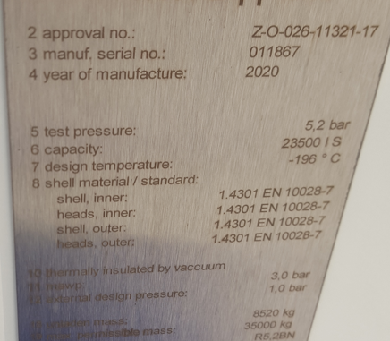
3. EIGA believes that it could cause confusion if the same mark is used to indicate a different meaning, even if it is marked in a different place.
4. As all tanks for refrigerated liquefied gases (6.8.3.2.11) and many tanks for liquefied gases (current 6.8.3.2.9) already have safety valves in line with the regulations, EIGA believes that it is easier and clearer if tanks which do not have safety valves are identified.
5. This would highlight the risk of BLEVEs occurring on these tanks. EIGA proposes marking these tanks, for example with an “H”, indicating that they are to be considered hermetically closed.
6. Orange coloured plates are used to identify dangerous goods and the associated hazards. These marks do not correspond with the equipment used to transport the dangerous goods. This may not be the best place to have marks concerning transport equipment design.
7. Should a mark before the hazard identification number be considered, this would require consequential ammendments of 5.3.2.3.1 and 5.3.2.3.1.
8. Transitional measures would be required.

