# Technology Interplay Brief

# Contents

* Objectives
* Key Takeaways
* Capacity Building
* Introduction
  + What is Carbon Neutrality?
  + The Energy Trilemma: A Framework for Sustainable Energy and Carbon Neutrality Policymaking
  + Why is Carbon Neutrality necessary?
  + Why are new technologies needed for Carbon Neurality?
  + Modelling as a tool for informed decision making
  + What is the Carbon Netrality Scenario?
* UNECE Region Carbon Neutral Energy System of the Future
  + Carbon Neutrality at a Glance
  + Primary Energy Supply
  + Final Energy Demand
  + Industry
  + Commercial and Residential Property
  + Transport
  + Electricity
  + Ask an Expert
* Technology Deep Dives
  + Are new Nuclear Power stations part of the solution?
  + CCUS
  + Is a Hydrogen-led economy feasible?
  + How can Methane management be scaled up?
  + Energy Efficiency and electrification
* Action starts now
* Carbon Neutrality by 2050: Regional Readiness Level
* Annex

# Objectives

* Raise awareness about the potential of technology integration and application to achieve carbon neutrality.
* Provide a range of policy options and solutions of analysis using different technology options to support the implementation of COP26 outcomes.
* Identify where and how UNECE can help member States by fostering co-operation and dialogue.

# Key Takeaways

* [Problem] Although COP26 was a positive step forward in the fight against climate change, climate models indicate that the targets set in the Paris Agreement and at COP26 fall short of what is required to meet the goal of limiting global warming to 1.5 – 2C.
* [Possible] There are clear pathways for policy makers to attain a carbon neutral energy system through technology interplay.
* [How] A rapid transition from fossil fuels to low- and zero-carbon technologies is vital to achieving net-zero emissions. Traditional fossil fuel use will decrease as technologies such as solar and wind, nuclear power, hydrogen and CCUS make progress alongside substantial reductions in energy demand through energy efficiency and increase in electricity capacity.
* [Implications] The practical delivery of any rapid pathway to carbon neutrality will be subject to capacity to build the necessary infrastructure and access natural resource constraints.
* [Action] The region needs to quickly deploy all currently available energy technologies to transition from fossil fuels to low- and zero-carbon technologies.
* [Cooperation] International cooperation will be essential to build resilience in the energy system, support the systemic lifestyle changes required across industry, buildings, and transport to scale up supportive policies, incentives and regulatory frameworks for all member states.
* [UNECE] UNECE is available to support policymakers with Carbon Neutrality Toolkits, sub-regional support and policy analysis to build a carbon neutral energy system of the future across finance, industry and global governance policymaking.

# Capacity Building

This brief builds on the recommendations from the Pathways to Sustainable Energy project and from the UNECE Carbon Neutrality Project.

The document is built upon the series of technology briefs that directly support implementation of the Carbon Neutrality project. The underlying objectives of this brief are:

* **Inform member States about a range of options** and solutions to attain carbon neutrality
* **Support policy makers** to reach carbon neutrality
* **Build capacity in economies** across the UNECE region to reach common goals

# Foreword

[COP26] The compromise deal at COP26 reflected the interests, contradictions and political will in the world today. Alongside my team of experts, I attended COP26 to meet with activists, diplomats and heads of state from the ECE region and beyond to find common ground in areas including sustainable energy. We delivered real action to move the dial on sustainable energy and our [commitment trifecta](https://unece.org/sites/default/files/2021-08/UNECE%20A%20Commitment%20Trifecta.pdf) and the [push to pivot](https://unece.org/sites/default/files/2021-09/CSE-302021%20INF.5%20UNECE%20A%20Push%20to%20Pivot%20.pdf).

[Energy] Energy is critical to support quality of life. Experts have found that there are clear pathways for policy makers to attain a carbon neutral energy system.Energy efficiency improvements, renewable energy, highly efficient fossil fuels with CCUS, nuclear power, and hydrogen will be part of the solution to attain carbon neutrality. However, only bold, immediate, and sustained action can decarbonize energy in time.

[Cooperation] International cooperation is essential to support all countries in the UNECE region to build resilience of the energy system and to accelerate energy transition towards attaining carbon neutrality. UNECE continues to offer a neutral platform for inclusive and transparent dialogue, exchanges of best practices and lessons learned to strive towards Energy for Sustainable Development.

[Why] Inaction is a policy choice that could lead to greater challenges in the future. Policy actions are needed now to build the necessary infrastructure and access natural resource constraints where It is becoming more complex and less practically possible to meet the target of limiting global warming to 1.5 degrees.

[Proposals] This document calls for ambitious and bold action from private sector, regulators and governments. Developing technologies will need new regulatory frameworks to support immediate commercialization. Policy frameworks should also incorporate legally binding commitments for increased international technology transfer and harmonised standards and definitions for ‘green’ hydrogen, energy efficiencies and conservation. All decisions should be assessed against existing and upcoming net zero/climate neutrality targets with all energy infrastructure built to be net-zero compliant. The investment in order to become a low-carbon economy is far less than the economic, social, and human cost of climate catastrophe. Integration of smart energy technologies, alongside the transformation of energy markets and downstream industries is a challenge, but also an opportunity.

[Conclusion] Approximately 80% of the primary energy mix is currently fossil fuel based. Although different countries will support different technologies in different ways, we need to deliver sustainable energy to address climate change as well as ensure quality of life at global level. In short: inaction is not a viable option. UNECE will continue to support all member states take action to accelerate their transformation and share good practice in urban and rural developments particularly cities, industry, buildings, and transport encouraging energy for sustainable development.

# Introduction

As the recent IPCC report confirms, **there is widespread scientific evidence that human activity has a significant impact on the climate**. Climate change is leading to extreme weather, and subsequent social and economic disruption, in every region of the world. At the same time, a sustainable energy system is critical for assuring quality of life and underpins attainment of the 2030 Agenda for Sustainable Development (2030 Agenda).

**Climate models indicate that the targets set in the Paris Agreement and at COP26 fall short** of what is required to meet the goal of limiting global warming to 1.5 – 2°C. There is also a disconnect between countries’ agreed energy and climate targets and the actual progress to date. We are running out of time to limit the impacts of climate change.

**Inaction is a policy choice that could lead to greater challenges in the future.** The global energy system is a complex cornerstone of all economies. On the supply side, national energy systems do not exist in isolation but are part of interconnected intra- and inter-regional systems. These systems are usually characterized by access to natural resources and technologies that can impact sustainable growth. A changing technology landscape largely driven by environmental concerns is having a large impact on energy system design and energy policy options. Once the energy system starts to change, industrial users and consumers will need time to adjust energy demand.

**Cleaner energy technologies are growing quickly, but are still at a very early stage in implementation**. On the supply side, there are new ways to produce energy including renewable energy technologies, hydrogen, fossil fuels with carbon capture use and storage (CCUS), and advanced nuclear reactors. The demand side has also experienced change, through the electrification of transport, new energy efficiency technologies and rise of smart information technologies.

**2021 provided much needed impetus towards achievable pathways towards carbon neutrality** amid increasingly urgent calls for action. In September 2021, the UN High-level Dialogue on Energy was the first global gathering on energy under the auspices of the General Assembly since 1981. It was the United Nations Year of Global Energy Action and saw the 26th UN Climate Change Conference (COP26) take place. At COP26, the final agreement:

*Calls upon Parties to accelerate the development, deployment and dissemination of technologies, and the adoption of policies, to transition towards low-emission energy systems, including by rapidly scaling up the deployment of clean power generation and energy efficiency measures, including accelerating efforts towards the phasedown of unabated coal power and phase-out of inefficient fossil fuel subsidies, while providing targeted support to the poorest and most vulnerable in line with national circumstances and recognizing the need for support towards a just transition.*

**This Technology Brief provides a clear pathway for policy makers to attain a carbon neutral energy system through technology interplay and implement the COP26 agreement.** The changing energy technology landscape impacts the UNECE Energy System with regional differences. This brief finds that there are many pathways to attain carbon neutrality that are compatible with national interests. Nonetheless, policy makers must finalise their preferred pathways and re-organise energy systems to act urgently. **The transformation of the energy system needs to start now and cannot be done independently.**

## The Carbon Neutral Energy System with Integrated Smart Technologies

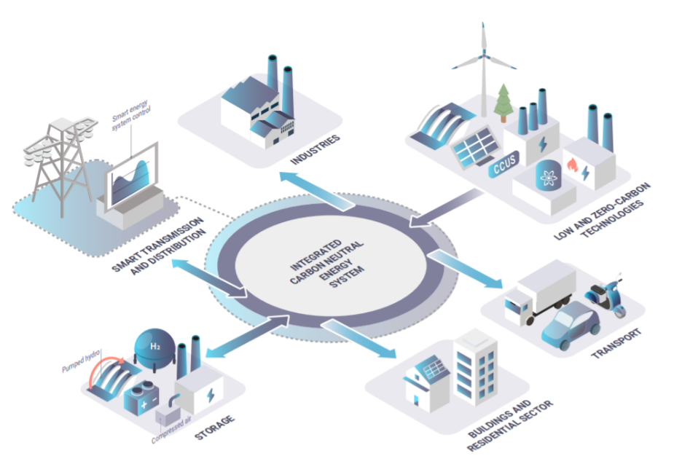

## What is Carbon Neutrality?

**Carbon Neutrality refers to achieving net-zero carbon emissions** that constrain global warming to 2°C preferably 1.5°C in line with the Paris Agreement. Carbon neutrality requires a careful balancing of reported carbon emissions with carbon removal, through natural sinks or engineered carbon removal technologies, or by eliminating carbon emissions altogether.

According to the Paris Agreement, carbon neutrality is defined as “achieving a balance between anthropogenic emissions by sources and removals by sinks of carbon emissions in the second half of this century”. This definition requires that every ton CO2 emitted by human activity is offset by an equivalent amount of CO2 removed, either through natural carbon sinks or engineered carbon removal technologies, such as carbon capture, use and storage (CCUS), bioenergy with carbon capture and storage (BECCS) and direct air capture. This definition also assumes that the natural carbon cycle remains stable in the second half of the century and does not become a net source emitter of carbon emissions.[1]

**Carbon neutrality is not an end state**. It is an essential part of the journey to stabilising the climate. As a standalone policy target, carbon neutrality will not be enough to limit global warming. If carbon neutrality is achieved too late, net-negative carbon emissions will be required to address the overshoot. In future, it is hoped that attaining carbon neutrality will move to managing carbon emissions over time and will need to be periodically revisited and address such issues as historical emissions.

## The Energy Trilemma: A Framework for Sustainable Energy and Carbon Neutrality Policymaking

**The energy trilemma refers to the interplay between energy security, quality of life, and environmental sustainability** at a national and regional level. The rapid transition towards sustainable energy will require careful decision making to maintain and develop quality of life and Agenda 2030 for Sustainable Development.[2]

**The trilemma is an important framework for analysing technology interplay**. The modelling and expert comments assume that the pace of economic development in each member state of the UNECE is maintained and that each member state will have its own energy preferences based on local policies, endowments and the energy distribution system to enable trade.

## Why is Carbon Neutrality necessary?

**The UNECE region will have to eliminate the emission of GHGs by using a mixture of new energy technologies** and changes in social behaviour to satisfy the sustainability criteria of the trilemma.

**The region needs to quickly deploy all currently available energy technologies**. This includes transforming the energy supply by installing carbon capture use and storage (CCUS) technologies in fossil fuel plants, scaling up renewable energy projects, deploying nuclear power and all other technologies considered in this review. Energy demand will need to be driven by lifestyle changes and actions that increasingly rely on energy efficiency, smart technologies, and the electrification of transport.

**Policies should encourage rather than delay changes in the energy system**. Previous modelling in the [Pathways to Sustainable Energy Project](https://unece.org/fileadmin/DAM/energy/se/pdfs/CSE/Publications/Final_Report_PathwaysToSE.pdf) showed that progress has been too slow and, in order to attain carbon neutrality on route to only the 2°C target, UNECE countries must either additionally cut, or capture at least 90Gt of CO2 by 2050 in a ‘middle of the road’ socio-economic forecast.[3] Policies are needed to reduce and decarbonise demand, decarbonise the energy supply to satisfy demand, reduce the disruption of the energy transition.

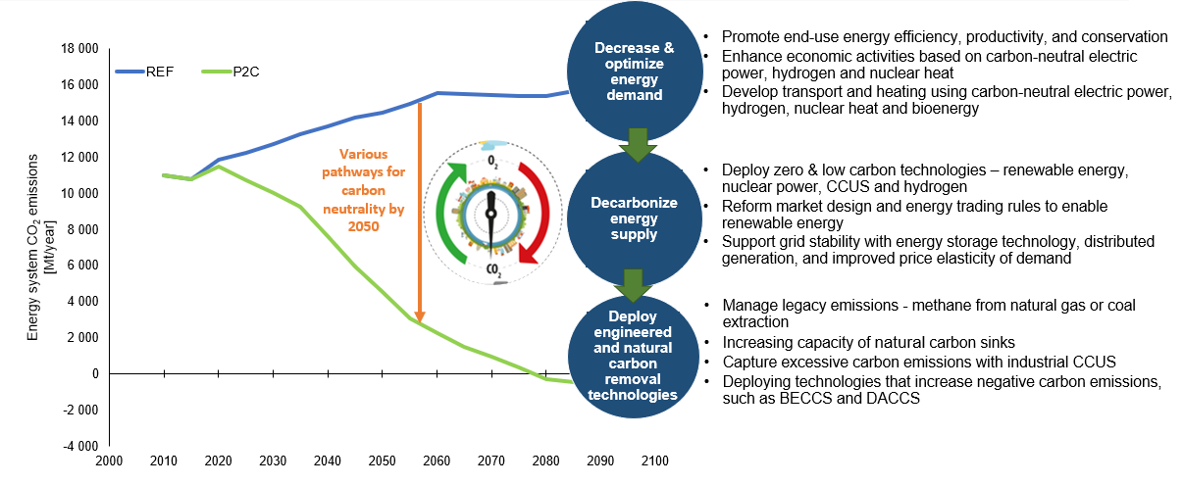

## Why are new energy technologies needed for carbon neutrality?”

**The complex energy system of the near future requires a variety of energy technologies**. UNECE supports a holistic approach to energy technologies to best represent the interests of all member countries.

**An expanded range of technologies are needed to attain carbon neutrality** by 2050 and the Agenda 2030 for Sustainable Development. The existing technology portfolio is not enough to attain carbon neutrality by 2050. The potential impact of new technologies needs to be modelled to support policy making by nations and industry alike to prepare for the energy system of the future.

**This report describes the most recent results from modelling an expanded set of technical options** available to support policymaking for international energy cooperation. The technologies modelled are Renewables, Carbon Capture and Storage, hydrogen and nuclear.

**Many developing technologies will need new regulatory frameworks to support immediate commercialization.** Energy experts are aware that energy is a highly regulated sector and that any technology development and deployment require suitable regulatory frameworks. The urgency of the energy transition requires policy makers coordination to ensure regulatory delays do not compromise the early attainment of Carbon Neutrality. The idea of a Social Readiness Level is used to align policy makers with Technology and Commercial Readiness Levels used by experts.[4]

**Modelling shows that there is no completely carbon neutral energy solution**. All technologies require materials and high-temperature processes that result in GHG emissions. Renewable energy solutions require steel, cement, and silicon. Electric vehicles and grids require rare earth metals in batteries. Energy investments may mean increased emissions today that will save emissions in the future. The modelling does not fulling account for this shift in energy and GHG emission patterns in the economy as it relies on historical trends.

**Policy makers can use a hierarchy of technologies**, based on [Life Cycle Analysis](https://unece.org/sites/default/files/2021-09/202109_UNECE_LCA_1.2_clean.pdf) studies, from those with the lowest carbon footprint to those that require significant carbon capture and storage to be carbon neutral. It is almost certain that all energy technologies will be needed during the transition. For example, policy makers can move to a hydrogen economy at the rate at which electrolysers using wind and solar energy can be built, or they can decouple investments by using hydrogen from methane and CCS to accelerate a hydrogen ecosystem infrastructure. Battery storage can be used to stabilise grid electricity or fossil fuels with CCS can be used in reserve.

**Energy infrastructure built now must be net-zero compliant to avoid stranded assets.** All infrastructure-scale assets have operational lives of more than 30 years. Therefore, any assets that are built now must comply with national emissions targets. Carbon capture, use and storage (CCUS) is a solution that adds flexibility because the rate at which we must decarbonise our society now is so fast that it would be socially disruptive. In certain essential industrial sectors such as cement, metals, and chemicals, carbon neutral technologies does not yet exist.

**The energy transition will be cost effective and least disruptive if all new assets are net-zero compliant.**  The introduction of CCUS will be needed for existing non-compliant infrastructure to reduce the carbon footprints and extend operational lives. An increased capacity of CCUS capacity could promote an enhanced emissions trading system. If carbon neutrality is achieved too late, having fully developed CCUS technologies will be significant for a carbon negative world.

Additional reports have been compiled for policy makers to support understanding the technologies modelled.

* Carbon Capture and Storage (CCUS) ([link](https://unece.org/sites/default/files/2021-03/CCUS%20brochure_EN_final.pdf))
* Nuclear power ([link](https://unece.org/sites/default/files/2021-08/Nuclear%20power%20brief_EN_0.pdf))
* Hydrogen ([link](https://unece.org/sites/default/files/2021-10/Hydrogen%20brief_EN_final_0.pdf))
* Energy Intensive Industries (work in progress)
* Renewable Energy ([link](https://unece.org/sites/default/files/2021-01/FIN%20RECOM_EN.pdf), [full report](https://unece.org/sites/default/files/2021-01/ENG%20UNECE_14.11.20.pdf))
* Life Cycle Analysis ([link](https://unece.org/sites/default/files/2021-09/202109_UNECE_LCA_1.2_clean.pdf))

## Modelling as a tool for informed decision making

**Technology interplay is critical in the energy system**. Modelling the energy system is useful to highlight how technologies interplay to ensure constant energy supply and demand, as well as efficient and sustainable energy generation, storage and transmission.

**Modelling allows policy makers to see implications for energy costs, storage and baseload or variable supply requirements**. Policy makers can use modelling to decide which technologies they are prepared to support by understanding investment costs, lead times, and online factors. The early engagement of policy makers in modelling exercises is important to enable informed, agile and responsive policy making to attain carbon neutrality. Policy agility and flexibility will be needed to change path if technologies in development do not yield their full potential.

**Business as usual governance of the UNECE energy system will not deliver the change required.** Given the shortage of time to reach carbon neutrality, the role of ‘futureproofing’ is becoming increasingly important and urgent. Limitations of critical resources required for an energy transition add uncertainty and complexity to the judgements to be made.

**The modelling used lowest cost to optimise the energy system under various policy scenarios to attain carbon neutrality by 2050**. Cost is often used as a proxy for carbon neutrality as renewable technologies have developed to be more competitive versus fossil fuels on a simple cost per unit of energy produced. Policy makers may wish to use different criteria for their energy system such as a preference for local resources, maximising employment and minimising foreign currency commitments.

## What is the Carbon Neutrality scenario?

**The carbon neutrality scenario modelled in this brief sets a viable path to attain carbon neutrality by 2050** using a ‘middle of the road’ socio-economic forecast to determine energy demand. The model considers the costs and lead-times of the current energy system and various energy technologies to estimate the technologies and capacities required for the lowest cost energy supply option. By imposing constraints, such as GHG emissions consistent with net zero emissions by 2050, the mix of energy supply will change to represent a carbon neutral scenario. The model also estimates the requirement for investments in the energy distribution system and energy trade.

**The more the process is done, the cheaper it becomes.** Costs of energy and lead time for technologies are based on assessments by experts in the technology. The ‘cost’ calculated includes an allowance for a return on investment to represent an investment case and includes an estimate of ‘cost learning’ through developed efficiencies and optimization, and ‘economies of scale’.

**The model considers energy demand, technology and infrastructure challenges** to attain net-zero emissions by using zero- and low-carbon technologies alongside existing energy technologies. Across the brief, the results of carbon neutrality scenarios are compared to ‘business as usual’ scenarios. These results effectively describe what would happen if no major changes to the energy system are enacted due to a lack of action in climate change mitigation.

**Further scenarios put emphasis on specific technologies** including Nuclear, Hydrogen and CCUS. This work used independent data and was cross-referenced with the UNECE energy technology briefs and consultations with the Group of Experts under the Sustainable Energy Programme and the Task Force on Carbon Neutrality. This work was also supported by a cross-departmental team of UNECE to highlight the integrated approach of the energy transformation.

# UNECE Region Energy System of the Future

## Carbon Neutrality at a Glance

**A rapid transition from fossil fuels to low- and zero-carbon technologies is vital to achieving net-zero emissions. Traditional fossil fuel use will decrease as technologies such as solar and wind, nuclear power, hydrogen and CCUS make progress. The practical delivery of any rapid pathway to carbon neutrality will be subject to capacity to build the necessary infrastructure and access natural resource constraints.**

**In 2021, the UNECE region is nowhere near achieving carbon neutrality**. Fossil fuels still account for over 80% of UNECE energy supply. Although sustainable energy capacity is growing quickly, the growth rate is currently not enough. Despite positive commitments by countries, the region is still heavily reliant on fossil fuels.

**Low- and zero-carbon solutions must be prioritised and built at scale to ensure carbon neutrality targets are met**. In a ‘business as usual scenario’ modelling the world is on a path to global average temperatures that are 4-6⁰C above pre-industrial levels. These levels are considered a catastrophic and existential threat to humanity.

|  |  |  |  |
| --- | --- | --- | --- |
| Energy Technology | What’s needed | Equivalent | Cut in global emissions |
| ☀Solar | 2.8 million football pitches of solar panels   (2346 GWh)  7 million utility-scale panels | The surface area of Belgium, or 0.07% of the whole UNECE region. | Would cut 1.4GT CO2 equivalent = 2.7% of global emissions (2019 baseline). |
| 💨Wind | About 500,000 wind turbines  (1893 GW) | About 110 million tons of steel, or 6% of the 2020 global steel production. | Would cut 2.4GT CO2 equivalent = 4.6% of global emissions. |
| 🌊 Hydro | (244 GW) | 244 GW is about 11 times larger than the Three Gorges Dam, by far the largest dam in the World.  Equivalent to doubling the Europe’s existing hydropower capacity. | Would cut 0.42GT CO2 equivalent = 0.8% of global emissions. |
| ☢️Nuclear | 350 new reactors (383 GW) | 383 GW is about 70 times larger than capacity of Gravelines Nuclear Power station in Northern France. | Would cut 1.4GT CO2 equivalent = 2.7% of global emissions. |
| 🏭Fossil Fuels | 80% of infrastructure retired   (-410 GW) | In North America, there are over 3400 fossil fuel-fired power plants |  |
| ☁️CCUS | Two years of current global CO2 emissions   (90 GT of CO2captured) | A gigaton is one billion tons and equivalent to 200 million elephants; enough elephants to stretch from the Earth to the moon |  |
| 🚗Transport | 400 million electric and fuel cell vehicles (1 GT of CO2 saved) | In 2019, an estimated 92 million cars were produced. |  |
| 🌳Nature | 75 million trees planted (1 GT of CO2 captured) | In the European Union, it is estimated that almost 300 million trees have grown each year between 2010 and 2015. |  |

**Carbon Neutrality requires a major shift in the allocation of resources in the future energy system.**  Modelling shows fossil fuel extraction investment needs to be diverted to CCUS, hydrogen while quadrupling investment in renewables, factor of 10 increase in nuclear, and a 50% increase in distribution. Most significantly, energy efficiency rises from 0.1 billion to 10 TRILLION.

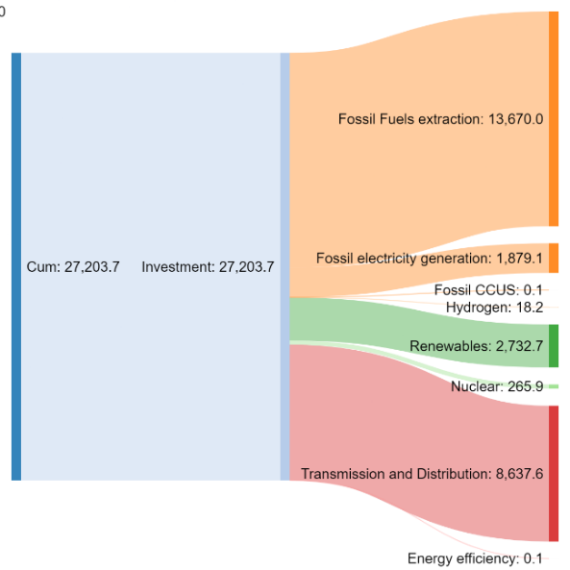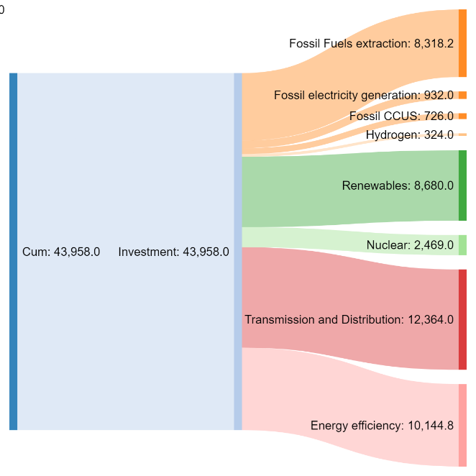

Figure 24 - UNECE Cumulative Investments in Energy 2020-2050: $27203 Billion Business as Usual Scenario  
Figure 25 - UNECE Cumulative Investments in Energy 2020-2050 $43958 Billion Carbon Neutrality Scenario

## Primary Energy Supply

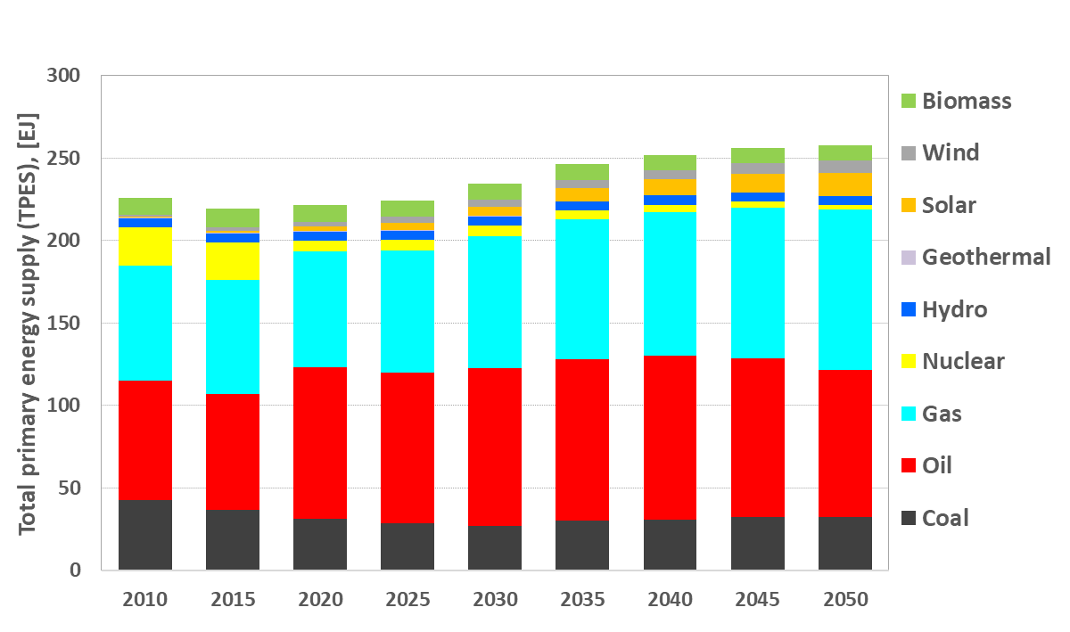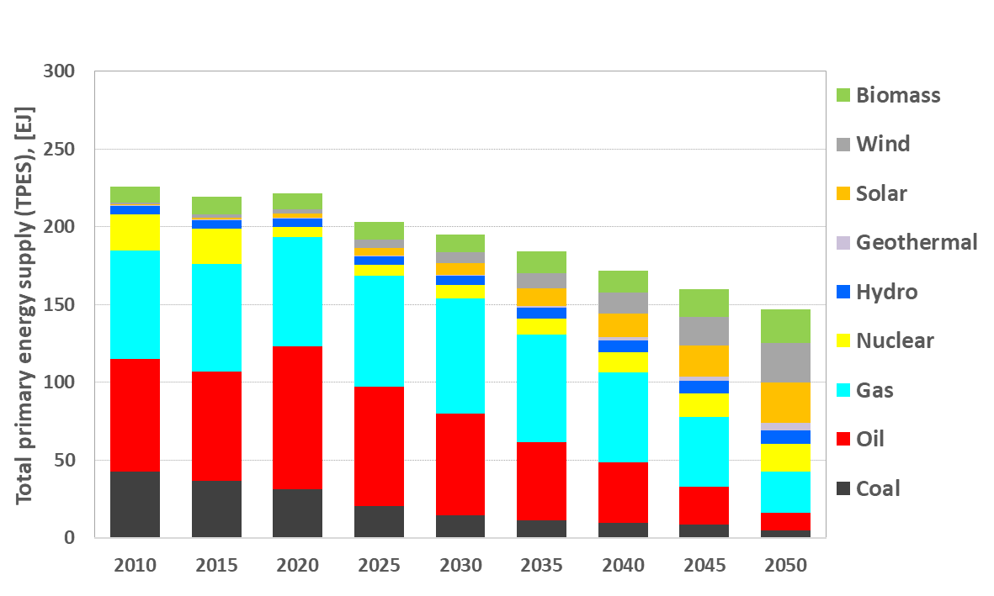

Figure 2 UNECE ‘Business as Usual’ Scenario: Total primary energy supply (TPES), [EJ]  
Figure 3 - UNECE ‘Carbon Neutrality’ Scenario: Total primary energy supply (TPES), [EJ]

**A carbon neutral future is** **achievable with the right policies, incentives and technology interplay** (figure 3). However, it looks very different to the ‘business as usual’ case (figure 2). Figure 3 represents what is possible if the region works together to decarbonise society. Most of the necessary technologies exist already and many are economically viable with the addition of appropriate regulatory frameworks.

**Modelling shows carbon neutrality is not easy to achieve**. In the next 30 years, solar and wind power needs to grow at XX% and YY% per year and nuclear is restored to a capacity last seen in 2010.

|  |  |
| --- | --- |
| Technology | Compound average growth rate in primary energy supply 2020-2050 (%) |
| Overall demand |  |
| Biomass |  |
| Wind |  |
| Solar |  |
| Geothermal |  |
| Nuclear |  |

*Table - Primary Energy Growth rates for low carbon technologies consistent with Carbon Neutrality by 2050*

**The fall in primary energy supply is mainly driven by continued improvements in energy efficiency throughout the energy system**. This can be achieved through an integrated and intelligent system that delivers demand via clean electrification, smart digital technology, and efficient buildings and infrastructure, along with a circular economy approach to water, waste and materials.[5] This is embedded in a whole system approach towards structural change in technology, lifestyle and economy.

**All technology solutions leading to carbon neutrality need to be supported.** For example, flexible policy incentives to scale up access to land/offshore sites for wind and solar, as well as permits for new nuclear and geological CCS can develop and implement technologies gives return on capital. The success of policies to promote renewable energy needs to be considered to kick start the move to alternative energy vehicles, CCUS and new energy storage systems.

**Coal, oil and natural gas in total energy supply will need to significantly decrease to achieve carbon neutrality by 2050**, unless member decide to preferentially support the use of CCUS. Renewable energy supply will grow followed by nuclear power. Growing deployment of variable renewable energy technologies will increasingly affect the grid stability and will require storage solutions to be developed and implemented widely to provide the buffer when real-time energy supply falls short to meet demand.

## Final Energy Demand

**The future carbon neutral energy system has electricity as its main energy vector.** This is a consequence of using more renewable energy. Renewable energy is hard to convert to a liquid fuel, and causes a shift to electricity in final energy demand, especially end-uses in transport and residential sectors.

**The impact of doubling electricity demand will have knock-on effects.** Systems will require installation of more transmission cables alongside enhanced capacity and efficiency. The reliability of the electrical system will become more important as a failure will impact almost every aspect of life.

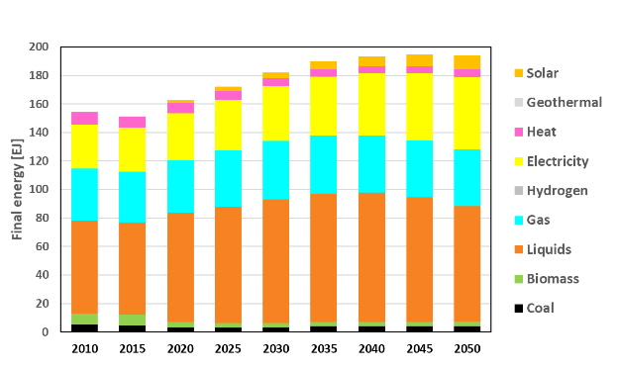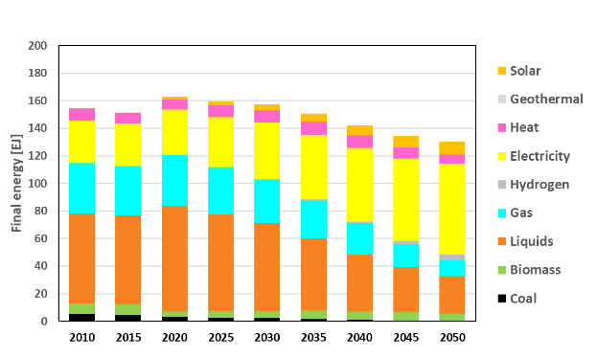

Figure 4 - UNECE ‘Business as Usual’ Scenario: Total final energy [EJ]   
Figure 5 - UNECE ‘Carbon Neutrality’ Scenario: Total final energy [EJ]

Note: Hydrogen is within “electricity” as it is either electrolysed or produced from oil/gas by electrically powered processes. Liquids include oil-liquids (heavy and light fuel oil) , bio-liquids (ethanol), gas liquids and coal-liquids (methanol).  
Biomass is local wood-based biomatter and forestry residues  
Heat is District heat and combined heat and power (CHP)

## Industry

**The decarbonisation of industry is a top priority to attain carbon neutrality and Paris Agreement targets.** Energy intensive industries are one of the principal greenhouse gas emitters, accounting for about 25% of total CO2 emissions globally. Cement, iron and steel, and chemicals and petrochemicals industries are the largest industrial CO2 emitters, with shares in the sector reaching 27%, 25%, and 14% respectively.

**Energy intensive industries will support low-carbon economic growth**. Among many other uses, steel and concrete structures are required to support energy transition - for wind power; thermal insulation for energy efficiency; lightweight materials for electric cars. Oil and natural gas will continue fuelling the industry as electrification of many processes will remain technically impossible.

Industrial energy can be divided into the electricity required to run factories (which is normally obtained from the grid), and energy for high temperature processes (for which electrical alternatives are not yet available) which includes the use of any waste heat in other parts of the factory. In general, the energy requirements are baseload and any interruption of supply is likely to be onerously disruptive. CO2 is also a by-product of some industrial processes. Fossil fuels are also the feedstock for the chemical industry.

**Industry will have to adapt to a diverse range of energy options including electricity, biomass, bio-liquids such as vegetable seed oils and hydrogen**. The development of policies for a circular economy are needed for this. Also, deployment of CCUS technologies in cement, fertiliser and petrochemical sectors will be a key enabler for achieving carbon neutrality.

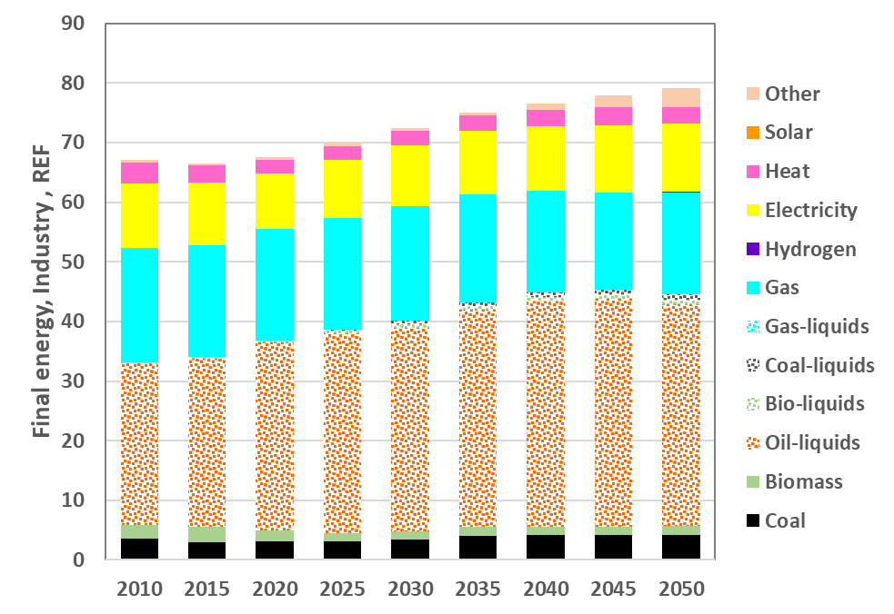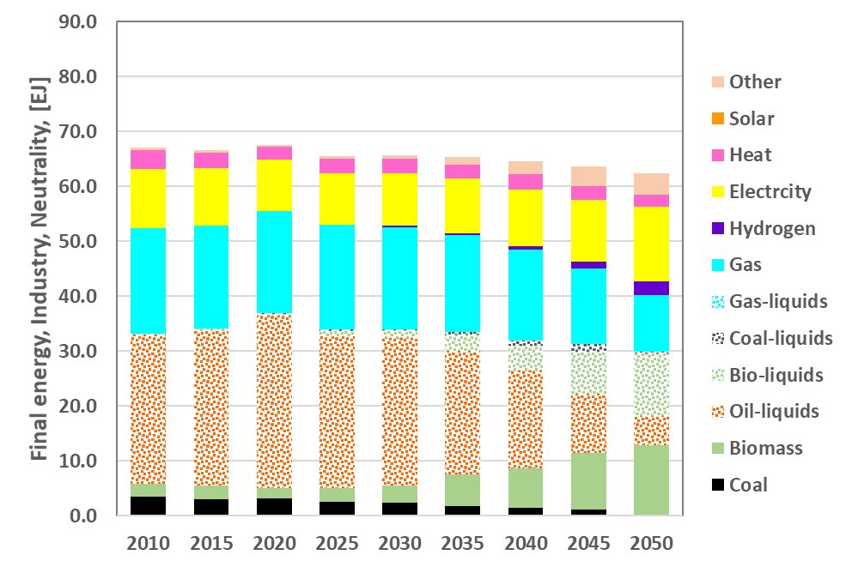

Figure 6 - UNECE ‘Business as Usual’ Scenario by Sector: Industry Total final energy supply, [EJ]  
Figure 7 - UNECE ‘Carbon Neutrality’ Scenario by Sector: Industry Total final energy supply, [EJ]  
Note: Electricity is a product produced from various power sources including fossil fuels and renewable energy.

## Residential and Commercial

**Residential and commercial sectors will require electrification at a scale and speed never seen before.** Most people in the UNECE region have their homes and businesses powered by natural gas and/or thermally generated electricity. Mass electrification will require a mix of policy options including better efficiency from the grid level to the installation of insulation and smart appliances.

**Hydrogen is expected to become a key power and heat source for homes in many regions by 2050**. Off-grid individual solar panels, wind turbines and heat pumps will also be required to see a dramatic increase.

**By 2050, natural gas, oil and coal are all but eliminated in servicing people’s residential and commercial buildings’ energy needs.** This is in addition to policy support for retrofitting buildings with insulation and improved energy efficiencies.

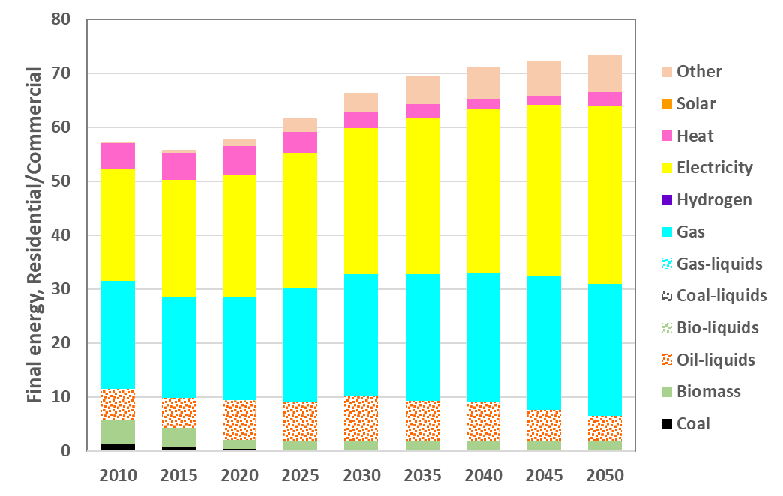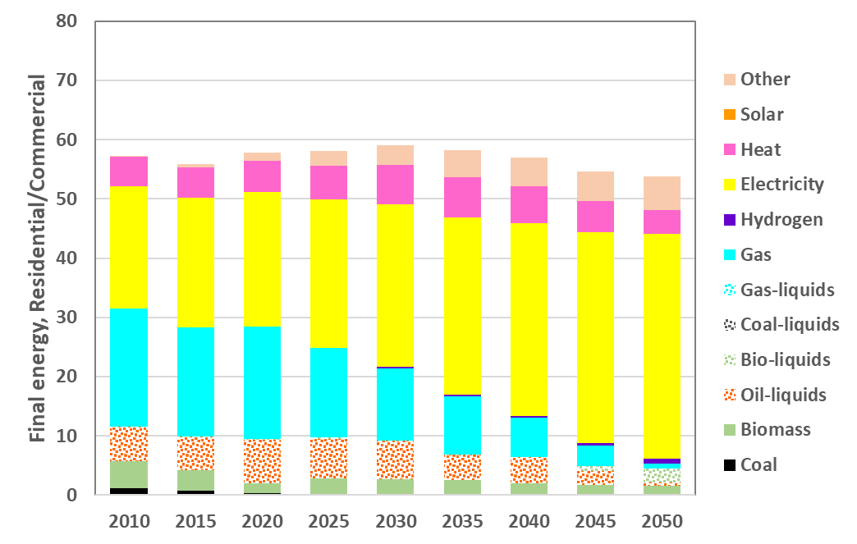

Figure 8 - UNECE ‘Business as Usual’ Scenario by Sector: Residential and Commercial Total final energy supply, [EJ]  
Figure 9 - UNECE ‘Carbon Neutrality’ Scenario by Sector: Residential and Commercial Total final energy supply, [EJ]

## Transport

**The transport sector is expected to experience deep structural changes**. Electric and hydrogen fuel cell cars, buses, trains and other transport will need to become commonplace across the region. While there is a strong push for such an ambitious shift in transport sector, it is important to note that a lack of raw materials such as lithium and cobalt as well as challenges associated with recyclability and short life spans of electric car batteries might hinder full electrification of a traditional urban car park.

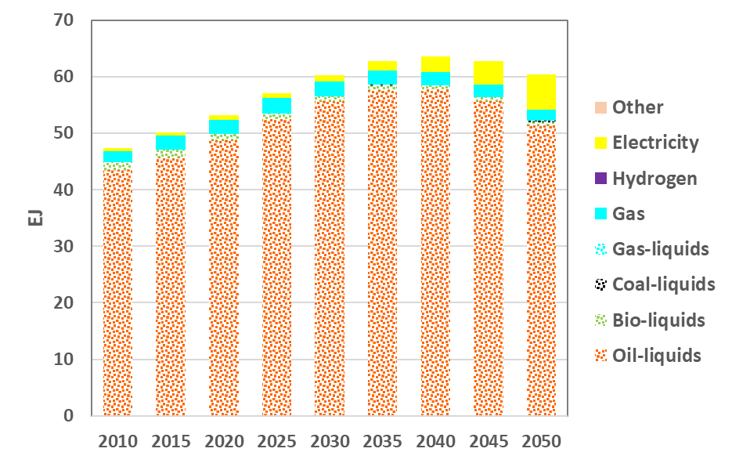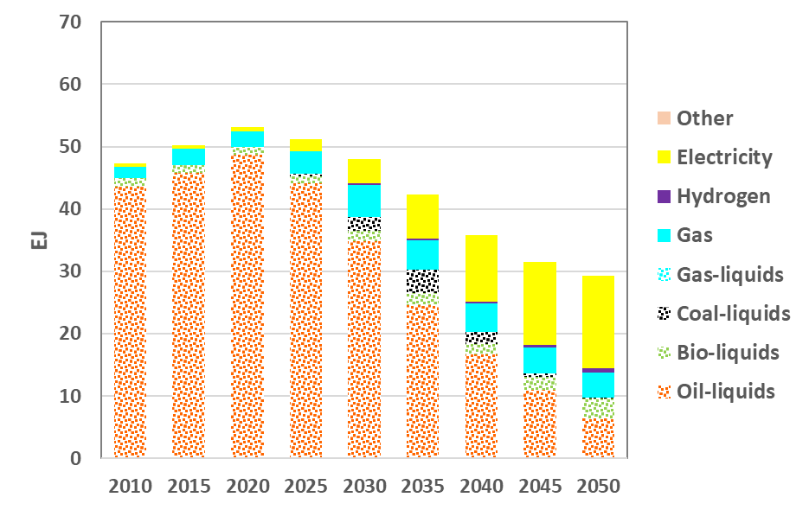

Figure 10 - UNECE ‘Business as Usual’ Scenario by Sector: Transport Total final energy supply, [EJ]  
Figure 11 - UNECE ‘Carbon Neutrality’ Scenario by Sector: Transport Total final energy supply, [EJ]

**Current changes are nowhere near enough.** Transport across the region is currently dominated by oil-liquids such as petrol and diesel. In recent years, transport has modernised with an increase in electrified railways and the introduction of electric and hydrogen powered vehicles. However, these have had a minor impact to date.

**Effective policy support is needed for market entry of new transport infrastructure.** In order to stimulate structural shifts to low-carbon fuels and technologies, emission taxes with removal of diesel cars could be considered. Other policy measures include government support for electric charging stations and hydrogen refuelling stations as well as encouraging flexible working schedules, car sharing and an increased uptake in public transport. Natural gas vehicles will also require major research and development to see minor increases in usage alongside bio-fuels such as bio-ethanol and bio-diesel vehicles.

**There remains serious technology challenges to decarbonising transport.** Although there are expected improvements in transport efficiency, lifestyle changes will also be required. All freight transport by road, sea and air continue to cause significant emissions.

This electrification of transport will impose a significant burden on the public. Firstly, it requires that the public purchase the electric vehicle and adapt to the shorter range and long ‘refuelling’ times. This is particularly challenging in poor and rural areas. Very cold and very hot regions pose their own issues with respect to battery performance. Efforts to persuade consumers to buy smaller cars, use less air conditioning etc would help reduce battery sizes.

For policy makers, the construction of electric vehicles brings forwards CO2 emissions (due to the battery) assuming a similar vehicle usage pattern. Also emission will only be reduced if the electricity is from low carbon sources. A comprehensive changing next work for homes and workplaces will be needed.

## Electricity

**Electrification is key to unlocking potential of decarbonisation across society**. Electrical installed capacity needs are required to double by 2050, partly due to the variability of renewables which must expand 100-fold in the next 30 years, as fossil fuels decline. Nuclear power capacity is also forecast to grow rapidly.

**The electrical distribution system needs an upgrade.** As demand for heating and vehicle charging climbs, the storage of grid electricity will also become a challenge. Today most regions keep significant stocks of fossil fuels to guarantee electrical supply and transportation fuels. In future, this burden will increasingly fall on electrical grid storage and gas supplies to countries that maintain the gas-powered electricity plants. Nuclear plants may also need to be made more flexible to allow load following.

The forecast for natural gas used to make electricity will also concern policy makers (Figure 13). There is a need to expand the use of natural gas until around 2035-2040, and then rapidly reduce its use to about the level in 2015. During the decline, the model indicates a shift of half the electricity capacity from natural gas to shift to using CCS. Given the typical lifetime of such power plants, it may be better to site any new plants at locations which are known to be suitable for CCS. Also a mechanism is required to ensure more expensive electricity produced with CCS is given preferential supply over non-CCS power plants during the decline. Finally, some flexibility is needed to review the capacity of electricity from natural gas needed to stabilise the grid dominated by renewable Wind and Solar energy by 2050.

**Centralised electricity targets, incentives and market mechanisms will be needed to redirect investments, handle the transition and manage the potential downsides of sustainable energy such as grid stability**. The best mix of different technologies will have to be determined for each grid, taking into account the potential variability of each renewable generation technology. Unique actions will be needed to protect hard-to-decarbonise sectors from loss of supply from the electricity grid and revolutionise private consumption.

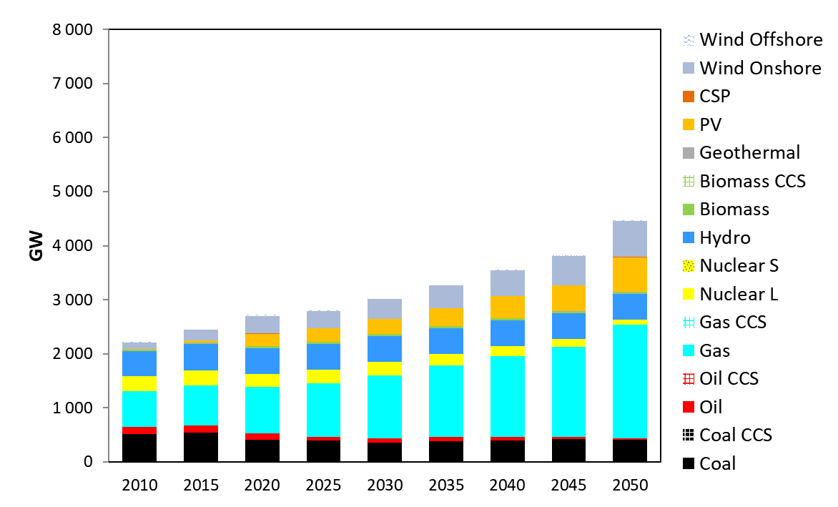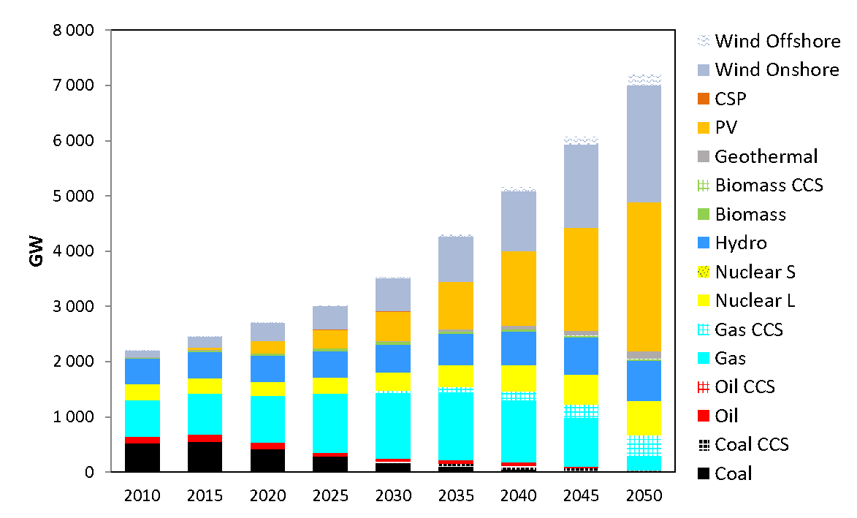

Figure 12 - UNECE ‘Business as Usual’ Scenario: Installed Electricity generation capacity [GW]  
Figure 13 - UNECE ‘Carbon Neutrality’ Scenario: Installed Electricity generation capacity [GW]

## Ask an expert

**Can the ECE region reach net-zero by 2050?**

Yes. It is possible to reach carbon neutrality through application of existing and new technology by 2050 with significant changes required across society to reach this goal. We can do this by:

* + - Improve end-use energy efficiency and productivity cost-effectively
    - Reduce losses in transformation, transmission, and distribution – reduce methane emissions, improve power generation efficiencies, improve total system efficiency
    - Shift to low- or no-carbon primary energy sources and realign investment and research from fossil fuel industries to low and Net Zero industries
    - Capture carbon emissions through faster deployment of CCUS and potentially through direct air removal technologies
    - Promote renewable gases and build on existing natural gas infrastructure which can be used to integrate them in a cost-efficient way
    - Promote research and innovation in clean hydrogen and develop hydrogen infrastructure
    - Broad deployment of innovative technologies for systemic decarbonisation that meets quality-of-life criteria
    - Stop all fossil fuel related subsidies and ensure fossil fuels users are charged their socio-economic costs
    - Manage carbon sinks and stores, notably forests and oceans

**Can we use Direct Air Capture to help reach net-zero quicker?**Modelling has included scenarios with Direct Air Capture of CO2 removal. Prioritising direct air capture to reaching net-zero emissions will cost billions more than using proven and developed sustainable energy technologies. It is better to start now to make the energy system sustainable through proven technologies. The later we leave it, the higher the economic and social cost.

**If we delay Net-Zero by 2050 to 2060, what are the effects?**Net-Zero carbon emissions is a key indicator in global action against climate change. Time is running out to combat the effects of climate change and inaction may lead to severe climate consequences. However, if targets were to be 90% by 2050 and 100% Net-Zero by 2060, the investments in the systemic change of the energy system would decrease by 14.6%. The costs of climate change impacts, such as extreme weather, are not included in the model, but experts would expect these costs to increase.

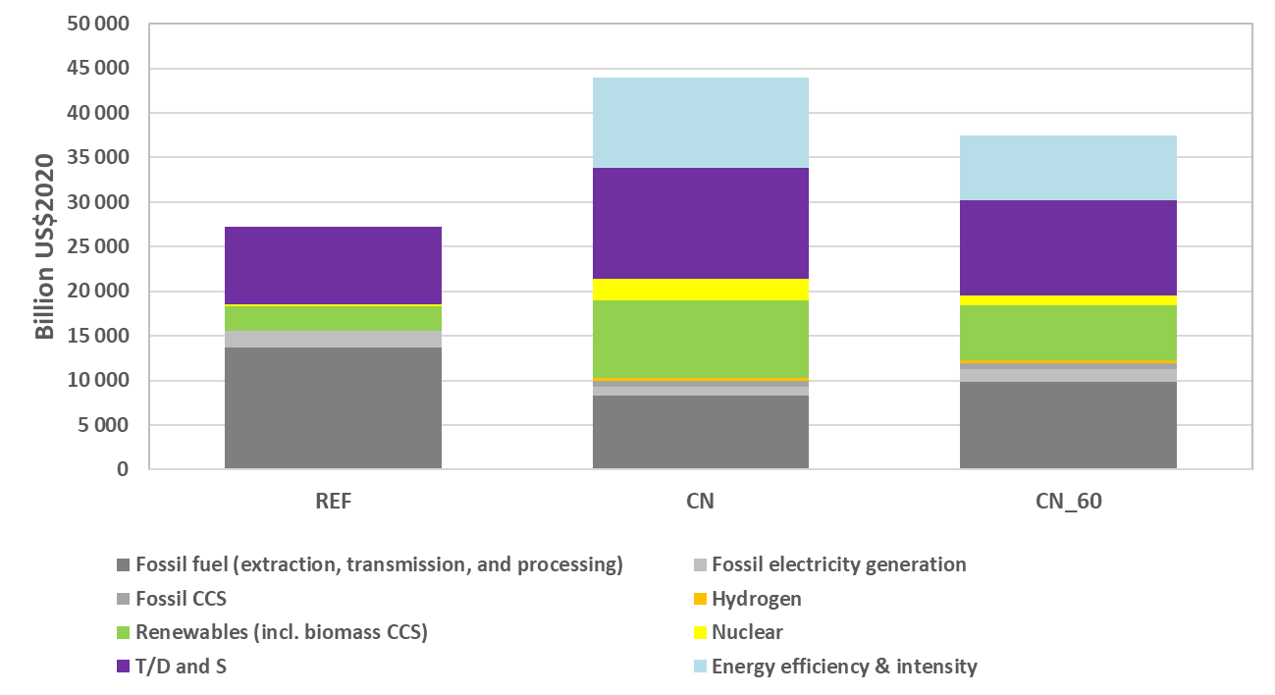

Figure 14 – UNECE Total Investment needs 2020-2050 Business as Usual, Carbon Neutral by 2050, Carbon Neutral by 2060 scenarios (billion $)

However, while the cost of implementing the transition decreases, the societal costs of the warmer climate for the additional years grows much faster than the savings. The impact of delaying net zero to 2060 would fail to restrict global warming to 1.5°C. Consequently, a recent Intergovernmental Panel on Climate Change stated that such a failure would see ‘stronger negative effects on intensity and frequency of extreme events, on resources, ecosystems, biodiversity, food security, cities, tourism, and carbon removal’.[6]

**What happens to fossil fuel use in the future?**

The aim of a wider sustainable energy system is to keep fossil fuels in the ground. However, radical transformational change of the energy system takes time. Many critical sectors of the economy are hard to decarbonise. By retrofitting fossil fuel plants with carbon capture and subsurface storage technologies, we can mitigate the effect of fossil fuels. In 2050, fossil fuels will account for a smaller percentage of energy consumption. Outside of the energy system, industry will still need fossil fuels for hard to decarbonise processes and as a feedstock.

**What is the share of renewables in the future?**

Renewables see a massive increase in use as the energy system moves towards carbon neutrality. By 2050, renewables will account for over 50% of primary energy supply in the carbon neutrality scenario. Therefore, vast targeted investments into renewable energy like never seen before are needed across the UNECE region.

**Is Carbon Neutrality the end point?**

No. The models indicate that achieving Carbon Neutrality is essential but not sufficient. After that Human Activities will, probably, still need us to absorb more carbon that we emit. The degree to which depends on whether we overshoot the carbon budget and how nature responds to the permanently higher level of CO2 in the atmosphere because the natural storage of gases such as CO2 and methane in oceans and on land are likely to change. This is not yet forecastable. Mankind will need to permanently and actively monitor the atmosphere.

**What really worries the experts about Carbon Neutrality?**

Probably the scale of the transformations which all have to happen at the same time and all over the world – renewables, nuclear, distribution and storage of electrical energy, electrical vehicle and the infrastructure, insulation of buildings, decarbonise of cement, steel, and chemicals, new technologies to develop and deploy. There are bound to be unforeseen consequences and new challenges. Overall that means a lot of financial and human resources need to be committed in a very short time.

## Technology Deep Dives

To illustrate the potential impact of new energy technologies, the carbon neutrality case was modified to show how the energy system changes should these new technologies succeed. This allows policy makers to understand the impact of introducing new technologies and, therefore, which ones to support with policy measures.

## Are new Nuclear Power stations part of the solution?

**Nuclear is an important source of low-carbon electricity and heat that contributes to carbon neutrality.** Several new reactor designs are being worked on which may open up new markets such as better load following, heat for industrial processes, combined heat and power production and electrolysis for hydrogen production.

**Nuclear is suited to delivering large amounts of low-carbon baseload power using very little land.** In a nuclear priority scenario, there is widespread usage of micro-reactors and small modular reactors in conjunction with large scale nuclear reactors. These new designs are expected to benefit from lower costs. In such a scenario, there is a modest increase of nuclear power capacity in the energy supply at the expense of renewable energies.

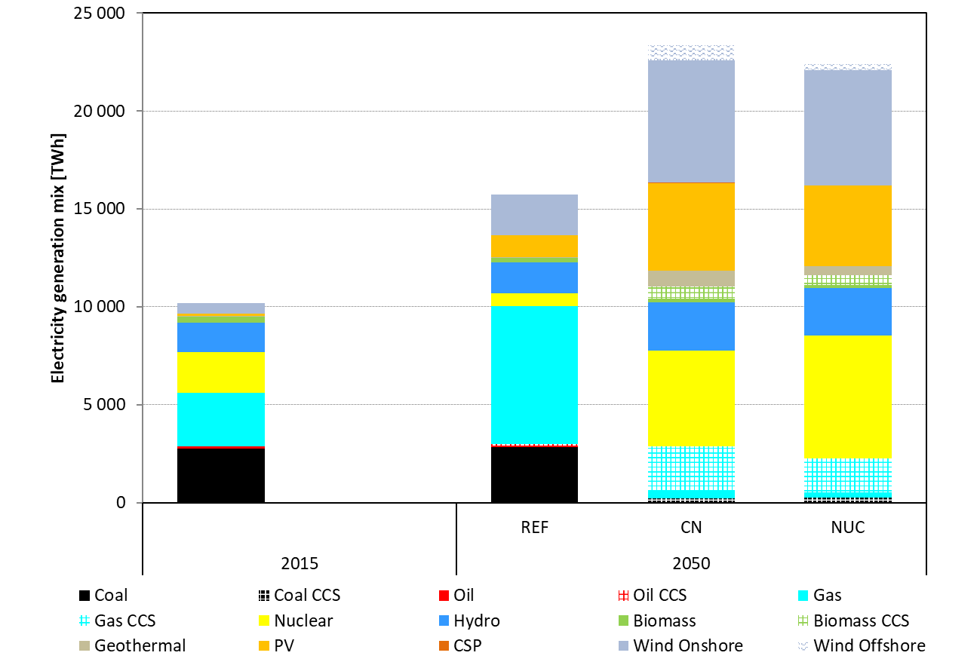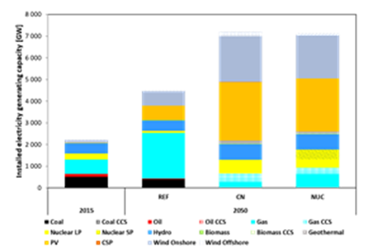  
Figure 15 - UNECE Electricity Generation (TWh) at 2015-levels, Business-as-Usual Scenario, Carbon Neutrality Scenario, and Nuclear Priority Scenario in 2050  
Figure 16 – UNECE Installed Electricity generation Capacity [GW] at 2015-levels, Business-as-Usual Scenario, Carbon Neutrality Scenario, and Nuclear Priority Scenario in 2050

## Is Carbon Capture, Use and Storage realistic?

**Carbon capture, use and storage (CCUS) technology is essential to mitigate climate change.** The costs of CCS are equivalent to about a doubling of the oil price which still keeps the cost of fossil fuels below their historic peak. CCUS has the potential to establish a pathway to carbon neutrality and meet emission targets at the same time mitigating the social and economic downsides of a rapid phase out of fossil fuels. It is also essential for energy intensive industries that are late to decarbonise or cannot decarbonise.

**In a CCUS Priority scenario, carbon capture technologies are installed at point sources such as polluting factories**. There is also further development of Biomass Energy with Carbon Capture and Storage (BECCS) and Direct Air Carbon Capture and Storage (DACCS).

**CCUS at point sources does not capture all the emissions**. Increasing the proportion captured CO2 increases both capital and operational costs.So, attaining full carbon neutrality means that all fossil fuel plants with CCUS installed need to be matched with some negative emissions capacity such as BECCS or Direct Air Capture.

In the Carbon Neutrality Case (Figure 6), CCUS plays an important, but declining role. In this CCUS Priority scenario, natural gas usage remains constant while oil and coal decrease, but not to the low levels seen in other carbon neutrality scenarios (figure 17).

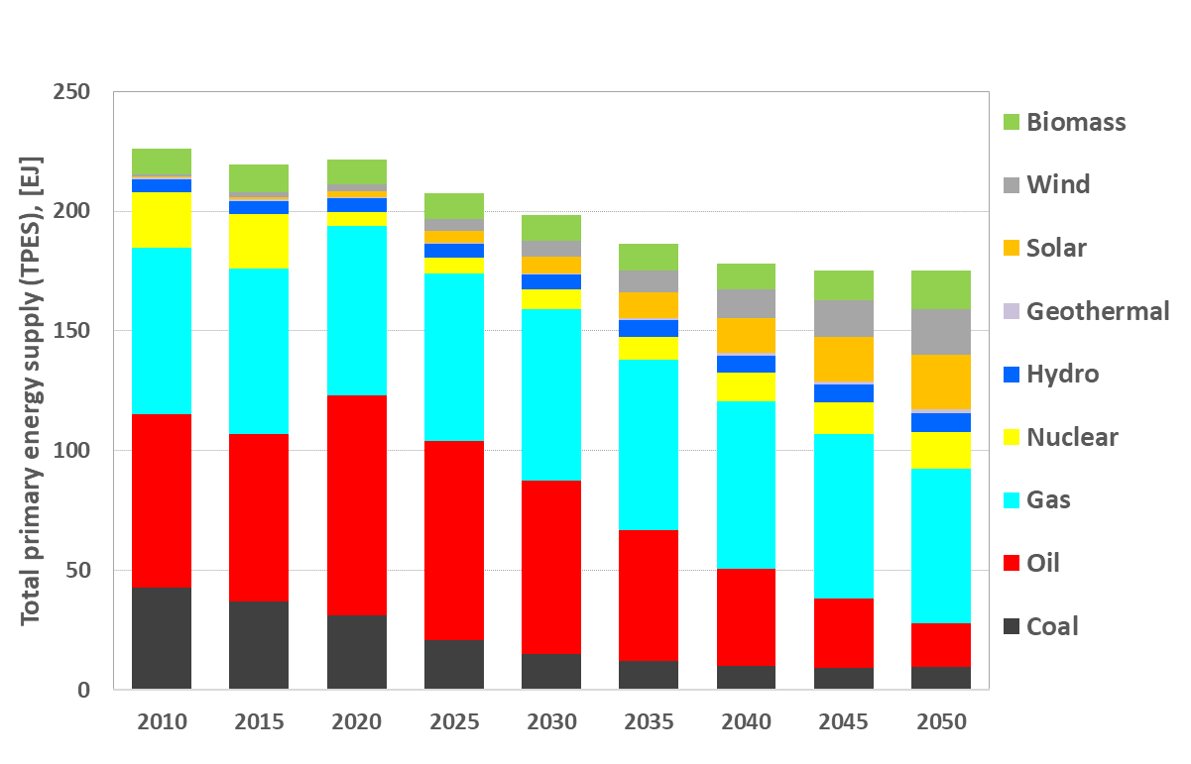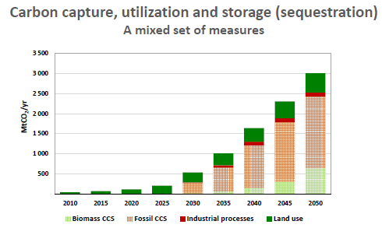

Figure 17 - UNECE ‘CCUS Priority’ Scenario: Total primary energy supply (TPES), [EJ]  
Figure 18 - UNECE CCUS in Carbon Neutrality Scenario

## Is a Hydrogen-led economy feasible?

**Hydrogen can be used as a backbone to modern society**. In a Hydrogen Priority scenario, hydrogen is assumed to be used across a range of sectors, such as transport, industry, power generation and heat for buildings.

**A massive increase of sustainable hydrogen electrolysers** connected to the electricity grid and low carbon electricity stations are needed to supply the increased demand. Therefore, nuclear, biomass, wind and solar power all see a notable increase for electricity supply. Perhaps surprisingly, hydrogen from fossil fuels with CCS also play a significant role and the region will depend on hydrogen imports by 2050. This scenario also highlights a need for the development of small modular nuclear reactors.

**Existing natural gas infrastructure will be repurposed** to integrate hydrogen produced through electrolysis form renewable electrical power as well as hydrogen produced through natural gas into the energy system.

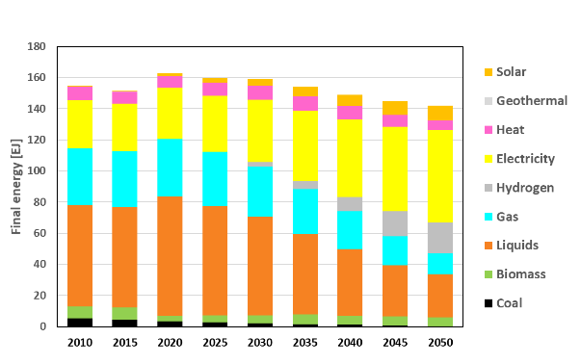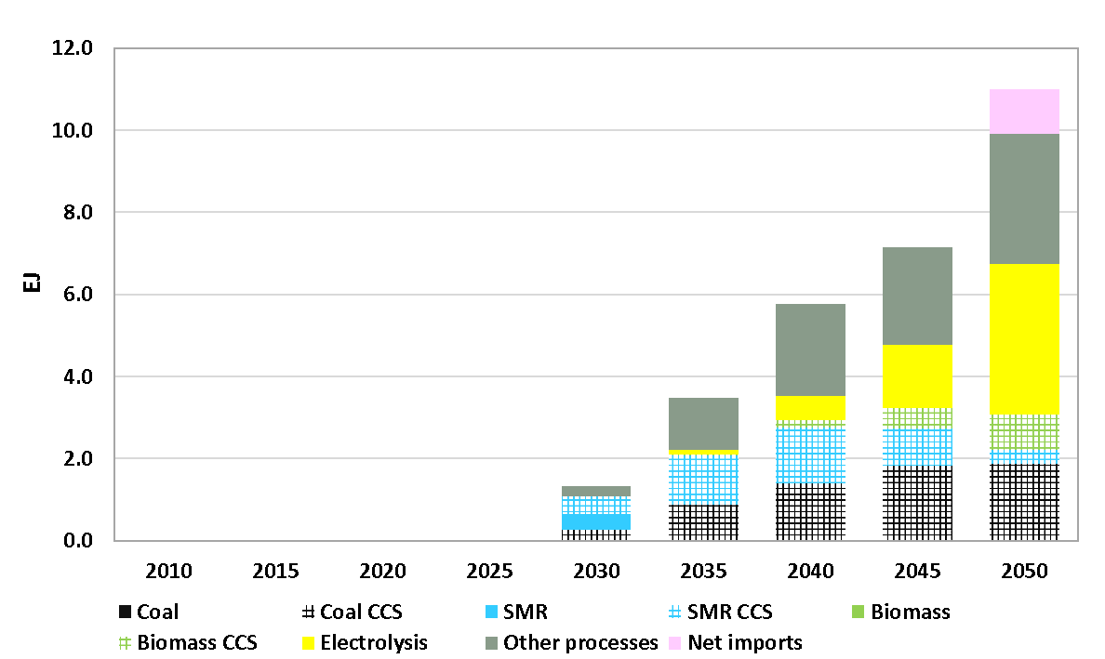

Figure 19 - UNECE 'Hydrogen Priority' Scenario: Final energy supply, [EJ]  
Figure 20 - UNECE Hydrogen production Carbon Neutrality Scenario [EJ]

**There is a need to develop new electrolysis technology that is better suited to very large-scale operations**. Using electrolysis to absorb intermittency of generation requires expensive investment into surplus electrolysers and addresses only half of the equation; the other half is variability of demand. Therefore, it may be more cost-effective to use large-scale storage both to match generation and demand and to deliver near-baseload electricity to electrolysers.

**Every UNECE region has plentiful geology well suited to the large-scale storage of both hydrogen and air for Compressed Air Energy Storage.** This can provide the capacity to help smooth fluctuations in energy demand.

## Energy Efficiency and electrification

**Energy efficiency and electrification are vital in all future carbon neutrality scenarios**. Energy supply and usage is required to decrease in all scenarios as a result of expected societal behavioural changes and improvements in energy efficiencies. Electrification through renewable is a key to increase energy efficiency at energy end use.

## How can Methane management be scaled up?

Although most documents and debates focus on CO2 emissions, that is usually shorthand for “CO2 equivalent” emissions: there are many other greenhouse gases, though they have a lesser role than carbon dioxide. The most important of these is methane, which affects global warming about 84 times as much as CO2, though it remains in the atmosphere for “only” a decade or so, compared with CO2 remaining for 300-1,000 years. The net effect of methane emissions over 100 years is 28 times an equivalent volume of CO2. Therefore, not only does it have an important role to play in itself, but also addressing methane emissions will benefit the climate much more quickly than addressing CO2.

Because methane has substantial value in itself, most emissions abatement technologies (e.g. capturing gas that is currently flared off; fixing seals in extraction wells, pipelines, storage and processing plant; improving combustion efficiency; capturing chimney emissions) are revenue positive or neutral, enabling some of the best cost/benefit ratios in the energy transition.

## Summary of deep dives

In all scenarios, the total final energy supply decreases due to a rapid transition from fossil fuels to low- and zero-carbon technologies. Traditional fossil fuel use will decrease as technologies such as solar and wind, nuclear power, hydrogen and CCUS make progress alongside substantial reductions in energy demand through energy efficiency and increase in electricity capacity.

There are very large variation in the demand fossil fuels depending on the policy choices made. The region becomes an net energy importer. A policy emphasis on CCUS drastically increases the demand for fossil fuels and reduces energy imports. An emphasis on hydrogen limits the decline in coal demand.

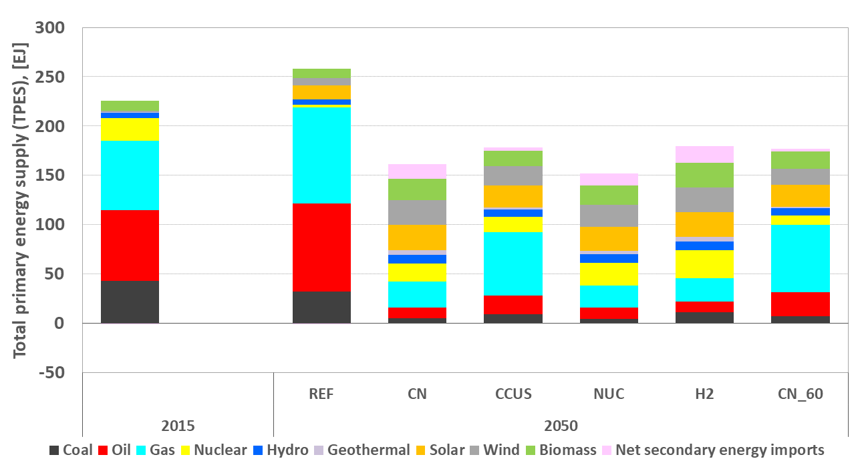

Figure 21 - Comparison across scenarios: Total primary energy supply (TPES), [EJ]  
2015 is benchmark scenario. REF is Reference Scenario. CN is Carbon Neutrality Scenario. CCUS, is Carbon Capture Priority Scenario. NUC is Nuclear Priority Scenario. H2 is Hydrogen Priority Scenario. CN 60 scenario is Carbon Neutrality by 2060 Scenario.

# Action starts now

**Action Starts Now** to make the required changes. Despite everything we know about the current state of our planet, national commitments made to date to address climate change are insufficient to keep global warming well below a 2°C increase above pre-industrial temperatures. Inaction is not a viable option.

**Technology interplay** is essential to achieving Carbon neutrality.

In order to reach net-zero carbon dioxide emissions, structural change will be required in the energy system and beyond. There is a gap between commitments and action, and time has run out to commence the structural change needed. The greater the delay, the greater the cost and disruption will become.

**All technologies** will be needed to achieve net-zero carbon dioxide emissions.

Government and industry are being encouraged to rethink energy in terms of securing affordable access to modern, sustainable energy services for all. Different countries will support different technologies in different ways according to political priorities and national circumstances. There is need for a policy and technology parity across low- and zero-carbon technologies. Energy demand as well as energy production should not go unnoticed. Improvements to energy efficiency and productivity have the potential to deliver quality of life with a lower environmental footprint. There is a need to modernise energy policy and technical infrastructure throughout global supply chains to enable integration of clean energy solutions and ensure that all new infrastructure investments are Net Zero compatible. Furthermore, development of natural and engineered carbon sink capacity, such as soil, forests and oceans and industrial CCUS needs to start now to be commonplace in the decades to come.

There is a focus, in most countries in the UNECE region, on the easier-to-decarbonise sectors which achieve the greatest benefits at the least cost. While this is excellent, the harder-to-decarbonise sectors (e.g. aviation, shipping, energy-intensive and/or highly emitting industries including mining, refining, steel, cement, chemicals, petrochemicals) need to be addressed much more urgently, or there will be insufficient time to implement the changes needed, which will also greatly increase the cost and disruption of doing so.

**Cross-border cooperation and dialogue** is critical to enhance inclusive multi-stakeholder initiatives.

Countries will not be able to embark on this journey in isolation. There will be need for sub-regional and regional coordination and cooperation to deliver common objectives more than ever before. Recent developments in energy markets worldwide have shown us that energy security and affordability remain the priorities. Prices for energy are spiking worldwide. These spikes are a consequence of a global economic recovery after COVID, high reliance on renewable energy capacity which under-performed, the lack of technology to store grid level amounts of electricity and a shortage of fossil fuel generating capacity. Increasing carbon prices across Europe and globally add additional pressure. If “Keeping the lights on” remains number one priority, flexibility about fossil fuels remaining in the energy mix during a transition needs to be supported by policies. Therefore, industry and government need to work hand-in-hand to deliver affordable access to modern, sustainable energy.

**More work is needed** for the structural change required.

The data supplied through modelling must be analysed further with more indicators complementing comprehensive policy approaches for decisionmakers. Careful approaches towards new projects will have severe ramifications on material use as well as rare materials including rare earth, cobalt and nickel for energy infrastructure and storage. Regulatory and contracting systems must also change to become less reliant on subsidies and other government interventions.

Furthermore, structural change will also have implications on people. The phasing out of fossil fuel plants will impact communities and carry a cost. Although the green transition has the potential to create prosperity for all, this will be need to managed carefully. Natural and human-made carbon sinks will put pressure our changing environmental landscape. These implications will require more investigation into sustainable approaches in the sub-regions of the ECE.

**Market mechanisms can redirect investment** to the modernisation and transformation of the energy system.

International cooperation from governments and industry alike is a critical to attaining carbon neutrality. While this project focuses on technologies, it is important to highlight that these technological changes will also need to be supported by new governance structures, laws, policies, investment, business models and societal changes.

The costs of many low carbon technologies are decreasing more than anticipated and with further research and development costs could decline further. Therefore, although carbon neutrality costs modelled are expected to be a 50% increase of a business as usual scenario, costs estimated in the project may be at the upper end of what is actually plays out. Overall, the costs of inaction from the effects of climate change will be far greater than the mitigation costs required.

**Mass cross-sectoral action starts now** to achieve long-term objectives.

More targeted action will be required to incentivise the private sector, regulators and governments to enable financing and development of needed infrastructure and resources. Restructure energy market frameworks and transform financial system to low-carbon economy. Investment required to attain carbon neutrality are significantly less than the economic, social, and human cost of climate catastrophe.

In order to reduce the financial burden of the transitions and to avoid stranding assets, using existing energy infrastructure including industry, transport and buildings will be essential to reach carbon neutrality.

**International cooperation is essential to support all countries in the UNECE region to build resilience of the energy system and to accelerate energy transition towards attaining carbon neutrality.** Different countries and sub-regions require different solutions based on their socio-economic and political circumstances as well as access to natural resources. UNECE continues to offer a neutral platform for inclusive and transparent dialogue, exchanges of best practices and lessons learned, and development of consensus on effective approaches to achieving carbon neutrality.

## The short-term towards 2025: Getting started

**Immediate** actions are:

* Improve energy efficiency and energy productivity in buildings and in industry
* Develop stronger methane management
* Implement a global framework for sustainable resource management in line with the 2030 Agenda for Sustainable Development
* Place a real price on greenhouse gases
* Re-design energy markets and encourage market intervention to invest and support new technologies such as hydrogen and carbon capture, use and storage to intensify efforts to improve social, technical and commercial readiness levels.
* Conduct life cycle analysis of all technology to understand potential environmental, economic, and social implications of the array of low- and zero-carbon technologies and the contribution these technologies can make to global sustainable development.
* Assess the impact of carbon neutrality on energy intensive industries. These deserve special attention as their integration into the energy system and large carbon footprints make their transformation towards a carbon neutral form of production challenging. Requirements for un-interruptible baseload electricity and high temperature process heat need special consideration.
* Research into new energy technologies is needed across all energy sectors to build and modernize energy systems of the future into a circular economy.
* Create long-duration contracts for new-build plants, major refurbishments and retro-fits with suitable lead times between contract award and delivery
* Lay the groundwork for the expected 30-year investment boom to double energy investment as compared to a business as usual scenario and effects of re-allocation of resources in the economy

## The medium-term towards 2030/2035: Setting the stage

**Medium**-term actions are:

* Decarbonize transport through demand, fuels and design
* Adapt the built environment to deliver superior outcomes in urban design and building retrofits
* Institute policies on a ‘just transition’ to include standards for closure of outdated energy infrastructure to ensure full societal and political support for change
* Embrace the concept of a circular carbon economy. Reducing, reusing, recycling and removing greenhouse gases (notably CO2 and methane) will drive structural shifts throughout the value chain and enable a systemic approach to industrial clusters across the region.
* Develop and deploy agnostic, rational, and pragmatic policy parity frameworks for technology based on the life cycle assessments. Many developing technologies need supportive regulatory frameworks to enable rapid commercialisation. Policymakers need to develop and integrate polices that would support faster technology deployment.
* Carefully manage the energy transition in order to control grid stability, hard to decarbonise sectors and wider effects on non-energy sectors and private consumption.
* Encourage introduction of new technologies onto the grid with early commitment to contracts
* Create regulatory definition of storage as a grid service without access charges to be on similar level to interconnectors and substations
* Develop regulatory and contractual enabling and incentives for electricity generation to benefit from delivering on-demand energy
* organise institutions towards rapid decision making, adaptability and flexibility by keeping a portfolio of energy options

## The long-term towards 2050: Transforming stringently

**Long**-term actions are:

* Prepare a hydrogen economy by repurposing and retrofitting existing gas infrastructure
* Ensure safe and acceptable deployment of nuclear
* Develop efficient and cost-effective durable energy storage technologies for hard-to-reach areas alongside variable energy sources
* Reinvent energy as a service industry to support robust policy and regulatory frameworks needed for zero- and low-carbon technologies such as CCUS, hydrogen and nuclear
* Prepare for the infrastructure required to rapidly decarbonise the ECE region by changing primary energy and social behaviours like never before.
* Construct electrical grids which span large areas, time zones and latitudes to average out local weather and sunlight patterns, which have adequate non-renewable but low carbon energy sources.
* Prepare the electrical market, so that in the event of a shortage blackouts have the least impact
* Develop technologies or demand management and grid scale energy storage
* Share grid transmission costs investment benefits with international cross-border projects
* Deepen international cooperation between member states on system design, energy and carbon trading

**Whole System Thinking and international cooperation across sectors** will be needed to attain carbon neutrality. Uniting the energy system, from generation to consumer, technology interplay will enable all parts of the energy system to thrive. (Clusters of Industry – see energy intensive industries brief) By redirecting investment from hydrocarbon-based industry to low and zero carbon alternatives, key goals such as decarbonising energy intensive industries and developing electrolysis technologies can be achieved.

The modern and sustainable energy system of the future will require a whole system thinking approach. International cooperation across sectors will be needed to attain carbon neutrality. Uniting the energy system, from generation to consumer, technology interplay will enable all parts of the energy system to thrive.

Technology interplay will require connecting the building blocks of a well-rounded energy system. Harmonised policies across market, digital and physical systems have the potential to ensure access to affordable, reliable, sustainable and modern energy for all.

## Carbon Neutrality by 2050: Regional Readiness Level

Regions across UNECE have taken varied policy approaches to attain carbon neutrality. Existing policies of sub-regions has been analysed to form a regional readiness level to achieve net-zero. This work can help identify which regions need most support in developing feasible carbon neutrality policies and objectives.

The regional readiness level takes into account:

* **Awareness** of Carbon Neutrality -> To what extent are carbon neutrality targets incorporated into national strategies and roadmaps?
* **Access** to technologies and technical know-how -> Does the country have access to technologies that are necessary to reach net-zero?
* **Application** of policy and regulatory frameworks to attain carbon neutrality -> Is the regulatory framework in place to support the deployment and commercialization of technologies necessary to attain carbon neutrality?
* **Ability** to acquire investments -> Does a country have financial mechanisms in place or access to foreign investments to support transition to carbon neutrality?
* **Action** in international energy cooperation -> To what degree is a country involved into sub-regional cooperation or projects of common interest to attain carbon neutrality?

**UNECE-wide:** A rapid transition from fossil fuels to low- and zero-carbon technologies is vital to achieving net-zero emissions. Traditional fossil fuels are set to decrease while new technologies such as hydrogen and CCUS make progress.

**Belarus, Moldova and Ukraine**: 2/5 A just transition towards deployment of low- and zero-carbon technologies such as nuclear, offshore wind and CCUS technologies is vital to achieving net-zero emissions.

**Central Asia**: 2/5 A massive switch from traditional fossil fuel extraction to carbon capture use and storage will provide adequate time to scale up deployment of wind, solar and hydro power plants.

*Walker Darke, UNECE Consultant in Sustainable Energy*In Central Asia, integrating solar and wind energy into power systems will be crucial to attaining the United Nations Sustainable Development Goals. In Kazakhstan, substantial progress has been made in facilitating market involvement through government auctions allowing private enterprises to bid for renewable energy systems. By centralising tender processes and harmonising supporting documentation, there has been increased national and international interest in auctions with interest from over 130 companies and counting.

Although there is more work to do in accelerating the installation of solar and wind in Kazakhstan, there are many good practices that policy makers can learn from. Policymakers in the region have harnessed international experience to harmonize national and international energy standards and subsequently strengthened market conditions for the modernization of renewable energy systems. In addition, developing legislative measures to support integration of variable renewable energy into power systems and establishing a guide for potential investors on renewable energy systems has increased renewable energy generating capacity in Kazakhstan by over 1700% since 2011.

This policy initiative has been supported by the United Nations in several ways. Kazakhstan’s Ministry of Energy has implemented UNECE recommendations on accelerating transboundary energy cooperation and creating power distribution schemes and environmental impact assessments in cooperation with the United Nations Development Program (UNDP).

**Central and Eastern Europe:** 4/5A swift modernisation of fossil fuel plants with carbon capture while expanding sustainable energy production through nuclear, biomass, wind and solar energy will put the region on course for carbon neutrality.

*Ingunn Svegården, Senior Vice President Renewables, Emerging Regions, Equinor*   
By 2030, wind energy is, according to the European Commission, set to become the electricity source with the highest share of power generation. Gross electricity generation from wind will need to more than triple by 2030. Between 2030 and 2050 a further 67% increase is needed.

Central and Eastern Europe represents around 25% of the EU-27 geographic area and can benefit greatly from these developments. All the same, their National Energy and Climate Plans are, apart from Poland, quite mute in terms of ambition levels and policy measures targeting the sector.

Well integrated into the world’s largest integrated energy market the region can with the right national and regional policy frameworks attract global investors looking for opportunities and government commitment. Important drivers of future scale will be:

* Improve access to new quality acreage.
* Design of targeted funding mechanism to industrialise floating offshore wind.
* Enhancement of grid capacity, cross-country and between onshore and offshore grids.
* Design solid regulatory frameworks for hybrid projects, where projects can attract support of multiple countries.
* Strengthen international cooperation to secure resources and experience transfer for unleashing the full potential of wind energy on the way to net-zero

*David Hess, Policy Analyst, World Nuclear Association*Nuclear energy is already well-established in Central and Eastern European countries and is set to grow even as some Western European countries move to reduce or phase out their fleets. Bulgaria, Czech Republic, Hungary, Romania, Slovak Republic and Slovenia already operate nuclear power plants and are committed to new units while Poland has confirmed its intentions as a nuclear newcomer nation with firm plans for large reactors and is exploring small modular reactors (SMRs). Estonia is also proactively assessing SMRs and may soon join Poland as a nuclear newcomer. Lithuania used to operate a nuclear power plant but this closed this in 2009 for political reasons.

The Czech Republic has the most advanced plans for new nuclear in the region. The Czech Republic currently has six nuclear reactors which generate about one-third of its electricity. The 2019 National Energy and Climate Plan of the Czech Republic emphasise the role of nuclear power to meet decarbonisation targets with stated gross electricity generation from nuclear power would increase from 29% (2016) to target level of 46–58 % by 2040. Ministry of Trade and Industry long-term plan for the nuclear industry involve 4 possible new reactors units at Dukovany and Temelin sites. Earlier in March 2020, CEZ announced that it had submitted a licence application for two new reactors up to 1200 MWe each at Dukovany site. In May 2021 the nuclear research institute, announced its project to design by 2035 a high-temperature gas-cooled reactor (HTR) aimed at the heating, cogeneration and industrial sectors.

The Czech government has taken a very pragmatic approach to financing in order to reduce and control the costs of the new nuclear units. It had agreed to a state loan covering 70% of the costs of building the new reactor. The loan would initially be interest free, followed by a rate of 2% once the plant begins operation. In July 2020 the Czech cabinet approved a proposed new law which would allow the government and CEZ to agree a minimum 30-year power purchase agreement (PPA) for Dukovany 5. The price should allow CEZ to recoup the investment cost and make a profit. The state would sell the electricity into the wholesale market.

**North America**: 4/5 Scaling up a variety of new and existing technologies has the potential to diversify energy sources for a future sustainable and secure energy supply.

*Beth Hardy, Vice President, Strategy & Stakeholder Relations at the International CCS Knowledge Centre*  
Canada is home to the world’s first large scale post-combustion CCS facility and plans to expand CCS into industrial cement plants. Cement manufacturing currently represents 7% of global emissions and industrial processes must be captured to lower emissions. IEA advises the use of alternative fuels in cement production must more than double by 2030.

By implementing CCUS, we have learnt that CCUS is a complex technology: It is not a ready-made solution like a solar panel or a wind turbine. CCUS facilities require strong feasibility studies to maximise sustainable resource management, site limitations and cost effectiveness. It is important for policymakers to share knowledge across international borders to speed up installation of facilities for a real impact on the sustainable development goals and the 2030 agenda.

**Russian Federation**: 2/5 Natural gas will continue to dominate energy mix. Nuclear can play a vital role in attaining carbon neutrality for the region alongside other sustainable technologies including wind and hydropower. Fossil fuels are required to be fitted with carbon capture and storage.

*Maxim Titov, Executive Director at the ENERPO Research Center, European University at Saint-Petersburg*Current Russian energy and climate policy is a result of compromise. It must remain attractive for global investors while monetizing the country's oil and gas reserves despite the decarbonization trend. However, it must also keep its social obligations for a reliable and affordable domestic energy supply.

The Ministry of Economic Development has developed four scenarios for their low-carbon strategy. The baseline scenario will reduce total greenhouse gas emissions to 1.194 billion tons of CO2-equivalent versus net emissions of 1.585 billion in 2019.

This scenario will cost the country 1.5% of GDP, and Russia does not aim to become carbon-neutral until 2050. However, the baseline scenario declares lower values of the accumulated greenhouse gas emissions in comparison with the EU until 2050.

The more intensive scenario promises to achieve carbon neutrality by 2060 and will cost about 4% of GDP, but the most aggressive scenario will achieve it by 2050. Both the intensive and aggressive scenarios require large-scale investments in decarbonizing the Russian economy.

Achieving these targets will also require recognition of GHG absorption for Russian forests that don’t currently exist, and the use of this mechanism in calculations has been met with criticism.

Additionally, Russia’s energy leaders including gas and oil executives and the Deputy Prime Minister have expressed a commitment to the development hydrogen and CCUS. While specific details are scarce and only in the memorandum of understanding stages, it demonstrates a vision of entering the emerging hydrogen market while also achieving its decarbonization targets.

**South Caucasus**: 2/5 Fossil fuels continue to play a role in the region with nuclear, renewables and energy efficiencies contributing to carbon neutrality goals.

**Western Balkans**: 2/5 Hydro, wind and nuclear should become the three key energy sources in the region as coal, oil and gas fitted with carbon capture technologies will be continue to be part of the energy system.

**Western Europe**: 5/5 Intensifying Wind, Solar and Biomass production are vital aspects of wholesale changes needed across national lines to support climate neutrality targets. As the world’s hub of innovative research in sustainable energy, Western Europe will become a climate role model for others to follow.

*Ulrik Stridbæk, Vice President of Ørsted*  
Europe will need to take an “all the above” strategy, massively expanding onshore wind, solar PV, offshore wind and grids. Offshore wind will have to be built out at a pace where we annually add the same quantity as we have added to date. The most pressing problem to solve is to find the space at sea. Policymakers will at the same time have to incentivise electrification, both direct and indirect through hydrogen.

*Helen Whately MP, Exchequer Secretary to the Treasury of the UK Government*   
Investing in new hydrogen industries could support thousands of new green jobs by 2030 and bring new economic opportunities to places like Humberside, Teesside, the North West and Scotland, helping to level up across all corners of the country. It follows the Chancellor’s commitment to a £240 million Net Zero Hydrogen Fund and a £1bn CCS infrastructure fund at the Spending Review 2020, to kick-start low carbon hydrogen production in the UK.    
   
It is fantastic to see how these world-leading projects can support the shared UN Sustainable Development Goals towards a clean, resilient, and sustainable economic recovery from COVID-19. The UK is working alongside international experts in sustainable energy technologies from countries including Norway and the Netherlands to improve regional cooperation and harmonise international standards.

# Annex

**Modelling Scenarios**

The modelling highlighted potential scenarios that are relevant to policymakers. These scenarios have been used across the analysis to form comprehensive findings and policy recommendations.

**Business as Usual scenario**: No major changes are enacted, due to a lack of action in sustainable energy and climate policies.

**UNECE Carbon Neutrality scenario**: Carbon neutrality is a universal target for nations of the United Nations Economic Commission for Europe as part of a collective energy system.

**Sub-Regional Carbon Neutrality scenarios:** A personalized scenario for each sub-region of the UNECE. See map on page XX for list of sub-regions.

**Technology specific scenarios** have been modelled to explore under-developed technologies. These are:

**Carbon Capture, Usage, and Storage** **scenario** (CCUS): Prioritises carbon capture and storage and direct air capture technologies. It applies four different technology configurations, taking into account current air capture designs with a flexible electricity demand, contribution to power balancing and reduction of renewable energy curtailment. The scenario also recognises the widely-agreed regional CO2 storage potentials.

**Nuclear energy scenario:** Prioritises Small Modular Reactors (SMR) to support flexible operations, provide low-temperature district heat in cogeneration, produce high temperature process heat in industry and support other processes such as hydrogen production. This scenario includes more pessimist assumptions for the potential of Direct Air Capture (25% of the CCUS scenario) and assumes the cost is equal to large reactors per unit of capacity ($/kW).

The **Hydrogen scenario**: Prioritises hydrogen production, synthesis and end uses in transport, industry and residential settings. The scenario includes an enhanced representation of hydrogen synthesis and conversion processes such as hydrogen to methane and hydrogen to liquids, and high-temperature electrolyzes combined with other technologies such as Nuclear.

**What the modelling tells us**

Modelling enables a transparency of assumptions to explore different futures with communication & stakeholder involvement. By testing hypotheses, policies & sensitivities, it helps explore different futures and insights.

By using modelling results to identify technology interplay, we have highlighted solutions towards a sub-regional approach to carbon neutrality. Modelling can inform policy makers on the implications of proposed domestic or international policies. However, models cannot independently determine the ‘best’ option.

However, it does not tell us the national constraints, social behaviours and other indirect consequences of redesigning the energy system. For example, there are building restrictions in national parks and personal finance constraints on sustainable energy such as purchasing electric and fuel cell cars. On a technical level, transforming the energy system will have major grid stability implications, require serious energy efficiency investments and the conducting of feasibility studies of technology interplay.

**How the modelling works**

Carbon neutrality from a modeler’s perspective is techno-economically feasible based on numerous and highly uncertain assumptions. The examples in this document are only a few of the many carbon neutrality scenarios that can be analyzed. More research needs to be done on the economic prospects that carbon neutrality has on society. Energy demand and lifestyle changes as well as associated infrastructure transformation remain key challenges.

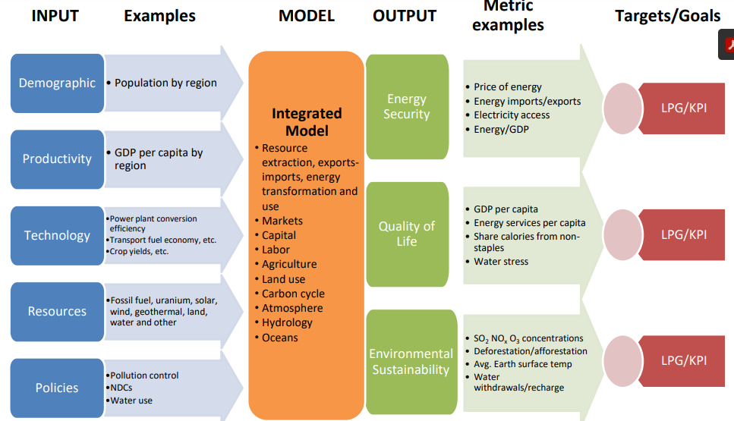

1. Note: Historical emissions of GHG from the ECE region compared to those of other regions are not taken into account. Note the recent IPPC statements on the increased understanding of ‘Tipping Points’ which may question this assumption.
2. The United Nations Sustainable Development Goals have been universally agreed to ensure access to affordable, reliable, sustainable and modern energy. Sustainable Development Goal (SDG) 7 ensures access to affordable, reliable and sustainable energy for all. This requires fundamental transformation of the energy system using the best available modern technologies.
3. Riahi K. et al (2017): The Shared Socioeconomic Pathways and their energy, land use, and greenhouse gas emissions implications: An overview. In: Global Environmental Change 42 (2017) 153–168
4. Carbon neutrality will need major changes to the way economies work. Any rapid introduction of change requires coordination of technology development, commercialization and the social acceptance. 'Readiness Levels' are a commonly used indicator of describing what needs to be addressed during the introduction of a change. See: Technology Brief: Carbon Capture Use and Storage, UNECE, 2021.
5. Net Zero Carbon Cities: An Integrated Approach, World Economic Forum (2021)
6. IPCC, 2021: Summary for Policymakers. In: Climate Change 2021: The Physical Science Basis. Contribution of

   Working Group I to the Sixth Assessment Report of the Intergovernmental Panel on Climate Change