|  |  |  |  |
| --- | --- | --- | --- |
|  | United Nations | ECE/TRANS/WP.29/GRVA/2021/29 | |
| Description: _unlogo | **Economic and Social Council** | | Distr.: General  12 July 2021  Original: English |

**Economic Commission for Europe**

Inland Transport Committee

**World Forum for Harmonization of Vehicle Regulations**

**Working Party on Automated/Autonomous and Connected Vehicles**

**Eleventh session**

Geneva, 27 September – 1 October 2021

Item 10 of the provisional agenda

**UN Regulation No. 90**

Proposal for amendments to UN Regulation No. 90 (Replacement brake parts)

Submitted by the expert from Italy[[1]](#footnote-2)\*

This proposal was prepared by the expert from Italy. It is submitted for review at the eleventh session of the Working Party on Automated/Autonomous and Connected Vehicles (GRVA) in September 2021. The modifications of the existing Regulation are marked in bold for new or strikethrough for deleted characters.

I. Proposal

*Annex 7a*

*Paragraph 1.,* amend to read:

“1. Grouping criteria

The grouping is made according to the following approach:

(a) According to the individual friction material of the brake lining;

(b) Depending on the area of the friction material area of the brake lining assembly operated by the piston/pistons of only one side of the brake caliper **or, in case of drum brakes, of only one brake shoe.**

Friction material area means all the area enclosed within the perimeter of the brake lining (see the red cross-hatched area, Figure 1**, Figure 2**), thus excluding the presence of any grooves and/or chamfers:

Figure 1

**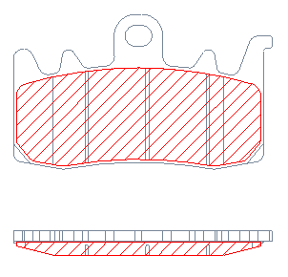**

**Figure 2**

**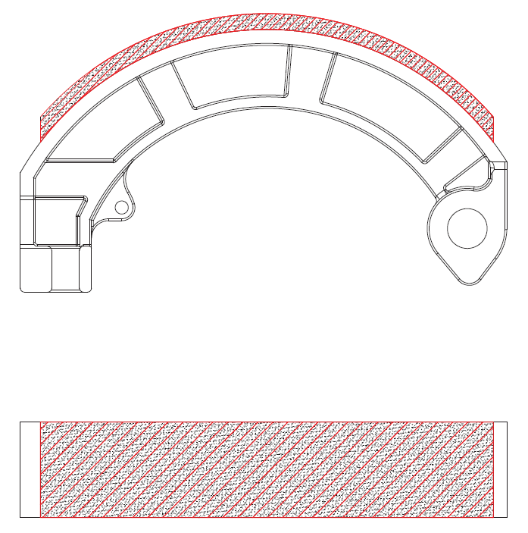**

Three area groups are foreseen, as in Table 1:

Table 1

|  |  |
| --- | --- |
| *Group* | *Brake lining area [cm2]* |
| A | ≤15 |
| B | > 15 ≤ 22 |
| C | > 22 |

*“*

*Paragraph 2.,* amend to read:

“2. Procedure for selection of the brake lining assembly representative of the group to be approved

The brake lining assembly to be approved is defined, according to the following criteria:

(a) Choice of friction material to be approved;

(b) Verification of the applications where the chosen friction material is applied;

(c) Definition of the area of the selected brake lining assemblies according to Table 1, and classification into groups A – B – C;

(d) For each group, selection of the most severe application, according to the highest value of the index Ep (kinetic energy by brake lining area), as follows:

Ep = ½\*M\*p\*(V\*c)2 / (S\*qp)

where:

Ep = kinetic energy index [kJ/cm2]

M = gross vehicle weight of the vehicle [kg]

p = allocation percentage of the vehicle weight:

(a) for front braking system:

(i) 75 per cent in case of 1 brake disc

(ii) 37.5 per cent in case of 2 brake discs

(b) for rear braking system:

(i) 50 per cent

V = vehicle maximum speed [m/s]

c = correction coefficient of speed:

(a) for front braking system = 0.8

(b) for rear braking system: variable according to the brake disc**, or drum,** diameter:

(i) 0.5 for Ø ≤ 245 [mm]

(ii) 0.6 per Ø > 245 < 280 [mm]

(iii) 0.75 per Ø ≥ 280 [mm]

S = brake lining area as defined in Table 1 [cm2].

qp = number of pads in 1 caliper **or number of active brake shoes of the relevant axle.**

II. Justification

1. Information have been found to be missing while implementing UN Regulation   
No. 90.

2. Despite of its purpose, which is to specify the grouping criteria of the brake lining assemblies for vehicles of Category L, Annex 7a does not provide explicit directions for the grouping of brake shoes.

3. Paragraph 2.2.3. defines *"Brake lining assembly"* as a component of a friction brake which is pressed against a drum or disc, respectively, to produce the friction force and a “*brake shoes assembly”* as a type of brake lining assembly. Therefore, it is necessary to provide clear instructions about grouping criteria for brake shoes (as already done for brake pads) to allow brake shoes manufacturers to proceed with the homologation accordingly to this Regulation.

4. This proposal is intended to clarify the regulation and its scope. It does not modify in any way its technical content.

1. \* In accordance with the programme of work of the Inland Transport Committee for 2021 as outlined in proposed programme budget for 2021 (A/75/6 (Sect.20), para 20.51), the World Forum will develop, harmonize and update UN Regulations in order to enhance the performance of vehicles. The present document is submitted in conformity with that mandate. [↑](#footnote-ref-2)