|  |  |  |  |
| --- | --- | --- | --- |
|  | United Nations | ECE/TRANS/WP.29/GRVA/2021/28 | |
| Description: _unlogo | **Economic and Social Council** | | Distr.: General  12 July 2021  Original: English |

**Economic Commission for Europe**

Inland Transport Committee

**World Forum for Harmonization of Vehicle Regulations**

**Working Party on Automated/Autonomous and Connected Vehicles**

**Eleventh session**

Geneva, 27 September – 1 October 2021

Item 10 of the provisional agenda

**UN Regulation No. 90**

Proposal for amendments to UN Regulation No. 90 (Replacement brake parts)

Submitted by the expert from Italy[[1]](#footnote-2)\*

This proposal was prepared by the expert from Italy and is submitted for review at the eleventh session of the Working Party on Automated/Autonomous and Connected Vehicles (GRVA) in September 2021. The modifications of the existing Regulation are marked in bold for new or strikethrough for deleted characters.

I. Proposal

*Annex 14,*

*Table A14/2.2.5,* amend to read:

|  |  |  |
| --- | --- | --- |
| *Disc Diameter*  *[mm]* | *Disc Thickness*  *[mm]* | *Tangential force F*  *[kN] min* |
| **≥ 150 < 250** | ≤ 3 | **≥ 8** |
| >3 ≤ 4 | **≥ 10** |
| > 4 | **≥ 12** |
| **≥ 250 < 350** | ≤ 4 | **≥ 8** |
| > 4 ≤ 5 | **≥ 11** |
| > 5 | **≥ 14** |

*Annex 15,*

*Insert a new paragraph 1.5.,* to read:

**“1.5. Definition of bell mounting face**

**“*Bell mounting face*” means the surface of a brake disc that goes in contact with wheel hub.**

**The mounting surface is calculated between the disc inner diameter T(i) and a diameter T(o) defined as the max diameter of area subjected to flatness restrictions as indicated on disc drawing (see figure 1).**

**In case of lacking of drawing indication, T(o) is defined as follows:**

**T(o) = T(k) + B + 10mm**

**Figure 1**

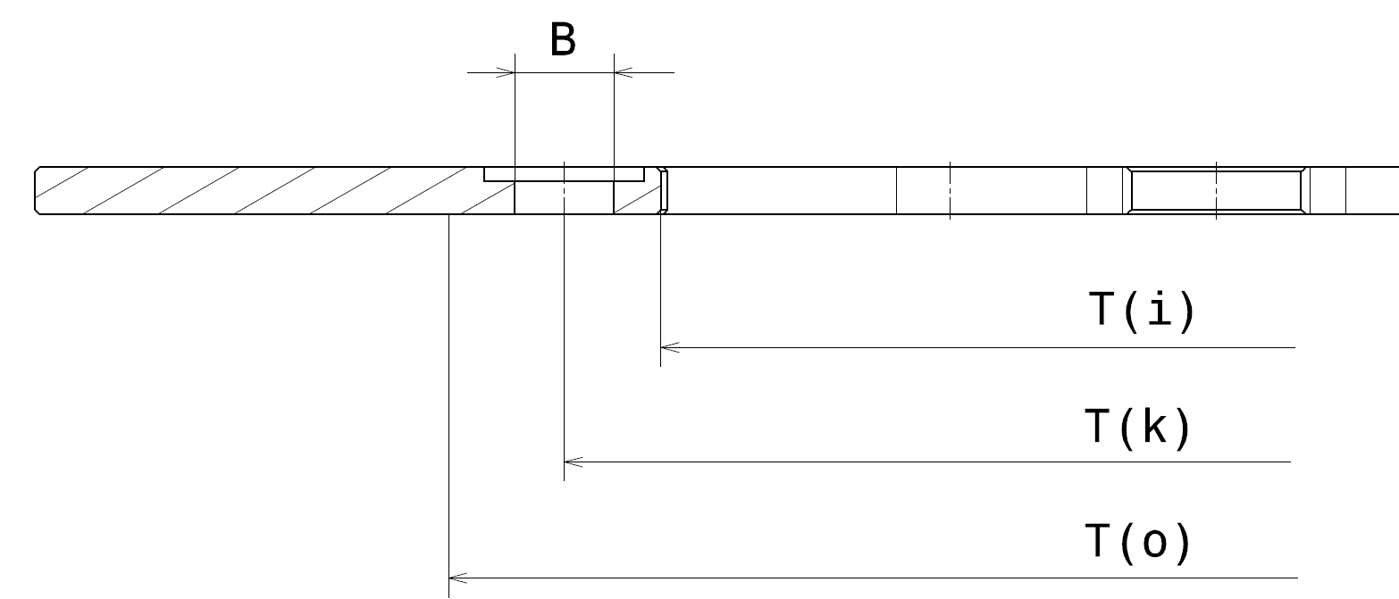

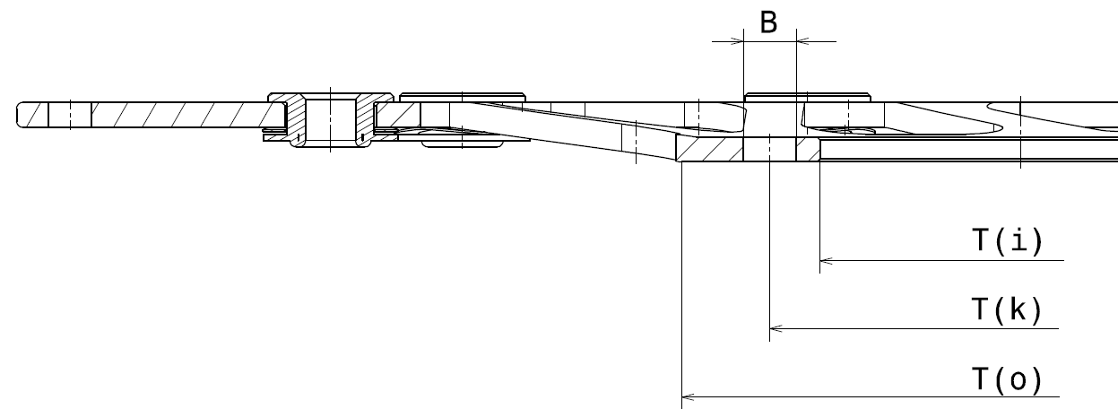”

*Insert a new paragraph 1.6.,* to read:

“1.6. Definition of reference disc

Within each discs group, the *reference disc* is the one which has the highest ratio of kinetic energy (considering all the replacement applications foreseen) and its mass, as described in paragraph 5.3.6.”

*Paragraph 2.3.,* amend to read:

“2.3. Braking surface lightening: any solution is allowed (holes, slots, wave, etc.) provided that **the ratio between the vehicle kinetic energy to the mass of the disc braking surface, must be same or higher than the reference disc (with tolerance of – 20 per cent maximum).**

**Example:**

**Outer diameter 300 mm,**

**radial width of the braking surface 36.5 mm ≥ total area A = 302 cm2**

**Lightening on the braking surface: 64 holes diameter 7 mm ≥ total area**

**B = 24.6 cm2**

**δ = Braking surface material specific weigh**

**Braking Surface Mass (BSM)= (A-B) \* Th \* δ**

**Vehicle kinetic energy K.E.= ½ m V2 (as defined in para. 5.3.6)**

**Braking Surface Lightening (BSL) 𝑟𝑎𝑡𝑖𝑜 = 𝐾.𝐸. / 𝐵SM**

*Paragraph 2.6.,* amend to read:

“2.6. Spokes of the bell with full/empty ratio – measured on the average circumference between end of the mounting face and ~~beginning of the braking surface~~ max **diameter of the bell** – ~~within the range ± 20 per cent~~ **same or higher than the reference disc (with a tolerance of -20% max)** , thickness **same or higher than the reference disc (with a tolerance of -15 per cent max)** ~~within the range (+ 30 per cent) ÷ (– 10 per cent)~~ and same mechanical properties, as specified in the international standard for materials, with respect to the reference disc.”

*Paragraph 2.9.,* amend to read:

2.9. Outer diameter included in the range of ~~50~~ **100** mm, according to Table 2.9.:

|  |  |  |  |
| --- | --- | --- | --- |
| *Range*  *[mm]* | *One piece* | *Composite fixed* | *Floating discs* |
| **≥ 150 < 250** | X | X | X |
| **≥ 250 < 350** | X | X | X |
| ~~≥ 250 < 300~~ | ~~X~~ | ~~X~~ | ~~X~~ |
| ~~≥ 300 < 350~~ | ~~X~~ | ~~X~~ | ~~X~~ |

“

II. Justification

1. Some important shortcomings were found, while implementing UN Regulation No. 90 (for the approval of replacement discs for motorcycles).

2. In particular, Annex 15, which defines criteria for the discs grouping, is complex to implemente: the contextual application of the nine criteria for the definition of disc groups generates a huge number of groups (some consisting of only a single disc).

3. This proposal, while maintaining the same nine criteria, also allows discs with a different geometry to be included in the same group as long as the disc itself is subject to lower thermal and mechanical stresses than the reference disc.

4. This proposal therefore aims at simplifying the definition of disk groups, reducing their number, while providing the same guarantees from a technical point of view.

5. Moreover, Annex 15 does not clearly define how to choose the reference disc for disc grouping and the current text does not clearly define how to select the reference disc.

6. The disc to be tested could be different from the reference disc used for disc group definition, provided that it is the one subject to “the highest braking torque and to the largest energy to be absorbed”.

7. The proposed modification clearly states that the reference disc used for disc group definition, shall be the one with the highest Kinetic Energy ratio, thinnest and more lightened bell and with the lowest number of fasteners.

8. The approval tests must be performed on the same disc, thus avoiding any ambiguity in the selection of the reference disc.

1. \* In accordance with the programme of work of the Inland Transport Committee for 2021 as outlined in proposed programme budget for 2021 (A/75/6 (Sect.20), para 20.51), the World Forum will develop, harmonize and update UN Regulations in order to enhance the performance of vehicles. The present document is submitted in conformity with that mandate. [↑](#footnote-ref-2)