|  |  |  |  |
| --- | --- | --- | --- |
|  | United Nations | ECE/TRANS/WP.29/GRBP/2021/24 | |
| _unlogo | **Economic and Social Council** | | Distr.: General  2 July 2021  Original: English |

**Economic Commission for Europe**

Inland Transport Committee

**World Forum for Harmonization of Vehicle Regulations**

**Working Party on Noise and Tyres**

**Seventy-fourth session**

Geneva, 15–17 September 2021

Item 4 of the provisional agenda

**UN Regulation No. 63 (Noise emissions of mopeds)**

Proposal for amendments to the 02 series of amendments to UN Regulation No. 63

Submitted by the experts from the International Motorcycle Manufacturers Association[[1]](#footnote-1)\*

The text reproduced below was prepared by the expert from the International Motorcycle Manufacturers Association (IMMA), in order to align the 02 series of amendments to UN Regulation No. 63 with standard 10844:2014 of the International Organization of Standardization (ISO). It is based upon UN Regulation No. 63 up to Supplement 4. The modifications to the Regulation are marked in bold for new or strikethrough for deleted characters.

I. Proposal

*Table of Contents, Annexes,* amend to read:

"5 ~~Specifications for the test site~~**Test track layout"**

*Paragraph 10.3.,* amend to read:

"10.3. **Notwithstanding the transitional provisions above,** Contracting Parties applying this Regulation ~~shall not refuse to~~ **may** grant ~~extensions of~~ type approvals ~~for existing types which have been granted~~ according to ~~the~~ **any** preceding series of amendments to this Regulation. **However, the specification of the test track may conform to ISO 10844:2014.**"

*Insert a new paragraph 10.4. to read:*

"**10.4. Contracting Parties applying this Regulation shall continue to grant extensions of existing approvals to any preceding series of amendments to this Regulation. However, the specification of the test track may conform to ISO 10844:2014."**

*Paragraphs 10.4. (former) to 10.6., renumber as 10.5. to 10.7., respectively.*

*Paragraphs 10.7. (former) and 10.8., to be deleted.*

*Annex 3,*

*Paragraph 2.1.1.*, amend to read:

"2.1.1. Test site

The test site shall consist of a central acceleration track surrounded by a substantially level test area. The test track shall be level; the track surface shall be dry and so designed that rolling sound remains low.

On the test site, free sound field conditions shall be maintained to within **±**1 dB between the sound source placed in the middle of the acceleration section and the microphone. This condition shall be deemed to be met if there are no large sound reflecting objects such as hedges, rocks, bridges or buildings within 50 m of the centre of the acceleration section.

No obstacle likely to affect the sound field shall be close to the microphone and no one shall come between the microphone and the sound source. The observer taking the measurements shall take up position so as to avoid influencing the metre readings.

The surface of the test track shall conform to ~~the requirements of Annex 5 to this Regulation or be in accordance to~~ ISO 10844:2014. ~~After the end of the period indicated in paragraph 10.8 of this Regulation only ISO 10844:2014 shall be used as reference.~~

*Annex 5,*

*Title,* amend to read:

“~~Specifications for the test site~~~~1~~ **Test track layout**”

*Footnote 1 to the title,* to be deleted.

*Footnote 2 to paragraph 1.,* to be deleted.

*Paragraph 1., 2., and 2.1. to 2.5.,* to be deleted.

*Paragraphs 3., 3.1., 3.2., 3.2.1., 3.2.1.1. to 3.2.1.4., and 3.2.2.,* to be deleted.

*Figure 1*, amend to read:

“Figure 1

**Test track layout with dimensions in meters**

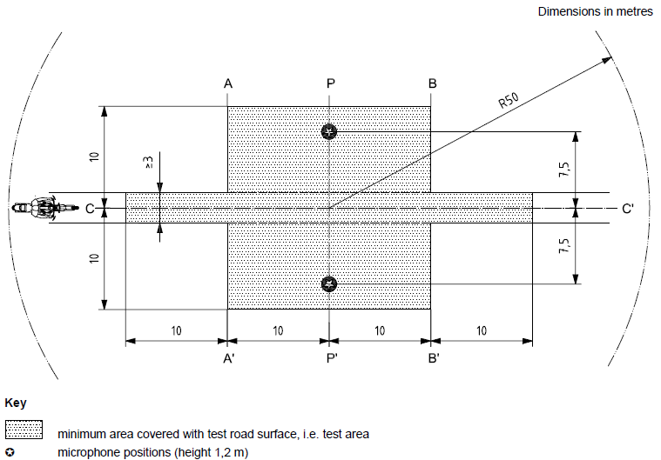

Key

|  |  |
| --- | --- |
|  | Minimum area covered with test road surface, i.e. test area |
|  | Microphone positions (height 1,2m) |

***Source: ISO 10844:1994, with modifications.****”*

*Figure 2 and Table 1,* to be deleted.

*Paragraph 4., 4.1. to 4.3., 5. and 5.1. to 5.3.,* to be deleted.

*Paragraph 6., 6.1., 6.1.1. to 6.1.6., 6.1.6.1. to 6.1.6.7. and 6.2.,* to be deleted.

II. Justification

This proposal aims to align the 02 series of amendments to UN Regulation No. 63 with ISO 10844:2014, eliminating provisions which are carried over from ISO 10844:1994, except for Figure 1 of Annex 5 which is referred to as explanations of the test track layout.

As from 20 January 2021, the specifications for the test site reproduced in Annex 5 will not be valid anymore but will be substituted by the provisions of ISO 10844:2014.

The date of 20 January 2021 derives from 60 months after the entry into force of Supplement 1 to the 02 series of amendments, according to paragraph 10.8. below:

*"10.8. As from 60 months after the date of entry into force of Supplement 1 to the 02 series of amendments to this Regulation, Contracting Parties applying this Regulation shall grant type approvals only if the vehicles type to be approved meets the requirements of this Regulation as amended by Supplement 1 to the 02 series of amendments to this Regulation."*

IMMA would like to replace the current Figure 1 of Annex 5 with the one above in a higher resolution. Such figure derives from an older version of ISO 10844; it was then modified to include a picture of a motorcycle that was not in 10844. ISO has confirmed permission to use such a figure.

This proposal aims to apply the same changes to UN Regulation No. 63 as adopted at the seventy-second session of the Working Party on Noise and Tyres (GRBP) (ECE/TRANS/WP.29/GRBP/2020/18) for UN Regulation No. 41, in addition to changing the transitional provisions.

Transitional Provisions

Because paragraph 2.1.1. of Annex 3 has been replaced by the content of this amendment proposal, paragraphs 10.7. and 10.8. are no longer necessary.

The transitional provisions have been aligned to the latest Transitional Guidelines, notably for paras. 10.3. and 10.4. which were respectively aligned to paras. V.9 and V.9bis. of the Transitional Guidelines (ECE/TRANS/WP.29/1044/Rev.3).

1. \* In accordance with the programme of work of the Inland Transport Committee for 2021 as outlined in proposed programme budget for 2021 (A/75/6 (Sect.20), para 20.51), the World Forum will develop, harmonize and update UN Regulations in order to enhance the performance of vehicles. The present document is submitted in conformity with that mandate. [↑](#footnote-ref-1)