UN/SCETDG/58/INF.25

Committee of Experts on the Transport of Dangerous Goods
and on the Globally Harmonized System of Classification
and Labelling of Chemicals 22 June 2021
Sub-Committee of Experts on the Transport of Dangerous Goods
Fifty-eighth session
Geneva, 28 June-2 July 2021
Item 3 of the provisional agenda
Listing, classification and packing
Clarification of generic concentration limits for skin corrosion classification in the UN Model Regulations
Transmitted by the expert from China
Objective
- To invite the Sub-Committee to clarify the generic concentration limits used in the calculation method for corrosive mixtures of Class 8 in the UN Model Regulations.
Background
2. According to the calculation method for corrosive mixtures of Class 8 in UN Model Regulations (21st edition), mixtures containing corrosive ingredients can be evaluated by calculation using the specific concentration limits (SCL) and generic concentration limits (GCL) of the corrosive ingredients, and the generic concentration limits are used only when there are no specific concentration limits.
3. In accordance with Figure 2.8.4.3 of the UN Model Regulations on the calculation method, if the concentration of ingredient of packaging group I is ≥ 5 %, the mixture is assigned to packaging group I, and if the concentration of ingredient of packaging group I is < 5 % but ≥ 1 %, the mixture is assigned to packaging group II (as shown in Figure 1 below). It seems that the generic concentration limits for substances of packaging group I to be assigned to packaging group II should be 1 %.
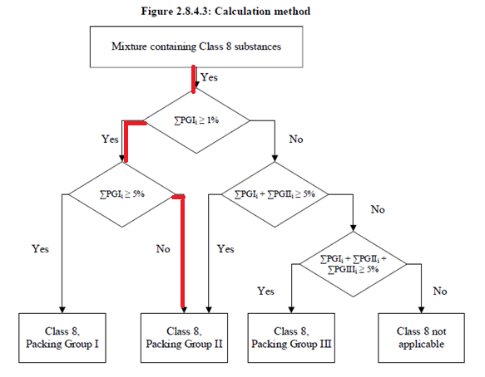
Figure 1: Calculation method in UN Model Regulations

4. Section 2.8.4.3.5 specifies that the generic concentration limits used in the calculation formula is the value shown in Figure 2.8.4.3. However, it is not specified whether the generic concentration limits for substances of packaging group I to be assigned to packaging group II is 1 % or 5 %.
5. In section 2.8.4.3.5 example 2, a mixture which contains three substances, A and B of packing group I with concentrations of 3 % and 2 %, and C of packing group III with concentration of 10 % (as shown in Figure 2 below) is assigned to packing group III. Furthermore, 5 % is chosen as the generic concentration limit for substance A of packing group I to be assigned to packing group II.
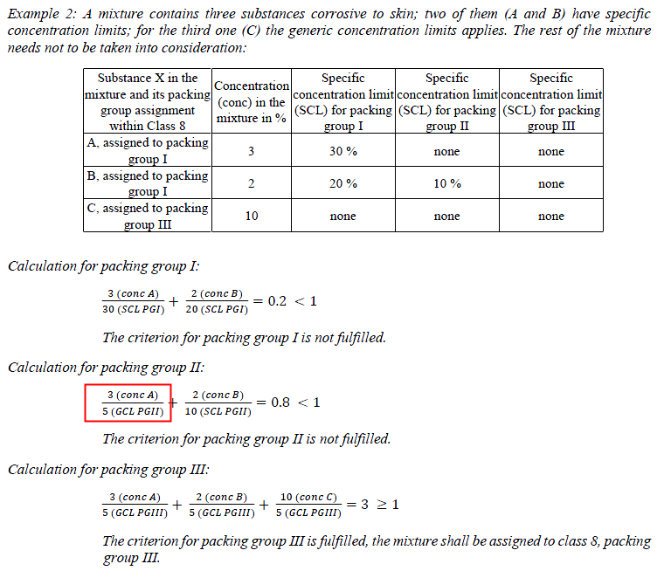
Figure 2: Section 2.8.4.3.5 example 2 in the UN Module Regulations
6. Although it is stated in 2.8.4.3.5 that the formula should be used when SCL is available instead of Figure 2.8.4.3, it is not stated that the formula cannot be used when no SCL is available. If we assume a case where no SCL is available (or understood as SCL is exactly equal to GCL), the critical concentrations for substances of packaging group I to be assigned to packaging group II obtained from Figure 2.8.4.3 and example 2 of section 2.8.4.3.5 are two different values. And, we cannot regard this as reasonable.
Proposal
7. Reviewing the proposal about the calculation method, Figure 2.8.4.3 was first proposed and approved by the Sub-Committee at its 49th session (INF.65). The formula and examples were later proposed to assist the understanding in cases with SCL. Figure 2.8.4.3 is more in line with the classification principle that the proposers want to put forward.

8. So, the experts from China would like to invite the Sub-Committee to clarify the following two issues:
(a) whether example 2 is appropriate; and
(b) how to determine the generic concentration limits used in the calculation formula in section 2.8.4.3.5, especially the generic concentration limits for substances of packaging group I to be assigned to packaging group II.

