Guidance on the issue of the declaration of conformity (Annex 1, Appendix 2 paragraph 7.3.6) and the dimensioning of Multi-Compartment, Multi-Temperature equipment (MTMC).

Introduction:

1. The new provisions coming into force on 6 July 2020, which require a declaration of conformity for MTMC to be supplied, leaves room for interpretation. Although actions to change the ATP have been taken, they take time to implement. For the interim period, the explanation in this guidance document is intended to help with a harmonized procedure to improve acceptance of equipment in the country of registration.

2. For all equipment, the heat transfer through the wall shall be determined and the refrigerating and/or heating capacity matched, including the applicable safety factor, to guarantee safe transport of perishable foodstuffs. Additionally Multi compartment equipment that are intended to maintain different temperatures in the individual compartments the heat transfer of each compartment shall be determined, the refrigerating capacity of the individual evaporator be matched, and the total capacity of the host unit be checked for all individual evaporators operating at different temperatures.

3. Modifications to the ATP as described in 7.3.6 entering into force on 6 July 2020, dictated that a declaration of conformity is to be issued to accompany the ATP certificate (Certificate of compliance). The declaration is intended to give information to carriers, consignors and control authorities if an equipment is suitable for a particular transport operation. In this it should be noted that based on article 4 of the ATP Treaty the selection of the equipment lies with the consignor and in some cases with the carrier.

Declaration of conformity

4. The declaration of conformity shall be issued by the competent authority issuing the ATP certificate of compliance. The Competent authority shall mark the declaration as appropriate. The declaration of conformity shall be appended to the ATP certificate and carried in the vehicle during carriage.

***Note 1:*** *In principle the declaration shall be drafted by the Competent Authority issuing the ATP certificate. However, in some contracting parties, the drafting of the declaration is expected to be performed by the technical service inspecting the equipment.*

***Note 2:*** *The original declaration remains valid unless the configuration of the equipment is changed. In case of transfer of the equipment to another contracting party the Competent authority may decide either to retain the original declaration or issue a new declaration based on the original one.*

5. The declaration of conformity shall be based on a calculation sheet presented to the competent authority by the equipment manufacturer when applying for an ATP certificate. The calculation sheet shall be traceable to the equipment. The calculation sheet may be made by either the equipment manufacturer, the thermal unit manufacturer or a technical service.

6. If the temperature conditions for each compartment will deviate from the   
standard -20 °C and + 20 °C range this shall be stated in the declaration.

7. The declaration shall follow the Lay-out given in Annex 1 as far as possible.

Dimensioning:

*Calculation:*

8. For each compartment the (heat) energy required, and evaporator capacity available, shall be checked in the worst-case position of the movable internal dividing walls. In this worst-case situation, the energy requirement and availability for all compartments serviced by the host unit shall be checked as well.

9. Calculation shall be based on the given insulation factors in Annex1. Appendix 2 paragraph 7.3.7.

*Use and validation of calculation tools.*

10. To perform the calculations a calculation tool is recommended. Before a tool is used it shall be validated by using the examples given in Annex 2 to this guidance document. The outcome of the calculations shall not vary by more than 5%.

**Annex 1.**

**Model No. 14**

Declaration of conformity for Multi Temperature – Multi compartment equipment

Supplementary document to the Certificate of Compliance as per Annex 1, appendix 2 paragraph 7.3.6

Top view sketch of the lay-out of the equipment:

*Indicating:  
-front and rear, numbering of compartments  
-lay-out of the compartments with fixed and movable bulkheads and the following dimensions in centimeters: inside dimensions of the body, thickness and lengths of the bulkheads.  
-most extreme position of movable dividing walls  
- Position of the host unit(s) and evaporators  
-material of the floor .*

(Example of top view sketch)

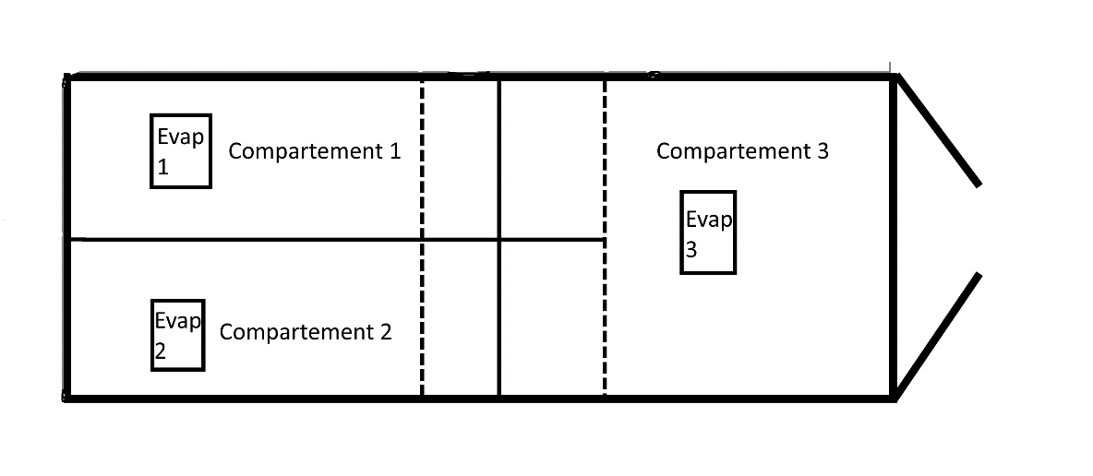

Insulated body:  
ATP test report number:  
Make:  
Serial number:

Host unit:  
ATP Test report number:  
Make:  
Serial Number:

Evaporators:  
ATP test report number:  
Make:  
Type:

Remarks:

(for example, limitations in compartment temperatures or dimensions, use of particular accessories as curtains etc.)

Authentication

Name of competent authority:  
Address:  
Telephone number:  
E-mail address:

Date and Place

**Annex 2.**

**Validation examples of the calculation tool**

***Validation sample 1***

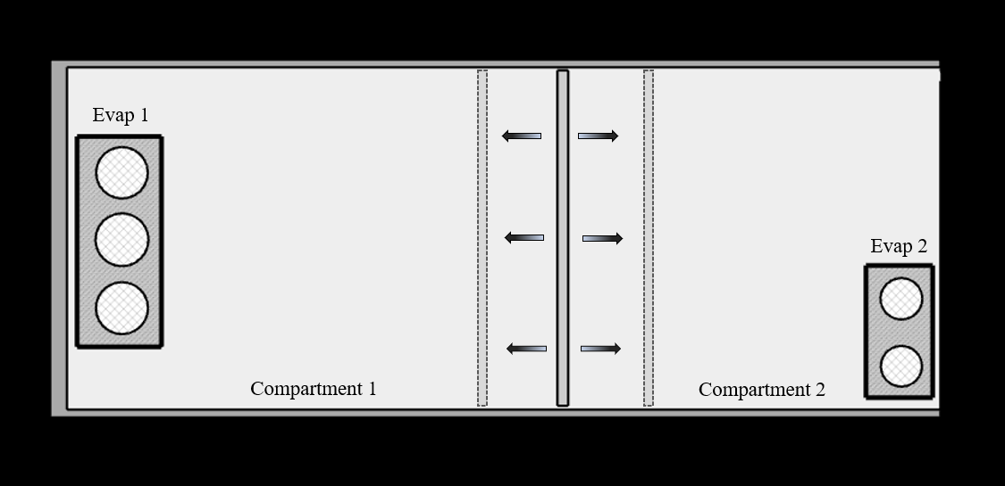

|  |  |  |  |
| --- | --- | --- | --- |
| **Calculation data Sample 1** | | | |
| **Dimensions** | | **Temperatures for calculation** | |
| Overall internal length | 13,00 m | External temperature | + 30 °C |
| Overall width | 2,50 m | Internal temperature Compartment 1 | + 20 °C |
| Overall Height | 2,60 m |
| K Value overall body | 0,40 W/m2/K | Internal temperature Compartment 2 | - 20 °C |
| Compartment 1 |  |
| Minimum length | 2,00 m | **Floor material** | GRP |
| Maximum length | 8,00 m |  |  |
| Compartment 2 |  | **Calculated energy demand** **in worst case** | |
| Minimum length | 4,95 m | Compartment 1 | -995 W |
| Maximum length | 10,95 m | Compartment 2 | 5 320 W |
| Thickness transversal partition | 50 mm |  |  |
| K-value transversal partition | 2,60 W/m2/K |  |  |

***Validation sample 2***

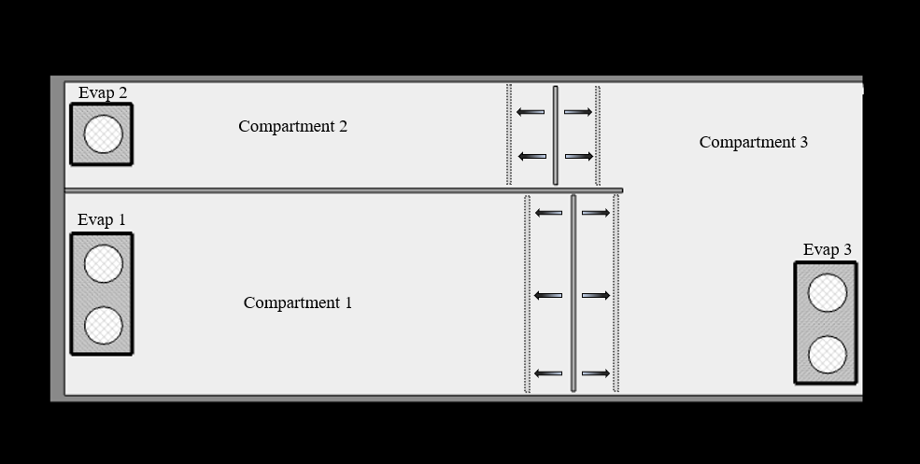

|  |  |  |  |
| --- | --- | --- | --- |
| **Calculation data Validation sample 2** | | | |
| **Dimensions** | | **Temperatures for calculation** | |
| Overall internal length | 13,00 m | External temperature | + 30 °C |
| Overall width | 2,50 m |  | **Sample 2** |
| Overall Height | 2,60 m | Internal temperature Compartment 1 | +20 °C |
| K Value overall body | 0,4 W/m2/K |
| Compartment 1 |  | Internal temperature Compartment 2 | -20 °C |
| Internal width | 1,20 m |
| Minimum length | 2,00 m | Internal temperature Compartment 3 | -20 °C |
| Maximum length | 8,00 m |
| Compartment 2 |  |  |  |
| Internal width | 1,25 m | **Floor material** | GRP |
| Minimum length | 2,00 m |  | |
| Maximum length | 8,00 m |  |  |
| Dimension of compartment 3 are self-determined by dimension of compartment 1 & 2 | |  |  |
| Thickness longitudinal partition | 50 mm | **Calculated energy demand in worst case** | |
| K-value longitudinal partition | 1,50 W/m2/K | Compartment 1 | -2 450 W |
| Thickness transversal partition | 50 mm | Compartment 2 | 3 726 W |
| K-value transversal partition | 2,60 W/m2/K | Compartment 3 | 2 556 W |

---