Informal document Supplementing the Justification of ‘Proposal for Amendments to the 03 series of Amendments to UN Regulation No. 79 (Steering equipment)’ ECE/TRANS/WP.29/GRVA/2021/10
Submitted by the expert from the European Association for Electromobility**
The text reproduced below was prepared by the expert from the European Association for Electromobility (AVERE) introducing supplemental justifications to ECE/TRANS/WP.29/GRVA/2021/10 amending UN Regulation No. 79. It is aimed at clarifying the text of the Regulation. The modifications to the existing text of the Regulation are marked in bold for new and strikethrough for deleted characters.

I. Justification
- As previously presented to GRVA, data from human driving provides evidence that a relevant portion of lane changes performed by human drivers will compromise up to and more than 7 seconds or more of total time, based on the duration of an active indicator lamp. The proposed amendment to increase the allowed time to begin the lane change manoeuvre is aimed to allow for more consistent performance of the lane change system which is in line with predictable and natural driving behavior. (Graph below based on 1000 manually driven vehicles over 30 days)
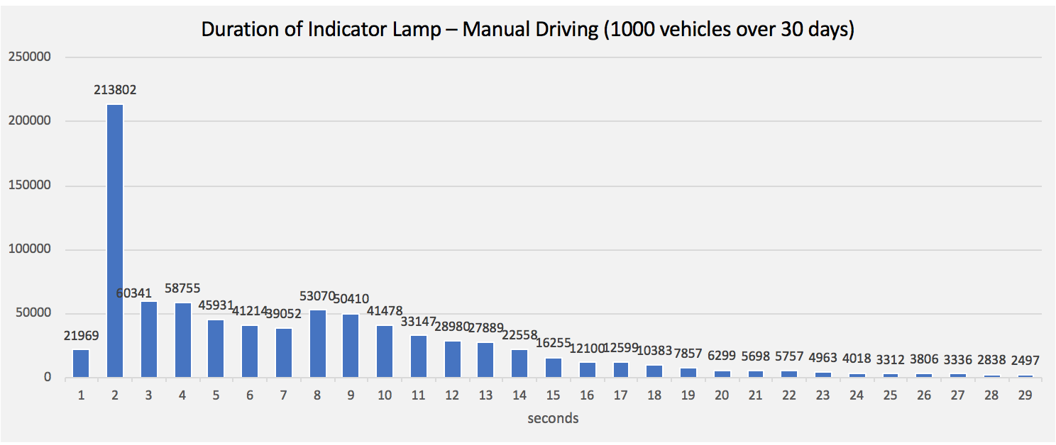

  - Some examples of longer indication time include situations where the driver needs to wait for a vehicle to pass (such as a truck) or when the driver needs to request sufficient space to perform the lane-change. We propose that a maximum time of up to 15 seconds for the system to start a lane change is required in order to allow ACSF of category C functionality in average driving situations. It should be noted that 7s is a maximum time to initiate the lane change and does not preclude shorter indicator times to be used by the driver. The longer time for indication also accommodates use in certain countries where cultural driving practice is to use the indicator well in advance of the lane change in order to clearly signal intent to other road users.
  - Global lane change systems which do not have similar limitations show good and safe performance. One manufacturer at AVERE has logged over a use of lane change systems over a lane keepin mileage of 1.6 billion kilometers with 0 lane change-related collisions. This exceeds over a 100 million lane changes with this system.
  - About 20% of lane changes performed in Europe result in aborts while such behavior is not present in the United States or other global markets that are not limited by the R79.03 requirements. Aborts are undesirable behavior and risks confusion of the driver or rear traffic. Data in graph below is collected in March 2021, equivalent to more than 20 million lane keeping miles across Europe (with R79.03), over a 100 million lane keeping miles in the U.S. (no R79.03).
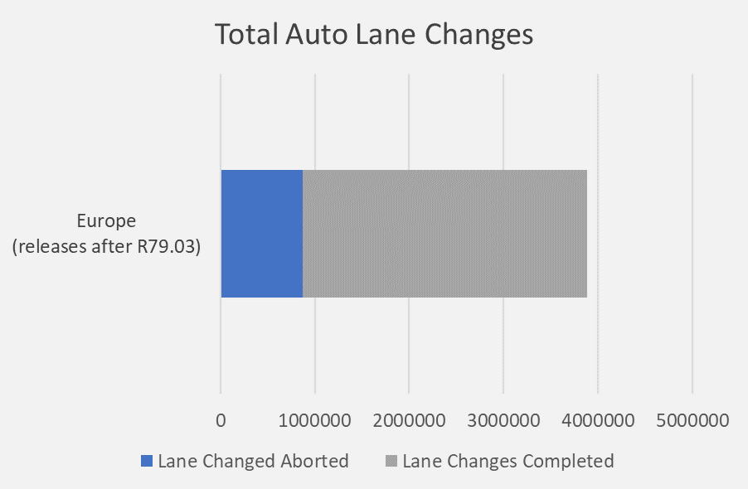
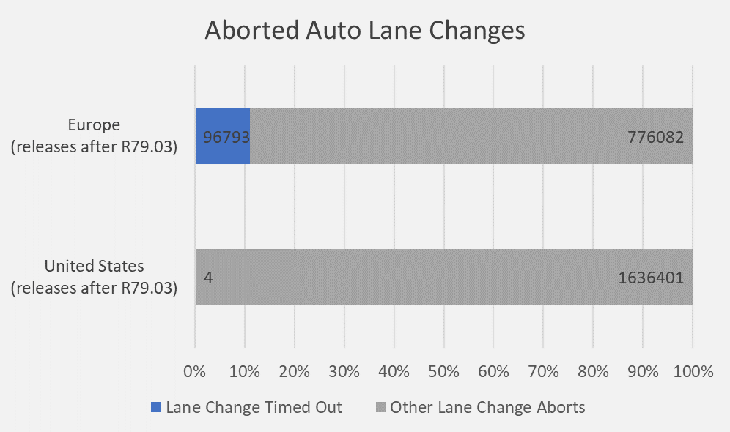

  - Lane Change performance based on a manufacturer’s customer fleet data between May and August 2019, around the time this manufacturer began complying with R79.03 requirements. Data represents around 9.6 million Lane Keeping kilometers across Europe in builds prior to R79.03, and around 9.6 million kilometers since R79.03. Data on graphs below represents around 66 million lane keeping kilometers in the U.S. in builds prior to R79.03, and around 71 million kilometers since R79.03 (though R79.03 restrictions do not apply in the US).
