Proposal of corrections to ECE/TRANS/WP.29/GRSP/2021/2
Proposal for Addendum 1 to Mutual Resolution No. 1 (Specifications for the Construction, Preparation and Certification of the 50th percentile male Biofidelic Rear Impact Dummy, (BioRID-II UN) anthropomorphic test Device)

I. Proposal
Contents, list of Appendices,
Appendix 7, amend to read:
“Appendix 7. – Limbs Arms and Hands”
Appendix 8., amend to read:
“Appendix 8. – Tools Legs and Feet”
Insert new Appendix 9, to read:
“Appendix 9. – Tools”
Text of the Resolution,
Annex 2, Engineering Drawings and Parts List, paragraph 4, amend to read:
"4. List of Appendices
Appendix 1. Assembly Drawings
Appendix 2. Head
Appendix 3. Cervical Spine
Appendix 4. Thoracic and Lumbar Spine
Appendix 5. Torso and Pelvis
Appendix 6. Muscle Substitute
Appendix 7. Limbs Arms and Hands
Appendix 8. Tools Legs and Feet
Appendix 9. – Tools."
Figure 81, amend to read:

"Figure 81
Inserting the Bumper in the Vertebra
Remove the two M2.5 SHCS that retain the T1 pin at the C7-T1 joint (Figure 82). Slide the T1 pin out of the vertebrae joint (Figure 83) and set it aside along with the two M2.5-0.45 x 8 SHCS for re-installation later.
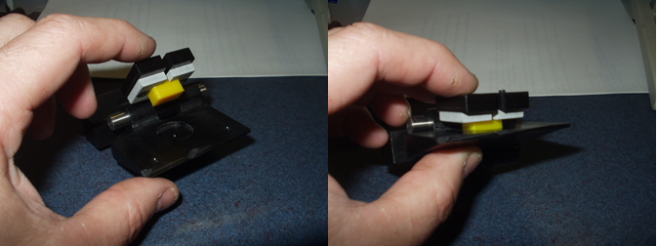
Remove the two M2.5 SHCS that retain the T1 pin at the C7-T1 joint (Figure 82). Slide the T1 pin out of the vertebrae joint (Figure 83) and set it aside along with the two M2.5-0.45 x 8 SHCS for re-installation later."

