|  |  |  |  |
| --- | --- | --- | --- |
|  | United Nations | ST/SG/AC.10/C.3/2021/28 | |
| _unlogo | **Secretariat** | | Distr.: General  20 April 2021  Original: English |

**Committee of Experts on the Transport of Dangerous Goods  
and on the Globally Harmonized System of Classification  
and Labelling of Chemicals**

**Sub-Committee of Experts on the Transport of Dangerous Goods**

**Fifty-eighth session**

Geneva, 28 June-2 July 2021  
Item 4 (f) of the provisional agenda

**Electric storage systems: miscellaneous**

Proposed amendments to packing instruction LP903

Submitted by PRBA – The Rechargeable Battery Association[[1]](#footnote-2),[[2]](#footnote-3)\*\*

Introduction

1. During the fifty-seventh session, PRBA filed informal document INF.34 in support of document ST/SG/AC.10/C.4/2020/52 (by the United Kingdom), which were intended to amend large packing instruction LP903 to allow multiple lithium cells and batteries and multiple items of equipment containing lithium batteries to be transported in a single large packaging. While concerns were expressed by members of the Sub-Committee on both documents, PRBA believes that the progress made during the fifty-seventh session to amend lithium battery large packing instruction LP906 and packing instruction P911 and the lithium battery manufacturing data provided below should be taken into consideration for amending large packing instruction LP903.

2. LP906 and P911 were developed for transporting lithium batteries “liable to rapidly disassemble, dangerously react, produce a flame, or a dangerous evolution of heat or a dangerous emission of toxic, corrosive, or flammable gases or vapours …”. The amendments adopted by the Sub-Committee during the fifty-seventh session authorize more than one battery in LP906 and P911 provided “the maximum number of batteries and items of equipment, the total maximum energy content of the batteries, and the configuration inside the package, including separations and protections of the parts, shall be considered”. PRBA believes a similar provision could be added to LP903 to provide an additional level of safety for packaging and shipping the large volumes of lithium cells and batteries that are expected to be manufactured over the next ten years.

3. The lithium ion battery industry continues to grow at a rapid pace with new “Gigafactories” planned in Europe, Asia, and North America. Below are data on the projected number of factories that will be constructed over the next seven years. These factories 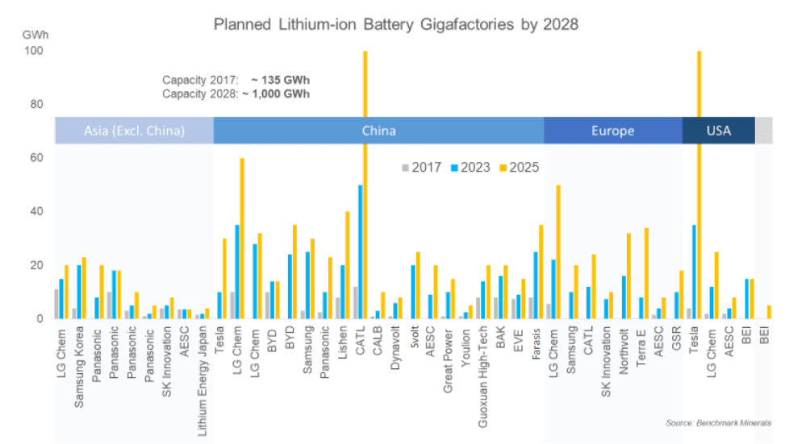will each have the capability of producing billions of cells annually for portable, industrial, and electric vehicle applications. The electric vehicle market is also expected to grow rapidly over the next seven years as countries attempt to reduce their greenhouse gas emissions and address climate change. The data below show the projected growth of the electric vehicle market over the next ten years.

**Projected Electric Vehicle Forecast**

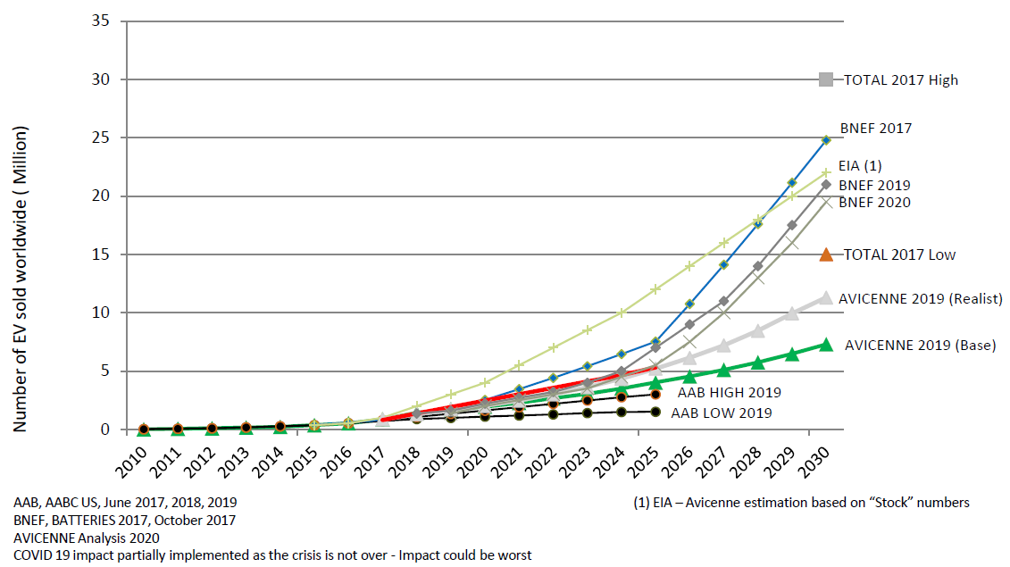

4. PRBA recognizes that concern has been expressed on the use of large packagings to transport large numbers of small cells. We therefore believe the provision adopted into LP906 and P911 that takes into account the “maximum number of batteries” and “configuration inside the package” should also be included LP903 to address these concerns.

5. PRBA also believes that authorizing large packaging of multiple lithium cells and batteries, properly isolated from one another, would pose no greater risk than numerous smaller packages containing the same number of cells when stacked on a pallet for transport - which is the method currently utilized. The use of a large packaging instead of numerous smaller packages contributes to safety by replacing the necessary handling of multiple small packages by the mechanical handling of a single large packaging. One PRBA member estimates that as many as 1000 fewer truck and rail shipments per year would be needed to transport their cells if the use of large packaging was authorized.

6. The method of using large packaging for lithium cells and batteries is not unlike the current provisions for Class 9 “safety devices” such as air bag modules (UN 3268) which include an explosives initiator, which are allowed not only in large packagings but in special handling devices to facilitate the installation of the articles at assembly plants. In a similar manner, the use of large packagings for lithium cells would ease handling and facilitate the installation of cells into large batteries that require hundreds or thousands of cells.

Proposal

7. PRBA proposes to amend in 4.1.4.3 large packing instruction LP903 as follows (new text is underlined, deleted text is ~~strike through~~):

“

|  |  |
| --- | --- |
| **LP903 PACKING INSTRUCTION LP903** | |
| This instruction applies to UN Nos. 3090, 3091, 3480 and 3481 | |
| The following large packagings are authorized for cells, ~~a single~~ batter~~y~~ies and for ~~a single item of~~ equipment containing batteries, provided that the general provisions of **4.1.1** and **4.1.3** are met:  Rigid large packagings conforming to the packing group II performance level, made of: | |
|  | steel (50A);  aluminium (50B);  metal other than steel or aluminium (50N);  rigid plastics (50H);  natural wood (50C);  plywood (50D);  reconstituted wood (50F);  rigid fibreboard (50G). |
| ~~The~~ Each cell, battery or ~~the~~ piece of equipment shall be wrapped or packed in an inner packaging and the outer packaging provided with dividers or partitions so that each battery or piece of equipment is separated to ensure ~~packed so~~ that the cell, battery or the equipment is protected against damage that may be caused by its movement of placement within the large packaging. | |
| **Additional requirement:**  Batteries shall be protected against short circuit.  The maximum number of cells and batteries and items of equipment, the total maximum energy content of the batteries, and the configuration inside the package, including separations and protections of the parts, shall be considered. | |

”

1. A/75/6 (Sect.20), para. 20.51 [↑](#footnote-ref-2)
2. \*\* **This document was scheduled for publication after the standard publication date owing to circumstances beyond the submitter's control.** [↑](#footnote-ref-3)