|  |  |  |  |
| --- | --- | --- | --- |
|  | United Nations | ST/SG/AC.10/C.3/2021/15 | |
| _unlogo | **Secretariat** | | Distr.: General  16 April 2021  Original: English |

**Committee of Experts on the Transport of Dangerous Goods  
and on the Globally Harmonized System of Classification  
and Labelling of Chemicals**

**Sub-Committee of Experts on the Transport of Dangerous Goods**

**Fifty-eighth session**

Geneva, 28 June-2 July 2021  
Item 2 (a) of the provisional agenda

**Explosives and related matters:   
review of test series 6**

Exit from Class 1 for very low hazard energetic articles

Submitted by the Institute of Makers of Explosives (IME), the Council on Safe Transportation of Hazardous Articles (COSTHA) and the Sporting Arms and Ammunition Manufacturers’ Institute (SAAMI)[[1]](#footnote-2)\*

Introduction

1. In this document IME, COSTHA and SAAMI describe 1.4S as having a low hazard, and the term “very low hazard” energetics is used to mean something exceeding the safety of 1.4S but which may not qualify for complete exclusion from the dangerous goods regulations (see chart in paragraph 14 below).

2. Articles containing any amount of explosives may only exit Class 1 if they demonstrate compliance with the criteria in 2.1.3.6.4 of the UN Model Regulations. These criteria determine whether the article has virtually no hazard, and if successful the article is excluded from regulation as a dangerous good unless it meets the definition of another class. A complete exit from dangerous goods often occurs. Examples include handheld medical inhalers, needleless injectors, pyro-mechanical electrical disconnects, and power device cartridges or micro gas generators incorporated into tools. Conversely, very low hazard energetic articles used in handheld tools may not qualify for exclusion when the same product is shipped separately and not incorporated into the tool, e.g., fixing cartridges for nail guns.

3. Other than the exclusion test just mentioned, the only other exits from Class 1 for energetic articles are special, use-based cases of safety devices and life-saving appliances, and matches classified as flammable solids. No quantifiable, scientific method exists for classifying very low hazard energetic articles outside of Class 1 but still within the scope of the UN Model Regulations when they are not directly intended to function as life-saving devices in transport conveyances.

4. Hereby, thought starter are presented to seek input as to whether others agree that this subject might have merit for further exploration, and if so, to gather information and begin work towards a solution.

The existing classification of safety devices and its non-suitability for very low hazard energetic articles

5. A well-known example of energetic articles being excluded from Class 1 is UN 3268, Safety Devices. These are kept within the scope of the UN Model Regulations and assigned to Class 9, unless they are installed in a vehicle component, in which case they exit the Model Regulations.[[2]](#footnote-3)

6. “Safety Devices” are defined in the Glossary: “Articles which contain pyrotechnic substances or dangerous goods of other classes and are used in vehicles, vessels or aircraft to enhance safety to persons. Examples are air bag inflators, air bag modules, seat-belt pretensioners and pyromechanical devices. These pyromechanical devices are assembled components for tasks such as but not limited to separation, locking, or release-and-drive or occupant restraint ...”

7. The term “Safety Devices” includes articles classified as Division 1.4G and Class 9 but only those meeting specialized criteria for the 6(c)-bonfire test of the Manual of Tests and Criteria (MTC) may be classified in Class 9. This is accomplished through Special Provision 280, which is applied to UN 3268. It states:

“280 This entry applies to safety devices for vehicles, vessels or aircraft, e.g. air bag inflators, air bag modules, seat-belt pretensioners, and pyromechanical devices, which contain dangerous goods of Class 1 or of other classes, when transported as component parts and if these articles as presented for transport have been tested in accordance with Test Series 6(c) of Part 1 of the Manual of Tests and Criteria, with no explosion of the device, no fragmentation of device casing or pressure receptacle, and no projection hazard nor thermal effect which would significantly hinder fire-fighting or emergency response efforts in the immediate vicinity. This entry does not apply to life saving appliances described in special provision 296 (UN Nos. 2990 and 3072).”

8. Special Provision 280 limits inclusion of energetic articles in Class 9:

* Only safety devices for vehicles, vessels or aircraft are included;
* Only safety devices meeting special criteria closely related to 1.4S criteria in the 6(c)-bonfire test are eligible for classification in Class 9. Such devices do not meet the Class 1 exclusion criteria of section 2.1.3.6.4.

9. The basis of assigning a device to Class 9 which only meets the equivalent of 1.4S criteria is the societal safety benefit: the benefit of lives saved by air bags in vehicles greatly outweighs the risk to life in transport. This approach is not applicable to very low hazard energetic articles which, although societally beneficial, do not provide the same direct life-saving benefit. Very low hazard energetic articles could easily meet and exceed the safety criteria of “safety devices”, but this does not mean that the approach to safety devices is incorrect or should be changed. If a classification scheme is developed for other products, it should (i) be separate from the approach to safety devices, and (ii) be based on quantitative safety thresholds rather than end use.

The case for exclusion of very low hazard energetic articles into another class

10. Despite 1.4S being the safest classification in Class 1 explosives, the use of the word “explosive” in a classification may indicate to decision makers in transport chains that there is a possibility of mass explosion or a security concern.[[3]](#footnote-4) This often results in severe impediments to transport and storage from various entities including civil aviation authorities, ports, carriers, insurers and building and fire safety authorities.

11. The issues impacting safety devices resulting in their removal from Class 1 also impact other explosive articles, for example:

* As listed by the International Air Transport Association (IATA), twenty-two countries only allow air transport of 1.4S explosives with prior authorization[[4]](#footnote-5), and this authorization may be difficult to obtain. Other countries likely have similar requirements.[[5]](#footnote-6) Furthermore, when authorization is obtained it may be on a per shipment basis. From a practical standpoint, distribution in this latter circumstance is often not viable.
* As listed by IATA, fourteen airlines do not accept explosives including 1.4S either domestically or internationally, other than certain exceptions for ammunition or company materials. Other airlines only accept 1.4S explosives with prior authorization.
* Shipment of 1.4S explosives by vessel can be difficult, as they are often not differentiated from explosives presenting a blast hazard.[[6]](#footnote-7) Additionally, small shipments by vessel may be logistically impractical, as 1.4S may not be allowed in consolidations by forwarders or carriers.
* Many non-developed countries are not capable of transporting explosives, including 1.4S, without special permission, licenses and even military escorts. These restrictions may hinder the distribution of any explosive in Class 1.
* Storage of 1.4S explosives is frequently based on transport classifications, and is often subject to site and building design requirements that are incompatible with normal manufacturing and warehousing assets. This results in the need for special infrastructure which is excessive and unfeasible for very low hazard energetics.[[7]](#footnote-8),[[8]](#footnote-9)

12. Currently the lack of an exit as described above may lead to dis-harmonization in transport. A device used for safety, but not a “Safety Device” used in conveyances, may still be assigned to Class 9 depending on the competent authority.

13. Many shippers of very low hazard energetic articles may seek new UN numbers and special provisions to overcome the disadvantages of assignment to Class 1. It may be more helpful to create an overarching classification scheme than to deal with these on a case-by-case basis which can lead to inconsistency and inequity.

14. Most classifications of explosive articles from high hazard to non-regulated are based on criteria, but this is not always the case for explosives classifications in Division 4.1 and Class 9, which are based on policy, as shown in the following chart:

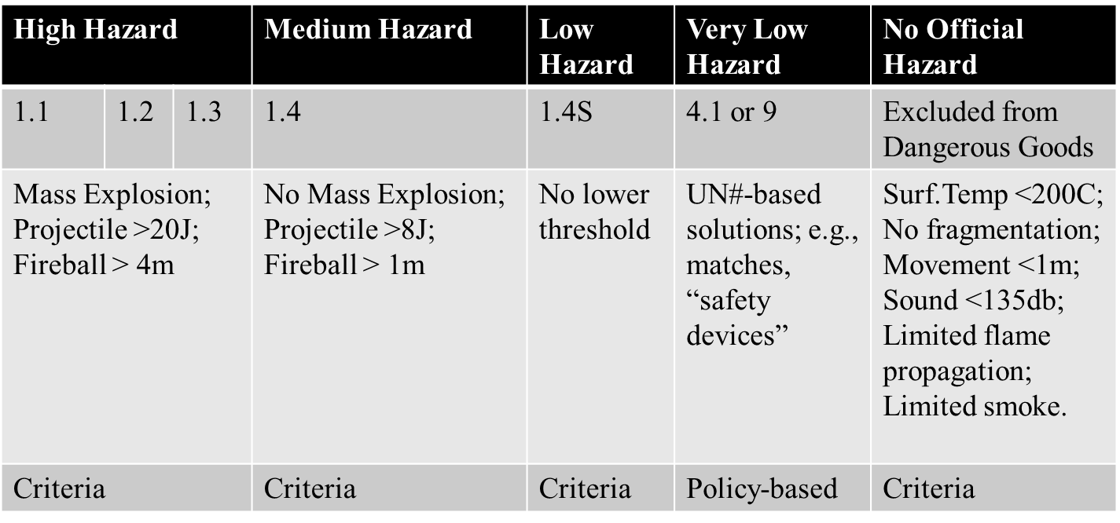

Thought-starter ideas for criteria

15. Very low hazard energetic articles are no more explosive than other flammable or pressurized dangerous goods. The following eligibility criteria could be applied:

* Prevent mass propagation at any quantity must rely solely on the design of the article, not packaging, and substances would not be eligible;
* Exclude articles which function by detonation with nearly complete disintegration of the article;
* Consider controlling the eligibility of articles which may present security concerns, regardless of hazard level;
* Apply the current Special Provision 296 restrictions for other Class 9 articles.

16. New quantitative criteria could be developed. For example, the existing test scheme for the exclusion of articles from dangerous goods in section 2.1.3.6.4 could be adapted with an additional set of criteria. This would have the advantage of testing the article and not the packaging. These criteria would be less stringent than currently found in section 2.1.3.6.4, but the article would be retained within the scope of the UN Model Regulations as a dangerous good. The criteria would be more stringent than those for classification as 1.4S. The resulting classification could fill a gap between Class 1 and complete exclusion from dangerous goods. Alternate thresholds for existing criteria might include surface temperature, fragmentation, movement, sound, flame, and smoke.

17. It has been suggested to revisit the definition of an “explosive article”, bearing in mind the effort which is already ongoing under the leadership of Sweden. Currently the definition would apply to any article containing explosives, but perhaps this should be reconsidered for very low hazard energetics that do not explode.

18. A cost-benefit analysis would be of value in assessing the issues discussed herein and potential solutions. The authors of this document seek input from impacted parties.

Proposal

19. IME, COSTHA and SAAMI propose a discussion on the merits of further work. If sufficient interest exists, it could be referred to the Explosives Working Group for examination of the technical and safety aspects and for recommendations related to the future development of amendments to the UN Model Regulations.

1. \* A/75/6 (Sect.20), para. 20.51 [↑](#footnote-ref-2)
2. Special Provision 289 of the UN Model Regulations states: “Safety devices, electrically initiated and safety devices, pyrotechnic installed in vehicles, vessels or aircraft or in completed components such as steering columns, door panels, seats, etc. are not subject to these Regulations.” [↑](#footnote-ref-3)
3. Security measures may be applied to any 1.4S explosive on the basis of it being an explosive, without regard to the indicative security list in Table 1.4.1. [↑](#footnote-ref-4)
4. Algeria, Belgium, Bahrain, Croatia, Egypt, Fiji, Ghana, Hong Kong, India, Italy, Kyrgyz Republic, Madagascar, Malaysia, Oman, Peru, Romania, Saudi Arabia, South Africa, Turkey, United Arab Emirates, United Kingdom, United States of America. [↑](#footnote-ref-5)
5. The IATA variations are unique and very helpful. That said, the list of governments having additional requirements in IATA variations is not comprehensive. For example, some of these national requirements are only known because an airline variation mentioned the policy of their competent authority, e.g., Algeria, India and Madagascar. The IATA airline variations are also not comprehensive. [↑](#footnote-ref-6)
6. See ST/SG/AC.10/C.3/2019/14, paragraphs 14-20. [↑](#footnote-ref-7)
7. This was the driving force behind the Globally Harmonized System (GHS) of Classification and Labelling of Chemicals initiative to create Chapter 2.17 for desensitized explosives, enabling them to be treated differently than explosives, thus avoiding the invalidation of existing infrastructure. [↑](#footnote-ref-8)
8. See GHS Chapter 2.1, section 2.1.1.3.2. [↑](#footnote-ref-9)