Proposal for Amendments to UN Regulation No. 34
(prevention of fire risks)
The text reproduced below was prepared by the expert from OICA for removing the categories M1 and N1 from the scope of the regulation. The modifications to the current text of the regulation are marked in bold for new and strikethrough for deleted characters.
- Proposal
Paragraph 1.,amend to read (footnote unchanged)
1. Scope
This Regulation applies:
1.1. Part I: To the approval of vehicles of categories M, N and O* with regard to the tank(s) for liquid fuel.
1.2. Part II-1: At the request of the manufacturer, to the approval of vehicles of categories M, N M₂, M₃, N₂, N₃ and O approved to Part I or IV of this Regulation fitted with liquid fuel tank(s) with regard to the prevention of fire risks in the event of a frontal and/or lateral collision as well as to the approval of vehicles of categories M₁ and N₁, which are of a total permissible mass exceeding 2.8 tonnes, and categories M₂, M₃, N₂, N₃ and O, fitted with tank(s) for liquid fuel, which have been approved to Part I or IV of this Regulation with regard to the prevention of fire risks in the event of a and/or rear collision.
Part II-2: To the approval of vehicles of categories M₁ and N₁, which are of a total permissible mass not exceeding 2.8 tonnes, fitted with liquid fuel tank(s) approved to Part I or IV of this Regulation with regard to the prevention of fire risks in the event of a rear collision.
1.3. Part III: To the approval of tanks for liquid fuel as separate technical units.
1.4. Part IV: To the approval of vehicles with regard to the installation of approved tanks for liquid fuel.”

Paragraph 3.1.4.2., amend to read:
“3.1.4.2. The number of this Regulation, followed by "RI", if the vehicle is approved pursuant to Part I of the Regulation, or by "RII-1" if the vehicle is approved pursuant to Parts I or IV and to Part II-1 of the Regulation, or by "RII-2" if the vehicle is approved pursuant to Parts I or IV and to Part II-2 of the Regulation, a dash and the approval number to the right of the circle prescribed in paragraph 3.1.4.1.”

Part II-1 (the title), amend to read (deletion of “-1”):
Part II-1 - Approval of vehicles with regard to the prevention of fire risks in the event of collision

Paragraph 7.2.2. to be deleted, and following paragraphs to be re-numbered accordingly.

Part II-2, delete

Annex 2, amend to read (changes highlighted in yellow – footnote unchanged):
“Model B
(See paragraph 3.1.5. of this Regulation)
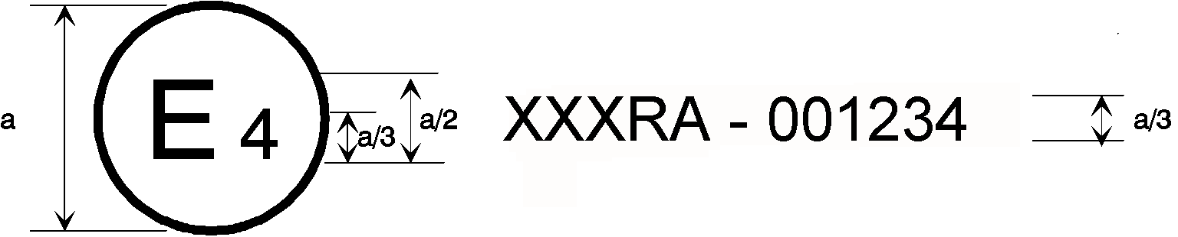
34RII-1 | 031234
33 | 001628

a = 8 mm minimum
The above approval mark affixed to a vehicle shows that the type concerned was approved in the Netherlands (E 4) pursuant to Regulations Nos. 34 Parts I or IV and II-1 and 33.* The approval numbers indicated that, at the date when the respective approvals were given, Regulation No. 34 included the 03 series of amendments and Regulation No. 33 was still in its original form.
34RII-2 | 031234
33 | 001628

The above approval mark affixed to a vehicle shows that the type concerned was approved in the Netherlands (E 4) pursuant to Regulations Nos. 34 Parts I or IV and II-2 and 33.* The approval numbers indicated that, at the date when the respective approvals were given,…”

- Justification
- The intention of this proposal is to avoid double approval with regard to fire risks by deleting the impact tests for M1 and N1 vehicles from Regulation 34.
- Those vehicles are indeed in the scope of Regulations Nos. 94, 95 and 153.
- Regulation No.153 actually better covers the prevention of fire risks than Regulation No.34 since it is covering fuel safety but also electric vehicles and hydrogen safety.

____________

