Heavy Vehicle Event Data Recorders
1.0 Introduction
This document discusses the feasibility of equipping heavy vehicle event data recorders (HVEDR) in motor coaches, buses and school buses and seeks feedback from interested parties on developing an UN regulation governing their requirements.
The document includes a summary of Canadian research of HVEDR following a collision between a city bus and a commuter train in 2013. It also summarizes international development of Event Data Recorders (EDR) technology and standards.
2.0 Transportation Safety Board of Canada Recommendation
On September 18, 2013, a collision occurred in Ottawa, Ontario, Canada between a commuter train and an inner city double-decker transport bus. The engine was equipped with electronic controls with HVEDR functionality.
The collision resulted in six-fatalities, nine-serious injuries and approximately 25-minor injuries among the occupants of the double-decker bus. The final investigation report authored by the TSB contained numerous safety recommendations, with one of those recommendations focused on commercial and passenger bus EDR.
3.0 Transport Canada Research
The TSB recommendation was the impetus for Transport Canada to initiate research on HVEDR. Mecanica Scientific Services Corporation was contracted to perform a feasibility study for developing a commercial passenger bus HVEDR standard for Canada.
3.1 Mecanica Feasibility Study (Published May 2018)
The in depth study performed an extensive literature review, analyzed collision statistics and the effects of EDRs on reduction in collisions and the usefulness of data acquired from HVEDR for collision investigations. It also assessed the feasibility of requiring these systems and the current implementation of HVEDR in the heavy duty vehicle fleet.
As part of its findings, the report stated, “Technical reasons against HVEDR implementation and standardization have not been discovered.” The study recommended leveraging current OEM ECUs for HVEDR purposes as a less costly option for OEMs to phase into compliance.
The study findings pointed to the importance of an HVEDR standardization entailing a common reporting format that included standardized data elements and reporting frequency. Events outside of crashes, such as hard brake events and aggressive driving events, should be included in this HVEDR technology to help coach commercial drivers and achieve lower accident rates, as numerous research studies had found.
Another recommendation was that the data should be archived in a common format as archiving data in an unconventional format makes it difficult to capture data into a tabular format with accurate results for meaningful crash analysis. A common data-retrieval tool compatible with any commercial bus regardless of the manufacturer, as modeled by the universal Bosch Crash Data Retrieval Tool for light vehicles, can be developed. By standardizing a common data imaging tool for HVEDR, training can be greatly simplified and government agencies, fleet managers and law enforcement agencies will not need to purchase and train on multiple tools for imaging data from commercial trucks and buses.
4.0 Society of Automotive Engineers (SAE), RP J2728: Heavy Vehicle Event Data Recorder Standard (Revised November, 2020)
The J2728 standard is currently under review by the SAE Truck and Bus Event Data Recorder Committee.
The purpose of the J2728 Standard is that it provides design and performance recommendations needed to develop an HVEDR with minimum capabilities. The standard applies to heavy-duty ground wheeled vehicles with a gross vehicle weight rating greater than 4536 kg.
The document generally follows the scope and structure of SAE J1698 EDR for light-duty vehicles. However, the differences in heavy vehicles as compared to light-duty vehicles necessitates alternate considerations in triggering mechanisms and data to be recorded.
The document provides a list of data elements and event triggers for the recording of event data relevant to crash investigations for Heavy Vehicles (HV). The document specifically focuses on a minimum set of data elements and includes recommended data sources and data formatting.
5.0 The United States Federal Department of Transportation, NHTSA
The NHTSA has established requirements for voluntarily installed EDR in light passenger vehicles with United States Regulation CFR Part 563 since August, 2006. NHTSA chose not to mandate installation of EDRs in order to encourage voluntary development and installation, while alleviating costs on manufacturers and consumers. The agency stated at the time that the “marketplace appears to be adopting EDRs and we do not currently see a need to mandate their installation.” In December, 2012, NHTSA published a notice of proposed rulemaking (NPRM) proposing to convert Part 563's “if-installed” requirements for EDRs into a new Federal Motor Vehicle Safety Standard (FMVSS) mandating installation of EDRs in most light vehicles. NHTSA believed that the universal installation of EDRs would improve vehicle safety by aiding the agency in investigating potential safety defects and developing new standards. In February 2019, NHTSA withdrew the December 2012 NPRM because the agency determined that a mandate is not necessary at this time to achieve the nearly universal installation of EDRs on new light vehicles.
6.0 World Forum for Harmonization of Vehicle Regulations WP.29
A new regulation for passenger / light-duty vehicle EDRs (UN Regulation 160), which was developed by the Informal Working Group (IWG) Data Storage System for Automated Driving / Event Data Recorder (DSSAD/EDR) was approved by WP.29 at its 183rd session in March of 2021. This regulation applies to vehicle categories M1 and N1 up to 3500 kg with regard to their EDRs.
The IWG presented its status and proposed workplan at the same WP.29 session (WP.29-183-12). Under its proposed workplan, “EDR for heavy duty vehicles” was included as an area for further discussion to support EU GRS 2026-2029.
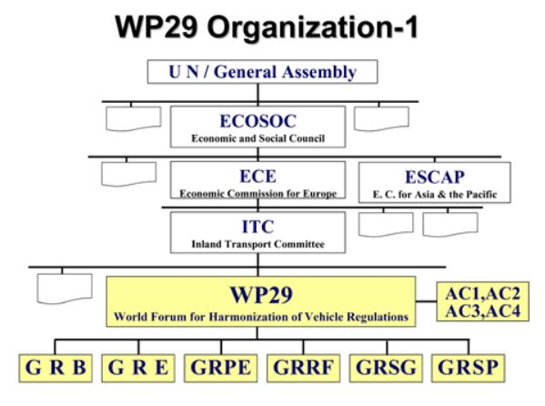
7.0 Conclusion
Technology and corresponding international standards development has progressed to a point where a HVEDR regulation can be developed. Canada supports this development and offers to share our research findings to support the work planned to be carried out within the DSSAD/EDR IWG.

