Proposal for amendments to UN Regulation No. 46 (Devices for indirect vision)

- Proposal
Paragraph 6.2.2.1.2., amend to read:
"6.2.2.1.2. Edges of fixing holes or recesses of which the diameter or longest diagonal is less than 12 mm are exempt from the radius requirements of paragraph 6.2.2.1.1. above provided that they are blunted.
The requirements in paragraph 6.2.2.1.1. above shall not apply to parts of the external surface which protrude less than 5 mm, but the outward facing angles of such parts shall be blunted, save where such parts protrude less than 1.5 mm. For determining the dimension of the projection, the following method shall apply:"

Insert a new paragraph 6.2.2.1.2.1., to read:
"6.2.2.1.2.1. The dimension of the projection of a component which is mounted on a convex surface may be determined either directly or by reference to a drawing of an appropriate section of this component in its installed condition."

Insert a new paragraph 6.2.2.1.2.2., to read:
"6.2.2.1.2.2. If the dimension of the projection of a component which is mounted on a surface other than convex cannot be determined by simple measurement, it shall be determined by the maximum variation of the distance of the centre of a 100 mm diameter sphere from the nominal line of the panel when the sphere is moved over and is in constant contact with that component. Figure 1 shows an example of the use of this procedure.

Figure 1
Example for the measurement by maximum variation"
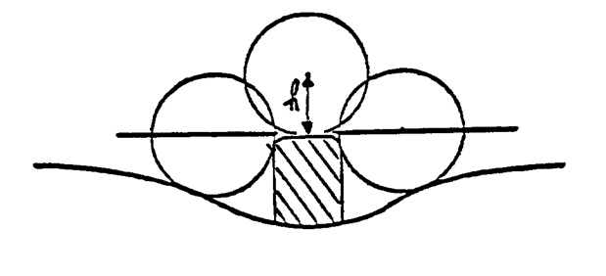

Paragraph 6.2.2.1.3., amend to read:
"6.2.2.1.3. For parts of the camera and the monitor which are made of a material with a Shore A hardness of less than 60 and which are mounted on a rigid support, the requirements of paragraph 6.2.2.1.1. above shall only apply to the support.
Edges of fixing holes or recesses of which the diameter or longest diagonalis less than 12 mm are exempt from the radius requirements of paragraph 6.2.2.1.1. above provided that they are blunted."

Insert a new paragraph 6.2.2.1.4., to read:
"6.2.2.1.4. For parts of the camera and the monitor which are made of a material with a Shore A hardness of less than 60 and which are mounted on a rigid support, the requirements of paragraph 6.2.2.1.1. above shall only apply to the support."

- Justification
In the UN Regulation No. 46 actually we have different requirements of the outer radius for a mirror system for indirect vision and a camera-monitor-device for indirect vision. For some safety functions (e.g. rain deflector, wind deflector) on the camera-monitor device, it would be useful to have the same requirements as a mirror system.

In the area of camera lenses special deflector geometry is necessary to improve the image quality captured by the camera. These deflectors are influencing or preventing air turbulences and through this are keeping rainwater and dirt particles away from the optical system.

____________

