Proposal to amend the document ECE/TRANS/WP.29/GRE/2021/2

Modifications to the current proposal text are marked in red and deleted parts by strikethrough in red.

I. Proposal

Insert new paragraph 2.6.4., to read:
"2.6.4. “Answer-back signal” means a signal that operates under the park condition, in conjunction with the locking and unlocking of the doors defined in paragraph 2.8. of UN Regulation No. 11, or in accordance with other conditions prescribed as conditions similar to this stated by the manufacturers."

Paragraph 5.1., amend to read:
"5.1. The lighting and light-signalling devices shall be so fitted that under the normal conditions of use and, if specified, the park condition (as defined in paragraphs 2.3.10., 2.3.10.1., and 2.3.10.2., 2.3.11., 2.3.11.1. and 2.3.11.2.), and notwithstanding any vibrations to which they may be subjected, they retain the characteristics prescribed by this Regulation and enable the vehicle to comply with the requirements of this Regulation. The lamps with no specifications under the park condition in this Regulation shall not be activated under the park condition. In particular, it shall not be possible for the lamps to be inadvertently maladjusted."

Insert new paragraph 6.27., to read:
"6.27. Answer-back signal
6.27.1. Presence
Optional
6.27.2. The answer-back signal shall comply with the following requirements:
(a) The signal shall only operate under the park condition of a vehicle.
(b) The duration of the optical indication shall not exceed 3 seconds.
(c) The signal shall be given by operation of the dipped-beam headlamps, the direction-indicator lamps, the stop lamps, the rear registration plate lamp(s), the front position lamps, the rear position lamps, the front fog lamps, the rear fog lamp(s), the parking lamps, the side-marker lamps, the end-outline marker lamps, the cornering lamps or the manoeuvring lamps] in accordance with the individual specifications applicable to each lamp; however, the signal may be flashing lamps."

Insert new paragraph 12.7 8, to read:

"[12.7 8. Transitional provisions applicable to 08[0x] series of amendments.
12.7 8.1. As from the official date of entry into force of the 08[0x] series of amendments, no Contracting Party applying this UN Regulation shall refuse to grant or refuse to accept UN type approvals under this UN Regulation as amended by the 08[0x] series of amendments.
12.7 8.2. As of 1 September [2023 2026] Contracting Parties applying this UN Regulation shall not be obliged to accept UN type approvals to the preceding series of amendments, first issued after 1 September [2023 2026].
12.7 8.3. Until 1 September [2027 2029], Contracting Parties applying this UN Regulation shall accept UN type approvals to the preceding series of amendments, first issued before 1 September [2023 2026].
12.7 8.4. As from 1 September [2027 2029], Contracting Parties applying this UN Regulation shall not be obliged to accept type approvals issued to the preceding series of amendments to this UN Regulation.
12.7 8.5. Notwithstanding the transitional provisions above, Contracting Parties who start to apply this UN Regulation after the date of entry into force of the most recent series of amendments are not obliged to accept UN type-approvals which were granted in accordance with any of the preceding series of amendments to this UN Regulation.
12.7 8.6. Notwithstanding paragraph 12.7.4. Contracting Parties applying this UN Regulation shall continue to accept UN type approvals to the preceding series of amendments to this UN Regulation, for the vehicle types which are not affected by the changes introduced by the 08[0x] series of amendments.
12.7 8.7. Contracting Parties applying this UN Regulation may grant UN type approvals according to any preceding series of amendments to this UN Regulation.
12.7 8.8 Contracting Parties applying this UN Regulation shall continue to grant extensions of existing approvals to any preceding series of amendments to this Regulation.]”

Annex 2, amend to read:
"Annex 2
Arrangements of approval marks
Model A
(See paragraph 4.4. of this Regulation)

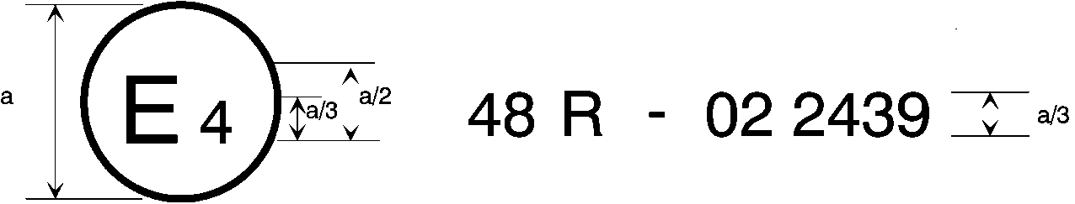
[0x]

a = 8 mm min.
The above approval mark affixed to a vehicle shows that the vehicle type concerned has, with regard to the installation of lighting and light-signalling devices, been approved in the Netherlands (E4) pursuant to UN Regulation No. 48 as amended by the 08[0x] series of amendments. The approval number indicates that the approval was granted in accordance with the requirements of UN Regulation No. 48 as amended by the 08[0x] series of amendments.

Model B
(See paragraph 4.5. of this Regulation)

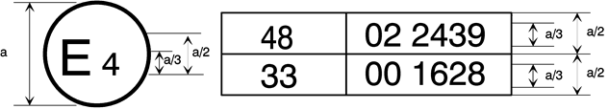
[0x]

a = 8 mm min.
The above approval mark affixed to a vehicle shows that the vehicle type concerned has been approved in the Netherlands (E 4) pursuant to UN Regulation No. 48 as amended by the 08[0x] series of amendments and UN Regulation No. 33.⁵ The approval number indicates that, at the dates when the respective approvals were given, UN Regulation No. 48 was amended by the 08[0x] series of amendments and UN Regulation No. 33 was still in its original form.
__________
⁵ The second number is given merely as an example.”

II. Justification
1. This proposal aims to require that lighting and light-signalling devices be turned on in compliance with the requirements of Regulation No. 48 even when a vehicle is under the park condition by adding “park condition” to the scope of Regulation No. 48. We believe that some regulation is necessary because if, for instance, the lights of a vehicle parked on the shoulder are turned on, they may cause hazards such as glare or distraction to other traffic users.

2. If there are lighting or light-signalling functions other than answer-back signals that should be reasonably allowed to flash under the park condition, we should address the issue by considering it in future international discussions and adding them to Regulation No. 48.

