Proposal to amend the document ECE/TRANS/WP.29/GRE/2021/2

Modifications to the current proposal text are marked in red and deleted parts by strikethrough in red.

I. Proposal

Insert new paragraph 2.6.4., to read:
"2.6.4. “Answer-back signal” means a flashing signal or a signal with increasing/reducing luminous intensity that operates under the park condition, in conjunction with either one or any combination of the following: the locking and unlocking of the doors, defined in paragraph 2.8. of UN Regulation No. 11, or in accordance with other conditions prescribed as conditions similar to this stated by the manufacturers., the opening and closing of the doors, and the detection of the vehicle user approaching with the key."

Paragraph 5.1., amend to read:
"5.1. The lighting and light-signalling devices shall be so fitted that under the normal conditions of use and, if specified, the park condition (as defined in paragraphs 2.3.10., 2.3.10.1., and 2.3.10.2., 2.3.11., 2.3.11.1. and 2.3.11.2.), and notwithstanding any vibrations to which they may be subjected, they retain the characteristics prescribed by this Regulation and enable the vehicle to comply with the requirements of this Regulation. The lamps with no specifications under the park condition in this Regulation shall not be activated under the park condition. In particular, it shall not be possible for the lamps to be inadvertently maladjusted."

Insert new paragraph 6.27., to read:
"6.27. Answer-back signal
6.27.1. Presence
Optional
6.27.2. The answer-back signal shall comply with the following requirements:
(a) The signal shall only operate under the park condition of a vehicle.
(b) The duration of the optical indication shall not exceed 3 seconds.
(c) The signal shall may only be given by operation of the [dipped-beam headlamps, the direction-indicator lamps, the stop lamps, the rear registration plate lamp(s), the front position lamps, the rear position lamps, the front fog lamps, the rear fog lamp(s), the parking lamps, the side-marker lamps, the end-outline marker lamps, the cornering lamps or the maneuvering lamps]. in accordance with the individual specifications applicable to each lamp; however, the signal may be flashing lamps. "
6.27.2. Number
In accordance with the individual specifications applicable to specific lamp used for the answer-back signal.
6.27.3. Arrangement
In accordance with the individual specifications applicable to specific lamp used for the answer-back signal.
6.27.4. Position
6.27.4.1. In width: in accordance with the individual specifications applicable to specific lamp used for the answer-back signal.
6.27.4.2. In height: in accordance with the individual specifications applicable to specific lamp used for the answer-back signal.
6.27.4.3. In length: in accordance with the individual specifications applicable to specific lamp used for the answer-back signal.
6.27.5. Geometric visibility
In accordance with the individual specifications applicable to specific lamp used for the answer-back signal.
6.27.6. Orientation
In accordance with the individual specifications applicable to specific lamp used for the answer-back signal.
6.27.7. Electrical connections
6.27.7.1. The answer-back signal shall only operate under the park condition of a vehicle.
6.27.7.2. The answer-back signal may only be activated automatically in conjunction with either one or any combination of the following: the locking and unlocking of the doors, the opening and closing of the doors, and the detection of the vehicle user approaching with the key.
6.27.7.3. The answer-back signal may be activated sequentially.
6.27.7.4. All the lamps used for the answer-back signal shall flash at a frequency not exceeding 2.0 Hz.
6.27.7.5. The duration of the optical indication shall not exceed 3 seconds.
6.27.7.6. The answer-back signal shall be switched ON and OFF automatically
6.27.7.7. The driver shall be able to deactivate and reactivate the answer-back signal manually.
6.27.7.8. Multiple lights may operate simultaneously.
6.27.9. Tell-tale
Optional.
6.27.10. Other requirements
None. "

Insert new paragraph 12.7., to read:

"[12.7. Transitional provisions applicable to the [08] series of amendments.

12.7.1. As from the official date of entry into force of the [08] series of amendments, no Contracting Party applying this UN Regulation shall refuse to grant or refuse to accept UN type approvals under this UN Regulation as amended by the[08] series of amendments.
12.7.2. As of 1 September [2023] Contracting Parties applying this UN Regulation shall not be obliged to accept UN type approvals to the preceding series of amendments, first issued after 1 September [2023].
12.7.3. Until 1 September [2027], Contracting Parties applying this UN Regulation shall accept UN type approvals to the preceding series of amendments, first issued before 1 September [2023].
12.7.4. As from 1 September [2027], Contracting Parties applying this UN Regulation shall not be obliged to accept type approvals issued to the preceding series of amendments to this UN Regulation.
12.7.5. Notwithstanding the transitional provisions above, Contracting Parties who start to apply this UN Regulation after the date of entry into force of the most recent series of amendments are not obliged to accept UN type-approvals which were granted in accordance with any of the preceding series of amendments to this UN Regulation.
12.7.6. Notwithstanding paragraph 12.7.4. Contracting Parties applying this UN Regulation shall continue to accept UN type approvals to the preceding series of amendments to this UN Regulation, for the vehicle types which are not affected by the changes introduced by the [08] series of amendments.
12.7.7. Contracting Parties applying this UN Regulation may grant UN type approvals according to any preceding series of amendments to this UN Regulation.
12.7.8 Contracting Parties applying this UN Regulation shall continue to grant extensions of existing approvals to any preceding series of amendments to this Regulation.] "

Annex 2, amend to read:
"Annex 2
Arrangements of approval marks
Model A
(See paragraph 4.4. of this Regulation)

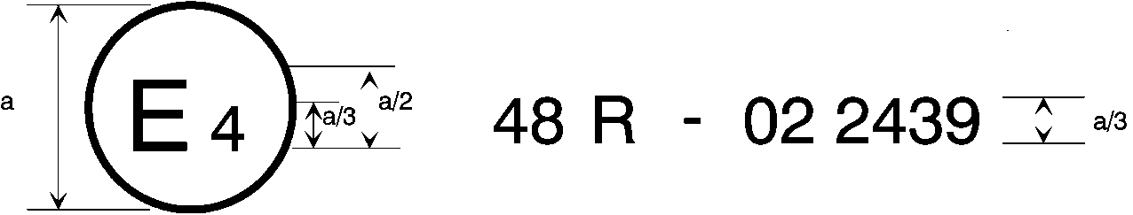
08
a = 8 mm min.
The above approval mark affixed to a vehicle shows that the vehicle type concerned has, with regard to the installation of lighting and light-signalling devices, been approved in the Netherlands (E4) pursuant to UN Regulation No. 48 as amended by the [08] series of amendments. The approval number indicates that the approval was granted in accordance with the requirements of UN Regulation No. 48 as amended by the [08] series of amendments.

Model B
(See paragraph 4.5. of this Regulation)

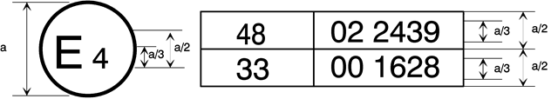
08
a = 8 mm min.
The above approval mark affixed to a vehicle shows that the vehicle type concerned has been approved in the Netherlands (E 4) pursuant to UN Regulation No. 48 as amended by the [08] series of amendments and UN Regulation No. 33.⁵ The approval number indicates that, at the dates when the respective approvals were given, UN Regulation No. 48 was amended by the [08] series of amendments and UN Regulation No. 33 was still in its original form.
__________
⁵ The second number is given merely as an example. "

II. Justification
- This proposal aims to introduce answer-back signals into R48. Many vehicles have already been fitted with answer-back signals. However, the current R48 has no provision for such signals, which may cause confusion or distraction to other road users. To address the issue, this proposal amends the Regulation to include a definition of answer-back signals, clarify that such signals may light up, and regulate them as necessary. The main requirements for an answer-back signal will be as follows.

- A new definition of answer-back signals will be given in paragraph 2.6.4. as “a flashing signal or a signal with increasing/reducing luminous intensity designed, under the park condition, to turn on in conjunction with either one or any combination of the following: the locking and unlocking of the doors, the opening and closing of the doors, the vehicle user approaching with the key” and their activation requirements will be given in paragraph 6.27.

- The maximum intensity and colour of an answer-back signal shall be the same as those of the original lamp.

- The duration of the optical indication of an answer-back signal shall not exceed 3 seconds in the same manner as the external status indicator of immobilisers.

- DRLs and reversing lamps shall not be allowed as the “types of lamps that can be used” selected based on the requests from manufacturers, because, for DRLs, they emit light upward which may cause glare for other traffic users and, for reversing lamps, they emit light upward and their white colour is supposed to tell other traffic that the vehicle is moving in the direction of the illumination, which may be misleading to other drivers.

6. This proposal document follows the example of exterior courtesy lamps introduced under GRE/2008/20, in which those lamps were prescribed as lamps that can be activated under the park condition.

