|  |  |  |  |
| --- | --- | --- | --- |
|  | United Nations | ECE/TRANS/WP.29/GRPE/2021/14 | |
| _unlogo | **Economic and Social Council** | | Distr.: General  17 March 2021  Original: English |

**Economic Commission for Europe**

Inland Transport Committee

**World Forum for Harmonization of Vehicle Regulations**

**Working Party on Pollution and Energy**

**Eighty-third session**

Geneva, 1-4 June 2021

Item 4(a) of the provisional agenda

**Heavy duty vehicles: UN Regulations Nos. 49   
(Emissions of compression ignition and positive   
ignition (LPG and CNG) engines) and 132   
(Retrofit Emissions Control devices (REC))**

Proposal for a new Supplement to 06 series of amendments to UN Regulation No. 49 (Emissions of compression ignition and positive ignition (LPG and CNG) engines)

Submitted by the expert from the International Organization of Motor Vehicle Manufacturers[[1]](#footnote-2)\*

The text reproduced below was prepared by the expert from the International Organization of Motor Vehicle Manufacturers (OICA). This document proposes to correct the improper or confusing provisions described in current text of 06 series of amendments to UN Regulation No.49. In the Part 1) the modifications (essentially corrections of mistakes) are derived from the amendments already approved by GRPE in January 2021 session, working document ECE/TRANS/WP.29/GRPE/2021/6 from EC, as modified by Informal Document GRPE-82-22. Other modifications are proposed by OICA experts in the Part 2). The modifications of the current text of the Regulation are marked in bold for new or strikethrough for deleted characters.

I. Proposal

***Part 1) - Amendments to ANNEX 4, in line with Working Document ECE/TRANS/WP.29/GRPE/2021/6 as modified by informal document GRPE-82-22***

*In Annex 4*

*Paragraph 8.4.2.3.*, *Equation (36)*, amend to read:

"…

The following equation shall be applied:

*~~m~~*~~gas~~ ~~=  (in g/test)~~

Where:

…"

*Paragraph 8.4.2.4., Equation (37)*, amend to read:

"…

The following equation shall be applied:

*~~m~~*~~gas~~ ~~=  (in g/test)~~

(37)

Where:

…"

*Paragraph 8.5.1.4.*, *Equation (54)*, amend to read:

"…

$Q_{SSV}=\frac{A_{0}}{60}d_{V}^{2}C_{d}p_{p}\sqrt{\left[\frac{1}{T}\left(r_{p}^{1.4286}-r_{p}^{1.7143}\right)∙\left(\frac{1}{1-r_{D}^{4}r_{p}^{1.4286}}\right)\right]}$ (54)

Where:

*A*0 is ~~0.006111~~**0.005692** in SI units of 

*d*V is the diameter of the SSV throat, ~~m~~**mm**

…"

*Paragraph 8.5.2.3.1.*, *Equation (57)*, amend to read:

"…

$u_{gas}=\frac{M_{gas}}{M_{d}×\left(1-\frac{1}{D}\right)+M_{e}×\left(\frac{1}{D}\right)}×\frac{1}{1000}$ (57)

…"

*Paragraph 8.6.1.,* amend to read:

"…

Depending on the measurement system and calculation method used, the uncorrected emissions results shall be calculated with equations 36, 37, 56, ~~57~~**58** or 62, respectively. For calculation of the corrected emissions, *c*gas in equations 36, 37, 56, ~~57~~**58** or 62, respectively, shall be replaced with *c*cor of equation 66. If instantaneous concentration values *c*gas,i are used in the respective equation, the corrected value shall also be applied as instantaneous value *c*cor,i. In equation**s** ~~57~~**58** **and 62**, the correction shall be applied to both the measured and the background concentration.

…"

*Paragraph 9.5.4.1.*, amend to read:

"9.5.4.1. Data analysis

…

$C_{d}=\frac{Q_{ssv}}{\frac{A_{0}}{60}×d_{V}^{2}×p_{p}×\sqrt{\left[\frac{1}{T}×\left(r_{p}^{1.4286}-r_{p}^{1.7143}\right)×\left(\frac{1}{1-r_{D}^{4}×r_{p}^{1.4286}}\right)\right]}} (89)$

Where:

*Q*SSV is the *airflow* rate at standard conditions (101.3 kPa, 273 K), m3/s

*T* is the temperature at the venturi inlet, K

*d*V is the diameter of the SSV throat, ~~m~~**mm**

…

$Re=A_{1}×60×\frac{Q_{SSV}}{d_{V}×μ}$ (90)

With

 (91)

Where:

A1 is ~~25.55152~~ **27.43831** in SI units of $\left(\frac{kg1}{m^{3}}\right)\left(\frac{min}{s}\right)\left(\frac{mm}{m}\right)$

*Q*SSV is the airflow *rate* at standard conditions (101.3 kPa, 273 K), m3/s

*d*V is the *diameter* of the SSV throat, ~~m~~**mm**

…"

*Annex 4 Appendix 2*

*Paragraph A.2.1.3.*, amend to read:

"A.2.1.3. Components of Figures 9 and 10

EP Exhaust pipe

~~SP~~**SP1** Raw exhaust gas sampling probe (Figure 9 only)

…"

*Paragraph A.2.2.1.*, amend to read:

"…

# Figure 12

# **Scheme of partial flow dilution system (total sampling type)**



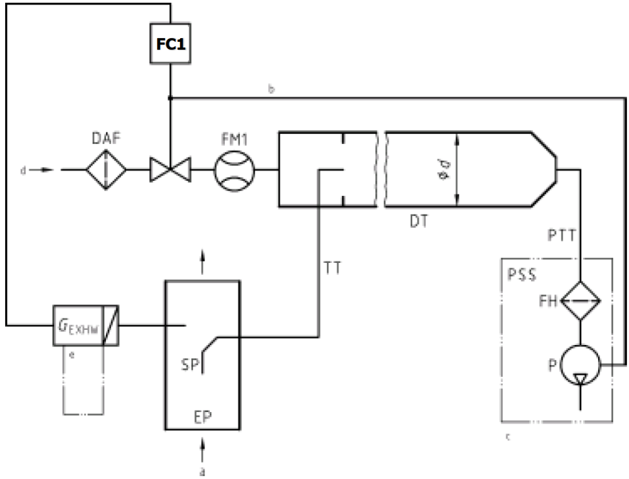

a = exhaust b = optional c = details see Figure 16

…"

*Paragraph A.2.2.5.*, amend to read:

"…

For a partial flow dilution system, a sample of the diluted exhaust gas is taken from the dilution tunnel DT through the particulate sampling probe PSP and the particulate transfer tube PTT by means of the sampling pump P, as shown in Figure 16. The sample is passed through the filter holder(s) FH that contain the particulate sampling filters. The sample flow rate is controlled by the flow controller ~~FC3~~**FC2**.

For of full flow dilution system, a double dilution particulate sampling system shall be used, as shown in Figure 17. A sample of the diluted exhaust gas is transferred from the dilution tunnel DT through the particulate sampling probe PSP and the particulate transfer tube PTT to the secondary dilution tunnel SDT, where it is diluted once more. The sample is then passed through the filter holder(s) FH that contain the particulate sampling filters. The diluent flow rate is usually constant whereas the sample flow rate is controlled by the flow controller ~~FC3~~**FC2**. If electronic flow compensation EFC (see Figure 15) is used, the total diluted exhaust gas flow is used as command signal for ~~FC3~~**FC2**.

…"

***Part 2) – Further amendments to ANNEX 4 proposed by OICA, not included in the document ECE/TRANS/WP.29/GRPE/2021/6***

*Paragraph 8.2.,* amend to read:

“8.2. NOx correction for humidity

As the NOx emission depends on ambient air conditions, the NOx concentration shall be corrected for humidity with the factors given in paragraph 8.2.1. or 8.2.2. The intake air humidity Ha may be derived from relative humidity measurement, dew point measurement, vapour pressure measurement or dry/wet bulb measurement using generally accepted equations.

**For all humidity calculations (for example Ha, Hd) using generally accepted equations the saturation vapour pressure is required. For calculating the saturation vapour pressure which is in general a function of the temperature (at the humidity measurement point) the equation D.15 specified in Annex D to ISO Standard 8178-4 should be used.”**

*Paragraph 9.2., Table 7,* amend to read:

"Table 7

**Linearity requirements of instruments and measurement systems**

|  |  |  |  |  |
| --- | --- | --- | --- | --- |
| *Measurement system* | ꭓ*min* X (*a1* - 1*)+ a0\* | *Slope a1* | *Standard error SEE* | *Coefficient of*  *Determination r2* |
| Engine speed | ≤ 0.05 % max | 0.98 - 1.02 | ≤ 2 % max | ≥ 0.990 |
| Engine torque | ≤ 1 % max | 0.98 - 1.02 | ≤ 2 % max | ≥ 0.990 |
| Fuel flow | ≤ 1 % max | 0.98 - 1.02 | ≤ 2 % max | ≥ 0.990 |
| Airflow | ≤ 1 % max | 0.98 - 1.02 | ≤ 2 % max | ≥ 0.990 |
| Exhaust gas flow | ≤ 1 % max | 0.98 - 1.02 | ≤ 2 % max | ≥ 0.990 |
| Diluent flow | ≤ 1 % max | 0.98 - 1.02 | ≤ 2 % max | ≥ 0.990 |
| Diluted exhaust gas flow | ≤ 1 % max | 0.98 - 1.02 | ≤ 2 % max | ≥ 0.990 |
| Sample flow | ≤ 1 % max | 0.98 - 1.02 | ≤ 2 % max | ≥ 0.990 |
| Gas analyzers | ≤ 0.5 % max | 0.99 - 1.01 | ≤ 1 % max | ≥ 0.998 |
| Gas dividers | ≤ 0.5 % max | 0.98 - 1.02 | ≤ 2 % max | ≥ 0.990 |
| Temperatures | ≤ 1 % max | 0.99 - 1.01 | ≤ 1 % max | ≥ 0.998 |
| Pressures | ≤ 1 % max | 0.99 - 1.01 | ≤ 1 % max | ≥ 0.998 |
| PM balance | ≤ 1 % max | 0.99 - 1.01 | ≤ 1 % max | ≥ 0.998 |
| **Humidity measurement device** | **≤ 2 % max.** | **0.98 – 1.02** | **≤ 2 %** | **≥ 0.95** |

"

*Paragraph 9.3.3.1.,* amend to read:

“9.3.3.1. Pure gas

…

Hydrogen~~-~~**~~helium~~**mixture (FID burner fuel)

(40 ± 1 per cent hydrogen, balance helium **or alternatively nitrogen**)

(Contamination ≤1 ppm C1, ≤400 ppm CO2)”

*Paragraph 9.3.6.8.,* amend to read:

“9.3.6.8. NO**x** mode

**~~Switched to~~** **Keeping** NO**x** mode with the ozonator deactivated, the flow of oxygen or synthetic air shall be shut off. The NOx reading of the analyzer shall not deviate by more than ±5 per cent from the value measured according to paragraph 9.3.6.2. (the analyzer is in the NO**x** mode).”

*Paragraph 9.3.6.2.,* amend to read:

“9.3.6.2. Calibration

The CLD and the HCLD shall be calibrated in the most common operating range following the manufacturer's specifications using zero and span gas (the NO content of which shall amount to about 80 per cent of the operating range and the NO2 concentration of the gas mixture to less than 5 per cent of the NO concentration). **With the ozonator deactivated**, the NOx analyzer shall be in the NO mode so that the span gas does not pass through the converter. The indicated concentration has

to be recorded.”

II. Justification

For Part 1)

1. Paragraph 8.4.2.3. /8.4.2.4.

In equations (36) and (37), all the calculation equations after Sigma need to be performed in Sigma. Therefore, parentheses are added to calculations after sigma.

2. Paragraph 8.5.1.4.

In the dimension of the volume flow equation, the coefficient *A0* must be divided by 60. Similarly, the coefficient *A0* must be 0.005692 in the standard conditions (273K, 101.3kPa). In addition, the unit of the SSV throat diameter *dV* must be (mm).

3. Paragraph 8.5.2.3.1.

Equation (57) needs to be multiplied by 1/1000 to adjust the number of digits. The number of digits is correctly adjusted in the equations (38) and (39), and the number of digits is similarly adjusted in the equation (57).

4. Paragraph 8.6.1.

In the text, the equation to be referenced is incorrect. It is equation (58) that needs to be referenced.

5. Paragraph 9.5.4.1.

The discharge coefficient of the SSV needs to be correlated with the SSV mass flow rate calculation formula. Therefore, the coefficient *A0* divided by 60 is added. In addition, the unit of the SSV throat diameter *dV* must be (mm).

Reynolds number must be multiplied by 60. The coefficient *A1* must be 27.43831 in the standard state (273K, 101.3kPa). In addition, the coefficient *A1* needs (kg) when converted to SI units.

6. Paragraph A.2.1.3.

In Figure 9, raw exhaust gas sampling probe is represented by “SP1”, whereas “SP” is indicated in the text. Therefore, it is necessary correctly set “SP1” in the text.

7. Paragraph A.2.2.1.

In the text, the flow controller is represented by “FC1”, whereas in Figure 12, it is “FC2”. Therefore, it is necessary to correctly set “FC1” in Figure 12.

8. Paragraph A.2.2.5.

In Figure 16 and Figure 17, the sample flow controller is represented as “FC2”, whereas in the text, it is “FC3”. Therefore, it is necessary correctly set “FC2” in the text.

For Part 2)

1. UN Regulation No.49 defines no linearity requirements for humidity sensors. As the humidity content of the intake air is an essential measure for the calculation of the specific exhaust emission, it is important to add requirement for humidity sensor.

Reference: ISO 16183 the accuracy of the absolute humidity shall be +- 5%.

2. Typo error, the instrument should be now in NOx mode.

3. To clarify the operation procedure, make the text easier to be understood.

1. \* In accordance with the programme of work of the Inland Transport Committee for 2021 as outlined in proposed programme budget for 2021 (A/75/6 (Sect.20), para 20.51), the World Forum will develop, harmonize and update UN Regulations in order to enhance the performance of vehicles. The present document is submitted in conformity with that mandate. [↑](#footnote-ref-2)