|  |  |  |  |
| --- | --- | --- | --- |
|  | United Nations | ST/SG/AC.10/48/Add.2 | |
| _unlogo | **Secretariat** | | Distr.: General  23 March 2021  English  Original: English and French |

**Committee of Experts on the Transport of Dangerous Goods  
and on the Globally Harmonized System of Classification  
and Labelling of Chemicals**

Report of the Committee of Experts on the Transport of Dangerous Goods and on the Globally Harmonized System of Classification and Labelling of Chemicals on its tenth session

held in Geneva on 11 December 2020

Addendum

Annex II

Amendments to the 7th revised edition of the Manual of Tests and Criteria (ST/SG/AC.10/11/Rev.7)

General table of contents

13 Replace “is an unstable explosive” by “can be assigned a division”.

14 Replace “is too dangerous for transport and classified as a GHS unstable explosive” by “can be assigned a division”.

Section 10

10.1.2 Amend to read as follows:

“10.1.2 The GHS hazard class of explosives covers all sectors. Class 1 of the Model Regulations is a subset of this class and comprises explosives as configured for transport.

Goods of class 1 must be assigned to one of the six divisions, depending on the type of hazard they present (see Chapter 2.1, paragraph 2.1.1.4 of the Model Regulations) and to one of the thirteen compatibility groups that identify the kinds of explosives that are deemed to be compatible. The division, and occasionally the compatibility group, is also used as a basis for classification in the GHS hazard class for explosives (see Chapter 2.1, section 2.1.2, of the GHS). In addition, the GHS hazard class also comprises explosives that are not assigned a division.

Explosives that are not assigned a division are forbidden for transport.”

The existing text in 10.1.2 starting with “The general scheme for...” is transferred to a new 10.1.3.

Renumber existing 10.1.3 and 10.1.4 as 10.1.4 and 10.1.5.

10.1.4 (renumbered) In the first sentence, replace “as presented” by “as configured”. In the last sentence, replace “transport classifications” by “classifications in the transport configuration”.

10.3.1.1 Amend to read as follows:

“10.3.1.1 The acceptance procedure is used to determine whether or not a substance or article as offered for classification is a candidate for the class of explosives. This is decided by determining whether a substance is either too insensitive for inclusion in this class or is accepted as an explosive but considered too sensitive to mechanical stimuli, heat or flame to assign a division; or whether the article or packaged article is accepted as an explosive but considered too sensitive to impact or heat to assign a division.”

Figure 10.1 In the box “CLASSIFY AS AN UNSTABLE EXPLOSIVE”, delete “UNSTABLE” and add a new line to read “No division assigned”.

Figure 10.2 In box 13, replace “unstable” by “too sensitive to assign a division”.

In box 16, replace “an unstable explosive” by “too sensitive to assign a division”.

Amend box 17 to read:

“CLASSIFY AS AN EXPLOSIVE

No division assigned”

In box 19, replace “ACCEPT INTO THIS CLASS” by “CLASSIFY AS AN EXPLOSIVE”.

10.3.2.4 In the first sentence, replace “unstable” by “too sensitive to assign a division”.

10.3.2.5 In the first sentence, replace “an unstable explosive” by “too sensitive to assign a division”.

10.4.1.1 Amend the first two sentences to read as follows:

“Unless considered too sensitive to assign a division, explosives may be assigned one of six divisions, depending on the type of hazard they present (see paragraph 2.1.1.4 of the Model Regulations and 2.1.2 of the GHS). Assigning a division is a prerequisite for the transport of explosives (see paragraph 10.1.2). The assignment procedure (figures 10.3 and 10.5) describes how to assign the division for explosive substances and articles. Explosives may also be declared from the outset to be in Division 1.1.”

In the next sentence, replace “assigned to” by “assigned”.

In the penultimate sentence, replace “2.1.1.2 (b) of the GHS” by “2.1.1.2.1 (b) of the GHS”.

Figure 10.4 In box 6, delete “unstable” and, at the end, add a full stop and “No division assigned.”.

In box 7, delete “other than as an unstable explosive” and replace the semicolon by a full stop.

Figure 10.6 (a) In the row for “Box 13”, replace “unstable” by “too sensitive to assign a division”.

Figure 10.6 (b) In box 13, replace “unstable” by “too sensitive to assign a division”.

In box 16, replace “an unstable explosive” by “too sensitive to assign a division”.

Amend box 17 to read:

“CLASSIFY AS AN EXPLOSIVE

No division assigned”

In box 19, replace “ACCEPT INTO THIS CLASS” by “CLASSIFY AS AN EXPLOSIVE”.

Figure 10.7 (a) In the row for “Box 13”, replace “unstable” by “too sensitive to assign a division”.

Figure 10.7 (b) In box 13, replace “unstable” by “too sensitive to assign a division”.

In box 16, replace “an unstable explosive” by “too sensitive to assign a division”.

Amend box 17 to read:

“CLASSIFY AS AN EXPLOSIVE

No division assigned”

In box 19, replace “ACCEPT INTO THIS CLASS” by “CLASSIFY AS AN EXPLOSIVE”.

Section 13

13.1 Amend the text below the heading to read as follows and delete the note:

“This test series is used to answer the questions in boxes 12 and 13 of Figure 10.2 by determining the sensitiveness of the substance to mechanical stimuli (impact and friction), to heat and to flame. The question in box 12 is answered "no" if a "+" is obtained in test type 3(c) and the substance is considered too sensitive to assign a division. The question in box 13 is answered "yes" if a "+" is obtained in any of the test types 3(a), 3(b) or 3(d). If a "+" is obtained, the substance is considered too sensitive to assign a division in the form in which it was tested but may be encapsulated or otherwise desensitized or packaged to reduce its sensitiveness to external stimuli.”

13.4.1.1 In the first sentence, replace “an unstable explosive” by “too sensitive to assign a division”.

13.4.1.4.1 In the first sentence, replace “an unstable explosive” by “too sensitive to assign a division”.

13.4.1.4.2 In the first sentence, replace “an unstable explosive” by “too sensitive to assign a division”.

13.4.2.1 In the first sentence, replace “an unstable explosive” by “too sensitive to assign a division”.

13.4.2.4 In the paragraph after the indents, in the first sentence, replace “an unstable explosive” by “too sensitive to assign a division”.

13.4.3.1 In the first sentence, replace “an unstable explosive” by “too sensitive to assign a division”.

13.4.3.4.1 In the paragraph after the indents, in the first and last sentences, replace “an unstable explosive” by “too sensitive to assign a division”.

13.4.3.4.2 In the paragraph after the indents, in the third and penultimate sentences, replace “an unstable explosive” by “too sensitive to assign a division”.

13.4.4.1 Replace “an unstable explosive” by “too sensitive to assign a division”.

13.4.4.4 In the paragraph after the indents, in the first sentence, replace “an unstable explosive” by “too sensitive to assign a division”.

13.4.5.1 In the first sentence, replace “an unstable explosive” by “too sensitive to assign a division”.

13.4.5.4.2 In the first sentence, replace “an unstable explosive” by “too sensitive to assign a division”.

13.4.5.4.3 In the first sentence, replace “an unstable explosive” by “too sensitive to assign a division”.

13.4.6.1 Replace “an unstable explosive” by “too sensitive to assign a division”.

13.4.6.4.1 In the paragraph after the indents, in the first sentence, replace “an unstable explosive” by “too sensitive to assign a division”.

13.4.6.4.2 In the paragraph after the indents, in the first sentence, replace “an unstable explosive” by “too sensitive to assign a division”.

13.4.7.1 Replace “an unstable explosive” by “too sensitive to assign a division”.

13.4.7.5.1 In the first sentence, replace “an unstable explosive” by “too sensitive to assign a division”.

13.4.7.5.2 In the first sentence, replace “an unstable explosive” by “too sensitive to assign a division”.

13.5.1.1 Replace “an unstable explosive” by “too sensitive to assign a division”.

13.5.1.4 In the paragraph after the indents, in the first sentence, replace “an unstable explosive” by “too sensitive to assign a division”.

13.5.2.1 Replace “an unstable explosive” by “too sensitive to assign a division”.

13.5.2.4 In the paragraph after the indents, in the first and last sentences, replace “an unstable explosive” by “too sensitive to assign a division”.

13.5.3.1 Replace “an unstable explosive” by “too sensitive to assign a division”.

13.5.3.4 In the paragraph after the indents, in the first sentence, replace “an unstable explosive” by “too sensitive to assign a division”.

13.5.4.1 Replace “an unstable explosive” by “too sensitive to assign a division”.

13.5.4.5 In the first sentence, replace “an unstable explosive” by “too sensitive to assign a division”.

13.6.1.3.1 Replace “too thermally unstable for transport and shall be categorized as an unstable explosive” by “considered too sensitive to assign a division”.

13.6.1.4.2 Replace “, shall be categorised as an unstable explosive and is not permitted for transport” by “and therefore too sensitive to assign a division”.

13.6.2.4.2 Replace “, shall be categorised as an unstable explosive and is not permitted for transport” by “and therefore too sensitive to assign a division”.

13.7.1.3 In the paragraph after the indents, in the second sentence, replace “an unstable explosive” by “too sensitive to assign a division”.

Section 14

14.1.1 In the first sentence, replace “too dangerous for transport” by “too sensitive to assign a division”.

14.4.1.1 In the first sentence, replace “too hazardous for transport” by “too sensitive to assign a division”.

14.4.1.4 In the first sentence, replace “too dangerous for transport” by “too sensitive to assign a division”.

14.5.1.4 In the first paragraph, replace “too dangerous to be transported” by “too sensitive to assign a division”.

14.5.2.4 In the first sentence, replace “too dangerous to transport” by “too sensitive to assign a division”.

Section 20

20.3.3.3 In the first sentence, after “differential scanning calorimetry” add “(DSC)”.

Modify the last sentence to read as follows: “If DSC is used, the onset temperature is defined as the temperature of the first noticeable exothermic effect (i.e. the heat production signal leaves the baseline).”

Insert a new section 20.3.4 to read as follows:

“**20.3.4 Thermal stability of samples and temperature control assessment for transport**

20.3.4.1 The provisions in this section are only applicable to samples of sections 2.4.2.3.2.4 (b) and 2.5.3.2.5.1 in cases where the SADT is not known.

20.3.4.2 If the decomposition onset in a DSC measured in accordance with 20.3.3.3 is found at 160 °C or above, the estimated SADT of the sample may be assumed to be greater than 55 °C. According to 2.4.2.3.4 of the Model Regulations, temperature control is not required in such cases. Isolated small exotherms less than 20 J/g preceding the main decomposition may be neglected.

20.3.4.3 For purposes of determining the need for temperature control, a thermal stress test based on DSC measurements may be applied as follows: A DSC is measured as outlined in 20.3.3.3 for the sample as offered for transport. A second sample is taken, and thermal stress is applied by tempering the sample in the closed DSC crucible at a defined constant temperature over a certain period of time. In standard cases, a 24-hour stress time is deemed sufficient. The stressed sample is then cooled to room temperature before being subjected to a DSC measurement at the same heating rate as before. If the decomposition behavior remains unchanged by comparison of the two DSCs in terms of decomposition onset, shape of curve, and energy within a measurement uncertainty of 10 %, the sample is considered stable at the applied stress temperature. For flat peaks with a maximum heat production of 0.2 W/g a deviation of 25 % is tolerable in temperature ranges below 250 °C and 40 % above this limit. If the stress test is passed according to these criteria at 60 °C, then no temperature control is required.

20.3.4.4 If the sample fails the stress test at 60 °C, then the same procedure should be applied at decreasing temperatures in steps of 10 K until the decomposition behavior remains unchanged. That temperature should be deemed the estimated SADT of the sample, and the control and emergency temperatures may then be derived in accordance with section 28.2.3 and table 28.2.

20.3.4.5 Examples for passing the thermal stress test are shown in figure 20.2. Figure 20.3 contains examples of samples failing the stress test. A flow chart for the procedure is given in figure 20.4.

**Figure 20.2: Examples of samples passing the thermal stress test**

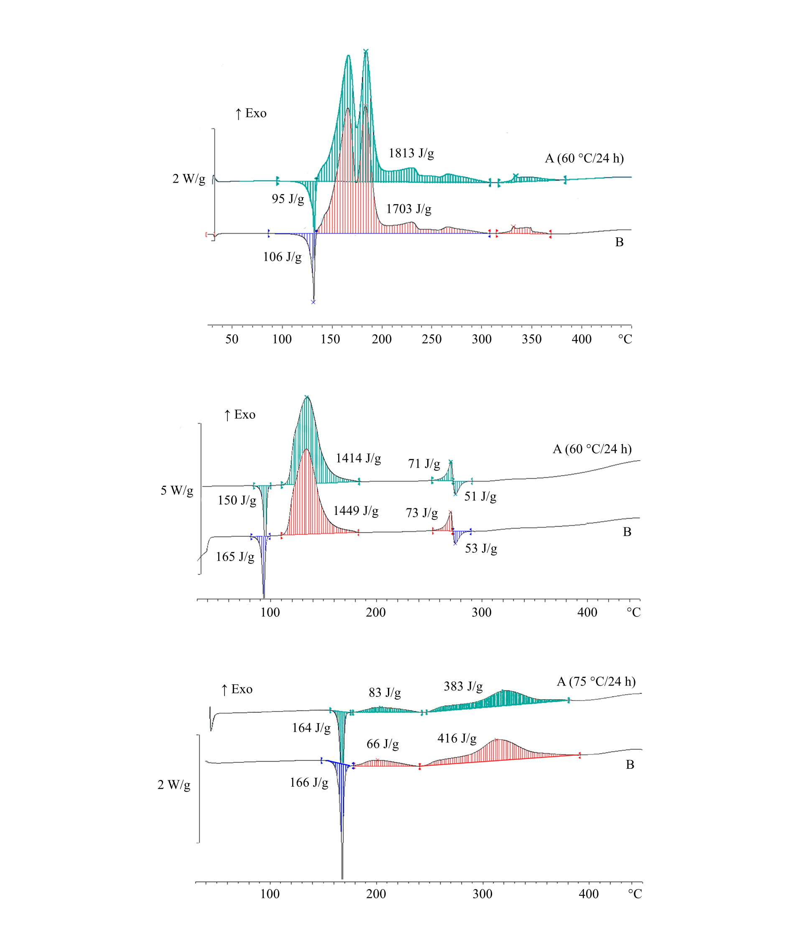

|  |  |  |  |
| --- | --- | --- | --- |
| (A) | Sample after thermal stress | (B) | Original sample |

**Figure 20.2: Examples of samples passing the thermal stress test (continued)**

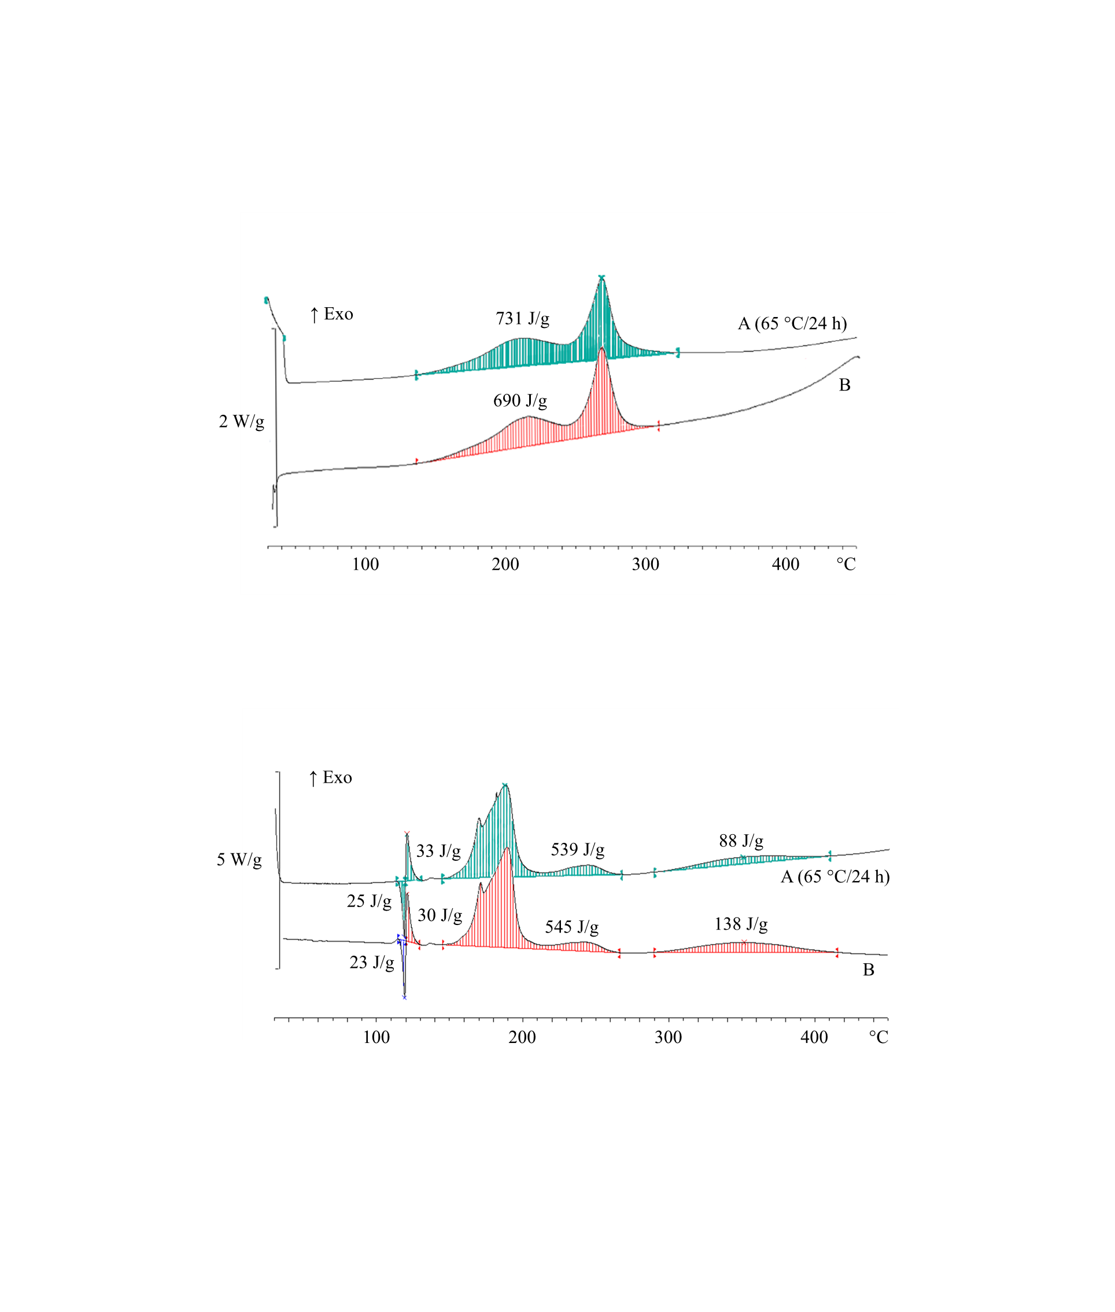

|  |  |  |  |
| --- | --- | --- | --- |
| (A) | Sample after thermal stress | (B) | Original sample |

**Figure 20.3: Examples of samples failing the thermal stress test**

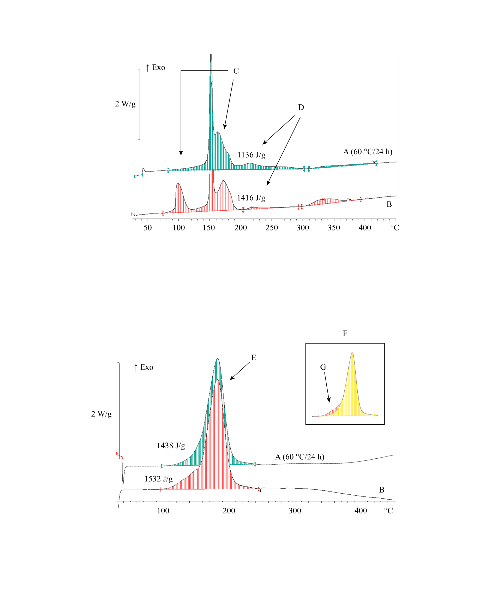

|  |  |  |  |
| --- | --- | --- | --- |
| (A) | Sample after thermal stress | (B) | Original sample |
| (C) | Fail due to different peak shape | (D) | Fail due to degradation (loss of energy > 10 %) |
| (E) | Fail due to different peak shape in spite of tolerable energy | (F) | Overlay of graphs |
| (G) | Shoulder of peak missing after thermal stress |  |  |

**Figure 20.4: Flow chart scheme for the assessment of thermal stability of samples according to 20.3.4**



***NOTE 1:*** *Isolated small exotherm (< 20 J/g) preceding the main decomposition may be neglected;*

***NOTE 2:*** *General tolerance for energy comparison due to measurement uncertainty: 10 %. For flat peaks with a maximum heat production of 0.2 W/g a deviation of 25 % is tolerable in temperature ranges below 250 °C and 40 % above this limit.*”

Renumber figures 20.2 and 20.3 as 20.5 and 20.6 respectively and update cross references in paragraph 20.5.1.

Section 28

28.1 Renumber the first paragraph under 28.1 as 28.1.1 and amend as follows:

The first amendment does not apply to the English text.

Amend the last sentence before the current sub-paragraphs (a) to (c) to read “To assist in interpreting the results, the following models can be used**1**:”

Replace current sub-paragraphs (a) to (c) with the following:

“ (a) Semenov model, in which the main resistance to heat flow is at the boundary (i.e. packaging). This model is generally applicable to homogeneous liquids but can also be applied to solids in packagings (excluding IBCs);

(b) Frank-Kamenetskii model, in which the main resistance to heat flow is within the substance.  This model is generally applicable to solids in larger packagings, IBCs or tanks;

(c) Thomas model, in which the resistance to heat flow is from both the boundary and the substance;

(d) Non-stationary models, e.g. finite element methods (FEM), or computational fluid dynamics (CFD) all combined with thermal kinetic methods.”

The references currently at the end of the paragraph become footnote “1” to read as follows:

“1 *References: N.N. Semenov, Z. Physik, 48, 1928, 571; D.A. Frank-Kamenetskii, Zhur. Fiz. Khim., 13, 1939, 738; P.H. Thomas, Trans. Faraday Soc., 54, 1958, 60.*”

Renumber the sentence “The text should be used….2.5.3.4 of the Model Regulations” as 28.1.2.

Insert the following new paragraph 28.1.3:

“28.1.3 Both the SADT and the SAPT may be influenced by factors such as aging of the sample, presence of stabilizers or impurities in the sample (including packaging materials in contact with the substance). These possible influencing factors should be considered when evaluating the results of an SADT or SAPT determination.”.

28.2.2 In table 28.1, amend the name of the test H.1 to read: “United States SADT/SAPT test” and replace “(IST)” by “(IST)b”.

28.2.6 Replace “The results obtained for the largest commercial package” by “The results obtained for larger packages”.

28.3.4 Replace “should be used for the actual determination” by “should be used for the final determination”.

28.3.5 Insert the following sentences after the first sentence:

“For all type of packagings up to 50 kg for solids or 200 kg/225 litres for liquids and for IBCs up to 1250 litres for liquids, a standard heat loss per unit of mass is given in Table 28.4. For other packagings, IBC’s or tanks or when there is a need for a heat loss value that deviates from the one as given in Table 28.4, the actual heat loss value per unit of mass has to be determined.”

In the sentence currently starting with “The heat loss per unit of mass”, amend the beginning to read “In this case, the heat loss per unit of mass of the package…” and replace “…heat transfer in the substance and the heat transfer through the packaging to the environment)” by “…heat transfer in the substance, heat transfer through the packaging and heat transfer from the outer wall of the packaging to the environment (see note))…”.

Insert a note to read as follows:

*“****NOTE:*** *For calculations, an external heat transfer coefficient (i.e. heat transfer from the outer wall of the packaging to the environment) of 5 W/m2.K can be used.”*

28.3.6 In the first sentence, replace “and surroundings” by “and its surroundings”.

Insert the following new fourth sentence: “For solids, for example, the packaging may be filled with dense soda ash (apparent density greater than 1 g/cm3) and this is heated to about 80 °C.”.

28.3.7 Amend the beginning of the first sentence to read as follows: “Standard heat loss characteristics of packages, IBCs and tanks are given in Table 28.4.”.

Replace current table 28.4 and its related notes with the following:

**“Table 28.4: Heat loss per unit mass from packages, IBCs and tanks**

|  |  |  |
| --- | --- | --- |
| **Type of receptacle** | **Normal capacity** | **Heat loss per unit mass, L (mW/K·kg)a** |
| **For liquids:** |  |  |
| Packagings | up to 200 kg/225 *l* | 40b |
| Packagings | larger than 200 kg/225 *l* | no standard valuec |
| IBCs | up to 1250 *l* | 30 |
| IBCs | larger than 1250 *l* | no standard valuec |
| Tanks | - | no standard valuec |
|  |  |  |
| **For solids:** |  |  |
| Packagings | up to 50 kg | 30b |
| Packagings | larger than 50 kg | no standard valuec |
| IBCs | - | no standard valuec |
| Tanks | - | no standard valuec |
| a *For test series H.4 the heat loss of the Dewar vessel to be used should be as close as possible to the value listed in the table.*  b *When determining the SADT for exemption or classification purposes, where the definition of the SADT is connected to a 50 kg package, a value of 60 mW/K·kg for liquids and 30 mW/K·kg for solids should be used. Such is the case when the SADT is used either to exclude a new substance from Division 4.1 as a self-reactive substance (see 20.2.1(e)), or to classify it under Type G as a self-reactive substance (see 20.4.2 (g)), or organic peroxide (see 20.4.3 (g)).*  c *Value should be determined for the actual configuration.* | | |

”.

28.4.1 Amend the name of the test to read: “United States SADT/SAPT test”.

28.4.1.1 In the first sentence, replace “self-accelerating decomposition” by “self-accelerating decomposition or polymerization” and in the last sentence delete “or polymerization reaction”.

28.4.1.2.3 In (c) insert “for all sides” after “distance”.

In the paragraph following (c), amend the last sentence to read as follows: “Examples of suitable small-package and large-package ovens are described below.”.

28.4.1.2.4 and 28.4.1.2.5 Amend current paragraphs 28.4.1.2.4 and 28.4.1.2.5 as follows:

* Current paragraph 28.4.1.2.4 becomes 28.4.1.2.3.1 with the following heading: “28.4.1.2.3.1 Example 1”. *(The text of current paragraph 28.4.1.2.4 remains unchanged).*
* Current paragraph 28.4.1.2.5 becomes 28.4.1.2.3.2 with the following heading: “28.4.1.2.3.2 Example 2”. *(The text of current paragraph 28.4.1.2.5 remains unchanged).*

Insert a new paragraph 28.4.1.2.3.3 to read as follows:

“28.4.1.2.3.3 Example 3

For tests at temperatures up to 75 °C, a double walled metal chamber (minimum separation distance from the package to the wall is 100 mm) may be used with fluid from a temperature-controlled circulating bath passed between the walls at the desired temperature. The test chamber is loosely closed by an insulated lid (e.g. made from 10 mm thick polyvinyl chloride). The temperature control should allow the desired temperature for a liquid inert sample to be maintained with a deviation of not more than ± 2 K for up to 10 days.”.

Renumber current paragraphs 28.4.1.2.6 to 28.4.1.2.8 as 28.4.1.2.4 to 28.4.1.2.6.

28.4.1.2.4 (new, former 28.4.1.2.6), in the first sentence insert “or Resistance Temperature Detector (RTD)” after “thermocouple”.

28.4.1.3.1 At the beginning of the second sentence insert “or RTD” after “thermocouple”.

28.4.1.3.2 Delete the last sentence (“Note the time…. maximum temperature.”).

28.4.1.3.4 Amend the end of the third sentence to read as follows: “…to determine if the SADT or SAPT is greater than the applicable temperature specified in Table 28.2.”.

28.4.1.5 In the table, insert the following rows at the end:

|  |  |  |  |
| --- | --- | --- | --- |
| **Substance** | **Sample mass  (kg)** | **Packaging** | **SADT/SAPT  (°C)** |
| Didecanoylperoxide, technically pure | 20 | 1G | 40 |
| 2,2´-Azodi-(isobutyronitrile) | 50 | 1G | 50 |

Figure 28.4.1.1 Amend the heading to read: “Small package oven (Example 1)”

Figure 28.4.1.2 Amend the heading to read: “Large package oven (top view and side view) (Example 2)”

28.4.2.1.1 In the second sentence replace “heat loss data relating to the package” by “heat loss data of the package”. Add the following last sentence and its related sub-paragraphs (a) and (b):

“There are two versions of the adiabatic storage test:

(a) Open version: A Dewar vessel within an oven is used. This set-up uses a capillary to prevent pressure build-up and a cooling system to limit the temperature increase due to a thermal runaway reaction;

(b) Closed version: A test vessel (e.g. Dewar or thin-walled vessel) is placed within an autoclave in an oven. Here the autoclave prevents the release of pressure to the surroundings during the test.”

28.4.2.1.2 Amend to read as follows:

“28.4.2.1.2 The smallest temperature rise that can be detected with this method depends on the properties of the sample, but generally corresponds to a heat generation rate of 15 mW/kg. The upper limit of the open version is determined by the capacity of the cooling system to safely cool the substance (up to 500 W/kg if water is used as coolant). The closed version can disregard this limit if performed in a high-pressure autoclave. The maximum allowable error in heat generation is 30 % at 15 mW/kg and 10 % from 100 mW/kg to 10 W/kg. The detection limit of the adiabatic test should be suitable for assessing the heat loss from the package under consideration (e.g. 100 to 500 mW/kg for L = 60 mW/K·kg). If significant extrapolation of heat production rates derived from adiabatic test data is required, a validation with additional isothermal tests is recommended.”

28.4.2.1.3 Replace the first sentence by the following:

“An explosion may occur in the open version of the test if the cooling system is activated at a stage where the rate of heat generation exceeds the cooling capacity of the apparatus. For the closed version an explosion could lead to a rupture of the autoclave or its fittings.”

28.4.2.2.1 Insert a heading to read as follows: “Open version” and amend the existing paragraph as follows:

* In the first sentence, replace “(1.0 or 1.5 litre)” by “(max. 3 litres) and insert a comma after “sample temperature”;
* Amend the fourth sentence to read as follows: “Pressure build-up in the Dewar vessel is prevented by a sufficiently long capillary tube made of an inert substance (e.g. 2 m long PTFE tube) through the insulated lid.”.
* In the seventh sentence replace “a secondary safety device is fitted which disconnects the power supply” by “a secondary safety device is used to disconnect the power supply”
* Amend the last sentence to read as follows: “A schematic drawing of an open apparatus for the adiabatic storage test is given in Figure 28.4.2.1.”.

28.4.2.2.2 Insert the following new paragraphs (current 28.4.2.2.2 becomes 28.4.2.2.3):

“28.4.2.2.2 Closed version

28.4.2.2.2.1 The apparatus consists of a suitable inert vessel (e.g. Dewar or thin-walled test cell) to contain the sample, a high-pressure autoclave and an insulated oven with a differential temperature control system. Thin-walled test cells require the use of a pressure control system to balance the internal and external cell pressure.

28.4.2.2.2.2 The phi-factor (heat capacity of the set-up and the sample divided by heat capacity of the sample) of the system should be known and be considered in evaluating the tests results. Therefore, a suitable combination of phi-factor, insulation, and amount of substance should be chosen. The heat losses from the apparatus and detection limit of the system also have to be taken into consideration. An inert heating coil may be inserted into the sample. In addition to the high-pressure autoclave, a secondary safety device is used to disconnect the power supply to the oven at a pre-set temperature.

28.4.2.2.2.3 The closed version of the test is preferred for substances with a high vapour pressure at the test temperature to prevent mass loss due to evaporation or for substances that decompose with severe pressure rises (which in case of an open version of the test would throw off the insulated lid or eject the sample from the test cell). The weight of the sample should be determined after the measurement to detect mass loss during the test. Leakage from the system and the resulting evaporation cooling can result in a significant loss of sensitivity in the test and a large margin of error in the results. The suitability of a test run in the open version can be evaluated by determining the mass loss of the sample after the test.”.

28.4.2.2.3 (new, former 28.4.2.2.2) Amend as follows:

* In the first sentence, after “platinum resistance sensors” insert “(RTD)”;
* In the second sentence, replace “surrounding air” with “surroundings”;
* Amend the end of the third sentence to read as follows: “…to monitor the temperature of the substance as well as (the air) in the oven.”.
* Amend the last sentence to read as follows: “For substances with an SADT or SAPT below ambient temperature, the test should be performed with sufficient cooling.”.

28.4.2.3.1 Amend to read as follows:

“28.4.2.3.1 Validation procedures

(a) The validation procedure A is as follows:

(i) Fill the Dewar vessel with a suitable inorganic salt, preferably with similar physical properties to the test substance (e.g. sodium chloride or dense soda ash). Alternatively, an oil of known specific heat capacity at the temperature of interest (e.g. silicone oil, apparent density 0.96 ± 0.02 at 20 °C and heat capacity 1.46 ± 0.02 J/g at 25 °C) may be used;

(ii) Place the Dewar vessel in the vessel holder of the oven and heat the validation substance in 20 °C steps using the internal heating system at a known power rating (e.g. 0.333 W or 1.000 W) and determine the heat losses at 40 °C, 60 °C, 80 °C and 100 °C;

(iii) Use the data to determine the heat capacity of the Dewar vessel and the test set-up using the method given in 28.4.2.4.

(b) The validation procedure B is as follows:

(i) In order to perform validation procedure B the test set-up should be well characterized (e.g. by performing validation procedure A first);

(ii) The test set-up must be validated using the method described in 28.4.2.4 with at least two standard substances or mixtures. Suitable choices for these standards are dicumylperoxide in ethylbenzene**2** (40:60 % w/w, SADT for a heat loss of 60 mW/K·kg should be 90 °C), or any of the substances from the example of results tables in chapter 28.”

Add the following footnote 2:

“2 *Reference: Dürrstein S., Kappler C., Neuhaus I., Malow M., Michael-Schulz H., Gödde M., 2016, Modell-based prediction of the adiabatic induction period and SADT of dicumyl peroxide solution and comparison to large-scale experiments performed using 216.5-liter barrels in the H.1 test, Chemical Engineering Transactions, 48, 475-480.”.*

28.4.2.3.2 Amend to read as follows:

“28.4.2.3.2 Test procedure

The test procedure is as follows:

(a) Fill the Dewar vessel/test cell with the weighed sample, including a representative amount of packaging material (if necessary), and place it in the vessel holder of the oven;

(b) Start the temperature monitoring and then increase the sample temperature to a pre-set temperature at which detectable self-heating may occur. The specific heat of the substance can either be calculated from the temperature rise, heating time and heating power, or be determined by any suitable calorimetric test method beforehand;

(c) Heat the sample to the set temperature, maintain the oven temperature and monitor the sample temperature. If no temperature rise due to self-heating is observed after temperature equilibration of the system (e.g. 24 h for the open system), increase the oven temperature by 5 °C. Repeat this procedure until self-heating is detected;

For the closed version the apparatus can be heated with < 0.5 W/kg until self-heating is detected. The heating power per unit mass should remain below the sensitivity for self-heating detection of the test equipment or autoclave;

(d) When self-heating is detected, the sample is allowed to heat up under adiabatic conditions to a pre-set temperature, at which point the cooling system is activated or the oven temperature has reached its limit;

For the open version this temperature should be set so that the rate of heat generation does not exceed the cooling capacity of the system;

For the closed version this temperature is usually a pre-set maximum oven temperature. The sample may exceed this temperature under non-adiabatic conditions.”.

28.4.2.4.1 Replace “°C/h” by “K/h”.

28.4.2.4.2 In the first sentence, replace “J/°C” by “J/K”. For “A” and “B”, replace the units by “K/h” and for Cp₁ by “J/K·kg”. For “B”, “M₁”and“Cp₁”, replace “calibration” by “validation”.

28.4.2.4.4 In the first sentence, replace “J/kg.°C” by “J/K·kg”. For “C”, replace “°C/h” by “K/h”.

28.4.2.4.5 Replace the unit for “D” by “K/h”.

28.4.2.4.6 In the first sentence insert “(QT)” after “per unit of mass”. In the second sentence, replace the unit of “L” by “W/K·kg”.

28.4.2.5 In the heading of the table, fourth column, replace “mW/kg.K” by “mW/K·kg”.

Insert a reference to note “a” against the name of the substances currently listed in the table and add a new row at the end as follows:

|  |  |  |  |  |
| --- | --- | --- | --- | --- |
| **Substance** | **Mass  (kg)** | **Packaging** | **Heat loss per unit mass (mW/K·kg)** | **SADT/SAPT  (°C)** |
| N-Vinylformamide | 1000 | 31H1 | 33 | 55 |

Add the following note “a” under the table:

*“a These historical examples were determined using heat losses that are higher than those currently recommended for classification purposes (see table 28.4).”.*

Figure 28.4.2.2 Replace with the following:

“**Figure 28.4.2.2: Example of determination of SADT or SAPT**



|  |  |  |  |  |  |  |
| --- | --- | --- | --- | --- | --- | --- |
|  | |  | |  | |  |
|  | Heat generation curve | |  | | Heat loss curve L = 0.06 W/K·Kg | | |
| (A) | Critical ambient temperature  (intercept of heat loss with the abscissa) | | (B) | | SADT or SAPT (critical ambient temperature rounded up to next higher multiple of 5 °C) | | |

”.

28.4.3.1.2 Delete. Current paragraph 28.4.3.1.3 becomes new paragraph 28.4.3.1.2.

28.4.3.1.2 (new, former 28.4.3.1.3) Amend the beginning of the first sentence to read as follows: “The usually robust construction of readily available apparatus, …”.

28.4.3.2 Amend the section to read as follows:

“28.4.3.2 *Apparatus and materials*

28.4.3.2.1 Isothermal calorimetry (IC)

Appropriate isothermal calorimeters can be used. The equipment should be able to measure heat generation values of 1 mW/kg to 1500 mW/kg in a temperature range of -20 °C to 200 °C. The maximum error in the heat generation should be less than 5 %. The equipment should be capable of maintaining the temperature to within 0.2 °C of the set temperature. Sample mass of test material should be at least 200 mg. Closed pressure resistant sample holders should be used and the material of the sample holder should not have catalytic effect on the decomposition behaviour of the test substance. This can be achieved by selecting the appropriate materials for the sample holders or by an appropriate passivation method of the sample holders.

28.4.3.2.2 The sample holder is placed on or around heat flow meter. The amount of substance in the sample holder is at least 200 mg. The material of the holder should be compatible with the sample. If an external reference is used it should be handled identical to the sample.

28.4.3.2.3 The heat flow from the sample is continuously recorded as a function of time (differential measurement) by a recorder or computer.”.

28.4.3.3 Amend the section to read as follows:

“28.4.3.3 *Procedure*

28.4.3.3.1 Calibration procedure

Before a measurement can be performed, the blank signal and the sensitivity of the heat flow meter need to be determined by the applicable calibration procedure for the equipment used covering the temperature range of the measurement.

28.4.3.3.2 Test procedure

The test procedure is as follows:

(a) Set the apparatus for the desired test temperature. The temperature selected should be sufficient to give a rate of heat generation between 5 mW to 1000 mW per kg of substance or for tanks a maximum heat generation rate between 1 and 100 mW/kg;

(b) Fill the sample holder with the weighed sample and with a representative quantity of packaging material (if metal) and insert the holder into the apparatus;

(c) Start monitoring the rate of heat production. The duration of each test depends on the test temperature and on the rate of heat production.   
The measuring time as given in Figure 28.4.3.1 can be used as guidance unless it leads to unrealistic measuring times (e.g. greater than 1000 hours). These measuring times are given to achieve a certain degree of conversion of the substance in order to take auto-catalytic effects into account**3**;

(d) At the end of the test the change in sample mass should be determined;

(e) The test is repeated with new samples at temperature intervals of 5 °C so that there are at least five results with a maximum heat generation rate between 5 and 1000 mW/kg or for tanks a maximum heat generation rate between 1 and 100 mW/kg.

**Figure 28.4.3.1: Measuring period as a function of maximum heat generation measured**

”

Insert a new footnote “3” to read as follows:

*“3 References:*

*1) J. L. C. van Geel, Investigations into Self-Ignition Hazard of Nitrate Ester Propellants, Thesis, Technical University of Delft, The Netherlands, 1969.*

*2) Barendregt, R.B., Thermal Investigation of Unstable Substances, Including a Comparison of Different Thermal Analytical Techniques, Thesis, Technical University of Delft, The Netherlands, 1981.”*

28.4.3.4.1 and 28.4.3.4.2 Delete. Current 28.4.3.4.3 becomes 28.4.3.4.1.

In the renumbered 28.4.3.4.1, in the second sentence, replace “mW/kg.°C” by “mW/K·kg”

28.4.3.5 In the heading of the table, replace “mW/kg.K” by “mW/K·kg”.

Insert a reference to note “a” against the names of all current substances listed in the table and add the following entries at the end:

|  |  |  |  |  |
| --- | --- | --- | --- | --- |
| **Substance** | **Mass (kg)** | **Packaging** | **Heat loss per unit mass (mW/K·kg)** | **SADT/SAPT (°C)** |
| Cumyl peroxyneodecanoate (75 %) | 25 | 3H1 | 40 | 10 |
| tert-Butyl peroxyneodecanoate | 25 | 3H1 | 40 | 15 |
| N-Vinylformamide | 1000 | 31H1 | 33 | 55 |

Add the following note “a” under the table:

**“a** *These historical examples were determined using heat losses that are higher than those currently recommended for classification purposes (see table 28.4).”.*

Current figures 28.4.3.1 and 28.4.3.2 Delete.

Insert the following new figure 28.4.3.2:

“Figure 28.4.3.2: Example of determination of SADT or SAPT



|  |  |  |  |  |  |  |
| --- | --- | --- | --- | --- | --- | --- |
|  | |  | |  | |  |
|  | Heat generation curve | |  | | Heat loss curve L = 0.06 W/K·kg | | |
| (A) | Critical ambient temperature  (intercept of heat loss with the abscissa) | | (B) | | SADT or SAPT (Critical ambient temperature rounded up to next higher multiple of 5 °C) | | |

”

28.4.4.1.1 In the first sentence insert “or polymerization” after “exothermic decomposition” and amend the last sentence to read as follows: “The method can be used for the determination of the SADT or SAPT of a liquid substance in its packaging, including IBCs and small tanks (up to 2 m³) as well as for a solid substance in its packaging up to 50 kg.”.

28.4.4.2.2 In the first sentence replace “cell” by “chamber”.

28.4.4.2.3 In the first sentence replace “1.5 to 2.0 mm” by “1.5 mm to 2.0 mm” and “is used” by “can be used”.

Amend the last two sentences to read as follows:

“The air temperature in the double walled metal chamber should be controlled so that the desired temperature for a liquid inert sample in the Dewar vessel can be maintained with a deviation of not more than ± 1 °C for up to 10 days. The air temperature in the double walled metal chamber and the sample temperature in the Dewar vessel should be measured and recorded.”

28.4.4.2.4 Amend the third sentence to read as follows: “The air temperature in the oven and the sample temperature in the Dewar vessel should be measured and recorded.”.

28.4.4.2.5 Add the following sentence at the end of the paragraph: “The air temperature in the chamber and the sample temperature in the Dewar vessel should be measured and recorded.”.

28.4.4.2.6 Amend the first sentence to read as follows: “Dewar vessels, with their closure system, are used with heat loss characteristics which are representative of the maximum package size under investigation (see also table 28.4).”.

Amend the end of the second sentence to read “should be made of inert material”.

Amend the beginning of the fourth sentence to read: “An example of a closure system” and insert “and wetted solids” after “medium volatility”.

Amend the fifth sentence to read as follows: “Samples which are highly volatile at the test temperature should be tested in a pressure-tight vessel that is made of a material compatible with the sample and fitted with a pressure relief valve.”.

28.4.4.2.7 Replace the second sentence with the following: “Small adjustments to the heat loss characteristics of the Dewar vessel can be achieved by varying the closure system.”.

In the last sentence replace “0.5 litres” by “0.3 litres”.

28.4.4.2.8 Amend the first two sentences to read as follows: “Dewar vessels with a volume of 300 – 500 ml, filled at 80 % with a liquid substance, with a heat loss as given in Table 28.4 should be used. For larger packages, IBCs or small tanks, larger Dewar vessels with lower heat losses per unit mass should be used (see Table 28.4).”.

Delete the last sentence “For example…and small tanks.”

28.4.4.3.1 In the second sentence, replace “under test” with “to be tested”. Replace the fourth sentence by: “In case of a cylindrical Dewar vessel, the temperature probe is inserted centrally 1/3 of the inner height of the Dewar from the bottom of the Dewar vessel.”.

28.4.4.3.2 In the penultimate sentence replace “if this occurs sooner” by “, whichever occurs sooner”. Delete the last sentence (“Note the time…maximum temperature.).

28.4.4.3.4 Delete the first sentence (“Repeat…steps”.). Amend the new first sentence to read as follows: “If the substance is being tested to determine if temperature control is necessary, perform sufficient tests, in steps of 5 °C using fresh samples, to determine the SADT or SAPT to the nearest 5 °C or to determine if the SADT or SAPT is equal to or less than the applicable temperature specified in Table 28.2.”.

28.4.4.4.1 Amend the first sentence to read as follows: “The SADT or SAPT is reported as the lowest chamber temperature at which the sample temperature exceeds the chamber temperature by 6 °C or more within the seven days testing time frame (see 28.4.4.3.2).”. In the second sentence delete “test” before “chamber”.

28.4.4.5 In the heading of the table, third column, replace “mW/kg.K” by “mW/K·kg”.

Insert a reference to a new note “c” after the name of all the substances currently listed in the table except for “2,2'-Azodi(isobutyronitrile)”.

For 2,2'-Azodi(isobutyronitrile), replace “0.18” by “0.28” and “62” by “27”.

Insert the following new entries at the end of the current list:

|  |  |  |  |
| --- | --- | --- | --- |
| **Substance** | **Sample mass (kg)** | **Dewar heat loss (mW/K·kg)** | **SADT/SAPT (°C)** |
| Dilauroyl peroxide, technically pure | 0.16 | 26 | 50 |
| Didecanoyl peroxide technically pure | 0.20 | 28 | 40 |
| N-Vinylformamide | 0.40 | 33 | 55 |

Insert the following new note “c” under the table:

*“****c*** *These historical examples were determined using heat losses that are higher than those currently recommended for classification purposes (see Table 28.4).”.*

Section 33

33.2.4.2 In the first sentence, insert “inner” before “width”.

Figure 33.2.4.1 Replace inset A with the following figure:

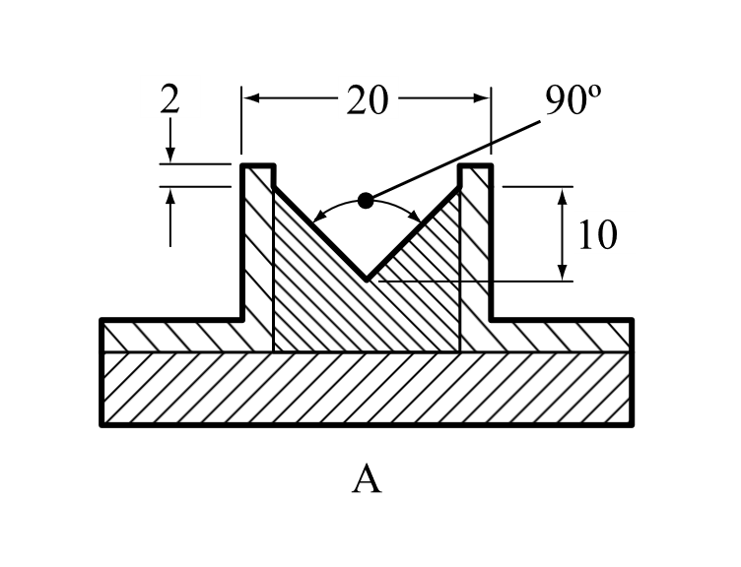

Section 34

34.4.1.2.6 and 34.4.3.2.3 At the end, insert a new note to read as follows:

“***NOTE:*** *In the case of a substance coated to reduce or suppress its oxidizing properties with a significant content (> 10 % by mass) of particles less than 500 μm, two sets of tests should be conducted: tests conducted with the substance as presented and tests conducted with particles less than 500 μm that were obtained from sieving the substance as presented. The substance should not be ground before sieving or testing. The final classification should be based on the test results with the most stringent classification.*”

Section 37

37.4.1 Delete.

37.4.1.1 (former) Renumber as 37.4.1.

37.4.1.1 Insert the following new 37.4.1.1:

“**37.4.1.1 *Introduction***

This test is used for determining the corrosive properties of liquids and solids that may become liquid as a substance corrosive to metal, packing group III/category 1.”

Renumber paragraphs 37.4.2, 37.4.3, 37.4.4, 37.4.4.1 and 37.4.4.2 as 37.4.1.2, 37.4.1.3, 37.4.1.4, 37.4.1.4.1 and 37.4.1.4.2. Renumber figures 37.4.2.1 and 37.4.2.2 as 37.4.1.1 and 37.4.1.2 respectively and update cross references in section 37.4 accordingly. Renumber tables 37.4.4.1 and 37.4.4.2 as 37.4.1.1 and 37.4.1.2 respectively.

37.4.2 (Renumbered 37.4.1.2) (b) Amend to read as follows:

“(b) Steel type S235JR+CR (1.0037, resp. St 37-2), S275J2G3+CR (1.0144, resp.   
St 44-3), ISO 3574, Unified Numbering System (UNS) G10200 or SAE 1020.”

Section 38

38.3.3 (d) In the last paragraph, after “another battery”, add “, vehicle,”.

38.3.3 (g) At the end, add the following new paragraphs:

“For an assembled battery not equipped with overcharge protection that is designed for use only as a component in another battery, in equipment, or in a vehicle, which affords such protection:

- the overcharge protection shall be verified at the battery, equipment or vehicle level, as appropriate, and

- the use of charging systems without overcharge protection shall be prevented through a physical system or process controls.”

38.3.5 Amend sub-paragraph (j) of the test summary to read as follows:

“(j) Name and title of responsible person as an indication of the validity of information provided.”

Section 41

41.1.3 Add a new paragraph 41.1.3 to read as follows:

“41.1.3 The portable tank or MEGC being subjected to the dynamic longitudinal impact test shall be dry prior to beginning the impact testing. If the facility or witnessing agency’s ability to identify potential sources of leakage is negatively impacted by weather conditions such as snow or rain that develop during testing, the impact testing shall be terminated. Impact testing shall only resume once the portable tank or MEGC is dry, and the snow or rain have stopped.”

Section 51

51.2.1 In footnote 1, amend the first sentence to read: “Explosives of GHS Chapter 2.1 that are considered too sensitive to assign a division can also be stabilized by desensitization and consequently may be classified as desensitized explosives, provided all criteria of GHS Chapter 2.17 are met.”.