|  |  |  |  |
| --- | --- | --- | --- |
|  | United Nations | ECE/TRANS/WP.29/GRE/2021/3 | |
| Description: _unlogo | **Economic and Social Council** | | Distr.: General  10 February 2021  Original: English |

**Economic Commission for Europe**

Inland Transport Committee

**World Forum for Harmonization of Vehicle Regulations**

**Working Party on Lighting and Light-Signalling**

**Eighty-fourth session**

Geneva, 26-30 April 2021

Item 5 of the provisional agenda

**UN Regulations Nos. 37 (Filament lamps), 99 (Gas discharge light sources), 128 (Light emitting diodes light sources) and the Consolidated Resolution on the common specification of light source categories**

Proposal for amendment to the Consolidated Resolution on the common specification of light source categories (R.E.5)

Submitted by the Task Force on Substitutes and Retrofits[[1]](#footnote-2)\*

The text reproduced below was prepared by the Task Force on Substitutes and Retrofits (TF SR), with the aim to introduce a new light emitting diode replacement light source (LEDr) category C5W. It takes into account the proposal in ECE/TRANS/WP.29/GRE/2020/16/Rev.1 for the introduction of the LEDr H11 categroy. The technical provisions are based on the equivalence criteria (informal document GRE-83-15). The modifications to the existing text of the Resolution are marked in bold for new or strikethrough for deleted characters.

I. Proposal

*The Status table*, insert a new row at the bottom to read:

*“*

|  |  |  |  |  |
| --- | --- | --- | --- | --- |
|  |  |  |  |  |
| **Amendment [x] to the Original Version** | **[xx.xx.2021]** | **[….]** | **[ECE/TRANS/WP.29/2021/xx]** | **Introduction of a new LED replacement light source category C5W as a package with Supplement [x] to UN Regulation No. 37** |

”

*Paragraph 3.3., insert a new category into the Group 5,* to read:

|  |  |
| --- | --- |
| ***Group 5*** | |
| ***LED replacement light source categories3, 4 only for use in lamps approved with filament light source(s) with the same category designation*** | |
| ***Category*** | ***Sheet number(s)*** |
| **C5W**  H11 | **C5W\_LEDr/1 to 4**  H11\_LEDr/1 to 7 |

*Annex 3, insert new sheet numbers,* to read:

*“*List of sheets for LED light sources and their sequence in this annex:

|  | *Sheet number(s)* |  |
| --- | --- | --- |
|  | C5W/LED/1 to 4  **C5W\_LEDr/1 to 4** |  |
|  | H11/LED/1 to 7 |  |
|  | H11\_LEDr/1 to 7 |  |
|  | L1/1 to 5 |  |
|  | LR1/1 to 5 |  |
|  | LW2/1 to 5 |  |
|  | L3/1 to 6 |  |
|  | LR4/1 to 5 |  |
|  | L5/1 to 6 |  |
|  | PY21W/LED/1 to 4 |  |
|  | R5W/LED/1 to 4 |  |
|  | W5W/LED/1 to 4 |  |

”

*After sheet C5W1/LED/4, insert new sheets C5W\_LEDr/1 to 4, to read*:

(see the following pages; one page per sheet)

**Category C5W Sheet C5W\_LEDr/1**

The drawings are intended only to illustrate the essential dimensions (in mm) of the LED light source.

Reference plane 10

Tcap 6/

Figure 1

**Main drawing**

11

Table 1

b/2

b/2

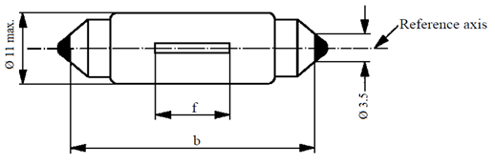

f

Ø 11 max.

Reference axis

Ø 3.5

**Essential electrical and photometrical characteristics of the LED light source**

| *Dimensions in mm* | | | *LED light sources of normal production* |
| --- | --- | --- | --- |
| b 1/ | | | 35.0 ± 1.0 |
| f 2/ | | | 9.0 nom. |
| Elevated ambient air temperature 4/ | | | 50°C |
| Cap SV8.5 in accordance with IEC Publication 60061 (sheet 7004-81-4) | | | |
| *Electrical and photometric characteristics 5/* | | | |
| Rated values | | Volts | 12 |
| Watts | 3 9/ |
| Test voltage (DC) | | Volts | 13.5 |
| Objective values | Power 7/ | Watts | 2.5 min.8/  5.5 max. 9/ |
| Electrical current 7/  at 12-14 V DC | mA | 150 min. 8/ |
| Luminous flux 3/ | lm | 45 ± 20 % |
| Luminous flux 3/  at 9V DC | lm | 9 min. |
| Cap temperature Tcap | °C | 75 max. 8/ |

1 This dimension corresponds to a distance between two apertures of 3.5 mm diameter each bearing against one of the caps.

2 To be checked by a “box system”, see Figure 2.

3 The light emitted shall be white, without a correlated colour temperature restriction.

4The luminous flux measured at the elevated ambient air temperature shall be at least 70% of the objective luminous flux (both measured at test voltage).

5 In case of a failure of any of the light emitting elements (open circuit failure), the LED light source shall either still comply to the requirements concerning luminous flux and luminous intensity distribution or stop emitting light whereby in the latter case the electrical current draw, when operated between 12 V and 14 V, shall be less than 10 mA.

6 Measurement point for cap temperature Tcap

7 Including AE device, if any

8 Not applicable for high-efficiency type (if no AE device is specified)

9 For high-efficiency type 1W rated value and 2W max. objective value applies

10 The reference plane is perpendicular to the reference axis and passing through the centre of the light source as defined by the dimension b/2

11 Position of polarity marking, in case of particular electrical polarity

**Category C5W Sheet C5W\_LEDr/2**

Screen projection requirements

The following test is intended to define the requirements for the apparent light emitting area of the LED light source and to determine whether the light emitting area is correctly positioned relative to the reference axis and reference plane in order to check compliance with the requirements.

The position of the light emitting area is checked by means of a box system defined by the projections when viewing along the direction  = 0° (top view)**,**  = 90° (front view)**,**  =180° (bottom view)**,**  = 270° (rear view) in the plane C0  (C,  as defined in Figure 3).

The proportion of the total luminous flux emitted into these viewing directions from the area(s) as defined in figure 2:

• A, B and C together shall be 70 per cent or more;

• B shall be 20 per cent or more;

• A and C shall each be 15 per cent or more.

These values shall be calculated as percentage of the total luminous flux emitted into the viewing direction from the maximum light source outline, i.e. a rectangle of length *b* = 36.0 mm and a height of 11 mm, aligned symmetrically to the reference axis and reference plane (see Figure 1).

Figure 2

**Box definition of the light emitting area**

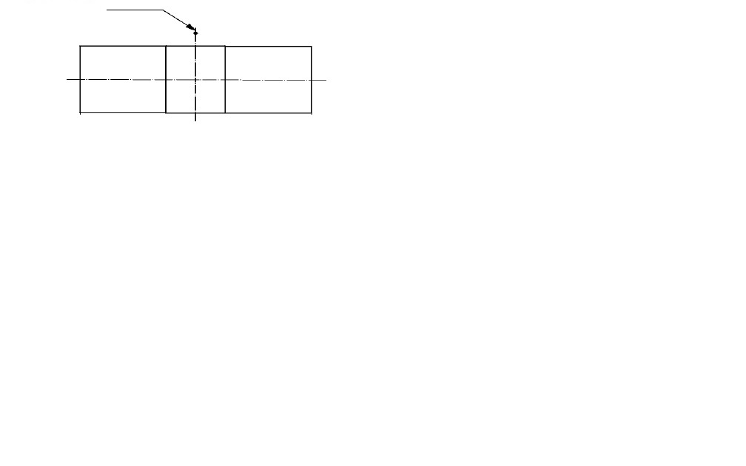

Reference plane

C

B

A

a

Reference axis

a

h3

h2

h1

h2

Table 2

**Dimensions of the box system in Figure 2**

|  |  |  |  |
| --- | --- | --- | --- |
| *Dimension (mm)* | *a* | *h1, h3* | *h2* |
| All views  (as specified above) | 2.5 | 6 | 2 |

**Category C5W Sheet C5W­\_LEDr/3**

Normalized luminous intensity distribution

The following test is intended to determine the normalized luminous intensity distribution of the light source in the C-planes as described in figure 3. The intersection of the reference axis and the reference plane is used as the coordinate system origin.

The light source is mounted on a flat plate with the corresponding holder features. The plate is fixed to the goniometer table by a bracket, so that the reference axis of the light source lines up with one of the rotating axis of the goniometer. The corresponding measurement set-up is described in figure 3.

Luminous intensity data is recorded with a standard photo-goniometer. The measurement distance should be chosen appropriately in order to make sure that the detector is located in the far field of the light distribution.

The measurements shall be performed in C-planes, where C0 (C180) shall be the reference plane of the light source. The C-planes to be measured shall be those specified in Table 3. The test points for each plane and multiple polar angles γ are specified in Table 3.

The measured luminous intensity values, normalised to the measured luminous flux of the individual light source under test, shall be converted to normalised luminous intensity values of a 1000 lm light source. These data shall comply with the tolerance band as defined in Table 3.

Figure 3  
**Setup to measure the luminous intensity distribution**

**(Definition of C-Planes and angle )**

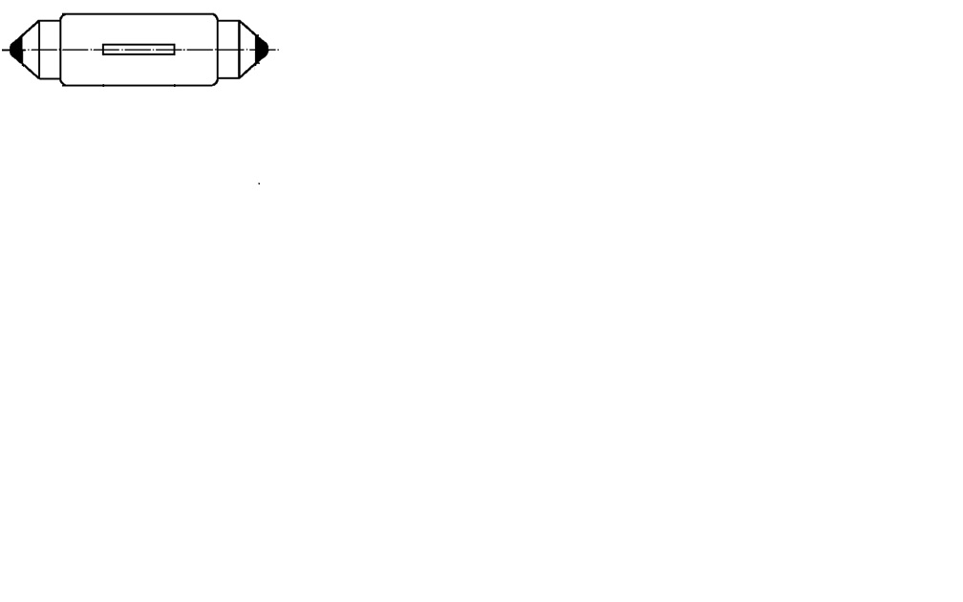

C0

C330

C30

Reference axis

Reference plane

****

View along reference axis

Side view

C150

C210

C180

C-planes: See CIE publication 70-1987, "The measurement of absolute intensity distributions".

**Category C5W Sheet C5W\_LEDr/4**

Table 3

**Test point values of normalized intensity in the planes C0, C30, C150, C180,C210, C330**

|  |  |  |
| --- | --- | --- |
|  | *LED light source of normal production* | |
| *γ* | *Minimum intensity  in cd /1000 lm* | *Maximum intensity  in cd /1000 lm* |
| 0° | 60 | 140 |
| 30° | 60 | 140 |
| 60° | 60 | 140 |
| 90° | 60 | 140 |
| 120° | 60 | 140 |
| 150° | 60 | 140 |

The luminous intensity distribution as described in Table 3 shall be substantially uniform, i.e. in between two adjacent grid points the relative luminous intensity requirement is calculated by linear interpolation using the two adjacent grid points. In case of doubt this may be checked in addition to verification of the grid points given in Table 3.

II. Justification

1. This proposal specifies a new category of LED replacement light source (LEDr) category C5W.
2. It is part of a package together with other proposals which aim to:

* Include a category of LED replacement light source (LEDr) category H11;
* Include the possibility of approval of LED replacement light sources according to UN Regulation No. 37;
* Exclude the possibility of approval of LED replacement light sources according to UN Regulation No. 128;
* Inform GRE on the *Equivalence Criteria,* *Guide for specifying LED replacement light source categories as equivalents for corresponding filament light source categories*, intended for publication on the GRE website under the section “Documents for reference only”.

1. This category was developed taking into account the photometric equivalence criteria: a dedicated near-field photometry, including homogeneity, and a dedicated far-field photometry.
2. Based on the detailed discussions in the TF SR on additional electrical and thermal characteristics necessary for safe interchangeability with filament light sources, it includes specific requirements on:

* Photometric performance at elevated ambient temperature;
* Photometric performance in the range of input voltages from 9 V to 14 V direct current (DC);
* Minimum power concumption of 2.5 W to ensure compatibility with failure-detection systems and an option for a “high efficiency” type intended for those vehicles without failure detection;
* Maximum cap temperature specification to avoid too high temperatures at the holder.

1. \* In accordance with the programme of work of the Inland Transport Committee for 2021 as outlined in proposed programme budget for 2021 (A/75/6 (Sect.20), para 20.51), the World Forum will develop, harmonize and update UN Regulations in order to enhance the performance of vehicles. The present document is submitted in conformity with that mandate. [↑](#footnote-ref-2)