|  |  |  |  |
| --- | --- | --- | --- |
|  | United Nations | ECE/TRANS/WP.29/GRSP/2021/15 | |
| _unlogo | **Economic and Social Council** | | Distr.: General  17 March 2021  English only |

**Economic Commission for Europe**

Inland Transport Committee

**World Forum for Harmonization of Vehicle Regulations**

**Working Party on Passive Safety Provisions**

**Sixty-ninth session**

Geneva, 17-21 May 2021

Item 9 of the provisional agenda

**UN Regulation No. 22 (Protective helmets)**

Proposal for Supplement 1 to the 06 series of amendments to UN Regulation No. 22 (Protective helmets)

Submitted by the experts from Italy and Spain[[1]](#footnote-1)\*

The text reproduced below was prepared by the Ad-Hoc group. The proposal addresses the need of a text that can be enforced in a practical manner until specific requirements for the accessories homologation independently from the helmets will be defined. The modifications to the current text of the UN Regulation are marked in bold for new or strikethrough for deleted characters.

I. Proposal

*The Title*, amend to read:

"Uniform provisions concerning the approval of protective helmets, ~~and~~ of their visors **and of their accessories** for drivers and passengers of motor cycles and mopeds."

*Table of contents,* insert new Annexes 1C, 2C and 20 to read:

"1C Communication concerning approval or extension or refusal or withdrawal of approval or production definitively discontinued of a type of accessory pursuant to UN Regulation No. 22

2C Example of the arrangement of the approval mark for an accessory

20 Accessories Assessment."

*Paragraph 1.*, amend to read:

"1. This Regulation applies to protective helmets for drivers and passengers of mopeds and of motor cycles with or without side-car [[2]](#footnote-2), to the visors fitted to such helmets or intended to be added to them **and to the accessories to be fitted to such helmets or intended to be added to them.**

**The accessories assessment is related only to the passive safety performances and to the compatibility to be fitted to a helmet ready for accessories**."

*Insert new paragraph 2.8.2.,* to read:

"**2.8.2. "Inner visor" means an additional insert to the outer visor which may bring additional functionalities to the visor**."

*Paragraph 2.22.*, amend to read:

"2.22. "*Accessory*" means any object intended to integrate the secondary functionalities of the helmet (e.g. ~~tear off inner visor~~, electronic devices and their support)."

*Insert new paragraphs 2.22.1. to 2.24.,* to read:

"**2.22.1. *"Universal accessory"* means an accessory designed to be fitted to any helmet that is Universal accessory ready.**

**2.22.2. *"Specific accessory"* means an accessory designed to be fitted to a specific helmet model.**

**2.23. "*Accessory type*" a category of accessory not showing differences with special regard to:**

**2.23.1. "*Manufacturer*" It is possible to have different trade mark, provided that a trade mark stated in the approval certificate is also present in an easily accessible position.**

**2.23.2. Secondary functionality/ies offered to the helmet.**

**2.23.3. External shape, main dimensions in all components and materials used.**

**2.24. Helmet category as per independently homologated accessories fitting**

**(UA) Universal accessory ready: helmet that foresees the addition of Universal accessories pursuant to the prescriptions of this Regulation.**

**(SA) Specific accessory ready: helmet that foresees the addition of Specific accessories**."

*Paragraphs 2.23.and 2.24.(former),* renumber as paragraphs 2.25 and 2.26

*Insert new paragraph 2.27*., to read:

"**2.27. *"Impact affected area"* means the projected area of the impact anvil onto the helmet exterior surface in any possible impact points foreseen by this Regulation.**"

*Paragraph 3.1.1.*, amend to read:

"3.1.1.  The application for approval of a protective helmet type, without or with one or more visor types **and without or with one or more specific accessories**, shall be submitted by the helmet manufacturer or by the holder of the manufacturer's name or trade mark or by his duly accredited representative, and for each type the application shall be accompanied by the following:"

*Paragraph 3.1.1.3.2.*, amend to read

"3.1.1.3.2. A technical description of the visor stating the materials used, the manufacturing processes and, where appropriate, the surface treatment**, if the visor can be fitted with an inner visor, drawings of the inner visor and its means of attachment.**"

*Insert new paragraphs 3.1.1.4. to 3.1.1.4.2.1*., to read:

"**3.1.1.4. If the helmet is fitted with one or more specific accessories:**

**3.1.1.4.1. Drawings in scale with sufficient detail to permit identification of the Specific accessory type and size and of its means of attachment to the helmet and every component such as kind of microphone or speakers.**

**3.1.1.4.1.1. A technical description of the Specific accessory stating its weight, dimensions, materials used and, where appropriate, the surface treatment.**

**3.1.1.4.2. If the helmet can be fitted with Universal accessories:**

**3.1.1.4.2.1. Drawings in scale with sufficient detail to permit identification of the area/s where can be fitted and the attachment means together with the specification of speakers space, if any, and microphone space, if any**."

*Paragraph 3.1.1.4. (former),* renumber as paragraph 3.1.1.5.and amend to read:

"**3.1.1.5**. A number of helmets, with or without visors **and with or without inner visors,** ~~out of 20 samples~~ of different sizes, sufficient to enable all the tests specified in paragraph 7.1. to be conducted and one helmet additionally to be retained by the technical service responsible for conducting the approval test. In the case of specific or universal accessories additional helmets will be supplied to the Technical Service to allow the necessary checks and tests specified in paragraph 7.1."

*Paragraph 3.1.1.5.(former),* renumber as paragraph 3.1.1.6. and amend to read:

"**3.1.1.6.** For each visor type, if any, 7 (+3 if optional test for mist retardant visor is carried out) visors taken from a sample of not less than 14 (+ 6 if optional test) specimens. 6 (+ 3 if optional test) visors shall be subjected to the tests and the seventh (or tenth if optional test) shall be retained by the technical service responsible for conducting the approval test**, if the visor can be fitted with an inner visor, enough inner visors to perform all the required tests.**"

*Paragraph 3.2.1.2.*, amend to read:

"3.2.1.2. A technical description of the visor stating materials used, the manufacturing processes and, where appropriate, the surface treatment, **if the visor can be fitted with an inner visor, drawings of the inner visor and its means of attachment.**"

*Paragraph 3.2.1.4.*, amend to read:

"3.2.1.4. For each visor type, if any, 7 (+3 if optional test for mist retardant visor is carried out) visors taken from a sample of not less than 14 (+ 6 if optional test) specimens and the helmets to which the visors are intended to be fitted.

6 (+ 3 if optional test) visors shall be subjected to the tests and the seventh (or tenth if optional test) shall be retained by the technical service responsible for conducting the approval test.

**If the visor can be fitted with an inner visor, enough inner visors to perform all the required tests.**"

*Insert new paragraphs 3.3. to 3.5*., to read:

"**3.3. Application for approval of an accessory type**

**3.3.1. The application for approval of a Universal accessory type shall be submitted by the accessory manufacturer or by the holder of the manufacturer's name or trade mark or by his duly accredited representative, and for each type the application shall be accompanied by the following:**

**3.3.1.1. Drawings in scale with sufficient detail to permit identification of the Universal accessory type and size and of its means of attachment to the helmet and every component such as kind of microphone or speakers. The drawings shall show the position intended for the approval mark as set out in paragraph 5.4.4.1.,**

**3.3.1.2. A technical description of the Universal accessory stating its weight, dimensions, materials used and, where appropriate, the surface treatment,**

**3.3.1.3. For each Universal accessory type, a number of devices sufficient to enable all the tests specified in paragraph 6.19, 7.4.2.1.2.3. and 7.4.3.5., if applicable, to be conducted and one device additionally to be retained by the technical service responsible for conducting the approval test.**

**3.3.2. The application for approval of a Specific accessory type shall be submitted by the accessory manufacturer or by the holder of the manufacturer's name or trade mark or by his duly accredited representative, and for each type the application shall be accompanied by the following:**

**3.3.2.1. Drawings in scale with sufficient detail to permit identification of the Specific accessory type and size and of its means of attachment to the helmet and every component such as kind of microphone or speakers if applicable here. The drawings shall show the position intended for the approval mark as set out in paragraph 5.4.4.1.,**

**3.3.2.2. A technical description of the Specific accessory stating its weight, dimensions, materials used and, where appropriate, the surface treatment,**

**3.3.2.3. For each Specific accessory type, a number of devices and helmets intended to be fitted with the specific accessory type sufficient to enable all the tests specified in chapters 6 and 7, if applicable, to be conducted and one device additionally to be retained by the technical service responsible for conducting the approval test.**

**3.3.2.4. List of approved helmet types to which the specific accessory may be fitted.**

**3.4. The competent authority shall verify the existence of satisfactory arrangements in order to ensure effective control of the conformity of production in accordance with the provisions of paragraph 10. and Annex 12 before type approval is granted.**

**3.5. In case of a specific accessory approval application, the competent authority shall verify the existence of the necessary agreements between the concerned helmet manufacturers and the specific accessory manufacturer in order to ensure that in all cases the performances of the helmet together with the specific accessory will fulfil the prescriptions laid down in this Regulation. In particular, in case any change is made to the helmet or accessory that will affect the joint performances, both manufacturers must be informed and they, both, have to apply for revision or extension of the certificate if necessary.**"

*Insert new paragraph 4.4*., to read:

"**4.4. The accessories submitted for approval in conformity with paragraph 3.3. above shall bear the applicant's trade name or mark**."

*Paragraph 4.4.(former),* renumber as paragraph 4.5.

*Paragraph 5.1.*, amend to read:

"5.1. Approval of a protective helmet type, without or with one or more visor types**, that may include inner visors, and without or with one or more specific accessories.**"

*Paragraph 5.1.1.*, amend to read:

"5.1.1 If the protective helmets and the visors, if any**, with and without inner visors, if any,** submitted in pursuance of paragraph 3.1.1.4. above meet the requirements of this Regulation, approval shall be granted."

*Paragraph 5.1.4.*, amend to read:

"5.1.4. In addition to the marks described in paragraph 4.1.1. above, the following particulars shall be indicated on every protective helmet conforming to a type approved under this Regulation by means of the labels referred to in paragraph ~~5.1.9.~~ **5.1.10**. below:"

*Insert new paragraphs 5.1.4.1.2.2. to 5.1.4.1.2.2.3*., to read:

"**5.1.4.1.2.2. Depending on universal accessory ready, specific accessory ready or both:**

**5.1.4.1.2.2.1. For universal accessory ready helmet, a slash and an additional one or various of the following symbols if applicable, separated by a dash:**

**"UA" if the helmet is ready for universal accessories**

**"S" if the helmet has been tested with speaker simulators**

**"M" if the helmet has been tested with microphone simulator**

**"F" if the helmet can install an accessory in the front side area**

**"L" if the helmet can install an accessory in the side area**

**"R" if the helmet can install an accessory in the rear area**

**5.1.4.1.2.2.2. For Specific accessory ready helmet, a slash and:**

**"SA" if the helmet has been tested with specific accessories**

**5.1.4.1.2.2.3. For Specific accessory ready and universal accessory ready helmet, a slash and:**

**The symbol specified in paragraph 5.1.4.1.2.2.2.**

**A dash and an additional or variety of the symbols, if applicable, laid down in paragraph 5.1.4.1.2.2.1.**"

*Paragraphs 5.1.4.1.2.2.(former),* renumber as paragraph 5.1.4.1.2.3.

*Paragraphs 5.1.4.1.2. to 5.1.4.1.4.(former),* renumber as paragraphs 5.1.4.1.3. to 5.1.4.1.5.

*Paragraphs 5.1.11. and 5.1.12.*, amend to read:

"5.1.11. The labels referred to in paragraph ~~5.1.9.~~ **5.1.10.** above may be issued either by the authority which has granted the approval or, subject to that authority's authorization, by the manufacturer.

5.1.12. The approval marks referred to in paragraph ~~5.1.9.~~ **5.1.10.** above shall be clearly legible and resistant to wear."

*Paragraph 5.2.*, amend to read:

"5.2. Approval of a visor type **without or with inner visor, if any,**"

*Paragraph 5.2.1.*, amend to read:

"5.2.1. Where the visors, **with and without inner visor, if any,** submitted in accordance with paragraph 3.2.1.4. above meet the requirements of paragraphs 6.15. and 7.8. of this Regulation, approval shall be granted."

*Insert new paragraphs 5.4. to 5.4.6*., to read:

"**5.4. Approval of an accessory**

**5.4.1. Where the accessories submitted in accordance with paragraph 3.3. above meet the requirements of this Regulation, approval shall be granted.**

**5.4.2. An approval number shall be assigned to each type approved. Its first two digits (at present 06) shall indicate the series of amendments incorporating the most recent major technical amendments made to the Regulation at the time of issue of the approval. The same Contracting Party shall not assign the same number to another accessory type covered by this Regulation.**

**5.4.3. Notice of approval or of extension or refusal or withdrawal of approval or production definitely discontinued of an accessory type pursuant to this Regulation shall be communicated to the Parties to the 1958 Agreement applying this Regulation, by means of a form conforming to the model in Annex 1C to this Regulation.**

**5.4.4. In addition to the marks prescribed in paragraph 4.4. above, the following particulars shall be affixed visibly and in a readily accessible place to every accessory conforming to a type approved under this Regulation:**

**5.4.4.1. An international approval mark consisting of:**

**5.4.4.1.1. The approval symbol described in paragraph 5.1.4.1.1.,**

**5.4.4.1.2. The approval number followed by:**

**5.4.4.1.2.1. A dash and the production batch number. The production batch numbers shall be continuous for all accessories of the same type approved, and each authority shall keep a register from which it can check that the type and production batches correspond.**

**5.4.4.1.2.2. Depending on universal or specific accessory:**

**5.4.4.1.2.2.1. For universal accessory, a dash and one or various symbols as applicable:**

**"S" if the Universal accessory include speakers**

**"M" if the Universal accessory include microphone**

**"F" if the Universal accessory is to be installed or has a component to be installed in the front side area of the helmet**

**"L" if the Universal accessory is to be installed or has a component to be installed in the side and**

**"R" if the Universal accessory is to be installed or has a component to be installed in the rear area of the helmet**

**5.4.4.1.2.2.2. For specific accessory, a dash and the symbol "SAcc".**

**5.4.5. The marking on the accessory shall be clearly legible and resistant to wear.**

**5.4.6. Annex 2C to this Regulation gives an example of the arrangement of approval mark for an accessory.**"

*Insert new paragraphs 6.3.1. to 6.3.1.9*., to read:

"**6.3.1. The helmets may be prepared for fitting Universal accessories**

**6.3.1.1. If an accessory has any component to be installed on the exterior of the helmet shell within any of the impact areas foreseen in this Regulation and those parts of the accessory have a thickness of more than [3] mm, the accessory shall be tested together with the helmet and the accessory becomes Specific accessory.**

**6.3.1.2. The helmet shall have some markings on the exterior of the helmet shell or any visible component to take them as a reference for the installation of the Universal accessories main external components.**

**The area where to fit the universal accessories shall grant at least [30mm] of distance from any point of any impact affected area to the lower edge of the helmet shell (the lower rubber rim is considered to be helmet shell for this purpose).**

**6.3.1.3. The installation of exterior accessories shall be done in such a way that no part of a Universal accessory, whose maximum main unit/units dimensions are those defined in Annex 20, will be located in an impact affected area.**

**The helmet designed to be fitted with Universal accessory shall have either appropriate space for attaching the device or clamping fixation system as foreseen in Annex 20. The space or clamping fixation shall be provided in both sides of the helmet for each declared position symmetrically located with respect to the longitudinal vertical plane. At least one position for accessories fixation has to be declared.**

**6.3.1.4. If the helmet fulfills the requirements of 6.3.1.2. and 6.3.1.3. it shall be marked as ready for Universal accessories "UA". The helmets marked as "UA" shall also fulfill additional requirements and tests prescribed by this Regulation.**

**6.3.1.5. If the helmet is prepared to fit speakers, the helmet shall have a dedicated space in the inner EPS of at least [41] mm diameter and a depth of at least [8] mm and be tested as well according to the tests foreseen in point 7.3. in the X point with the speakers simulators defined in Annex 20. In this case, the helmet will be marked as "S".**

**6.3.1.6. If the helmet is prepared to fit microphone and the helmet is of type P or P/J, the helmet shall be tested according to the tests foreseen in point 7.3. in the S point with the microphone simulator defined in Annex 20 located in a specific location foreseen on the helmet for the microphone or, if there is not such a specific location perfectly marked, the worst case position at the discretion of the Technical Service. In this case, the helmet will be marked as "M". Any helmet ready for universal accessories of type J or NP shall be marked as "M".**

**6.3.1.7. If the helmet has the accessory space or clamping fixation in the front-side position, the helmet shall be marked as "F".**

**6.3.1.8. If the helmet has the accessory space or clamping fixation in the side position, the helmet shall be marked as "L".**

**6.3.1.9. If the helmet is prepared to fit a rear mounted accessory, the helmet shall be marked as "R".**"

*Paragraph 6.4.2.,* amend to read:

"6.4.2. At the rear, the rigid parts and, in particular, the shell shall not be within a cylinder defined as follows (see Annex 4, Figure 1 B):

(a) Diameter 100 mm;

(b) Axis, situated at the intersection of the medium plane of symmetry of the headform and of a plane parallel to and 110 mm below the reference plane.

**In case the helmet will be marked as "R" (able to fit rear mounted Universal accessories), a rear accessory simulator as defined in Annex 20 will be fitted for the assessment of this requirement**."

*Insert new paragraphs 6.19. to 6.19.9.,* to read:

"**6.19. Accessories**

**6.19.1. The systems of attachment of an accessory to a helmet shall be such that they must not modify in any case the integrity of any of the safety helmet components, in particular, no modifications on the external shell or to the inner energy absorbing padding are allowed.**

**6.19.2. If the accessories have some parts that have to be fixed inside of the helmet, those parts shall not have inward-facing sharp edges; rigid, projecting internal parts shall be covered with padding so that any stresses transmitted to the head are not highly concentrated.**

**6.19.3. All projections from or irregularities in the outer surface of the accessory greater than 2 mm from the helmet shell shall be tested for shear and friction assessment according to paragraphs 7.4.2. when the accessory is to be fitted on the exterior of the helmet shell.**

**6.19.4. All projections from or irregularities in the outer surface of the accessory support greater than 2 mm from the helmet shell, when the support can be installed without the accessory in place, it shall be tested for shear and friction assessment according to paragraphs 7.4.2.**

**6.19.5. For those parts of the accessories coming into contact with the skin, the materials used shall be known not to undergo appreciable alteration through the effect of perspiration or of toilet preparations. The manufacturer shall not use materials known to cause skin troubles. The suitability of a proposed new material shall be established by the manufacturer.**

**6.19.6. Dimensions and weight**

**6.19.6.1. The accessory, or each accessory component if there are more than one, that are to be affixed on the outer helmet shell, must fit in the fixtures defined in Annex 20 depending on its fitting position.**

**Flexible thin components of the accessories can exceed from, or can be mounted separately, from the fixture volumes.**

**6.19.6.2. The maximum dimensions of the speakers and of the microphone, if any, are indicated in Annex 20.**

**6.19.6.3. The maximum weight of the accessory, including its support if any, shall be no more than [250g].**

**6.19.7. The mechanical characteristics of the speakers must fulfil the requirements set for those components in Annex 20 Part 1.**

**6.19.8. When the accessories to be fitted have any component, different from speakers, microphone or clamping, to be installed on the interior of the helmet shell, the component shall fulfil the following requirements:**

**6.19.8.1. The material has to be flexible and of a maximum thickness of [2] mm or**

**6.19.8.2. Have the required thickness but covered with padding and/or attached to a flexible support and/or located in such a place in order not to generate any hard point in the event of an impact.**

**6.19.9. Any accessory component laying in the field of vision must be made of transparent material or located in such a way to prevent interference with the field of vision.**"

*Paragraph 7.3.1.3.5*., amend to read:

"7.3.1.3.5. Helmets placed on the market with **specific** accessories shall be examined to assess that the supplementary equipment has no adverse effect and that in any case the protective helmet and/or visor still complies with all the requirements.

Note: The evaluation shall be done with and without the accessory and their support with particular attention, as example, to energy absorption, sharp edges and field of vision.

**Helmets marked as "S" have to be examined to assess that the speaker simulator defined in Annex 20 has no adverse effect and that in any case the protective helmet still complies with all the requirements.**

**Helmets marked as "M", with the exception of "J" and "NP" helmets, have to be examined to assess that the microphone simulator defined in Annex 20 has no adverse effect and that in any case the protective helmet still complies with all the requirements.**

No helmet shall be modified from its original specification as manufactured. Accessories must be fitted in accordance with the helmet manufacturer’s instructions **and, if it is the case, in accordance as well with the accessory manufacturers instructions.**"

*Paragraph 7.4.2.1.2*., amend to read:

"7.4.2.1.2. Positioning of the helmets **and accessories.**"

*Paragraph 7.4.2.1.2.2*., amend to read:

"7.4.2.1.2.2. The helmet shall be tested in any condition in which it may be placed on the market, that is both with and without **specific** accessories if they are supplied as original equipment. …"

*Insert a new paragraph 7.4.2.1.2.3*., to read:

"**7.4.2.1.2.3. The Universal accessory and, if it is the case, its support, must be placed on the helmet simulator defined in Figure 1d of Annex 8 and tested in the worst case as defined by the Technical Service**."

*Paragraph 7.4.2.1.2.*,amend to read:

*"*7.4.2.2.1. *Description*

…

(g) A system to support a headform and to apply a force to the helmet normal to the carriage.

**(h) A helmet simulator that can be exchanged by the headform mentioned in (g) above where accessories can be attached**."

*Paragraph 7.4.2.3*., amend to read:

"7.4.2.3. Selection of test points

Any point on the helmet **or accessory** may be selected for friction and/or shear assessment. A helmet **or an accessory** shall be tested as many times as necessary to ensure that all notable features are evaluated with one test only per feature. Re-orientate the helmet **or helmet simulator** as necessary to allow every feature to be tested. For shear assessment evaluate all different external projections greater than 2 mm above the outer surface of the shell.

For friction assessment evaluate areas of the outer surface that are likely to produce the greatest friction.

The rim of the shell and the upper and lower edge of the visor situated within an area bounded by a sector of 120° divided symmetrically by the vertical longitudinal plane of symmetry of the helmet do not constitute a projection for the purpose of this test. **The lower part of the accessories mounted on the rim will be considered to be part of the helmet rim**."

*Insert new paragraphs 7.13.3. and 7.13.4*., to read:

"**7.13.3. Helmets equipped with specific accessories must be assessed with and without the accessories.**

**7.13.4. Helmets marked as "UA" must be tested as well with each of the accessory simulators and/or a combination of them, the total weight of the accessories with which the helmet will be tested will not exceed [500g]. The tests done will be specified in the test report. The accessories simulators are defined in Annex 20, Part 3**."

*Paragraph 9.3*., amend to read:

"9.3. Production qualification of the visors **including inner visor, if any**

The production of each new approved type of visor (approved as such or as forming part of the helmet) must be subjected to production qualification tests.

…"

*Paragraph 10.1.,* amend to read:

"10.1. The helmet, visor **including inner visor, if any**, (whether the visor is approved as such or as forming part of the helmet) **or universal accessory** approved under this Regulation, having satisfied the acceptability …"

*Paragraph 10.3.4*., amend to read:

"10.3.4. Analyze the results of each type of test in order to verify and ensure the stability of the helmet, visor **or universal accessory** characteristics, making allowances for the variations of industrial production;"

*Paragraph 10.3.5*., amend to read:

"10.3.5. Ensure that for each type of helmet, visor **or universal accessory** at least those tests prescribed in paragraphs 10.5.**,** 10.6. **and 10.7**. of the present Regulation are carried out;"

*Paragraph 10.6*., amend to read:

"10.6. Minimum conditions for the control of conformity of visors **including inner visor, if any**

In agreement with …"

*Insert new paragraphs 10.7. to 10.7.1.3*., to read:

"**10.7. Minimum conditions for the control of conformity of universal accessories. For specific accessories, the conformity must be checked together with the specific helmet models for which they have been declared.**

**In agreement with the relevant authorities, the holder of an approval will undertake the control of conformity following the method of batch control (paragraph 10.7.1.).**

**10.7.1. Batch control**

**10.7.1.1. The holder of an approval must divide the universal accessories into batches which are as uniform as possible in regard to raw materials or intermediate products involved in their manufacture, and in regard to production conditions. The numbers in a batch must not exceed 3,200 units.**

**In agreement with the relevant authorities the tests can be carried out by the technical service or by the holder of an approval.**

**10.7.1.2. For each batch, a sample must be taken in accordance with the provisions of paragraph 10.5.1.4. The sample may be taken before the batch is complete provided the sample is taken from a larger sample consisting of not less than 20 per cent of the final batch quantity.**

**10.7.1.3. In order to be accepted, a batch of universal accessories must satisfy the following conditions:**

|  | | | ***Tests to be conducted*** | | |  | | |
| --- | --- | --- | --- | --- | --- | --- | --- | --- |
| **Numbers in  the batch** | **Number of samples** | **Combined number of samples** | **Group A** | **Group B** |  | **Acceptance criteria** | **Rejection criteria** | **Stringency of inspection** |
| **0 < N # 500** | **1st = 4** | **10** | **3** | **1** |  | **0** | **2** | **Normal** |
| **2nd = 4** | **3** | **1** |  | **1** | **2** |
| **500 < N # 3200** | **1st = 4** | **10** | **4** | **1** |  | **0** | **2** | **Normal** |
| **2nd = 4** | **4** | **1** |  | **1** | **2** |
| **0 < N # 1200** | **1st = 8** | **16** | **6** | **2** |  | **0** | **2** | **Strengthened** |
| **2nd = 8** | **6** | **2** |  | **1** | **2** |
| **1200< N # 3200** | **1st = 13** | **26** | **10** | **3** |  | **0** | **3** | **Strengthened** |
| **2nd =13** | **10** | **3** |  | **3** | **4** |

**Test group A**

**Speakers mechanical characteristics, if any, - para.6.19.7.**

**Test group B**

**Shear and friction Test - para.6.19.3.**

**- para 6.19.4 (if needed)**

**Dimensions of the components must be checked.**

**This dual sampling plan functions as follows:**

**For a normal control, if the first sample does not contain any defective units the batch is accepted without testing a second sample. If it contains two defective units the batch is rejected.**

**Finally, if it contains one defective unit a second sample is extracted, and it is the cumulative number which must satisfy the condition of column 7 of the table above.**

**There is a change from normal control to strengthened control if, out of 5 consecutive batches, 2 are rejected. Normal control is resumed if 5 consecutive batches are accepted.**

**If 2 consecutive batches subjected to the strengthened control are rejected, the provisions of paragraph 12. are applied.**"

*Paragraph 11*., amend to read:

"11. Modification and extension of approval of a helmet, ~~or~~ a visor type **or an accessory**."

*Paragraph 11.1 and 11.1.1*., amend to read:

"11.1. Every modification of the helmet and/or the visor type **or of the accessory** shall be notified to the Type Approval Authority which approved the helmet and/or the visor type **or the accessory**. The department may then either:

11.1.1. Consider that the modifications made are unlikely to have an appreciable adverse effect and that in any case the protective helmet and/or visor **or accessory** still complies with the requirements; or"

*Paragraph 11.3.,* amend to read:

"11.3. The competent authority issuing the extension of approval shall assign a series number for such an extension and inform thereof the other Parties to the 1958 Agreement applying this Regulation by means of a communication form conforming to the model in Annex 1A**, or** Annex 1B **or Annex 1C** to this Regulation."

*Paragraph 12.1*., amend to read:

"12.1. The approval granted in respect of a helmet or a visor type **or an accessory** pursuant to this Regulation may be withdrawn if the requirements set forth above are not met."

*Paragraph 12.2*., amend to read:

"12.2. If a Contracting Party to the Agreement applying this Regulation withdraws an approval it has previously granted, it shall forthwith so notify the other Contracting Parties applying this Regulation by means of a communication form conforming to the model in Annex 1A**,** ~~or~~ Annex 1B **or 1C** to this Regulation."

*Paragraph 13*., amend to read:

"13. Production definitively discontinued

If the holder of the approval completely ceases to manufacture a helmet or a visor type **or an accessory** approved in accordance with this Regulation, he shall so inform the authority which granted the approval.

Upon receiving the relevant communication that authority shall inform thereof the other Parties to the 1958 Agreement applying this Regulation by means of a communication form conforming to the model in Annex 1A, Annex 1B **or Annex 1C** to this Regulation."

*Paragraph 14.1.,* amend to read:

"14.1. …

"Does not protect chin from impacts" together with the symbol indicating the unsuitability of the lower face cover to offer any protection against impacts to the chin.

**If the helmet is ready for Accessories:**

**A clear description on where to install the accessories by using the reference mark or marks stated in point 6.3.3. as well as clear indications on how to fit the speakers and/or microphone or any other component if it is the case.**

**A general warning shall be given to the user concerning the danger of making any alterations or additions to the helmet or visor, without the approval of the Type Approval Authority, that may result in a lower safety for the user.**

**A general warning shall be given to the user concerning the danger of fitting non homologated accessories. Only homologated accessories will maintain the helmet safety.**

**A general warning shall be given to the user stating that no accessory shall be mounted on the helmet if some of the symbols marked in the accessory homologation is not marked in the helmet homologation label**."

*Insert new paragraphs 14.8. to 14.10*., to read:

"14.8. Every universal accessory placed on the market shall be accompanied by information in the national language, or in at least one of the national languages, of the country of destination.

This information shall contain advice on how to install it in the suitable helmets and information on those aspects specified in paragraphs 14.6.1. to 14.6.2. The instructions must refer to the helmet owner manual for the right installation place.

A general warning shall be given to the user stating that no accessory shall be mounted on helmets whose symbols marked in the helmet homologation label do not include all the symbols marked in the accessory homologation label.

14.9. For universal accessory the following label shall be included in the instructions provided by the accessory manufacturer:

|  |
| --- |
| Notice 1. This is a "Universal" accessory. It is approved to Regulation No. 22, 06 series of amendments, for general use in helmets ready for accessories "UA" and it will fit most, but not all, helmets.  2. A correct fit is likely if the helmet manufacturer has declared in the helmet handbook that the helmet is capable of accepting a "Universal" accessory and it is marked as such in the homologation label of the helmet.  4. If in doubt, consult either the accessory manufacturer, the helmet manufacturer or the retailer. |

14.10. Every specific accessory placed in the market shall be accompanied by information in the national language, or in at least one of the national languages, of the country of destination.

This information shall contain advice on how to install it in the suitable helmets and information on those aspects specified in paragraphs 14.6.1. to 14.6.2. The instructions must refer to the helmet owner manual for the right installation place.

A list of helmets with which the accessory has been tested and approved will be provided together with the approval number given to those helmets."

*Annex 1A,* amend to read:

Annex 1A

Communication

(Maximum format: A4 (210 x 297 mm)

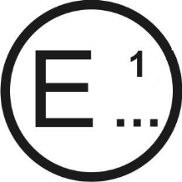[[3]](#footnote-3)

issued by: Name of administration:

......................................

......................................

......................................

Concerning: [[4]](#footnote-4)2 Approval granted

Approval extended

Approval refused

Approval withdrawn

Production definitively discontinued

of a type of protective helmet without/with 2 one/more 2 visor type(s) pursuant to UN Regulation No. 22

Approval No.: ............................................ Extension No.: ..........................................

1. Trade mark:

2. Type:

3. Sizes:

4. Manufacturer's name:

5. Address:

6. If applicable, name of manufacturer's representative:

7. Address:

8. Brief description of helmet:

9. Helmet without lower face cover (J) / with protective lower face cover

(P) / with non protective lower face cover (NP)/ with detachable or movable lower

face cover (P/J) 2

10. Type of visor or visors:

11. Brief description of visor or visors, **and inner visor if any**:

**12. Helmet ready for specific accessory (SA)/ready for universal accessories (UA) 2**

**13. Accessories included in the helmet homologation and functionality ....................**

**14. If UA helmet, speakers (S)/Microphone (M)/Front mounting (F) /**

**Side mounting (L), Rear mounting (R)2**

1**5**. Submitted for approval on:

1**6**. Technical service responsible for conducting approval tests:

1**7**. Date of report issued by that service:

1**8**. Number of report issued by that service:

1**9**. Comments:

**20**. Approval granted/extended/refused/withdrawn 2

**21**. Place:

**22**. Date:

**23**. Signature:

**24**. The following documents, bearing the approval number shown above, are available on request "

*Annex 1B, item 7*., amend to read:

"7. Brief description of visor, **and inner visor if any:** "

*Insert new Annex1C*, to read:

"Annex 1C

Communication

(Maximum format: A4 (210 x 297 mm)

[[5]](#footnote-5)

issued by: Name of administration:

......................................

......................................

......................................

Concerning:[[6]](#footnote-6)2 Approval granted

Approval extended

Approval refused

Approval withdrawn

Production definitively discontinued

of a type of a helmet accessory pursuant to UN Regulation No. 22

Approval No.: ............................................ Extension No.: ..........................................

1. Trade mark:

2. Type:

3. Manufacturer's name:

4. Address:

5. If applicable, name of manufacturer's representative:

6. Address:

7. Brief description of the accessory/ies (functionality/ies)2/:

8. Accessory: Specific accessory (SA) / Universal accessory (UA)2/

9. In case of SA, types of helmet to which the accessory may be fitted:

10. In case of UA, with speakers (S)/ microphone (M)/mounting location (F) (L) (R)2/

11. Submitted for approval on:

12. Technical service responsible for conducting approval tests:

13. Number of report issued by that service:

14. Remarks:

15. Approval granted/extended/refused/withdrawn 2/

16. Place:

17. Date:

18. Signature:

19. The following documents, bearing the approval number shown above,

are available on request "

*Annex 2A*, amend to read:

"Annex 2A

I. Protective helmet

Example of the arrangement of approval mark for a protective helmet without or with one or more types of visor

(See paragraph 5.1. of this Regulation)

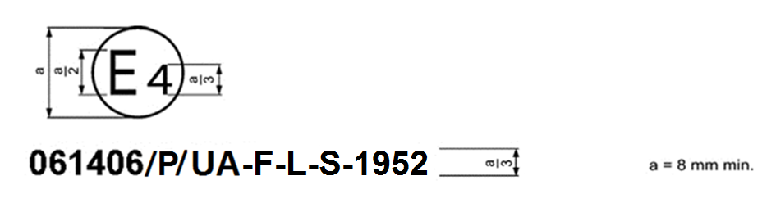

The above approval mark affixed to a protective helmet shows that the helmet type concerned has been approved in the Netherlands (E 4) under approval number 061406~~/J~~. The approval number shows that this approval concerns a helmet **which has a lower face protective cover (P)** and was granted in accordance with the requirements of UN Regulation No. 22 already incorporating the 06 series of amendments at the time of approval, **that it can be fitted with a universal accessory having speakers and mounted in the front or in the side of the helmet** and that its production serial number is 1952,

*Note*: The approval number and the production serial number shall be placed close to the circle and either above or below the letter "E" or to the left or right of that letter. The digits of the approval number and of the production serial number shall be on the same side of the letter "E" and face the same direction. The use of Roman numerals as approval numbers should be avoided so as to prevent any confusion with other symbols."

*Insert a new Annex 2C*, to read:

"Annex 2C

Example of the arrangement of the approval mark for a universal accessory

**(See paragraph 5.4.6. of this Regulation)**

**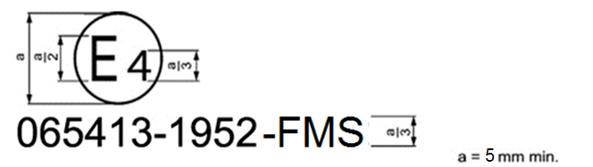**

**The above approval mark affixed to a universal accessory shows that the universalaccessory type concerned has been approved in the Netherlands (E 4) under approval number 065413. The approval number shows that approval was granted in accordance with the requirements of the Regulation incorporating the 06 series of amendments at the time of approval, that its production batch is 1952 and that is approved for Front mounting and has Microphone and Speakers.**

***Note*: The approval number and the production batch number shall be placed close to the circle and either above or below the letter "E" or to the left or right of that letter. The digits of the approval number and of the production batch number shall be on the same side of the letter "E" and face the same direction. The use of Roman numerals as approval numbers should be avoided so as to prevent any confusion with other symbols.**

**Due to space restrictions, the approval number could be placed on the side of the accessory facing to the helmet provided that the accessory will have a support plate and that can be easily detachable without any tool for checking.**

Example of the arrangement of the approval mark for a specific accessory

**(See paragraph 5.4.6. of this Regulation)**

**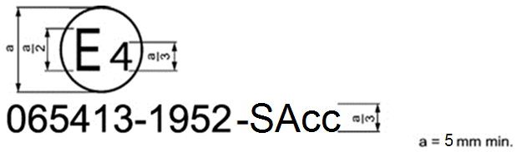**

**The above approval mark affixed to a specific accessory shows that the specificaccessory type concerned has been approved in the Netherlands (E 4) under approval number 065413. The approval number shows that approval was granted in accordance with the requirements of the Regulation incorporating the 06 series of amendments at the time of approval, and that its production batch is 1952.**"

*Annex 8, insert new figure 1d,* to read:

"Figure 1d  
**Example of a helmet simulator for accessories projections and surface friction (method B)**

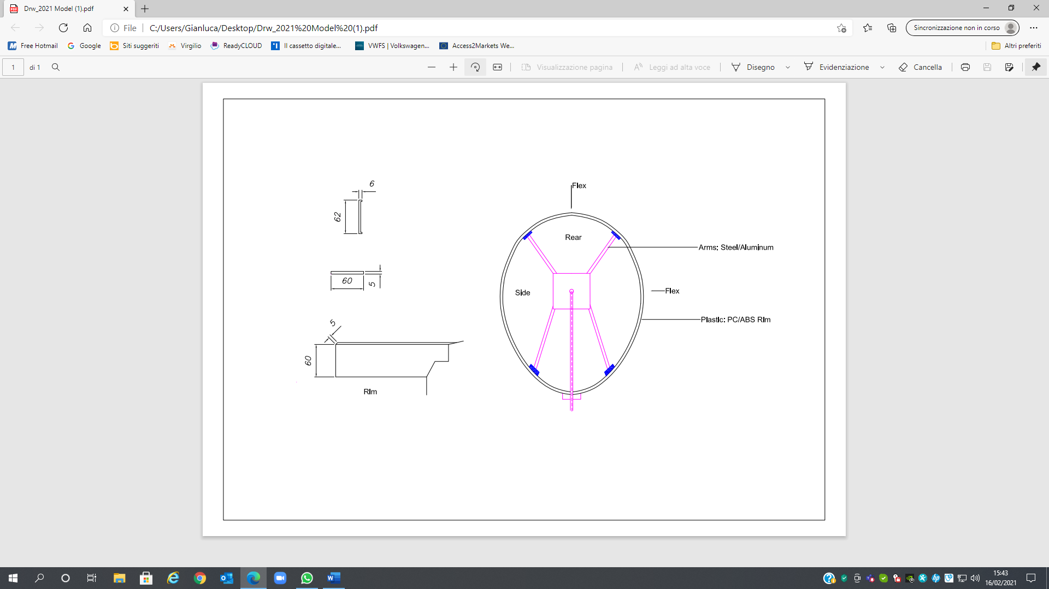

**Simulator and characteristics must be detail defined.**"

*Insert new Annex 20*, to read:

"Annex 20

Accessories assessment and clamping space dimensions for helmets

Part 1. Accessories assessment

1. **Measurement of the maximum dimensions of externally fitted accessories:**

**For the measurement of the dimensions, only the accessory plus the support, if any, have to be measured. If the device is fitted with a foldable antenna, the system must fit in the fixture with the antenna in folded position. If the antenna is flexible, the antenna may exceed the fixture dimensions.**

**Flexible, thin components can exceed the volume or can be assembled separately on the shell.**

**1.1 For front mounted accessories:**

**Accessories must fit in the following fixtures dimensions:**

Figure 1  
**Fixture for left front- side mounting (for right side mounting apply symmetry)**

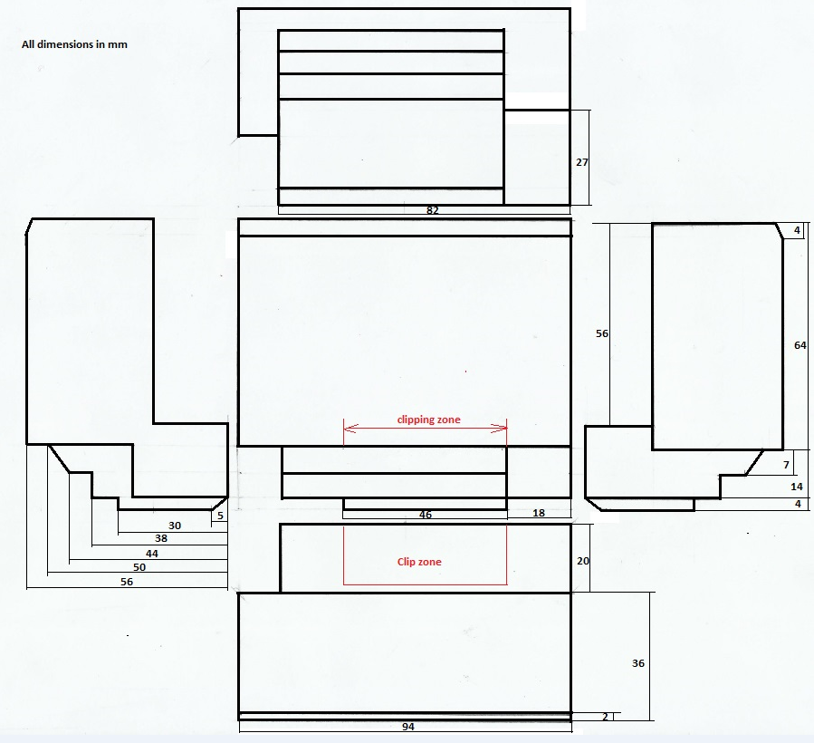

**VOLUME: 279,432 mm3**

**1.2. For side mounting accessories**

Figure 2   
**Fixture for left side mounting (for right side mounting apply symmetry)**

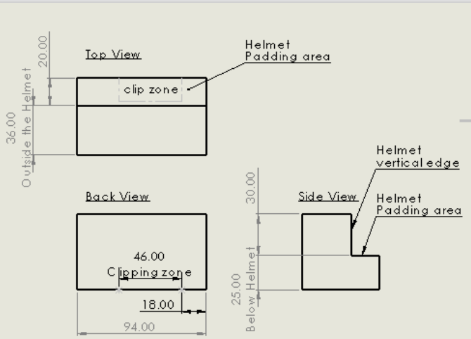.

**VOLUME: 233,120 mm3**

**1.3. For rear mounting accessories**

Figure 3

**The rear mounting clamping solution offered by the accessories manufacturers will not invade the impact affected area.**

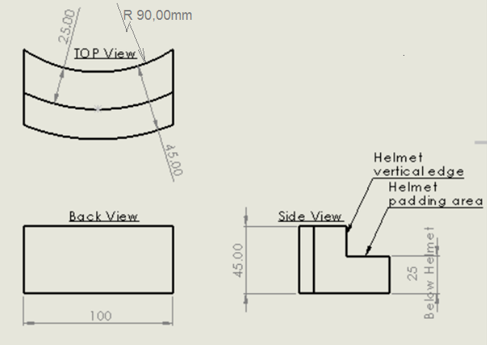

**VOLUME: 157,957 mm3**

**2. Maximum dimensions of speakers and microphones:**

**2.1. Speakers**

**The speakers must be contained in a cylinder of [40] mm diameter and [14] mm thick.**

**2.2. Microphone**

**The microphone must be contained in a paralelepided of the following dimensions:**

**Length: 35 mm**

**Width: 18 mm**

**Height (dimension from the chin protective padding towards the headform ): 11,5 mm**

**The boom, if any, must be flexible and not have an external diameter of more than [10] mm**

**3. Mechanical characterization of the speakers:**

**[Testing procedure to be drafted. Limits to be set].**

**The obtained chart for the speakers must fall below the line defining the upper corridor limit.**

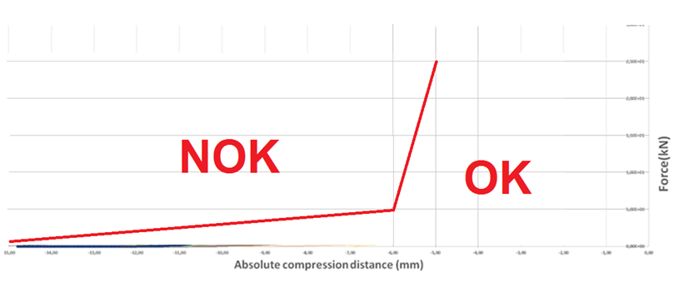

**4. Speakers and microphone simulators for helmet testing.**

**4.1. Speakers simulator.**

**The speaker simulator will be made from rigid plastic and will have a dimension of [40+0-1]mm diameter and [5] mm thick.**

**[Material characteristics to be defined]**

**4.2. Microphone simulator.**

**The microphone simulator will be made from rigid plastic and will have a parallelepipedic shape with the following dimensions:**

**Length: [35] mm (horizontal transversal dimension)**

**Width: [18] mm (vertical dimension)**

**Height: [11,5] mm (horizontal longitudinal dimension)**

**[Material characteristics to be defined]**

Part 2. Clamping space dimensions for helmets (optional)

**1. The helmet clamping free space dimensions for front and side mounting will be, at least, the following ones:**

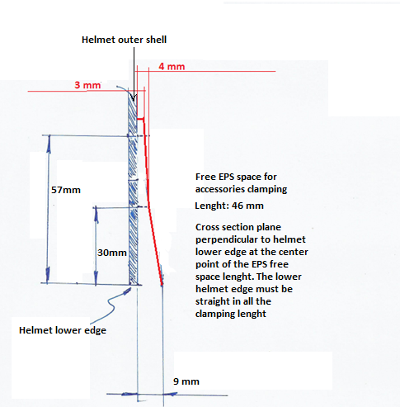

**Length of clamping according to the fixture drawings**

**2. Helmet clamping free space dimensions for rear mounting**

**The helmet must allow the insertion of a flat metal sheet of [1] mm thickness, as one of the possible fixation systems for rear positioning of the accessories, between the EPS and the external shell.**

Part 3. Accessories simulators for the tests foreseen in 7.13

**The shape will be like the correspondent fixture depending on the helmet positioning and will have the following mass:**

**(a) Front mounted accessories: [250 g]**

**(b) Side mounted accessories: [250 g]**

**(c) Rear mounted accessories: [250 g]**

**Clamping/fixing of the simulator to the helmet can be done at the Technical Service discretion but method must be noted and filed within the test report. The clamping/fixing system together with the fixture must not exceed the target weight.**

**Note: Only for testing purposes the fixation of the simulator to the helmet with screws is acceptable."**

II. Justification

The proposed change to the text seeks to resolve the issue raised by the document GRSP-67-09-Rev.1™. The use of an aftermarket product cannot cause a UN Approval to become invalid. Changes made to the helmet by the user are not covered by the UN Regulation No. 22 Type Approval.

1. \* In accordance with the programme of work of the Inland Transport Committee for 2021 as outlined in proposed programme budget for 2021 (A/75/6 (Sect.20), para 20.51), the World Forum will develop, harmonize and update UN Regulations in order to enhance the performance of vehicles. The present document is submitted in conformity with that mandate. [↑](#footnote-ref-1)
2. Protective helmets for wear in competitions may have to comply with stricter provisions. [↑](#footnote-ref-2)
3. 1. Distinguishing number of the country which has granted/extended/refused/withdrawn an approval (see

   approval provisions in the Regulation). [↑](#footnote-ref-3)
4. 2. Strike out what does not apply [↑](#footnote-ref-4)
5. 1 Distinguishing of the country which has granted/extended/refused/withdrawn an approval (see approval provisions in the Regulation). [↑](#footnote-ref-5)
6. 2 Strike out what does not apply [↑](#footnote-ref-6)