|  |  |  |  |
| --- | --- | --- | --- |
|  | United Nations | ECE/TRANS/WP.29/2021/53 | |
| _unlogo | **Economic and Social Council** | | Distr.: General  18 December 2020  Original: English |

**Economic Commission for Europe**

Inland Transport Committee

**World Forum for Harmonization of Vehicle Regulations**

**183rd session**

Geneva, 9-11 March 2021

Item 14.2.1 of the provisional agenda

**1998 Agreement:  
Consideration and vote by AC.3 of draft UN GTRs  
and/or draft amendments to established UN GTRs, if any**

Proposal for Amendment 3 to UN Global Technical Regulation No. 9 (Pedestrian Protection)

Submitted by the Working Party on Passive Safety[[1]](#footnote-2)\*, [[2]](#footnote-3)\*\*

The text reproduced below was adopted by the Working Party on Passive Safety (GRSP) at its sixty-seventh session (ECE/TRANS/WP.29/GRSP/67, para. 5). It is based on ECE/TRANS/WP.29/GRSP/2014/5, as amended by Annex II to the report. It is submitted to the World Forum for Harmonization of Vehicle Regulations (WP.29) and to the Executive Committee (AC.3) of the 1998 Agreement for consideration at its March 2021 sessions.

*In the text of the regulation (part B),*

*Paragraph 3.1.*, amend to read:

"3.1. "*Adult headform test area*" is an area on the outer surfaces of the front structure. The area is bounded:

(a) In the front, by a wrap around distance (WAD) of 1,700 or a line 82.5 mm rearward of the bonnet leading edge reference line, whichever is most rearward at a given lateral position,

(b) At the rear, by a WAD 2,100 or a line 82.5 mm forward of the bonnet rear reference line, whichever is most forward at a given lateral position; and

(c) At each side, by a line 82.5 mm inside the side reference line.

The distance of 82.5 mm is to be set with a flexible tape held tautly along the outer surface of the vehicle."

*Insert a new paragraph 3.8*., to read:

"3.8. "*Bonnet top test area*" is composed of the child headform test area and the adult headform test area as defined in paragraphs 3.14. and 3.1 respectively."

*Paragraphs 3.8.to 3.10. (former)*, renumber as paragraphs 3.9. to 3.11.

*Paragraph 3.11. (former)*, renumber as paragraph 3.12. and amend to read:

"3.12. "*Bumper test area*" means either the front vehicle fascia between the left and right corner of bumper as defined in paragraph 3.15., minus the areas covered by the distance of 42 mm inboard of each corner of bumper, as measured horizontally and perpendicular to the longitudinal median plane of the vehicle, or between the outermost ends of the bumper beam as defined in paragraph 3.9. (see Figure 5D), minus the areas covered by the distance of 42 mm inboard of each end of the bumper beam, as measured horizontally and perpendicular to the longitudinal median plane of the vehicle, whichever area is wider."

*Paragraph 3.12. (former)*, renumber as paragraph 3.13.

*Paragraph 3.13. (former*), renumber as paragraph 3.14. and amend to read:

"3.14. "*Child headform test area*" is an area on the outer surfaces of the front structure. The area is bounded:

(a) In the front, by a WAD 1,000 or a line 82.5 mm rearward of the bonnet leading edge reference line, whichever is most rearward at a given lateral position;

(b) At the rear, by a WAD 1,700 or a line 82.5 mm forward of the bonnet rear reference line; whichever is most forward at a given lateral position, and

(c) At each side, by a line 82.5 mm inside the side reference line.

The distance of 82.5 mm is to be set with a flexible tape held tautly along the outer surface of the vehicle."

*Paragraphs 3.14. to 3.19. (former)*, renumber as paragraphs 3.15. to 3.20.

*Paragraph 3.20. (former)*, shall be deleted

*Insert new paragraphs 3.21. to 3.21.2.*, to read:

"3.21. "*Measuring point*"

The measuring point may also be referred to as "test point" or "impact point". In all cases, the result of the test shall be attributed to this point, independent of where the first contact occurs.

3.21.1. "*Measuring point*" for the headform test means a point on the vehicle’s outer surface selected for assessment. The measuring point is where the headform’s profile contacts the vehicle’s outer surface cross section in a vertical longitudinal plane through the center of gravity of the headform (see Figure 6A).

3.21.2. "*Measuring point*" for the lower legform to bumper test and the upper legform to bumper test is located in the vertical longitudinal plane through the central axis of the impactor (see Figure 6B)."

*Paragraphs 3.21. to 3.24. (former)*, renumber as paragraphs 3.22. to 3.25.

*Paragraphs 3.25.(former)*, renumber as paragraphs 3.26. and amend to read:

"3.26. "*Primary reference marks*" means holes, surfaces, marks and identification signs on the vehicle body. The type of reference mark used and the vertical (Z) position of each mark relative to the ground shall be specified by the vehicle manufacturer according to the running conditions specified in paragraph 3.24. These marks shall be selected such as to be able to easily check the vehicle front and rear ride heights and vehicle attitude.

The primary reference marks shall be within ± 25 mm of the design position in the vertical (Z) axis. All tests are conducted with either the vehicle or all further measurements adjusted to simulate the vehicle being in the design position. This position shall be considered to be the normal ride attitude."

*Paragraph 3.26. (former),* renumber as paragraph 3.27.

*Paragraph 3.28. (former)*, shall be deleted.

*Figure 6,* shall be deleted

*Insert new Figures 6A and 6B*, to read:

"Figure 6A   
**Measuring point in the vertical longitudinal plane through the centre of the headform impactor (see paragraph 3.21.1)** **[[3]](#footnote-4)**

**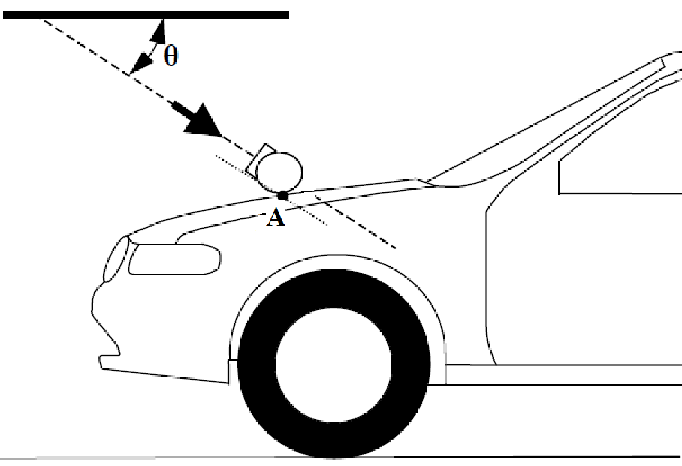**

A Measuring Point  
θ Impact angle

Figure 6B

**Measuring point in the vertical longitudinal plane through the central axis of the legform impactor (see paragraph 3.21.2)**

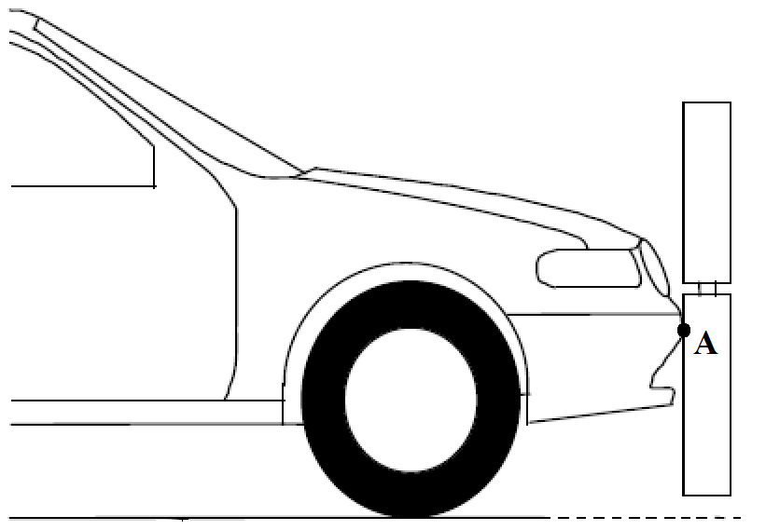

A Measuring point

"

*Paragraph 4.1.*, amend to read:

"4.1. *Legform test to bumper*

For vehicles with a lower bumper height at the test position of less than 425 mm, the requirements of paragraph 4.1.1. shall be applied.

For vehicles with a lower bumper height at the test position which is greater than or equal to 425 mm and less than 500 mm, the requirements of either paragraph 4.1.1. or 4.1.2., at the choice of the manufacturer, shall be applied.

For vehicles with a lower bumper height at the test position of greater than, or equal to 500 mm, the requirements of paragraph 4.1.2. shall be applied."

*Paragraph 5.2.3.*, amend to read:

"5.2.3. The HIC recorded shall not exceed 1,000 over a minimum of one half of the child headform test area and 1,000 over two thirds of the bonnet top test area. The HIC for the remaining areas shall not exceed 1,700 for both headforms.

In case there is only a child headform test area, the HIC recorded shall not exceed 1,000 over two thirds of the test area. For the remaining area the HIC shall not exceed 1,700."

*Paragraph 5.2.4.1.*, amend to read:

"5.2.4.1. The manufacturer shall identify the zones of the bonnet top test area where the HIC must not exceed 1,000 (HIC1000 Zone) or 1,700 (HIC1700 Zone) (see Figure 11)."

*Figure 11(former)*, shall be deleted

*Insert new Figure 11,* to read*:*

"Figure 11

**Example of marking of HIC1000 zone and HIC1700 zone**

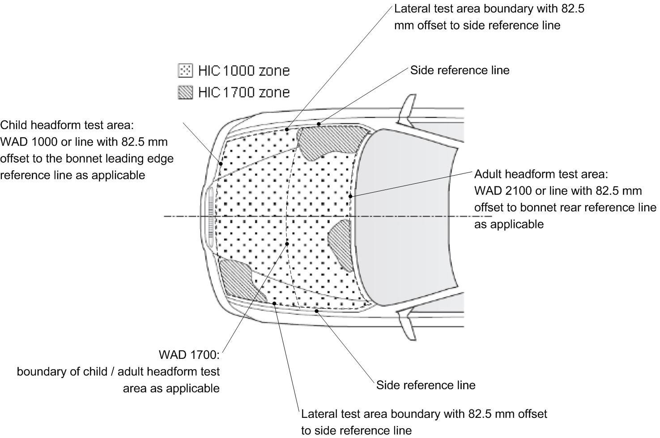"

*Paragraph 5.2.4.3., amend to read*:

"5.2.4.3. The areas of "HIC1000 zone" and "HIC1700 zone" may consist of several parts, with the number of these parts not being limited. The determination of the impacted zone is done by the measuring point."

*Paragraph 5.2.4.4.,* amend to read:

"5.2.4.4. The calculation of the surface of the bonnet top test area as well as the surface areas of "HIC1000 zone" and "HIC1700 zone" shall be done on the basis of a projected bonnet when viewed from a horizontal plane parallel to the horizontal zero plane above the vehicle, on the basis of the drawing data supplied by the manufacturer."

*Paragraph 6.3.1.2.8.*, amend to read:

"6.3.1.2.8. The test impactor or at least the foam flesh shall be stored during a period of at least four hours in a controlled storage area with a stabilized humidity of 35 percent ± 15 percent and a stabilized temperature of 20 ± 4 °C prior to impactor removal for certification. After removal from the storage the impactor shall not be subjected to conditions other than those pertaining in the test area."

*Paragraph 7.1.1.1.*, amend to read:

"7.1.1.1. The selected measuring points shall be in the bumper test area as defined in paragraph 3.12."

*Paragraph 7.1.1.3.3., amend to read*:

"7.1.1.3.3. For the lower legform testing, a horizontal and vertical impact tolerance of ± 10 mm shall apply."

*Paragraphs 7.1.2.1. and 7.1.2.2.*, amend to read:

"7.1.2.1. The selected measuring points shall be in the bumper test area as defined in paragraph 3.12."

7.1.2.2. The direction of impact shall be parallel to the longitudinal axis of the vehicle, with the axis of the upper legform vertical at the time of first contact. The tolerance to this direction is ± 2°.

At the time of first contact the impactor centre line shall be vertically midway between the upper bumper reference line and the lower bumper reference line with a ± 10 mm tolerance and the impactor vertical centre line shall be positioned laterally with a tolerance of ± 10 mm."

*Paragraph 7.2.3.*, amend to read:

"7.2.3. Recording

The acceleration time histories shall be recorded, and HIC shall be calculated. The measuring point on the front structure of the vehicle shall be recorded. Recording of test results shall be in accordance with ISO 6487:2002."

*Paragraphs 7.3.2. and 7.3.3.*, amend to read:

"7.3.2. No measuring point shall be located so that the impactor will impact the test area with a glancing blow resulting in a more severe second impact outside the test area.

The selected measuring points on the bonnet for the child headform impactor shall be within the child headform test area as defined in paragraph 3.14.

7.3.3. For the child headform testing, a longitudinal and transversal impact tolerance of ± 10 mm shall apply. This tolerance is measured along the surface of the bonnet."

*Paragraphs 7.4.2. and 7.4.3.*, amend to read:

"7.4.2. No measuring point shall be located so that the impactor will impact the test area with a glancing blow resulting in a more severe second impact outside the test area.

The selected measuring points on the bonnet for the adult headform impactor shall be: within the adult headform test area as defined in paragraph 3.1."

7.4.3. For the adult headform testing, a longitudinal and transversal impact tolerance of ± 10 mm shall apply. This tolerance is measured along the surface of the bonnet."

*Paragraphs 8.2.2.to 8.2.2.4.*, amend to read:

"8.2.2. Certification

8.2.2.1. The foam flesh for the test impactor shall be stored during a period of at least four hours in a controlled storage area with a stabilized humidity of 35 ± 10 per cent and a stabilized temperature of 20° ± 2°C prior to impactor removal for certification. The test impactor itself shall have a temperature of 20° ± 2°C at the time of impact. The temperature tolerances for the test impactor shall apply at a relative humidity of 40 ± 30 per cent after a soak period of at least four hours prior to their application in a test.

8.2.2.2. The test facility used for the certification test shall have a stabilized humidity of 40 ± 30 per cent and a stabilized temperature of 20° ± 4°C during certification.

8.2.2.3. Each certification shall be completed within two hours of when the impactor to be certified is removed from the controlled storage area.

8.2.2.4. Relative humidity and temperature of the certification area shall be measured at the time of certification, and recorded in a certification report."

1. \* In accordance with the programme of work of the Inland Transport Committee for 2020 as outlined in proposed programme budget for 2020 (A/74/6 (part V sect. 20) para 20.37), the World Forum will develop, harmonize and update UN Regulations in order to enhance the performance of vehicles. The present document is submitted in conformity with that mandate. [↑](#footnote-ref-2)
2. \*\* This document was scheduled for publication after the standard publication date owing to circumstances beyond the submitter's control. [↑](#footnote-ref-3)
3. *Note*: due to the spatial geometry of the bonnet top, the first contact may not occur in the same vertical longitudinal or transverse plane which contains measuring point A. [↑](#footnote-ref-4)