|  |  |  |  |
| --- | --- | --- | --- |
|  | United Nations | ECE/TRANS/WP.29/GRSG/2021/8 | |
| _unlogo | **Economic and Social Council** | | Distr.: General  29 January 2021  Original: English |

**Economic Commission for Europe**

Inland Transport Committee

**World Forum for Harmonization of Vehicle Regulations**

**Working Party on General Safety Provisions**

**121st session**

Geneva, 12-16 April 2021

Item 8 (a) of the provisional agenda

**Amendments to gas-fuelled vehicle regulations**

**UN Regulation No. 67 (LPG vehicles)**

Proposal for the 04 series of amendments to Regulation No. 67 (LPG Vehicles)

Submitted by the expert from the Netherlands [[1]](#footnote-2)\*

The text reproduced below was prepared by the expert from the Netherlands, aiming to update the existing requirements on identification of LPG-fuelled buses and to introduce similar identification requirements for trucks. The modifications to the current text of the UN Regulation are marked in bold for new or strikethrough for deleted characters.

.

I. Proposal

*Paragraph 5.2.,* amend to read:

"5.2. An approval number shall be assigned to each type of equipment **approved in accordance with Schedule 4 of the Agreement (E/ECE/TRANS/505/Rev.3).** ~~Its first two digits (at present 03 corresponding to the 03 series of amendments) shall indicate the series of amendments incorporating the most recent major technical amendments made to the Regulation at the time of issue of the approval. The same Contracting Party shall not assign this alphanumeric code to another type of equipment~~."

*Paragraph 16.2.,* amend to read:

"16.2.An approval number shall be assigned to each type of vehicle **approved in accordance with Schedule 4 of the Agreement (E/ECE/TRANS/505/Rev.3).**~~Its first two digits shall indicate the series of amendments incorporating the most recent major technical amendments made to the Regulation at the time of issue of the approval~~."

*Paragraphs 17.1.8. to 17.1.8.2.,* amend to read:

"17.1.8. **Identification of LPG-fuelled vehicles**

17.1.8.1. Vehicles of categories M2**/N2** and M3**/N3** **shall be labelled** as specified in Annex 17.

17.1.8.2. **These labels shall be placed on the front of the vehicle and on the left side as well as on the right side of the vehicle; for the side if available in vicinity of a front door. If there is no front door available, the label has to be placed on the first third of the vehicle length. In addition, for vehicles of category M2 and M3, a label shall be fixed to the rear of the vehicle.**

~~The plate shall be installed on the front and rear of the M2 or M3 category vehicle and on the outside of the doors on the left-hand side for the right hand drive vehicles and on the right-hand side for the left hand drive vehicles~~."

*Insert new paragraphs 22.19. to 22.23.,* to read:

**"22.19. As from the official date of entry into force of the 04 series of amendments, no Contracting Party applying this Regulation shall refuse to grant or refuse to accept type approvals under this Regulation as amended by the 03 series of amendments.**

**22.20. As from [1 September 2023], Contracting Parties applying this Regulation shall not be obliged to accept type approvals to the preceding series of amendments, first issued after [1 September 2023].**

**22.21. Until [1 September 2025], Contracting Parties applying this Regulation shall accept type approvals to the preceding series of amendments, first issued before [1 September 2023].**

**22.22. As from [1 September 2025], Contracting Parties applying this Regulation shall not be obliged to accept type approvals issued to the preceding series of amendments to this Regulation.**

**22.23. Notwithstanding paragraph 22.22. above, Contracting Parties applying the UN Regulation shall continue to accept UN type-approvals issued according to the preceding series of amendments to the UN Regulation, for the vehicles / vehicle systems / vehicle components which are not affected by the changes introduced by the 04 series of amendments."**

*Annex 17* amend to read:

**"Annex 17**

**Provisions regarding LPG identification marks for vehicles of categories M2/N2 and M3/N3.**

**(Paragraph 17.1.8. of this Regulation)**

*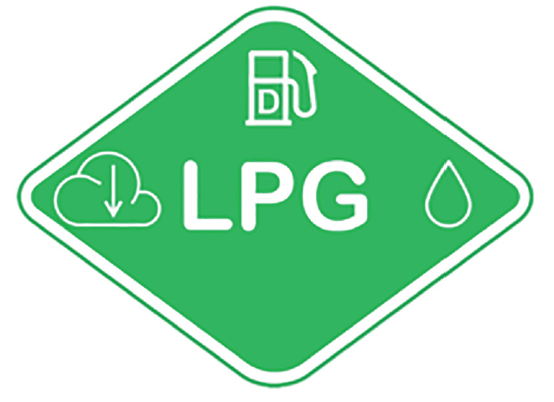*

**The label shall be weather resistant.**

**The centre zone indicates the first energy source**

**The upper zone indicates the second energy source**

**The left zone indicates the gas behaviour due to density**

**The right zone indicates the state of aggregation of stored gaseous fuel**

**Layout and symbols shall be in accordance with ISO 17840-4:2018**

**The colour and dimensions of the label shall fulfil the following requirements:**

**Colours:**

**Background: Green, RGB code 0, 176, 80**

**Border: white reflecting**

**Letters and symbols: white reflecting**

**Dimensions:**

**Sticker width: > 110 mm**

**Sticker height: > 80 mm "**

II. Justification

1. Provisions for identification of Gaseous and Liquified fuels have been laid down in UN Regulations for LPG-fuelled M2 and M3 vehicles only (UN Regulation No. 67, paragraph 17.1.8., including Annex 16 for details), CNG/LNG-fuelled M2 and M3 vehicles only (UN Regulation No. 110, paragraph 18.1.8., including Annex 6 and 7 for details) and Hydrogen vehicles (UN Regulation No. 134, paragraph 7.1.7. including Annex 6 for details)

2. The background for the updated labelling is to help emergency services to determine the approach of these vehicles in case of a fire. (In fire conditions it may be decided to cool the tanks or cylinders to prevent the activation of the TPRD’s or if the fire is progressed beyond this stage to take measures to mitigate the effects of a flare or explosion. Compressed and liquefied gases behave differently in fire conditions).

3. Extension of the scope to N2/N3 vehicles is necessary due to the wide variety of these vehicles nowadays, whereas in the past, they were usually equipped with a diesel powered driveline.

4. For the installation of labels this proposal seeks consistency with UN Regulation No. 134.

5. CTIF recommends to use symbols which are in line with International Standard ISO 17840-4, Part 4 Propulsion energy identification. (CTIF, historic French abbreviation for "Comité Technique International de prevention et d'extinction de Feu").

6. For the appearance of the label, this proposal seeks consistency with the above mentioned ISO standard.

7. Location of stickers based upon recommendations from CTIF.\_

1. \* In accordance with the programme of work of the Inland Transport Committee for 2021 as outlined in proposed programme budget for 2021 (A/75/6 (Sect.20), para 20.51), the World Forum will develop, harmonize and update UN Regulations in order to enhance the performance of vehicles. The present document is submitted in conformity with that mandate [↑](#footnote-ref-2)