 | INF.25
Economic Commission for Europe  Inland Transport Committee  Working Party on the Transport of Dangerous Goods  Joint Meeting of Experts on the Regulations annexed to the  European Agreement concerning the International Carriage  of Dangerous Goods by Inland Waterways (ADN)  (ADN Safety Committee)  Thirty-seventh session  Geneva, 25-29 January 2021  Item 5 (b) of the provisional agenda  Proposals for amendments to the regulations annexed to the ADN:  other proposals |  | 22 January 2021  English
Supporting reaction of EBU/ESO to ECE/TRANS/WP.15/AC.2/2020/36 (NL) and ECE/TRANS/WP.15/AC.2/2021/03 (D)
Transmitted by EBU and ESO
1. Both document 2020/36 and 2021/03 have to do with the way of enabling the air into the tank barges during degassing towards a reception facility.
2. In general EBU/ESO supports the content of both proposals but, by adding this document, we would like to provide some information from the practise on board, to ensure a solution can be reached which is in line with the practise and off course, safety is guaranteed buy also to enable all parties to imagine how the practise looks like.
Spring loaded low pressure valve
3. At first we must stipulate that far too much attention is paid to the non-spring loaded low pressure vacuum valve, which CAN be used if there is no aerating possible from the reception facility. It is just one of the options to aerate the barge.
4. It is correct and confirmed by one of the biggest suppliers of autonomic protection systems (Protego) that “spring loaded” must be striken through for a low pressure valve, as the techniques to let this valve earlier open than the regular spring loaded vacuum valves (-3,5 kPa) are technically impossible with the use of springs. Only technique by gravity can be used to design and produce a vacuum valve which opens at a lower setting (f.e. -1,5 kPa).
5. This is correctly framed in working document 2020/36, “spring loaded” shall be deleted and we should rename this option as “low-pressure valve”. Germany named the valve in document 2021/3 “pressure-equalizing valve” and later “additional vacuum valve” which could also accurate.
6. The additional low-pressure valve should in our opinion be considered as exemptional possibility, EBU/ESO consider this method as ‘last option’ and prefers other ways to equalize the vacuum.
Aerating the barge
7. More important for the practise is as following:
Barges can be aerated (or “equalized” of vacuum/pressure) during (unloading and) degassing by the following methods:
(a) Aerating by providing air from the reception facility (EBU/ESO’s preference)
(b) Aerating by suction of air by automatic opening low pressure vacuum valve / pressure-equalizing valve, installed on board (see pictures “alternatives” below);
(c) Aerating by opening the “devices for the safe depressurization of cargo tanks” (for “open products”);
(d) Aerating by suction of air into the cargo tanks through the flame arrestors (for “open products”);
(e) Supply of inert gas instead of her, supplied by reception facility of barges N₂-generator on board;
(f) An example of “closed equalization” of the vacuum could be seen within following picture of todays’ degassing towards a mobile degassing facility:
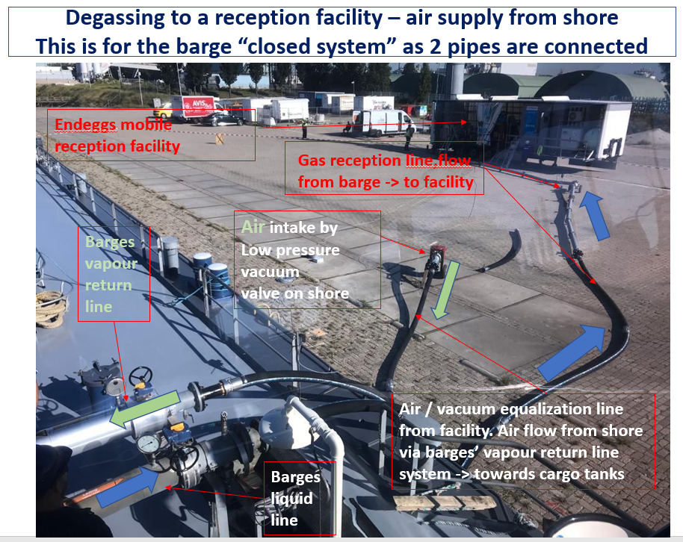
Animation, supporting the informal working group on degassing
8. This procedure was also explained in the animation https://www.youtube.com/watch?v=wHzeOzenifM which was presented in the ADN Safety Committee in the august session of 2017, supporting WD 2017/47 of the IWG Degassing. We would recommend watching the animation again.
9. The animation is, in our opinion still perfectly reflecting the practise, if you consider “spring loaded low pressure vacuum valve” just as “low pressure vacuum valve”.

A closed system (preference of EBU/ESO):
10. 2 pipes/hoses are connected, air from ‘shore’:

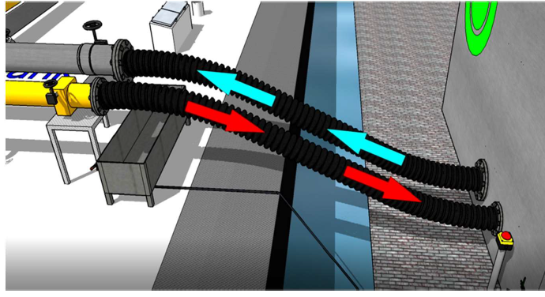
Alternatives:
11. Portable (NOT-SPRING LOADED) low pressure vacuum valve.
This should be seen as possible option, not an obligation to have such a valve on board. It can also be brought on board from the reception facility, been connected before and disconnected after the degassing has been finished (and returned to the shore).
The portable low pressure vacuum valve could be installed on the manifold of the barge, in this case on the end-blind-flange where during loading and unloading the arm/hose for loading/unloading is connected, but also on the vapour return line or in the middle of the cross-over
(a) Connection of portable low-pressure valve on liquid end flange of barges manifold:
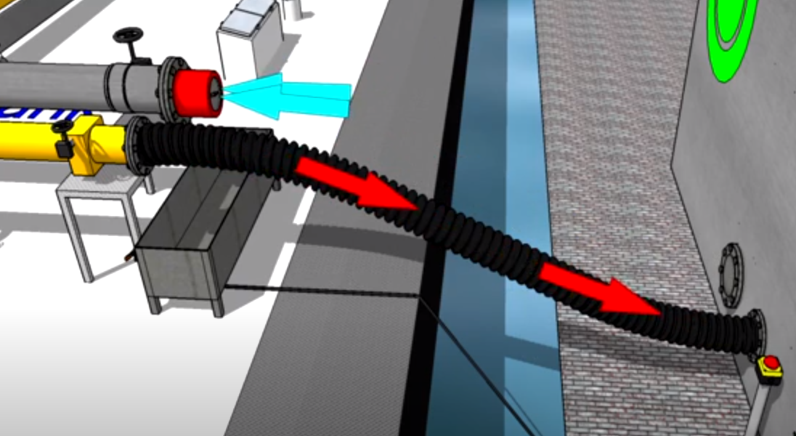
(b) Connection on vapor return line end flangs of barges manifold:
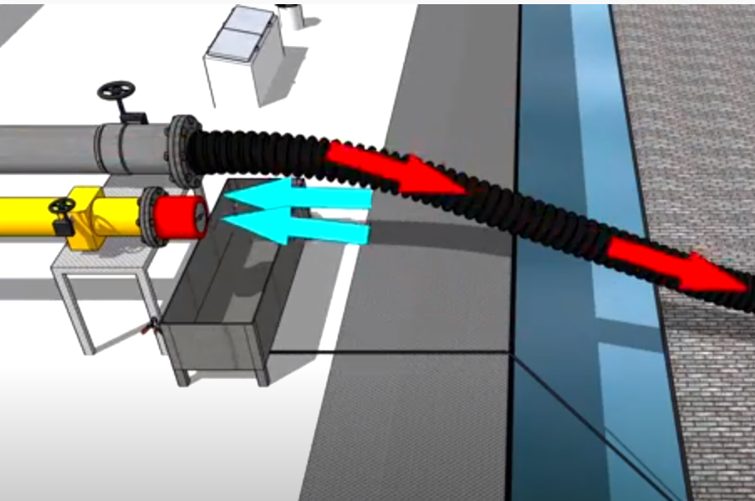
(c) Connection to the blind flange in the center of the crossover of a barges manifold.
This is mostly also the connection on which the hose is connected from the barges ventilator to degas to the atmosphere, when the barge is underway.
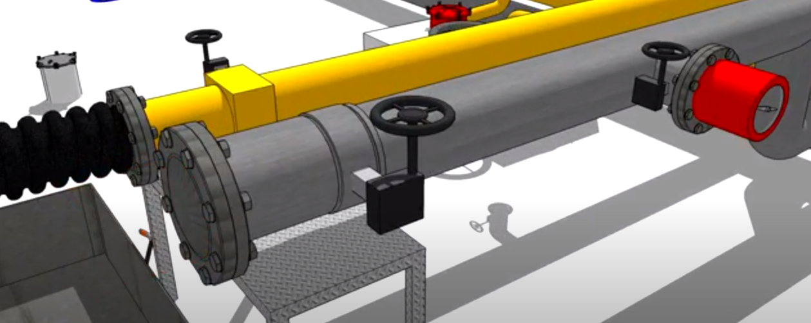
Close out
In the German document, is also in our opinion correctly phrased under 5 c) that type G barges do not degas under such a procedure anyway, and therefore, the text in 9.3.1. 62 can be deleted anyway. From our point of view it can be skipped from part 9 for all type of tank barges as it is not an obligation, but only an option.
Regarding 5G; it is correct that the operator of the reception facility generally does not have access to the technical equipment on board the vessel, but nevertheless we think the question is relevant. The question lets both parties conform HOW the aerating will be performed. This is a important safety aspect of which, in our opinion, both parties shall discuss on, agree on and formalize in the checklist 8.6.4.
Further, EBO/ESO supports the Dutch and German proposal.
We would like to end with the remark that we expect that in the near future, there will come more initiatives, innovations and probably even inventions regarding this environmental topic, especially in relation towards the implementation of the CDNI-treaty. EBU/ESO will follow and our members will be motivated in cooperating in testing programs, etc. to enable the developments to be tested in real life. As soon as new developments are applicable and relevant, they will be proposed in the ADN Safety Committee.

