 | INF.21
Economic Commission for Europe  Inland Transport Committee  Working Party on the Transport of Dangerous Goods  Joint Meeting of Experts on the Regulations annexed to the  European Agreement concerning the International Carriage  of Dangerous Goods by Inland Waterways (ADN)  (ADN Safety Committee)  Thirty-seventh session  Geneva, 25-29 January 2021  Item 4 (c) of the provisional agenda  Implementation of the European Agreement concerning the International Carriage of Dangerous Goods by Inland Waterways (ADN):  interpretation of the Regulations annexed to ADN |  | 20 January 2021  English
The use of cofferdams as ballast tank – ADN 7.2.3.20
Submitted by EBU and ESO
I. Introduction
1. On several canals in Western-Europe, there is very limited height of the bridges to sail under (until 4,20 m). Especially empty barges have very limited possibilities to reduce their height (“air draft”) and unfortunately yearly about 30 times a wheelhouse hits a bridge as an accident with, in some cases even lethal results.
2. EBU / ESO would like to draw attention for the Platform Zero Incidents (PZI) which is an initiative of the inland shipping industry. Charter companies, shipping companies, and ship owners share and develop knowledge on incidents within the industry in order to prevent a repetition of incidents and learn from each other and stakeholders.
3. PZI contributes to the aspiration of reaching zero incidents in inland shipping. Most of the members are tank barge operators. EBU/ESO is happy with this initiative and supports PZI. The database with figures is considered as a big value.
4. Incident data collected by the Platform Zero Incidents show conservative figures as follows, about tank barges and bridge collision over the last 5 years:
- 64 incidents registered regarding collision of wheelhouse with a bridge, wheelhouse (partly destroyed), serious damage of the wheel house and navigation apparatus etc. > € 50.000,-
- 2 incidents registered in which a crew member died as a result of the collision
- 4 crew members were wounded seriously as result of the collision
5. It has to be taken in account that the membership and notifications towards PZI and her incident database, is on a voluntary base and not all tank barges are connected with PZI. This means that the figures should be seen as ‘the top of the iceberg’ and many likewise cases are hidden ‘below the surface’ and not registered within. Besides dry cargo incident are nearly not within this database.
6. These collisions are a big problem for the barging industry and not easy to solve. Due to this critical situation EBU and ESO would like to discuss a probable solution, which has been allowed and used in the past; the use of the cofferdam as extra ballast tank. This is practically easy to be done and increases the draft of the barge with approx. 12-16 cm. which leads also to an extra 12-16 cm. bridge ‘clearance’.
II. Current provisions of ballast and historical review
7. In the current ADN states 7.2.3.20 “Water ballast”:
“Cofferdams (and hold spaces containing insulated cargo tanks) shall not be filled with water.”
8. This provision exists since a long time in the ADN(R), as far as we could trace back at least already in the ADNR of 1997 under Rn. 210 320.
9. ADN 1.6.7.2.2.2 provides a transitional provision for this article 7.2.3.20.1:
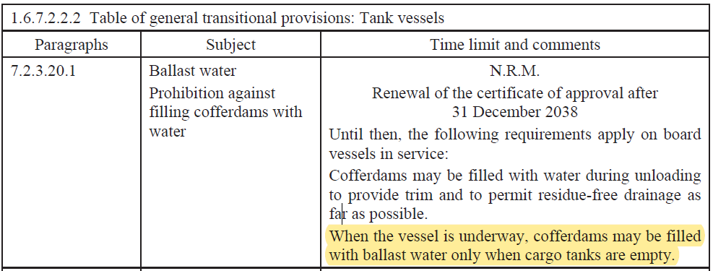

10. This implies, that because no date is inserted after “N.R.M.” the transitional provision is applicable for barges, built before 26 May 2000 (ADN 1.6.7.1.2 (b)-last paragraph).
III. Practise
11. The provisions already exist for a long time but in the last 3 decades, the fleet composition has been changed enormously; from mainly single hull barges in the early ‘90’s towards > 90% double hull barges nowadays.
12. Double hull barges are equipped with ballast tanks (9.3.x.11.5) and to sail when they are empty of cargo, on the canals, those ballast tanks are filled frequently, to fulfil the necessary reduce of the height of the barges and to sail safe under the bridges.
13. It is a fact that the double hull barges have a bigger height in the cargo area, to be able to carry more or less the same amount of product, compared to the former single hull barge with the same dimensions of length and width. This, because as the U-formed double hulls around the cargo tanks of a double hull barge (on portside, starboard and the bottom under the tanks) reduces the cargo tank sizes in the width of the barge.
14. Cofferdams (type N and type C) are equipped to fill them with water within 30 minutes, in case of fire (9.3.x.20.2). The filling of the cofferdam provides approximately an 40-50 m3 and thus 40-50 tons of water ballast, which increases an extra draft of approximately 16 cm, which thus results in 16 cm’s less air draft and 16 cm’s more bridge clearance above the wheel house.
15. To give an insight in the practise of sailing on the channels with a (hydraulic) lowered wheelhouse see the picture attached.
IV. Proposal
16. For the barging industry it is unclear why it is not allowed to ballast by using the cofferdams and we do not see any negative aspect of doing so. We see nearly no difference with the U-tanks around the cargo tanks, which are designated as ballast tanks.
17. It would help our industry to gain a bigger safety marge, sailing under bridges, which directly results in a safety improvement during the voyage, for ship and crew. Less bridge collision incidents could be expected.
18. For barges built, before 23-5-2000 it is allowed to use the cofferdam as “ballast tank” until renewing of the Certificate of Approval, after 2038.
19. EBU/ESO would ask the Safety Committee to give information about the background of this provision and asks the safety committee to reconsider the prohibition to put ballast in cofferdams as mentioned in ADN 7.2.3.20 as this would -as far as we see- only have safety benefits. (The proposal includes ballast only in the ballast tanks and cofferdams, hold spaces containing insulated cargo tanks are excluded from the scope of this proposal).

Annex
2 pictures showing the clearance of wheelhouse tops under brigdes of the Wesel-Datteln-Kanal in Gemany

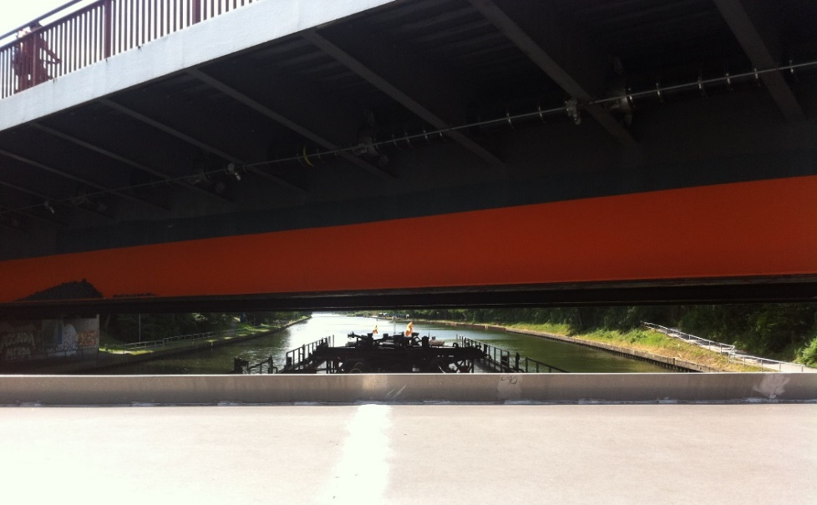

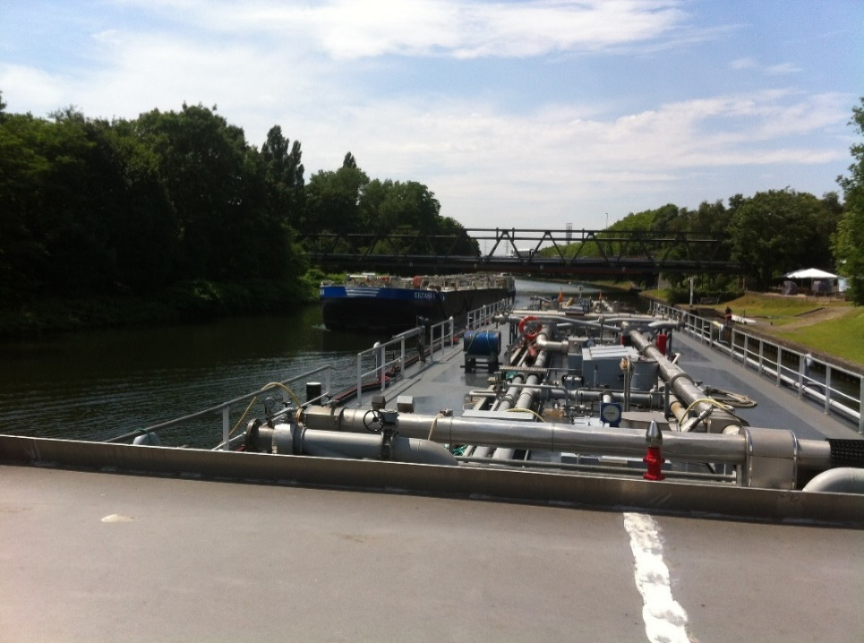

www.platformzeroincidents.nl

