# INTERPREFY

Page 1

**USER GUIDE FOR REMOTE DELEGATES, at Aarhus Convention 13TFAJ, 15-16 February 2021**

* Please join the testing one hour before formal sessions in mornings (at 9 a.m. Geneva time) and afternoons (at 1 p.m. Geneva). **During testing: “Raise your hand/Click on the green hand” so that the moderators can help you test your connection.**
* In between the morning and afternoon sessions, and at the end of meeting each day, please **LOG OUT**

# STEP ONE – Log into our Platform

1. **Connect USB headset** with a microphone to the PC or laptop. Do not use mobile phone or tablet.



1. Open browser: **Google Chrome or Firefox**
2. Enter the link **to be sent to the registered participants**:



1. Type in the username **in MANDATORY format**:

* **For representatives of Governments: COUNTRY NAME_FirstName_LastName**
* **For representatives of Organizations: ORGANIZATION NAME_FirstName_LastName**
* **For individuals: PUBLIC_FirstName_LastName**

Note, the above username will be shown to all participants as your identification linked to the entity that you represent. If naming standards are not adhered, the Chairman may disconnect you from the meeting. **Do NOT check the box “I am a Meeting Host”. Click on “Submit” blue button.**

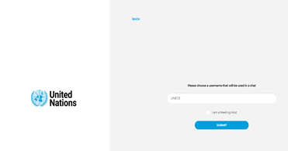



**Do NOT check**

1. You will receive notification message – **Host has joined the meeting.**

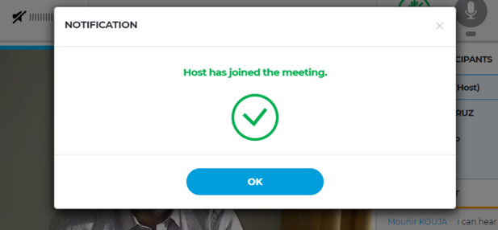

Page 2

1. Check if browser permanent access to the microphone or camera is allowed

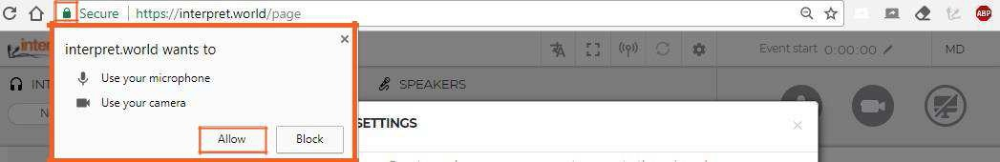

1. The following window will appear to select:

- **Language:** choose the language of **interpretation** - **English, French, or Russian; or “none”** if you wish to listen **in original languages)**. For the test, please select “**none”**

- **Audio/video devices**: use proper **USB** headset and **USB** camera (or integrated camera).

## Never use audio from your PC!

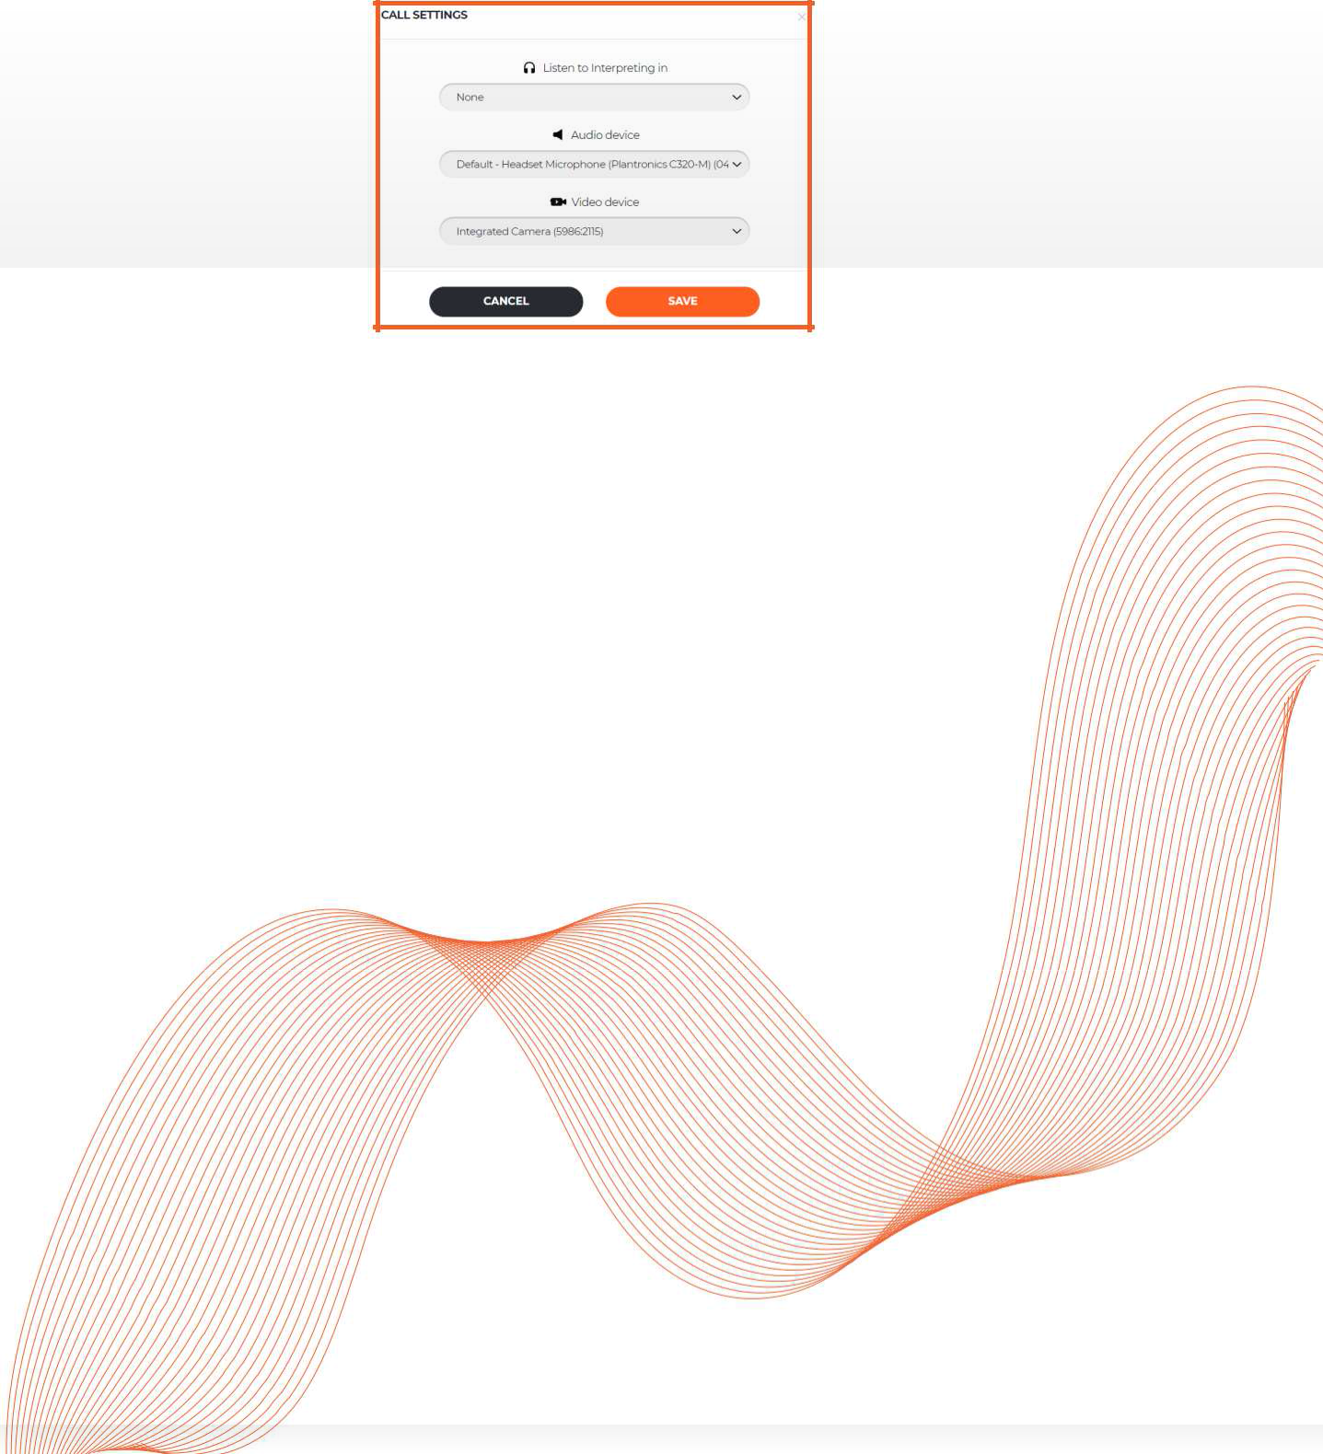By using your PC microphone, you will give audio troubles to other participants and interpreters. Both, audio and video devices should be plugged in before opening the platform.

***If you cannot hear the floor, you can try to change audio settings and click restart all lines***

Restart all lines

Select audio/video settings

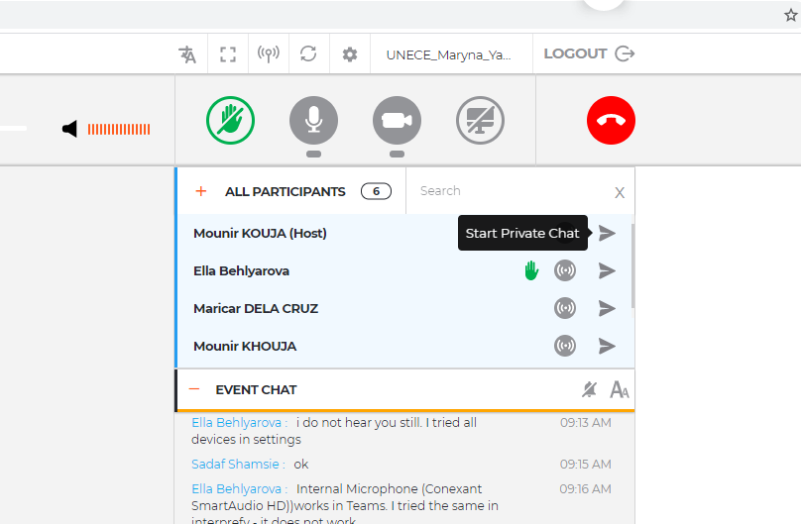



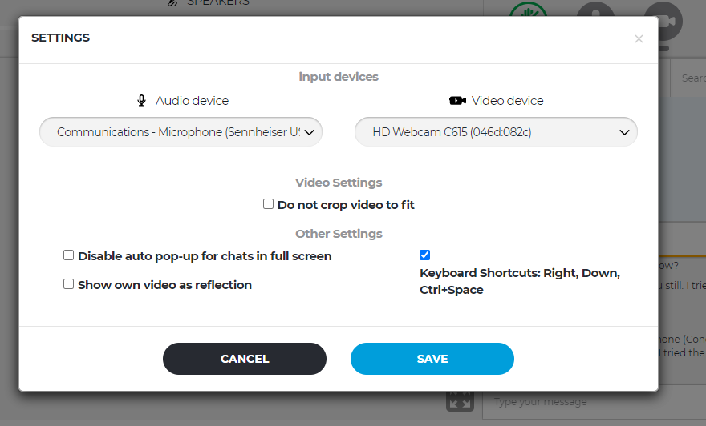

***You are all set up and ready to use the Interprefy platform!***

Page 3

# STEP TWO - How to request the floor to speak

## The Chair will invite speakers to take the floor in accordance with requests submitted by delegations to the secretariat prior to the meeting.

## In addition, subject to time availability, ad hoc requests to take the floor during the meeting could be submitted by clicking the green hand icon (raise your hand) once the respective agenda item is open.

## Note, if your statement is not within the scope of the agenda items or disrespectful language is used, you might be refused to take the floor or your microphone will be muted.

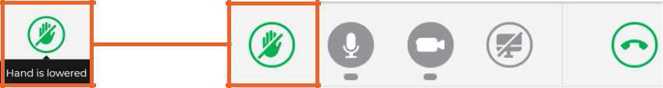

1. Once the Chair invited you to speak, the following message pops up on the screen to allow you streaming. Press the button **Audio and Video** to select both, audio and video streams.

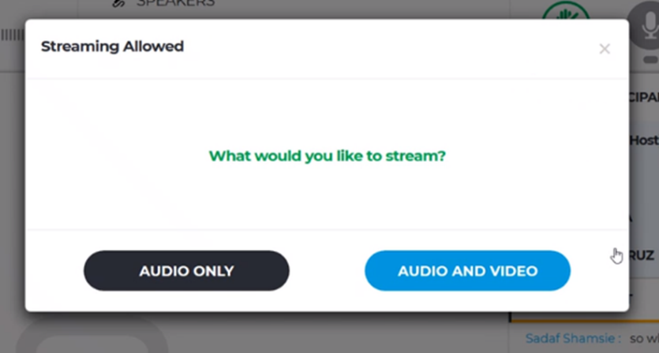

1. Once your intervention is over, use the button to stop your streaming. **Red** means you are streaming, **green** means that you are not streaming.



1. **AUTO VOLUME enabled -** Auto Volume switch is turned on by default. When this switch is on, the volume is automatically adjusted between interpreting and the Floor: when the interpreter is muted, user hears Floor, and when interpreter is speaking, user hears interpreting. This way, participant does not need to switch between channels and only hears the language he/she understands, either on the Floor or through the interpreter.

Page 4

1. Watch, listen and talk to the other participants. Watch presentations and/or video feeds from other participants.

Choose full screen (Hover the mouse over the video and icon will become visible)

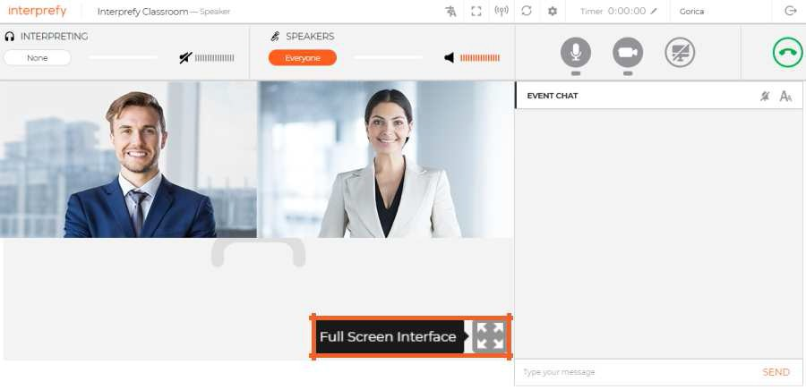

1. The **EVENT Chat (general chat)** in Interprefy is disabled and **shall not be used.**

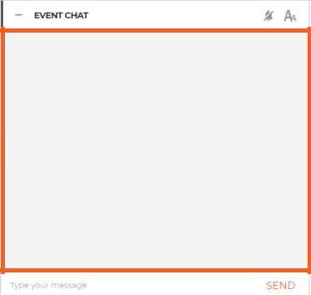

## PRIVATE CHAT

Use **PRIVATE CHAT** to communicate individually with other participants, Aarhus secretariat and UNOG technical support staff. **If remote delegate wishes to intervene or clarify any substantive or procedural matters, PRIVATE CHAT with the Aarhus secretariat should be used.**

Private chat is activated by clicking on an arrow on the right side.

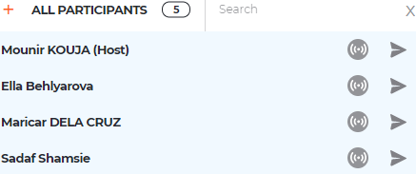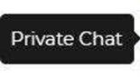



You can check for the received **PRIVATE** messages in bottom right corner – blue circle.



Page 5

# STEP THREE - Troubleshooting

**1.** Use following link if you are not able to connect or if getting any error messages when trying to stream your audio and video https://interpret.world/test

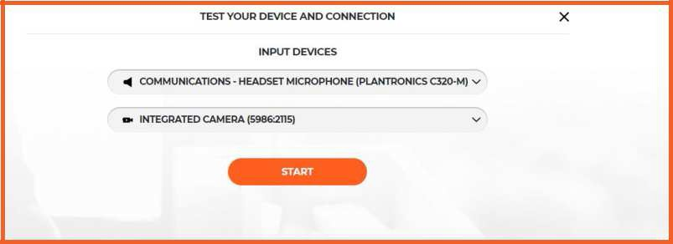

**2.** If facing any problem with audio and video, during the meeting itself use button RESTART ALL LINES (above hand icon). If issue persists - reload browser.

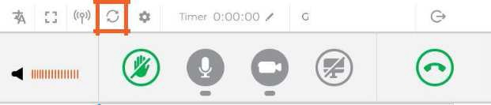

**3. Checklist for a successful virtual connection:**

* **Use a** **stable and strong internet connection - via Ethernet (LAN) cable** rather than via Wi-Fi. (Not less than 4-6 Mbps up/down. You may check here [http://interprefy.speedtestcustom.com/](https://eur02.safelinks.protection.outlook.com/?url=http%3A%2F%2Finterprefy.speedtestcustom.com%2F&data=02%7C01%7Ceia.conv%40un.org%7C818f4fca0aa84959d53408d84802c0e3%7C0f9e35db544f4f60bdcc5ea416e6dc70%7C0%7C0%7C637338523944101881&sdata=xbCQigHBBV6jMeiGKd9nlZxqncBvA72fxnnGzkueJp4%3D&reserved=0)).
* **Use a PC or a laptop**: the platform does not work with mobile devices (I-Pads, mobile phones).
* **Use a USB headset with a microphone**
* **Use** **Google Chrome or Firefox** browser
* **Close all other running applications** on your computer as Interprefy takes up lots of memory
* **Test your device and connection beforehand**: by copying this link into Google Chrome or Firefox browser: [https://interpret.world/test](https://eur02.safelinks.protection.outlook.com/?url=https%3A%2F%2Finterpret.world%2Ftest&data=02%7C01%7Ceia.conv%40un.org%7C818f4fca0aa84959d53408d84802c0e3%7C0f9e35db544f4f60bdcc5ea416e6dc70%7C0%7C0%7C637338523944111878&sdata=c%2FzSeAjn%2FyFYn02hyRNt14%2FxvB9WGF9wfWhb8kZZJJQ%3D&reserved=0)
* **Join the testing** one hour before formal sessions in mornings (at 9 a.m. Geneva time) and afternoons (at 1 p.m. Geneva time). **During testing: “Raise your hand/Click on the green hand” so that the technical staff can help you to test your connection.**
* In between the morning and afternoon sessions, and at the end of meeting each day, please **LOG OUT (upper right corner** **)** **– AND JUST USE THE SAME LINK TO RECONNECT TO THE MEETING THORUGHOUT THE MEETING**

**4. Interprefy troubleshooting wikipage:**

<https://statswiki.unece.org/display/MWHW/Interprefy+Troubleshooting>

**5. Useful Videos:**

-Equipment setup: <https://youtu.be/V6FIIj35GNI>

-Speaker tutorial: <https://youtu.be/16GxvdQxzBY>

**6.** **Contacts**:

For substantive or procedural matters:

* During the meeting hours: chat to the private channel **“Aarhus secretariat”**
* Outside the meeting hours: write to [**public.participation@un.org**](mailto:public.participation@un.org)

For technical assistance:

* During the meeting hours: chat to the private channel to Technical Staff, who is **identified by “UNOG Moderator (Host)”.**
* Outside the meeting hours: write to [**public.participation@un.org**](mailto:public.participation@un.org)

****