Transmitted by the experts of the Informal Working Group on Measurement Uncertainties (IWG MU) | Informal document GRBP-73-17  (73rd GRBP, 26-29 January 2021,  agenda item 3)

Proposal for amendments to UN Regulation No. 51.03
Annex 3, Paragraph 1.4., 1.5. & 2.1.3.

The changes compared to UN Regulation No. 51.03 for text moved to another place only are marked in bold, for added text in bold and strike through for deleted text.
- Proposal:
Annex 3, Paragraph 1.4., amend to read:
“1.4. Instrumentation for speed measurements
The engine speed shall be measured with instrumentation having an accuracy of ±2 per cent or better at the engine speeds required for the measurements being performed.
The road speed of the vehicle shall be measured with a continuous speed measuring device instrumentation having an accuracy of at least ±0.5 km/h, when using continuous measurement devices.
If testing uses independent measurements of speed, this instrumentation shall meet specification limits of at least ±0.2 km/h.”

Annex 3, Paragraph 1.5., amend to read:
“1.5. Meteorological instrumentation
The meteorological instrumentation used to monitor the environmental conditions during the test shall include the following devices, which meet at least the given accuracy:
(a) Temperature measuring device, ±1 °C;
(b) Wind speed-measuring device, ±1.0 m/s;
(c) Barometric pressure measuring device, ±5 hPa;
(d) A relative humidity measuring device, ±5 per cent.
A monitoring of the wind speed is not mandated, when tests are carried out in an indoor facility.”

Annex 3, Paragraph 2.1.3., amend to read:
“2.1.3. Ambient conditions
2.1.3.1. Ambient Condition Indoor
2.1.3.1.1. General
Meteorological conditions are specified to provide a range of normal operating temperatures and to prevent abnormal readings due to extreme environmental conditions.
The meteorological instrumentation shall deliver data representative for the test site and values of temperature, relative humidity, and barometric pressure shall be recorded during the measurement interval.
2.1.3.1.2. Temperature
The measurements shall be made when the ambient air temperature is within the range from 5 °C to 40 °C.
The ambient temperature may of necessity be restricted to a narrower temperature range such that all key vehicle functionalities (e.g. start/stop, hybrid propulsion, battery propulsion, fuel-cell stack operation) are enabled according to manufacturer's specifications.”
2.1.3.1.3. Wind
n.a.
2.1.3.1.4. Background Noise
For indoor testing, background noise shall take into account noise emissions produced by the dynamometer rollers, ventilation systems, and facility exhaust gas systems.

2.1.3.2. Ambient Condition Outdoor
2.1.3.2.1. General
The surface of the site shall be free of powdery snow, tall grass, loose soil or cinders. There shall be no obstacle which could affect the sound field within the vicinity of the microphone and the sound source. The observer carrying out the measurements shall so position themself as not to affect the readings of the measuring instrument.
Measurements shall not be made under adverse weather conditions. It shall be ensured that the results are not affected by gusts of wind.
The meteorological instrumentation should be positioned adjacent to the test area at a height of 1.2 m ± 0.02 m.
A value representative of air and road surface temperature, wind speed and direction, relative humidity, and barometric pressure shall be recorded during the sound measurement interval.
2.1.3.2.2. Temperature
The measurements shall be made when the ambient air temperature is within the range from 5 °C to 40 °C and the test surface temperature within the range from 5 °C to [60] °C.
Tests carried out on request of the manufacturer at temperatures below 5° C shall be accepted as well.
The ambient temperature may of necessity be restricted to a narrower temperature range such that all key vehicle functionalities (e.g. start/stop, hybrid propulsion, battery propulsion, fuel-cell stack operation) are enabled according to manufacturer's specifications.”
2.1.3.2.3. Wind
The tests shall not be carried out if the wind speed, including gusts, at microphone height exceeds 5 m/s, during the sound measurement interval.

2.1.3.2.4. Background Noise
Any sound peak which appears to be unrelated to the characteristics of the general sound level of the vehicle shall be ignored in taking the readings.
The background noise shall be measured for duration of 10 seconds immediately before and after a series of vehicle tests. The measurements shall be made with the same microphones and microphone locations used during the test. The A-weighted maximum sound pressure level shall be reported.
The background noise (including any wind noise) shall be at least 10 dB(A) below the A-weighted sound pressure level produced by the vehicle under test. If the difference between the ambient noise and the measured sound is between 10 and 15 dB(A), in order to calculate the test results the appropriate correction shall be subtracted from the readings on the sound-level meter, as in the following table:
Difference between ambient noise and sound to be measured dB(A) | 10 | 11 | 12 | 13 | 14 | 15
Correction dB(A) | 0.5 | 0.4 | 0.3 | 0.2 | 0.1 | 0.0

“
- For clarification only:
Text from Annex 3, Former Paragraph 2.1.3.
The surface of the site shall be free of powdery snow, tall grass, loose soil or cinders. There shall be no obstacle which could affect the sound field within the vicinity of the microphone and the sound source. The observer carrying out the measurements shall so position themself as not to affect the readings of the measuring instrument.
Measurements shall not be made under adverse weather conditions. It shall be ensured that the results are not affected by gusts of wind.
The meteorological instrumentation should be positioned adjacent to the test area at a height of 1.2 m ± 0.02 m.
moved to Annex 3, New Paragraph 2.1.3.2.1.
The measurements shall be made when the ambient air temperature is within the range from 5 °C to 40 °C.
Tests carried out on request of the manufacturer at temperatures below 5° C shall be accepted as well.
moved to Annex 3, New Paragraph 2.1.3.2.2.:
The tests shall not be carried out if the wind speed, including gusts, at microphone height exceeds 5 m/s, during the sound measurement interval.
moved to Annex 3, New Paragraph 2.1.3.2.3.:
A value representative of temperature, wind speed and direction, relative humidity, and barometric pressure shall be recorded during the sound measurement interval.
moved to Annex 3, New Paragraph 2.1.3.2.1.

Any sound peak which appears to be unrelated to the characteristics of the general sound level of the vehicle shall be ignored in taking the readings.
The background noise shall be measured for duration of 10 seconds immediately before and after a series of vehicle tests. The measurements shall be made with the same microphones and microphone locations used during the test. The A-weighted maximum sound pressure level shall be reported.
The background noise (including any wind noise) shall be at least 10 dB(A) below the A-weighted sound pressure level produced by the vehicle under test. If the difference between the ambient noise and the measured sound is between 10 and 15 dB(A), in order to calculate the test results the appropriate correction shall be subtracted from the readings on the sound-level meter, as in the following table:
Difference between ambient noise and sound to be measured dB(A) | 10 | 11 | 12 | 13 | 14 | 15
Correction dB(A) | 0.5 | 0.4 | 0.3 | 0.2 | 0.1 | 0.0
moved to Annex 3, New Paragraph 2.1.3.2.4.
For indoor testing, background noise shall take into account noise emissions produced by the dynamometer rollers, ventilation systems, and facility exhaust gas systems.
moved to Annex 3, New Paragraph 2.1.3.1.4.

- Justification:
Annex 3, Paragraph 1.4.
The determination of the vehicle speed by independent speed measuring devices has been deleted to improve the accuracy in determination of speed and acceleration (which is calculated out of the speed measurements and thus more sensitive to variation).

Annex 3, Paragraph 1.5.
A sentence was added to clarify that no determination of the wind speed is needed for indoor testing

General regarding Annex 3, Paragraph 2.1.3.
The chapter for ambient conditions has been completely restructured for more clarity and to differentiate between indoor and outdoor testing.

Annex 3, Paragraph 2.1.3.1.2.
Clarifies the temperature range for indoor facilities. There is no need to require more narrow temperature conditions for air temperature compared to outdoor testing, as outdoor testing will stay the reference for all tests.

New text was added to clarify, that especially with new technologies the manufacturer may determine more narrow temperature conditions, if otherwise the key functionalities (e.g. start/stop, hybrid propulsion, battery propulsion, fuel-cell stack operation) cannot be ensured.

Annex 3, Paragraph 2.1.3.2.2.
Clarifies the temperature range for outdoor facilities. New requirements for road surface temperature has been introduced. The maximum temperature is under discussion to be either aligned with UN R117 to 50°C or the be expanded for practical reasons to 60°C. There is evidence that 60 °C surface temperature correlates for with the actual mandated 40°C air temperature.

The tyre rolling sound component will be corrected to a reference temperature (pending work package). Thus the temperature range is less critical as today.

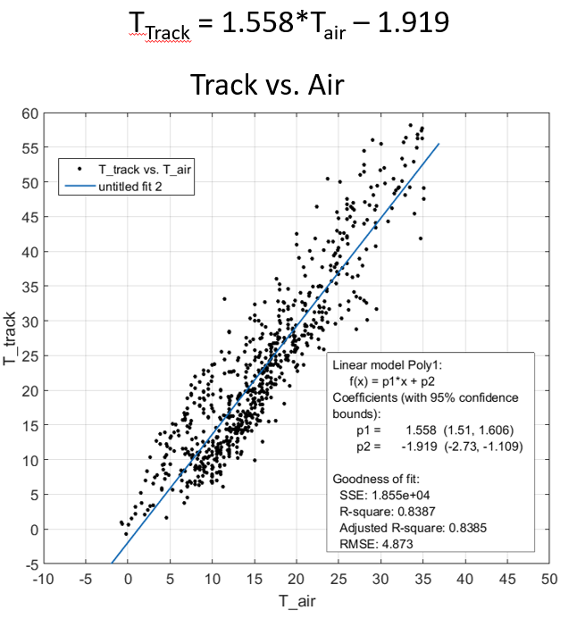
Measurements of air and track surface temperature
(about 700) measurement points under various
ambient conditions (summer, winter, cloudy, sunny, etc…)

New text was added here as well to clarify, that especially with new technologies the manufacturer may determine more narrow temperature conditions, if otherwise the key functionalities (e.g. start/stop, hybrid propulsion, battery propulsion, fuel-cell stack operation) cannot be ensured.

