Transmitted by the experts of IWG MU

Informal Document GRBP-73-15
(73rd GRBP, 26-29 January 2021,
agenda item 3)

DRAFT DOCUMENT OF REFERENCE:
A GENERAL APPROACH TO ESTIMATE MEASUREMENT UNCERTAINTIES

- Background

In all kind of testing of objects according to standards, there is a certain measurement uncertainty. This is also the case of the measurement of sound levels of vehicles and tyres, for example during type approval of these objects. In standards used for such measurements (ISO, ANSI, CEN, etc.) a separate chapter on measurement uncertainty is mandatory. However, this is not the case in UN ECE regulations.

The focus on In-use compliance checking of vehicles is increasing, as the introduction of the Regulation (EU) 2018/858¹ (Marked surveillance) is showing. In the US., such testing has been in place for decades for emissions and safety (not noise).

These kinds of tests will then be performed by institutions not involved in the original type approval test ("third party"). Therefore, uncertainties connected to such market surveillance tests will be of uttermost importance, as a failure they could withdraw any previous given type approval to the vehicle/object.

Such third-party testing is not within the scope of UN ECE, however measurement uncertainties have also an important role in general for Conformity of Production (COP), which is part of UN ECE regulations for vehicles and tyres.

GRBP has therefore been asked to establish an Informal Working Group on measurement uncertainties to work on the following topics:
- Improvements of test methods
- Compensation, if possible (systematic errors)
- Remaining uncertainties (random errors)

This Draft rapport outline the general approach to measurement uncertainty, based on both ISO 5725² and ISO/IEC Guide 98-3 (GUM)³. However, the steps of defining the uncertainty of a measurement based on ISO 5725 do not differ significant from the GUM. Therefore, the statistical method described in this report will mainly focus on the GUM.

- General considerations

Measurement procedures are always affected by factors causing disturbances leading to variation in the results observed by the same subject. The source and nature of these perturbations are not completely known and can sometimes affect the end-result in a non-predictable way.
A measured result shall be understood as an approximation to the true result, which by itself is unknown.
- Two measurements are deemed to provide the same result if their test results are within a given uncertainty.

Thus, the knowledge of the measurement uncertainty is important as it provides information about the precision and repeatability of measurements.

It is important to minimize the uncertainties, e.g. by narrowing ambient and test conditions or by corrections. Any residual uncertainty shall be covered by tolerances.

In general, measurement deviations can be of two different kinds:
- Systematic errors, which can be compensated for
- Random errors, which cannot be compensated for

To compensate for systematic errors, a correlation between the measurand and the influence factor must be known.

Random errors can be reduced by increasing the number of measurements.

When all known systematic errors have been compensated for, the final result will be a value with estimated tolerances, calculated from the expanded uncertainty.

Figure 2.1 shows a two-dimensional approach where both systematic and random errors are included.

Systematic errors
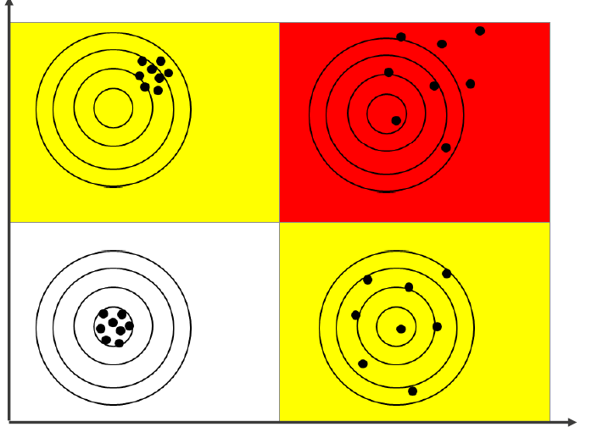
Random errors

Figure 2.1 Two-dimensional approach according to ISO 5725

Any measured result will consist of the measured value + uncertainty.
The bottom to the left represents a "true" (or precise) value with a small variation of the results. The upper left is gives "true" value with defined systematic errors, which can be corrected for.
The lower right corner is also a "true" value, with random errors, giving a certain dispersion of results. The upper right hand red area is neither precise or true, and a true value cannot be established.

Such a two-dimensional approach is according to the procedure given in ISO 5725.

It should be noted that the approach to define the uncertainty contribution as given by the GUM do not distinguish between random or systematic errors.

- How to handle measurement uncertainty

To reduce measurement uncertainty, the following approach is recommended⁴:

- Avoidance of uncertainties
Normally, a regulation/measuring method defines certain tolerances within which the measurements can be performed. It is important to understand the possibilities to reduce uncertainty by limiting boundary conditions.

As an example, measurements according to UN ECE Reg.117 on rolling sound can be performed with a test track surface temperature between +5 to + 50 °C. These limited boundary conditions are chosen to reduce measurement variation, as well as to provide reasonable testing time throughout the year.

- Use of compensations (reducing systematic errors)
Staying with the UN ECE R117 example, the measured sound level at a certain surface temperature shall then be corrected to a reference temperature of + 20 °C, based on a defined correction between road surface temperature and measured sound level. The correction does not eliminate measurement uncertainty, but it does reduce the measurement uncertainty. The lowest possible uncertainty is if all measurements are performed at + 20 °C.

- Use of an uncertainty model
As there is never a "true" value for the final result, there is a need to use an uncertainty model to define the tolerances (as expected variance) of the measured value. Such uncertainty models are defined in ISO 5725 and in the ISO/IEC Guide 98-3.

- Repetition of measurements
In a regulation/measuring method, a certain number of repetitions of a test condition can be defined, as a means to reduce uncertainties. Therefore, by repeating measurements under equal boundary conditions, using the mathematical mean of the measurements minimizes the uncertainty, as the influence of random errors will be reduced. An example of this practice is the use of four measurement runs in UN ECE R51.03 which are then mathematically averaged.

This approach is shown in figure 3.1

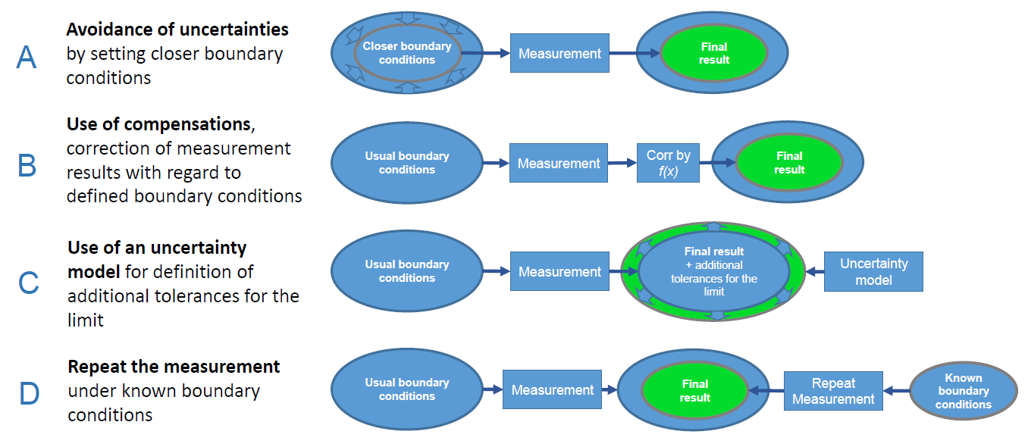
Figure 3.1 Approach to reduce measurement uncertainty⁴

- ISO/IEC 98-3 (GUM) approach

An input quantity to the uncertainty model is never exact, so an assessment must be done.
In most cases, a measurand Y is not measured directly, but is determined from N other quantities X₁, X₂,…, X_{N} through a functional relationship:

Y = ƒ (X₁, X₂,…, X_{N}) (1)

The input quantities X₁, X₂,…, X_{N} upon where the output quantity Y depends, may themselves be viewed as measurands and may themselves depend on other quantities, including corrections and correction factors for systematic errors.

An estimate of the measurand Y denoted by y, is obtained from Equation (1) using input estimates x₁, x₂,….,x_{N} for the values of N quantities X₁, X₂,…, X_{N}. Thus, the output estimate y, which is the results of the measurements, is given by:

y = ƒ (x₁, x₂,…,x_{N}) (2)

If the input quantity can lie on both sides of the true value and the probability is higher if it is closer to the true value than further away from it, one can assume a normal ("gaussian") distribution as a good approximation. Figure 4.1 show such a normal distribution, where µ is the mean value of the variance V of the quantity and σ is the standard deviation.

.

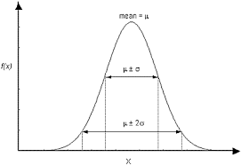

Figure 4.1 Normal ("gaussian") distribution

If all values of the input quantity are equally likely within a given interval, the distribution is rectangular, as shown in figure 4.2.
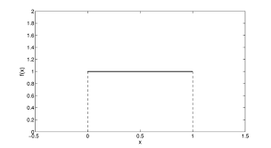

Figure 4.2 Rectangular distribution within the interval 0 to 1.

In some cases, the input quantity can only lie above or below a fixed value, and in that case, one has a single-sided distribution. In some cases, a half-normal distribution (single-sided) can also be a good approximation, if for example, the input quantity is more likely to lie close to a limit value, than further away.

The final resulting value consists of the measured value + the input quantity for the uncertainty factor, δ₁ to δ_{i}

Y_{final} = Y_{meas} + δ₁ + δ₂ + δ₃ + δ₄ +··········+ δ_{i} (3)

The uncertainty contribution on the measurand due to the input quantity δ_{i} is c_{i} µ_{i}, where c_{i} is the sensitivity coefficient and µ_{i} the uncertainty.

The sensitivity coefficients are partial derivatives used to describe how the output estimate y varies with the values of the input estimates in equation (2).

The sensitivity coefficients show how the variables in (2) will influence the magnitude of the result of y,
They function as a multiplier used to convert the uncertainty components to the right units and magnitude for the uncertainty analysis.

If there is no need for a sensitivity coefficient, for example if the input quantities or uncertainty contributors are all reported in the same unit of measure. In such cases, the sensitivity coefficient can be set to 1.

The combined standard uncertainty u_{c}(y) will then be the positive square roots of the combined variances:

u_{c}(y) = √∑µ² (4)

The combined standard uncertainty is expressed as the standard deviation of the measurand.

The expanded standard uncertainty, U, is calculated by multiplying the combined standard uncertainty, u_{c}(y), with a coverage factor, k, for the chosen coverage probability:

U = k· u_{c}(y) (5)

The coverage factor can be chosen such that the result U can be interpreted as the width of a certain confidence interval (although the GUM states that this is statistically not totally true).
Normally, the k factor lies between 2 and 3, which correspond to a level of confidence of approximately 95 % or 99 %. However, in other cases k can also be less than 2.
The result of the measurement is then conveniently expressed as:

Y = y ± U (6)

For practical reasons, a table with an uncertainty budget should be set up, where all relevant quantities are defined. An example of such table is shown, below, taken from an ISO standard to measure the stationary sound pressure level from road vehicles⁵.

Table 4.1 Uncertainty budget for determination of reported sound pressure level⁵
Quantity | Estimate  dB | Standard uncertainty, µ_{i},  dB | Probability distribution | Sensitivity coefficient,  c_{i} | Uncertainty contribution, c_{i} µ_{i},  dB
L_{Ameas, i} | L_{Ameas, i} | - | - | - | -
δ₁ | - | - | - | - | -
δ₂ | - | - | - | - | -
δ₃ | - | - | - | - | -
δ₄ | - | - | - | - | -
δ₅ | - | - | - | - | -
δ₆ | - | - | - | - | -

- ISO 5725 approach

ISO 5725 – Accuracy (trueness and precision) of measurement methods and results².

The method consists of 6 parts:
Part 1: General principles and definitions
Part 2: Basic method for the determination of repeatability and reproducibility of a standard measurement method
Part 3: Intermediate measures of the precision of a standard measurement method
Part 4: Basic methods for the determination of the trueness of a standard measurement method
Part 5: Alternative methods for the determination of the precision of a standard measurement method
Part 6: Use in practice of accuracy values

This standard is primarily suited for inter- or intra-laboratory comparisons of results.

The following is a basic summary of the statistical model given in Part 1 of the standard and from UTAC⁶:

For estimation of the accuracy (trueness and precision) of a measurement method, one can assume that every test result, Y, is the sum of three components:

Y_{ij} = m + L_{i} + ɛ_{ij} (7)

where:
Y_{ij} is the j^{th} test result from laboratory i
m is the general mean (expectation);
L_{i} is the laboratory effect i, i = 1 to p, with variance σ_{L}²;
p is the number of laboratories participating.
ɛ_{ij} is the residue (random error) on the j^{th} result from laboratory i, j to n, with variances:

var(L) = σ_{L}² (8)
var(ɛ) = σ_{ɛ}² (9)

Methods are given in Part 3 for measuring the size of some of the random components of L.
In general, L, can be considered as the sum of both random and systematic errors.

Within a single laboratory, its variance under repeatable conditions is called the within-laboratory variance and is expressed as:

σ_{L}² = var(ɛ) = σ_{W}² (10)

This arithmetic mean is taken over all those laboratories taking part in the accuracy experiment which remain after outliers have been removed.

When this basic model is adopted, the repeatability variance is measured directly as the variance of the error term ɛ, but the reproducibility variance depends on the sum of the repeatability variance and the between-laboratory variance in (8).

For precision evaluations:
- Repeatability standard deviation: σ_{r} = σ_{ɛ}
- Reproducibility standard deviation: σ_{R}² = σ_{L}² + σ_{r}²

Variance component estimation:
- Repeatability: s_{r} = s_{ɛ}
- Reproducibility: s_{R}² = s_{ɛ}² + s_{L}²

For trueness evaluations:

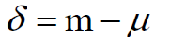 (11)

where µ is the reference value if it exists
Estimated by:

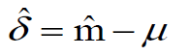 (12)

The combined uncertainty u_{c}(y) comes from the values of precision:

- in conditions of repeatability: u_{c}(y) = s_{ɛ}
- in conditions of reproducibility: u_{c}(y) = s_{R}

The expanded uncertainty: U = k· u_{c}(y) (13)

Where k is the chosen coverage factor.

- Example of estimation of calculation of expanded uncertainty – UNECE Reg.51.03 and ISO 362-1.

In UNECE Reg.51.03, the test method for M1, N1 and M2 < 3500 kg classes of vehicles (Annex 3) is based on two driving conditions; a constant speed test, L_{crs}, and a wide-open throttle acceleration test, L_{wot}, to determine the final type approval level, L_{urban}.

In the table⁷ below, the impact of the different quantities on these indicators has been estimated for the Run-to-run, Day-to-day, Site-to-site and Vehicle-to-vehicle situations.
Some of the different impacts are based on calculations from tolerances in the regulations, while others are based on experiences. Based on the probability distribution, the variance and the standard deviation is calculated. For each of the quantities, their contribution (in %) has been calculated and the colour scheme makes it easy to understand the influence of the quantity to the total uncertainty. Some of these quantities can be compensated for, like the influence of temperature and test track variations, while other is of random type, like instrumentation accuracy and cannot be compensated. In the example shown below, the estimated total expanded uncertainty has been calculated to ± 3.01 dB for a coverage factor of k = 2 (95 % level of confidence).

Table 6.1 Example of calculation of uncertainties for UNECE Reg.51.03⁷
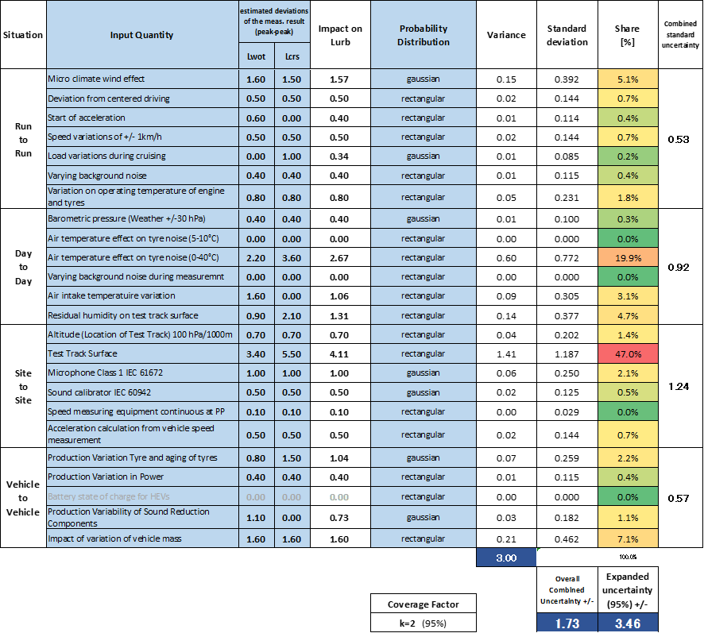

In ISO 362-1, the appendix dealing with the measurement uncertainty has recently been updated in the ongoing revision.
In table 6.2, the uncertainty budget for the parameters influencing the total expanded uncertainty is listed. Note that in this table, the 95 % uncertainty for Site-to-Site (2.7 dB) included the uncertainty of Run-to-Run and Day-to-Day.

Table 6.2 Uncertainty budget for determination of urban sound pressure level
Situation | Quantity | Peak to peak estimation L_{wot} | Peak to peak estimation L_{crs} | Impact on L_{urban} | Probability distribution | Standard uncertainty | 95% Uncertainty
 |  | dB | dB | dB |  | +/-dB | +/-dB
Run to Run | Micro-climate wind effect | 0,5 | 0,5 | 0,50 | gaussian | 0,13 | 0,6
 | Deviation from centered driving | 0,5 | 0,5 | 0,50 | rectangular | 0,14
 | Start of acceleration | 0,5 | 0,5 | 0,50 | rectangular | 0,14
 | Speed variations of +/- 1km/h | 0,3 | 0,3 | 0,30 | rectangular | 0,09
 | Load variations during cruising | 0,3 | 0,5 | 0,37 | gaussian | 0,09
 | Varying background noise | 0,1 | 0,1 | 0,10 | rectangular | 0,03
 | Variation on operating temperature of engine (WOT) and tyres (WOT&CRS) ==> See ISO 362-1 NOTE | 0.25 | 0,25 | 0,25 | rectangular | 0,07
Day to Day | Barometric pressure (Weather +/- 30 hPa) | 1,0 | 0,0 | 0,66 | gaussian | 0,17 | 1,7
 | Air temperature effect on tyre noise (5-10°C) | 0,0 | 0,0 | 0,00 | rectangular | 0,00
 | Air temperature effect on tyre noise (10-40°C) | 2,0 | 2,0 | 2,00 | rectangular | 0,58
 | Varying background noise during measurement | 1,0 | 1,0 | 1,00 | rectangular | 0,29
 | Air intake temperature variation | 1,5 | 0,0 | 0,99 | rectangular | 0,29
 | Residual humidity on test track surface | 1,0 | 1,0 | 1,00 | rectangular | 0,29
Site to Site | Altitude (Location of Test Track) -100 hPa/1000m  (from 1015 to 915 hPa) | 1,00 | 0,0 | 0,66 | rectangular | 0,19 | 2,7
 | Test Track Surface | 3,5 | 5,0 | 4,01 | rectangular | 1,00
 | Microphone Class 1 IEC 61672 | 0,6 | 0,6 | 0,60 | gaussian | 0,15
 | Sound calibrator IEC 60942 | 0,8 | 0,8 | 0,80 | gaussian | 0,20
 | Speed measuring equipment continuous at PP | 0,1 | 0,1 | 0,10 | rectangular | 0,03
 | Acceleration calculation from vehicle speed measurement | 0,5 | 0,0 | 0,33 | rectangular | 0,10

References

[1] Regulation (EU) 2018/858 on the approval and market surveillance of motor vehicles and
their trailers, and of systems, components and separate technical units intended for such
vehicles.
[2] ISO 5725:1994. Accuracy (trueness and precision) of measurement methods and results
– Part 1 to Part 6.
[3] ISO/IEC Guide 98-3:2008. Uncertainty of measurements. Part 3 – Guide to the
expression of uncertainty in measurements (GUM:1995).
[4] GRBP TFMU-02-04. How to handle measurement uncertainties. OICA, TF MU, Brussels,
Nov.2019.
[5] ISO 5130:2019. Acoustics – Measurements of sound pressure level emitted by stationary
road vehicles. Geneva, Switzerland.
[6] GRBP TFMU-01-04. Experimental approach for evaluating uncertainties associated to
stationary vehicle noise according to ISO 5725. UTAC, TF MU, Brussels, May 2019.
[7] GRBP TFMU-02-06. (OICA) MU Calculation Sheet rev7 public.xlsx, Brussels, Nov.2019

