Submitted by the expert from IMMA | Informal document GRBP-73-04  (73rd GRBP, 26 - 29 January 2021,  agenda item 2)

Proposal for amendments to the 04 series of amendments
to UN Regulation No.41 (Noise of L3 category of vehicles)

The text reproduced below was prepared by the expert from the International Motorcycle Manufacturers Association (IMMA) to amend UN Regulation No. 41-04 Supplement 8, in order to correct some references. The modifications to Regulation No. 41 are marked in bold for new or strikethrough for deleted characters.
I. Proposal
Paragraph 5., amend to read:
5. Approval
5.1. If the motor cycle type submitted for approval pursuant to this Regulation meets the requirements of paragraphs 6. and 7. below, approval of that motor cycle type shall be granted.
5.2.1. An approval number shall be assigned to each type approved. Its first two digits indicate the series of amendments incorporating the most recent major technical amendments made to the Regulation at the time of issue of the approval. The same Contracting Party may not assign the same number to another motorcycle type.
5.2.2. Multiple exhaust or silencing system configurations shall be explicitly listed under the same approval of a type of motorcycle with their respective test results.
5.3. Notice of approval or of refusal of approval of a motorcycle type pursuant to this Regulation shall be communicated to the Parties to the Agreement which apply this Regulation, by means of a form conforming to the model in Annex 1 to this Regulation and of drawings of the exhaust or silencing system, supplied by the applicant for approval in a format not exceeding A4 (210 × 297 mm) or folded to that format and on an appropriate scale.
5.4. The respective information for multiple exhaust or silencing system configurations mentioned in paragraph 5.2.2. above shall be provided for in Annex 1 to this Regulation.
5.5. There shall be affixed, conspicuously and in a readily accessible place specified on the approval form, to every motor cycle conforming to a motor cycle type approved under this Regulation an international approval mark consisting of:
5.5.1. A circle surrounding the letter "E" followed by the distinguishing number of the country which has granted approval³; and
5.5.2. The number of this Regulation, followed by the letter "R", a dash and the approval number to the right of the circle prescribed in paragraph 5.4.1.5.5.1.
5.6. If the motor cycle conforms to a motor cycle type approved, under one or more other Regulations annexed to the Agreement, in the country which has granted approval under this Regulation, the symbol prescribed in paragraph 5.4.1.5.5.1. need not be repeated; in such a case the Regulation and approval numbers and the additional symbols of all the Regulations under which approval has been granted in the country which has granted approval under this Regulation shall be placed in vertical columns to the right of the symbol prescribed in paragraph 5.4.1.5.5.1.
5.7. The approval mark shall be clearly legible and be indelible.
5.8. The approval mark shall be placed close to or on the motor cycle data plate affixed by the manufacturer.
5.9. Annex 2 to this Regulation gives examples of arrangements of the approval mark.

Annex 2, amend to read:
Annex 2
Arrangements of approval marks
Model A
(See paragraph 5.4.5.5. of this Regulation)
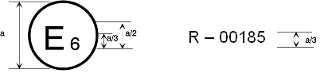
41 R - 04 2439
4
a = 8 mm min
The above approval mark affixed to a motor cycle shows that the motor cycle type concerned has, with regard to noise, been approved in the Netherlands (E4) pursuant to Regulation No. 41 under approval number 042439. The first two digits of the approval number indicate that the approval was granted in accordance with the requirements of Regulation No. 41 as amended by the 04 series of amendments.
Model B
(See paragraph 5.5.5.6. of this Regulation)
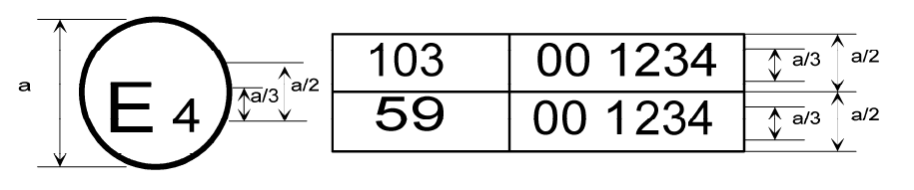
41
04 2439
10
01 1628
41
41
41
41
41
a = 8 mm min
The above approval mark affixed to a motor cycle shows that the motor cycle type concerned has been approved in the Netherlands (E4) pursuant to Regulations Nos. 41 and 10. The first two digits of the approval numbers indicate that on the date on which these approvals were granted, Regulation No. 41 included 04 series of amendments and Regulation No. 10 included the 01 series of amendments.

II. Justification
Proposal to correct some references, which need to be updated as a consequence of document WP.29/2020/70, adopted at the June 2020 WP.29 session.
Notably:
- Paragraph 5.4.1 shall be renumbered as paragraph 5.5.1.
- Paragraphs 5.4. and 5.5. shall be respectively renumbered as paragraphs 5.5. and 5.6.

_________________________

