|  |  |  |  |
| --- | --- | --- | --- |
|  | United Nations | ECE/TRANS/WP.29/2021/41 | |
| _unlogo | **Economic and Social Council** | | Distr.: General  18 December 2020  Original: English |

**Economic Commission for Europe**

Inland Transport Committee

**World Forum for Harmonization of Vehicle Regulations**

**183rd session**

Geneva, 9-11 March 2021

Item 4.9.14 of the provisional agenda

**1958 Agreement:  
Consideration of draft amendments to existing   
UN Regulations submitted by GRE**

Proposal for Supplement 1 to the 02 series of amendments to UN Regulation No. 113 (Headlamps emitting a symmetrical passing-beam)

Submitted by the Working Party on Lighting and Light-Signalling[[1]](#footnote-2)\*, [[2]](#footnote-3)\*\*

The text reproduced below was adopted by the Working Party on Lighting and Light-Signalling (GRE) at its eighty-third session (ECE/TRANS/WP.29/GRE/83, para. 10). It is based on informal document GRE-83-07. It is submitted to the World Forum for Harmonization of Vehicle Regulations (WP.29) and to the Administrative Committee (AC.1) for consideration at their March 2021 sessions.

*Annex 3*

*Figure C,* amend to read:

# "Figure C

**Passing beam test points and zones for Class B headlamp(s):**

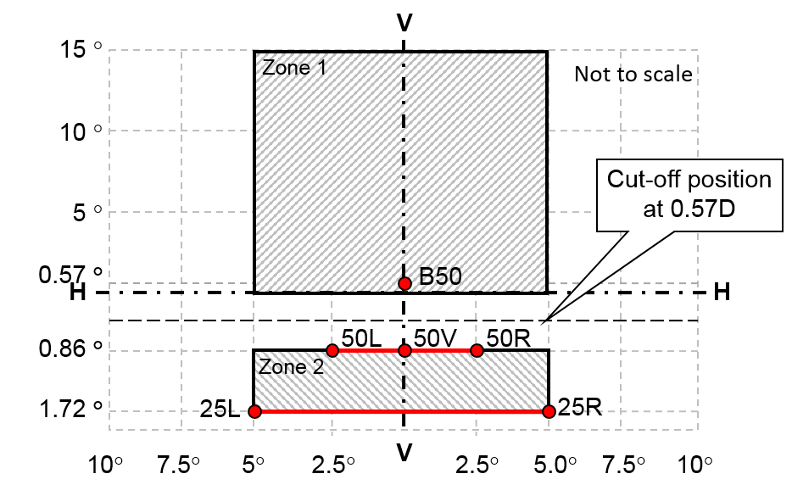

…"

1. \* In accordance with the programme of work of the Inland Transport Committee for 2020 as outlined in proposed programme budget for 2020 (A/74/6 (part V sect. 20) para 20.37), the World Forum will develop, harmonize and update UN Regulations in order to enhance the performance of vehicles. The present document is submitted in conformity with that mandate. [↑](#footnote-ref-2)
2. \*\* This document was scheduled for publication after the standard publication date owing to circumstances beyond the submitter's control. [↑](#footnote-ref-3)