|  |  |  |  |
| --- | --- | --- | --- |
|  | United Nations | ECE/TRANS/2021/11 | |
| _unlogo | **Economic and Social Council** | | Distr.: General  11 December 2020  Original: English |

**Economic Commission for Europe**

Inland Transport Committee

**Eighty-third session**

Geneva, 23–26 February 2021  
Item 7 (a) of the provisional agenda  
**Strategic questions of a horizontal and cross-sectoral policy   
or regulatory nature: Status of accession to international   
United Nations inland transport conventions and agreements**

Status of accession to international United Nations inland transport conventions and agreements

Note by the secretariat

|  |
| --- |
| *Summary* |
| This document presents the status of accessions by ECE and non-ECE member States to the United Nations transport agreements and conventions administered by ECE. |
| On 8 December 2020, the total number of contracting parties to the 59 United Nations legal instruments in the field of transport administered by ECE was 1,801, with fifteen new contracting parties to seventeen legal instruments. |
| The Committee may wish to **invite countries**, which have not yet done so, to accede to the United Nations conventions and other legal instruments in inland transport administered by the Committee and its subsidiary bodies. |
|  |

I. Overview

1. Figure I below shows the growth of the total number of contracting parties to legal instruments on inland transport concluded under the purview of the Inland Transport Committee (ITC). On 8 December 2020, the total number of contracting parties to the 59 United Nations legal instruments in the field of transport administered by the United Nations Economic Commission for Europe (ECE) was 1,801, with fifteen new contracting parties to seventeen legal instruments (see annex for details). Out of these 59 legal instruments, ten have not yet entered into force. The summary tables on the status of signatures, ratifications and accessions for all legal instruments are available at www.unece.org/trans/conventn/intro.html.

Figure I

**Annual Growth of Contracting Parties to Legal Instruments on inland transport under the purview of the ITC**

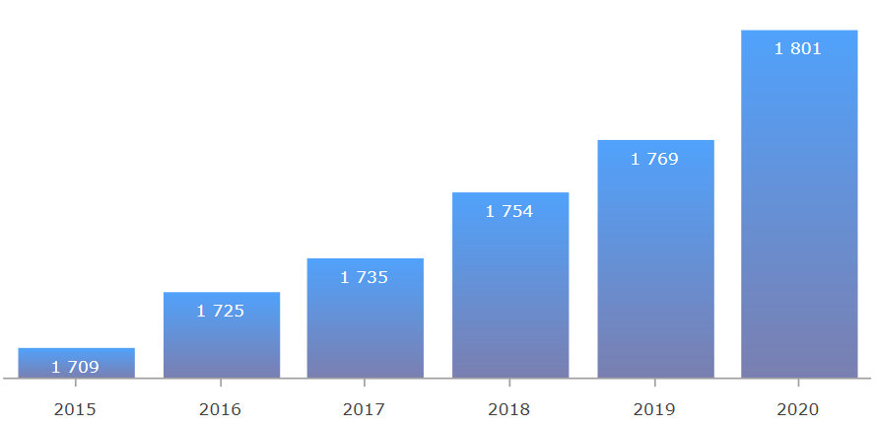

*Source*: ECE

2. Figure II below illustrates the evolution of accessions by ECE and non-ECE member States since 1950.

Figure II

**Accession of ECE and non-ECE Contracting Parties (1950**–**2020)**

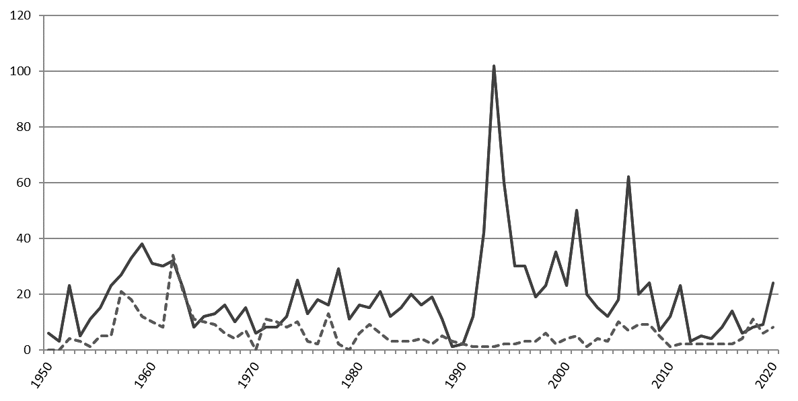

*Legend:* Solid line: ECE member States - Dotted line: non-ECE member States

*Source*: ECE

3. Of the 193 United Nations Member States, 150 States (78 per cent) are contracting parties to at least one legal instrument on inland transport, in addition to two Permanent Observers to the United Nations and one non-State contracting party. Eleven per cent of the United Nations Member States are contracting parties to at least 30 legal instruments.

**II. Geographical Distribution of Contracting Parties**

4. The total number of contracting parties to the 59 transport conventions is 1,801 (as of 8 December 2020). Of these, 1,387 are ECE member States and 414 are non-ECE member States.

5. Of the 150 United Nations member States that are contracting parties, 94 (63 per cent) are non-ECE member States.

6. Out of the 59 legal instruments under the purview of ITC, 49 are in force. Non-ECE member States are contracting parties to 32 transport conventions, representing 30 per cent of the total number of accessions to these conventions. This also means that about 60 per cent of United Nations transport conventions serviced by ECE and in force, have a geographical coverage beyond the territory of ECE. On average, each ECE member State is party to 25 legal instruments, while each non-ECE member State is party to 4.3 legal instruments.

Figure III

**ECE and non-ECE member States Contracting Parties to at least one United Nations Transport Convention**

*Legend:* Dark grey: contracting parties - Light grey: non-contracting parties

*Source:* ECE

7. The European Union is currently the only non-State contracting party to United Nations legal instruments under the purview of the Committee. It is party to seven legal instruments.

8. Forty-three United Nations Member States are not contracting parties to any legal instruments on inland transport concluded under the purview of ITC: Angola, Belize, Bhutan, Bolivia (Plurinational State of), Chad, Colombia, Comoros, Democratic People's Republic of Korea, Djibouti, Dominica, Equatorial Guinea, Eritrea, Ethiopia, Gabon, Gambia, Grenada, Guinea, Guinea-Bissau, Kiribati, Libya, Maldives, Marshall Islands, Mauritania, Micronesia (Federated States of), Mozambique, Nauru, Nicaragua, Palau, Panama, Saint Kitts and Nevis, Saint Lucia, Saint Vincent and the Grenadines, Samoa, Sao Tome and Principe, Somalia, South Sudan, Suriname, Swaziland, Timor-Leste, Tuvalu, Vanuatu, Yemen and Zambia.

9. The Committee may wish to consider this information and provide guidance on ways to increase the number of new accessions to the legal instruments under its purview.

Annex

Accessions registered from 1 January – 8 December 2020

| *Date* | *Contracting party* | *Convention* |
| --- | --- | --- |
| 16/10/2020 | Uzbekistan | Additional Protocol to the CMR concerning the electronic consignment note (e-CMR) |
| 07/10/2020 | Afghanistan | Convention on the Contract for the International Carriage of Goods by Road (CMR), of 19 May 1956 |
| 23/09/2020 | Oman | Convention on the Contract for the International Carriage of Goods by Road (CMR), of 19 May 1956 |
| 23/09/2020 | Oman | Additional Protocol to the CMR concerning the electronic consignment note (e-CMR) |
| 30/08/2020 | Turkmenistan | European Agreement on Main International Traffic Arteries (AGR), of 15 November 1975 |
| 30/08/2020 | Turkmenistan | European Agreement on Main International Railway Lines (AGC), of 31 May 1985 |
| 30/08/2020 | Turkmenistan | European Agreement on Important International Combined Transport Lines and Related Installations (AGTC), of 1 February 1991 |
| 30/08/2020 | Turkmenistan | European Agreement supplementing the 1968 Convention on Road Traffic, of 1 May 1971 |
| 30/08/2020 | Turkmenistan | European Agreement supplementing the Convention on Road Signs and Signals (1968), of 1 May 1971 |
| 30/08/2020 | Turkmenistan | Protocol on Road Markings, Additional to the European Agreement supplementing the Convention on Road Signs and Signals, of 1 March 1973 |
| 07/08/2020 | Bosnia and Herzegovina | Protocol to the Convention on the Contract for the International Carriage of Goods by Road (CMR), of 5 July 1978 |
| 01/07/2020 | Ukraine | Additional Protocol to the CMR concerning the electronic consignment note (e-CMR) |
| 19/06/2020 | Serbia | Protocol to the Convention on the Contract for the International Carriage of Goods by Road (CMR), of 5 July 1978 |
| 15/06/2020 | Ukraine | Protocol to the Convention on the Contract for the International Carriage of Goods by Road (CMR), of 5 July 1978 |
| 11/06/2020 | Norway | Additional Protocol to the CMR concerning the electronic consignment note (e-CMR) |
| 09/06/2020 | Oman | Convention on Road Traffic, of 8 November 1968 |
| 01/05/2020 | Thailand | Convention on Road Traffic, of 8 November 1968 |
| 12/03/2020 | Brunei Darussalam | Convention on Road Traffic, of 19 September 1949 |
| 09/03/2020 | Sweden | Additional Protocol to the CMR concerning the electronic consignment note (e-CMR) |
| 02/03/2020 | Liechtenstein | Convention on Road Traffic, of 19 September 1949 |
| 02/03/2020 | Liechtenstein | Convention on Road Traffic, of 8 November 1968 |
| 02/03/2020 | Liechtenstein | Protocol on Road Signs and Signals, of 19 September 1949 |
| 02/03/2020 | Liechtenstein | Convention on Road Signs and Signals, of 8 November 1968 |
| 02/03/2020 | Liechtenstein | European Agreement supplementing the 1968 Convention on Road Traffic, of 1 May 1971 |
| 02/03/2020 | Liechtenstein | European Agreement supplementing the Convention on Road Signs and Signals (1968), of 1 May 1971 |
| 02/03/2020 | Liechtenstein | European Agreement supplementing the 1949 Convention on Road Traffic and the 1949 Protocol on Road Signs and Signals of 16 September 1950 |
| 02/03/2020 | Liechtenstein | Protocol on Road Markings, Additional to the European Agreement supplementing the Convention on Road Signs and Signals, of 1 March 1973 |
| 24/02/2020 | Pakistan | Agreement concerning the Adoption of Uniform Technical Prescriptions for Wheeled Vehicles, Equipment and Parts which can be fitted and /or be used on Wheeled Vehicles and the Conditions for Reciprocal Recognition of Approvals Granted on the Basis of these Prescriptions, of 20 March 1958 |
| 07/02/2020 | Croatia | Convention on Road Traffic, of 19 September 1949 |
| 03/02/2020 | Honduras | Convention on Road Traffic, of 8 November 1968 |
| 24/01/2020 | Uzbekistan | Agreement concerning the International Carriage of Dangerous Goods by Road (ADR), of 30 September 1957 |
| 24/01/2020 | Uzbekistan | Protocol amending article 1 (a), article 14 (1) and article 14 (3) (b) of the European Agreement of 30 September 1957 concerning the International Carriage of Dangerous Goods by Road (ADR), of 28 October 1993 |