|  |  |  |
| --- | --- | --- |
|  | E/ECE/324/Rev.1/Add.98/Rev.3/Amend.1−E/ECE/TRANS/505/Rev.1/Add.98/Rev.3/Amend.1 | |
|  |  | 9 November 2015 |

Agreement

Concerning the Adoption of Uniform Technical Prescriptions for Wheeled Vehicles, Equipment and Parts which can be Fitted and/or be Used on Wheeled Vehicles and the Conditions for Reciprocal Recognition of Approvals Granted on the Basis of these Prescriptions[1]*

(Revision 2, including the amendments which entered into force on 16 October 1995)

_________

Addendum 98 – Regulation No. 99

Revision 3 - Amendment 1

Supplement 10 to the original version of the Regulation – Date of entry into force:   
8 October 2015

Uniform provisions concerning the approval of gas-discharge light sources for use in approved gas-discharge lamp units of power-driven vehicles

This document is meant purely as documentation tool. The authentic and legal binding text is: ECE/TRANS/WP.29/2015/28.

**_________**



**UNITED NATIONS**

*Paragraph 3.6.2.,* amend to read:

"3.6.2. Run-up

3.6.2.1. For gas-discharge light sources having an objective luminous flux which exceeds 2,000 lm:

When measured according to the conditions specified in Annex 4, the gas-discharge light source shall emit at least:

After 1 second: 25 per cent of its objective luminous flux;

After 4 seconds: 80 per cent of its objective luminous flux.

The objective luminous flux as indicated on the relevant data sheet.

3.6.2.2. For gas-discharge light sources having an objective luminous flux which does not exceed 2,000 lm and does not contain black stripes:

When measured according to the conditions specified in Annex 4, the gas-discharge light sources shall emit at least 800 lm after 1 second and at least 1,000 lm after 4 seconds.

The objective luminous flux as indicated on the relevant data sheet.

For gas-discharge light sources having an objective luminous flux which does not exceed 2,000 lm but does contain black stripes:

When measured according to the conditions specified in Annex 4, the gas-discharge light sources shall emit at least 700 lm after 1 second and at least 900 lm after 4 seconds.

The objective luminous flux as indicated on the relevant data sheet."

*Annex 1,*

*List of categories of gas-discharge light sources and their sheet numbers,* amend to read:

"

| *Light source category* |  | *Sheet numbers* |
| --- | --- | --- |
| D1R |  | DxR/1 to 7 |
| D1S |  | DxS/1 to 6 |
| D2R |  | DxR/1 to 7 |
| D2S |  | DxS/1 to 6 |
| D3R |  | DxR/1 to 7 |
| D3S |  | DxS/1 to 6 |
| D4R |  | DxR/1 to 7 |
| D4S |  | DxS/1 to 6 |
| D5S |  | D5S/1 to 5 |
| D6S |  | D6S/1 to 5 |
| D8R |  | D8R/1 to 6 |
| D8S |  | D8S/1 to 5 |

"

*List of sheets for gas-discharge light sources and their sequence in this annex*, amend to read:

"

|  |  |
| --- | --- |
| *Sheet numbers* |  |
| DxR/1 to 7 | (Sheet DxR/6: two pages) |
| DxS/1 to 6 |  |
| D5S/1 to 5 |  |
| D6S/1 to 5 |  |
| D8S/1 to 5 |  |
| D8R/1 to 6 |  |

"

*Sheet DxR/4, the table,* amend to read:

"…

|  |  |
| --- | --- |
| D1R: Cap PK32d-3  D2R: Cap P32d-3  D3R: Cap PK32d-6  D4R: Cap P32d-6 | in accordance with IEC Publication 60061 (sheet 7004-111-5) |

…"

*Sheet DxS/4, the table,* amend to read:

"…

|  |  |
| --- | --- |
| D1S: Cap PK32d-2  D2S: Cap P32d-2  D3S: Cap PK32d-5  D4S: Cap P32d-5 | in accordance with IEC Publication 60061 (sheet 7004-111-5) |

…"

*Sheet D5S/3, the table,* amend to read:

"…

|  |  |
| --- | --- |
| D5S: Cap PK32d-**7** | in accordance with IEC Publication 60061 (sheet 7004-111-5) |

…"

*Sheet D6S/3, the table,* amend to read:

"…

|  |  |
| --- | --- |
| D6S: Cap P32d-1 | in accordance with IEC Publication 60061 (sheet 7004-111-5) |

…"

*Sheet D8S/3, the table,* amend to read:

"…

|  |  |
| --- | --- |
| D8S: Cap PK32d-1 | in accordance with IEC Publication 60061 (sheet 7004-111-5) |

…"

*After sheet D8S/5, insert new sheets D8R/1 to 6,* to read (see following pages; one page per sheet):

"

**Category D8R Sheet D8R/1**

The drawings are intended only to illustrate the essential dimensions (in mm)

of the gas-discharge light source

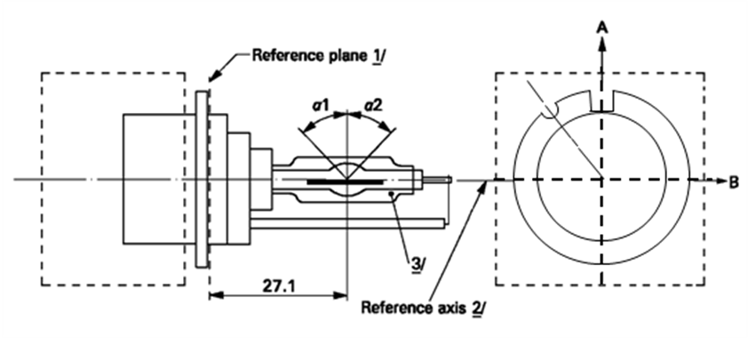

**Reference axis *2***

**Reference plane *1***

View from C

**C**

Figure 1

**Category D8R - Cap PK32d-8**

**1** The reference plane is defined by the positions on the surface of the holder on which the three supporting bosses of the cap ring will rest.

**2** See sheet D8R/2.

**3** When measured at a distance of27.1 mm from the reference plane and with respect to the mid-point of the inner bulb, the outer bulb shall have an eccentricity of 1 mm max.

**Category D8R Sheet D8R/2**

The cap shall be pushed in this direction

**Reference axis**



Figure 2

**Definition of reference axis1**



**Reference axis**

Figure 3

**Maximum lamp outline2**

**1** The reference axis is perpendicular to the reference plane and crosses the intersection of the two parallel lines as indicated in figure 2.

**2** Glass bulb and supports shall not exceed the envelope, as indicated in figure 3.The envelope is concentric with the reference axis.

**Category D8R Sheet D8R/3**

|  |  |  |  |  |  |
| --- | --- | --- | --- | --- | --- |
| *Dimensions* | | | | *Production*  *light sources* | *Standard*  *light sources* |
| Position of the electrodes | | | | Sheet D8R/4 | |
| Position and form of the arc | | | | Sheet D8R/5 | |
| α11 | | | | 55° min. | |
| α21 | | | | 55° min. | |
| D8R: Cap PK32d-8 | | in accordance with IEC Publication 60061(sheet 7004-111-5) | | | |
| Electrical and photometric characteristics | | | | | |
| Rated voltage of the ballast | | | V | 12 2 | 12 |
| Rated wattage | | | W | 25 | 25 |
| Test voltage | | | V | 13.2 | 13.2 |
| Objective lamp voltage | | | V | 42 ± 9 | 42 ± 4 |
| Objective lamp wattage | | | W | 25 ± 3 | 25 ± 0.5 |
| Objective Luminous flux | | | lm | 1900 ± 300 | 1900 ± 100 |
| Chromaticity coordinates | Objective | |  | x = 0.375 | y = 0.375 |
| Tolerance area 3 | | Boundaries | x = 0.345  x = 0.405 | y = 0.150 + 0.640 x  y = 0.050 + 0.750 x |
| Intersection  points | x = 0.345 | y = 0.371 |
| x = 0.405 | y = 0.409 |
| x = 0.405 | y = 0.354 |
| x = 0.345 | y = 0.309 |
| Hot-restrike switch-off time | | | s | 10 | 10 |

**1** The part of the bulb within the angles α1 and α2 shall be the light emitting part. This part shall be as homogeneous in form as possible and shall be optically distortion free. This applies to the whole bulb circumference within the angles α1 and α2 except for the black stripes.

**2** Application voltages of ballasts may differ from 12 V.

**3** See Annex 4.

**Category D8R Sheet D8R/4**

Position of the electrodes

This test is used to determine whether the electrodes are correctly positioned relative to the reference axis and the reference plane.

Top view (schematic):

Reference axis

a2

b2

25.15mm from reference plane

c

Reference plane

a1

b1

Side view (schematic):

Reference axis

a2

b2

25.15mm from reference plane

c

Reference plane

0.10 mm

a1

b1

Measuring direction: light source side and top view

The arc attachment point to the electrode nearest to the reference plane shall be positioned in the area defined by a1 and b1. The arc attachment point to the electrode furthest from the reference plane shall be positioned in the area defined by a2 and b2.

|  |  |  |
| --- | --- | --- |
| *Dimension*  *in* *mm* | *Production*  *light* *sources* | *Standard*  *light* *sources* |
| a1 | 0.50 | 0.20 |
| a2 | 0.70 | 0.35 |
| b1 | 0.40 | 0.15 |
| b2 | 0.80 | 0.30 |
| c | 3.90 | 3.90 |

**Category D8R Sheet D8R/5**

Position and form of the arc

This test is used to determine the form of the arc and its position relative to the reference axis and the reference plane by measuring its bending and diffusion in the cross section at a distance 27.1 mm from the reference plane.



|  |  |  |
| --- | --- | --- |
|  |  |  |
| Relative luminance distribution in the central cross section D. | The form of the arc is for illustration purpose only. | Measuring direction:  light source side view |

When measuring the relative luminance distribution in the central cross section as indicated in the drawing above, the maximum value shall be located within the distance r from the reference axis. The point of 20 per cent of the maximum value shall be within s.

|  |  |  |
| --- | --- | --- |
| *Dimension* *in* *mm* | *Production* *light* *sources* | *Standard* *light* *sources* |
| r (arc bending) | 0.50 +/- 0.25 | 0.50 +/- 0.15 |
| s (arc diffusion) | 0.70 +/- 0.25 | 0.70 +/- 0.15 |

**Category D8R Sheet D8R/6**

Position of black stripes

This test is used to determine whether the black stripes are correctly positioned relative to the reference axis and the reference plane.

When measuring the luminance distribution of the arc in the central cross section as defined on sheet D8R/5, after having turned the light source so that the black stripe is covering the arc, the measured luminance shall be ≤ 0.5 % of Lmax.

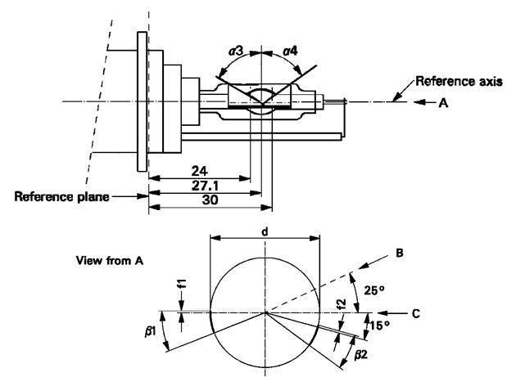

Reference axis

Reference plane

View from A

|  |  |  |
| --- | --- | --- |
| *Dimensions* | *Production light sources* | *Standard light sources* |
| α3 | 70° min. | |
| α4 | 65° min. | |
| β1/24, β1/30, β2/24, β2/30 | 25° ± 5° | |
| f1/24, f2/24 1/ | 0 ± 0.25 | 0 ± 0.20 |
| f1/30 1/ | f1/24 mv ± 0.15 2/ | f1/24 mv ± 0.1 |
| f2/30 1/ | f2/24 mv ± 0.15 2/ | f2/24 mv ± 0.1 |
| f1/24 mv - f2/24 mv | ± 0.3 max. | ± 0.2 max. |
| d | 9 ± 1 | |

1/ "f1/.." means dimension f1 to be measured at the distance from the reference plane indicated in mm after the stroke.

2/ "../24 mv" means the value measured at a distance of 24 mm from the reference plane. "

*Annex 4,*

*Paragraph 10.,* amend the text to read (and keep the drawing):

"10. Colour

The colour of the light source shall be measured in an integrating sphere using a measuring system which shows the CIE chromaticity co-ordinates of the received light with a resolution of ±0.002. The following figure shows the colour tolerance area for colour white and the restricted tolerance area for the gas-discharge light sources D1R, D1S, D2R, D2S, D3R, D3S, D4R, D4S, D5S, D6S**,** D8R and D8S."

1. * Former title of the Agreement: Agreement Concerning the Adoption of Uniform Conditions of Approval and Reciprocal Recognition of Approval for Motor Vehicle Equipment and Parts, done at Geneva on 20 March 1958.