|  |  |  |
| --- | --- | --- |
|  | E/ECE/324/Rev.1/Add.43/Rev.3/Amend.2−E/ECE/TRANS/505/Rev.1/Add.43/Rev.3/Amend.2 | |
|  |  | 22 June 2015 |

Agreement

Concerning the Adoption of Uniform Technical Prescriptions for Wheeled Vehicles, Equipment and Parts which can be Fitted and/or be Used on Wheeled Vehicles and the Conditions for Reciprocal Recognition of Approvals Granted on the Basis of these Prescriptions[1]*

(Revision 2, including the amendments which entered into force on 16 October 1995)

_________

Addendum 43 – Regulation No. 44

Revision 3 - Amendment 2

Supplement 9 to the 04 series of amendments – Date of entry into force: 15 June 2015

Uniform provisions concerning the approval of restraining devices for child occupants of power-driven vehicles ("Child Restraint Systems")

This document is meant purely as documentation tool. The authentic and legal binding text is: ECE/TRANS/WP.29/2014/73.

**_________**



**UNITED NATIONS**

*Paragraph 2.7.,* amend to read:

"2.7. "*Impact shield*" means a device secured in front of the child and designed to distribute the restraining forces over the greater part of the height of the child's body in the event of a frontal impact.

With reference to paragraph 2.1.3., these are divided in two classes:

Class A: Integral

Class B: Non integral."

*Paragraphs 6.1.5. and 6.1.6.,* amend to read:

"6.1.5. The child restraint manufacturer has to declare in written form that the toxicity of materials used in the manufacture of restraint systems and accessible to the restrained child is in conformity with the relevant parts of EN 71:2009, part 3. Tests confirming the validity of the declaration may be carried out at the discretion of the test authority. This paragraph does not apply to restraint devices of groups II and III.

6.1.6. The child restraint manufacturer has to declare in written form that the flammability of materials used to manufacture the restraint system is in conformity with the relevant parts of EN 71:2009 part 2. Tests confirming the validity of the declaration may be carried out at the discretion of the test authority."

*Paragraph 6.1.12*., amend to read:

"6.1.12. Child restraint systems of group I shall belong to the integral class unless they are fitted with an impact shield of Class B, as defined in paragraph 2.7. of this Regulation."

*Paragraph 7.1.4.1.8.,* amend to read:

"7.1.4.1.8. During the dynamic tests, the standard safety-belt used to install an integral child restraint shall not become disengaged from any guide or locking device utilized for the test conducted.

During the dynamic tests, the standard safety-belt used to install a non-integral child restraint, shall not become disengaged from any guide or locking device utilized for the test conducted; however, for the shoulder portion of the standard safety-belt this shall be judged up to the moment that the maximum horizontal head excursion of the dummy is reached. Furthermore during the dynamic test of a non-integral child restraint, the limit of acceptable movement of the shoulder belt is that the lower edge of the shoulder portion of the standard safety-belt shall not be lower than the dummy's elbow at the point of maximum horizontal head excursion of the dummy."

*Paragraph 7.1.4.4.1.2.3*., amend to read:

"7.1.4.4.1.2.3. Child restraints other than group 0 not supported by the dashboard:

The head of the manikin shall not pass the planes FD, FG and DE, as shown in Figure 4 below and there shall be no direct contact of the manikin head with the bar. This shall be judged up to 300 ms or the moment that the manikin has come to a definitive standstill whatever occurs first.

In the case …"

*Paragraph 8.1.3.7.6*., amend to read:

"8.1.3.7.6. If the child restraint system is suitable for two or more mass groups, the tests shall be carried out using the lightest and heaviest manikins specified above for each of the groups concerned."

*Paragraph 8.1.3.7.10*., amend to read:

"8.1.3.7.10. The test specified in paragraph 7.1.4.1.10.1.2. above shall only be carried out with the largest manikin for which the child restraint is designed. Where multiple configurations of the child restraint system are possible (e.g. upright/reclined), the configuration which generates the worst case horizontal head excursion shall be used for this test."

*Paragraph 11.2.*, amend to read:

"11.2. Qualifying the production of child restraint systems

The production of ...

For this purpose, a random sample of 5 child restraint systems will be taken from the first production batch by the Technical Service who conducted the approval tests, or by a Technical Service appointed by the same Type Approval Authority who will grant the approval, or by the Type Approval Authority itself.

Six sample units may be selected randomly in case that the condition of paragraph 7.1.4.4.1.2.3. above is selected as the test condition of conducting a test described in 11.2.1.1.).

The first production batch ..."

*Paragraph 11.2.1.1*., amend to read:

"11.2.1.1. Five child restraint systems shall be subjected to the dynamic test described in paragraph 8.1.3. The Technical Service that conducted the type approval tests shall choose the conditions that produced the maximum horizontal head excursion during the type approval dynamic tests, excluding the conditions described in paragraphs 7.1.4.4.1.2.3. above, that refers to the test without 100 mm bar configuration only, and paragraph 7.1.4.1.10.1.2. above. All the five child restraint systems shall be tested under the same conditions.

If, during at least one of the five tests performed, the CRS touches the bar, a further test shall be performed in the condition described in paragraph 7.1.4.4.1.2.3 above which refers to the test without 100 mm bar. This further test shall not be used for the calculation described in paragraph 11.2.1.3., subparagraph (a) below."

*Annex 13,*

*Paragraphs 2. and 3.,* amend to read:

"2. The three-point retracting belt has the following rigid parts: a retractor (R), a pillar loop (P), two anchorage points (A1 and A2) (see Figure 1b)…

3. …

The value of X in Figure 1b below…"

*Paragraphs 5. and 6.*, amend to read:

"5. The two-point static belt as shown in Figure 1a consists of …

6. … The value of Y in Figure 1a is …"

*Figure 1,* amend to read:

"Figures 1a and 1b

**Standard seat belt configurations**

Figure 1a  
**Two-point static belt**



Figure 1b  
**Three-point retracting belt**

"

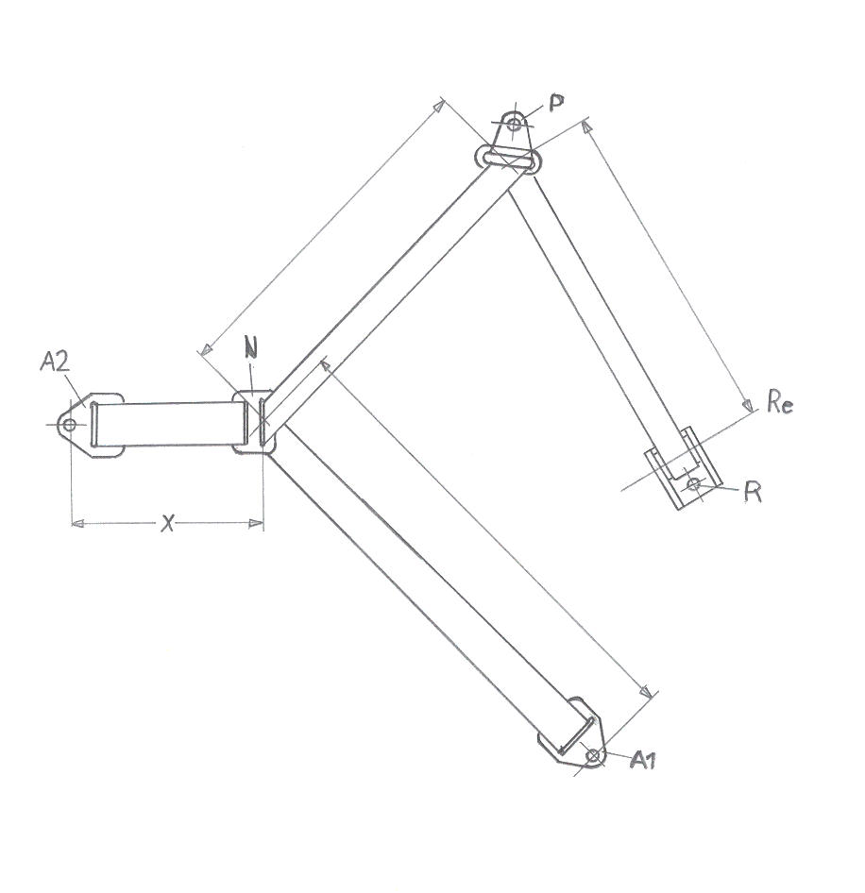

1. * Former title of the Agreement: Agreement Concerning the Adoption of Uniform Conditions of Approval and Reciprocal Recognition of Approval for Motor Vehicle Equipment and Parts, done at Geneva on 20 March 1958.