UN/SCETDG/56/INF.41

Committee of Experts on the Transport of Dangerous Goods
and on the Globally Harmonized System of Classification
and Labelling of Chemicals 2 December 2019
Sub-Committee of Experts on the Transport of Dangerous Goods
Fifty-sixth session
Geneva, 2-11 December 2019
Item 3 of the provisional agenda
Listing, classification and packing

The background of batteries (wet, non-spillable) installed in cargo transport units and amendments to ST/SG/AC.10/C.3/2019/48
Transmitted by the expert from China

Introduction
1. China presented a document on the provisions for batteries (wet, non-spillable) installed in cargo transport units (CTUs) at the fifty-sixth session of the Sub-Committee (ST/SG/AC.10/C.3/2019/48).
2. In the meantime, China received some feedback on this paper, suggesting detailed introduction of the CTUs equipped with batteries (wet, non-spillable) be provided that makes the proposal clearer.
3. Specifically, the expert from Sweden proposed some amendments regarding option 2 in ST/SG/AC.10/C.3/2019/48. Firstly, maintain the current name for the lithium batteries installed in CTUs, and instead add, individually, the name for the wet batteries installed in CTUs in full length. Secondly, restructure special provision 389 to make it more legible and user-friendly.
4. China supports and thanks the above suggestions and as a response, provides additional information and amendments to ST/SG/AC.10/C.3/2019/48 as contained in paragraph 9.
Background
5. In order to facilitate transportation and deployment, some devices are installed in CTUs and transported as a whole. For safety or operational purposes, these CTUs are equipped with batteries (UN 2800), fire suppression (fire extinguishers, UN 1044) and air conditioning systems (refrigerating machines, UN 2857). Pictures with examples of such CTUs are included in the Annex.
6. In accordance with the Model Regulations, UN2800 (BATTERIES, WET, NON-SPILLABLE, electric storage) can be exempted if it meets special provision 238. However, when shipped separately, conditioning systems (refrigerating machines, UN 2857) can be partially exempted and fire suppression (fire extinguishers, UN1044) cannot.
7. As a result, even if the batteries (wet, non-spillable) installed in CTUs meets the requirements of special provision 238 and is exempted, the whole CTU still needs to be managed and transported as dangerous goods, causing unnecessary time and management costs, and negatively affecting the smooth delivery of goods in remote areas.
8. Therefore, with reference to entry UN 3536 (LITHIUM BATTERIES INSTALLED IN CARGO TRANSPORT UNIT lithium ion batteries or lithium metal batteries), China presented a document (ST/SG/AC.10/C.3/2019/48) on the provisions for batteries (wet, non-spillable) installed in CTUs at the fifty-sixth session of the Sub-Committee, with a view to addressing the transport of large wet and non-spillable battery systems installed in CTUs and fitted with fire extinguishers and refrigerating machines.
Proposal
9. Modify option 2 in ST/SG/AC.10/C.3/2019/48 as follows :
In the Dangerous Goods List in Chapter 3.2, modify the entry UN 3536 as follows:
UN No. | Name and description | Class or division | Subsi-diary risk | UN packing group | Special provi-sions | Limited and excepted quantities |  | Packagings and IBCs |  | Portable tanks and bulk containers
 |  |  |  |  |  |  |  | Packing instructions | Special packing provisions | Instruc-tions | Special provisions
(1) | (2) | (3) | (4) | (5) | (6) | (7a) | (7b) | (8) | (9) | (10) | (11)
3536 | LITHIUM BATTERIES INSTALLED IN CARGO TRANSPORT UNIT  lithium ion batteries or lithium metal batteries  or BATTERIES,WET,NON-SPILLABLE INSTALLED IN CARGO TRANSPORT UNIT | 9 |  |  | 389 | 0 | E0
In Chapter 3.3, modify special provision 389, as follows:
“389 This entry only applies to lithium ion batteries or lithium metal batteries or batteries (wet, non-spillable) installed in a cargo transport unit and designed only to provide power external to the cargo transport unit. The following conditions shall be met:
(a) The lithium batteries shall meet the requirements of 2.9.4(a) to (g) and contain the necessary systems to prevent overcharge and over discharge between the batteries.
(b) The batteries (wet, non-spillable) shall meet the requirements of special provision 238 (a). If the batteries (wet, non-spillable) installed in a cargo transport unit, meet all the requirements of special provision 238, the cargo transport units are not subject to these Regulations.
The batteries shall be securely attached to the interior structure of the cargo transport unit (e.g., by means of placement in racks, cabinets, etc.) in such a manner as to prevent short circuits, accidental operation, and significant movement relative to the cargo transport unit under the shocks, loadings and vibrations normally incident to transport. Dangerous goods necessary for the safe and proper operation of the cargo transport unit (e.g., fire extinguishing systems and air conditioning systems), shall be properly secured to or installed in the cargo transport unit and are not otherwise subject to these Regulations. Dangerous goods not necessary for the safe and proper operation of the cargo transport unit shall not be transported within the cargo transport unit.
The batteries inside the cargo transport unit are not subject to marking or labelling requirements. The cargo transport unit shall display the UN number in accordance with 5.3.2.1.2 and be placarded on two opposing sides in accordance with 5.3.1.1.2.”.

Annex
1. Overall structure of the CTUs:
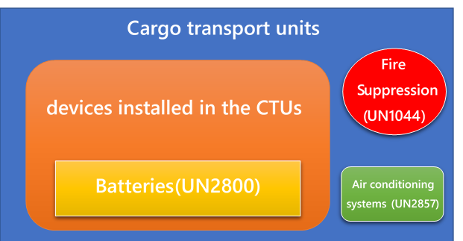
2. Devices and batteries :
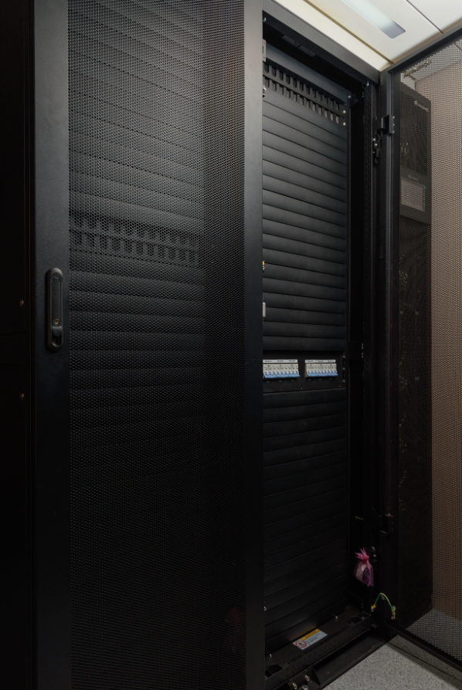
3. Fire suppression (UN1044) :
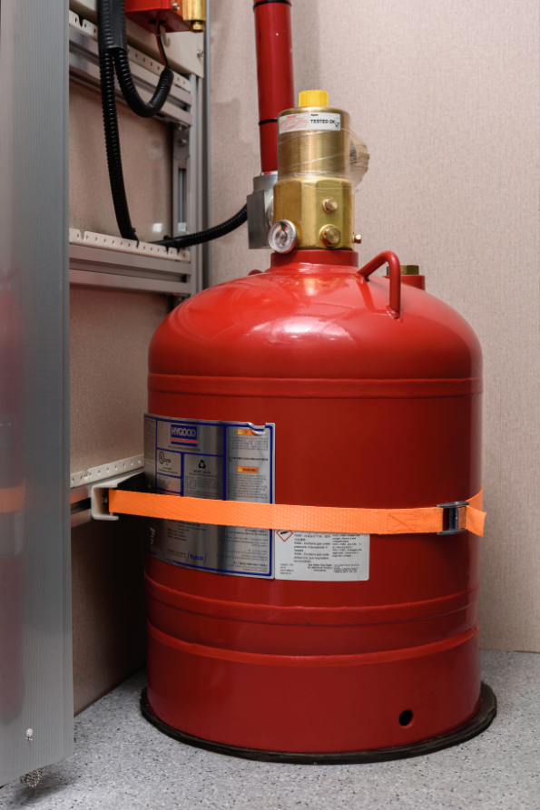

4. Conditioning systems (UN2857) :
