UN/SCETDG/56/INF.8
UN/SCEGHS/38/INF.6

Committee of Experts on the Transport of Dangerous Goods
and on the Globally Harmonized System of Classification
and Labelling of Chemicals 1 November 2019
Sub-Committee of Experts on the  Transport of Dangerous Goods | Sub-Committee of Experts on the Globally Harmonized System of Classification and Labelling of Chemicals
Fifty-sixth session | Thirty-eight session
Geneva, 2-11 December 2019  Item 10 (d) of the provisional agenda  Issues relating to the Globally Harmonized System of Classification and Labelling of Chemicals: review of Chapter 2.1 | Geneva, 11-13 December 2019  Item 2 (b) of the provisional agenda  Classification criteria and related hazard communication: review of Chapter 2.1
Advanced draft of a new Chapter 2.1 for the GHS
Transmitted by the expert from Sweden
Introduction
- In document ST/SG/AC.10/C.4/2019/10 to the 38th session of the SCEGHS , a status report of the work on reviewing GHS Chapter 2.1 (explosives) is given. In that document it is also announced that an advanced draft of a new Chapter 2.1 can be expected to appear before the Sub-Committee(s). Annex I to this informal document contains that draft new chapter.
- This document has been written and submitted by the expert from Sweden in his capacity as leader of the Informal Correspondence Group for the review of GHS Chapter 2.1 (ICG). While the ICG has not been part in the authoring of this paper, a draft of it was circulated within the group before its submission. Any explicit views expressed in this document are therefore those of the expert from Sweden alone.
- In the time that has past since document ST/SG/AC.10/C.4/2019/10 was submitted, there have been intense discussions between the more active members of the ICG on a variety of topics. These were based on a draft new Chapter 2.1 that the expert from Sweden sent out to the ICG in the beginning of July 2019, which was subsequently commented on by some ICG-members. The outcome of this process is the draft Chapter 2.1 as in annex I to this informal document.
- In addition, the expert from Sweden has sent out a document to the ICG comparing the texts as in annex I to those of the July draft, so that the changes can be scrutinised. ICG-members have, however, not been given sufficient time to condense or comment on these new texts before this informal document was submitted. The expert from Sweden has asked the ICG-members to provide their comments to the new texts before the 38th session of the SCEGHS, so that they can be discussed at that meeting if needed.
- As indicated in document ST/SG/AC.10/C.4/2019/10, the classification criteria of the new system, including the scope of the hazard class, were in principle finalised at the combined meeting of the Working Group on Explosives (EWG) and the ICG that was held in parallel to the 55th session of the SCETDG in July 2019. What remained was some fine-tuning and possible redistributions of texts, and this has been worked on in the ICG ever since. The criteria of the new system, as displayed in the draft chapter in annex I, have indeed been somewhat reworded and redistributed, but remain the same as those accepted by the EWG (as reported in INF.24 and INF.21 to the 37th session of the SCEGHS).
- As also indicated in document ST/SG/AC.10/C.4/2019/10, the remaining open issues of the chapter mainly revolve around the hazard communication elements for the sub-categories within Category 2 of the new system. These were discussed at the meeting of the ICG held during the 37th SCEGHS, and while most elements could be tentatively agreed then, some of them remained open. The outcome of that meeting is found in INF.26 to the 37th session of the SCEGHS, and these remaining open issues on hazard communication are addressed in some detail below.
- As is immediately evident by examining annex I, the draft new Chapter 2.1 is quite different to the current Chapter 2.1 (as in GHS Rev. 8). This make it virtually impossible to provide a version where the changes are visible in a useful way. Instead of showing all the changes, an overview of the main changes as compared to the current chapter is given in annex II to this document. The overarching change is of course the extended classification system as such, and the associated changes to the hazard communication elements.
- Annex III to this document shows an alternative way of displaying the criteria for classification into the categories and sub-categories, by merging the tables in sections 2.1.2.1 and 2.1.2.3 of the chapter as in annex I. This came up in the discussions within the ICG as an alternative which seemed preferable to some ICG-members. In this merged version, the criteria are intended to be exactly the same as those of the chapter as in annex I. Further scrutiny is, however, needed to make sure that they actually are the same, so annex III is to be taken as a possible alternative layout of the criteria only.
Main open issues
Open issue 1 – the symbol, or no symbol, for Sub-category 2C
- From the ICG-meeting during the 37th session of the SCEGHS, and subsequent discussions in the ICG, the expert from Sweden has understood that most experts seem to agree that the exploding bomb symbol (pictogram GHS01) would exaggerate hazard posed by explosives in Sub-category 2C. Regarding the use of the flame symbol (pictogram GHS02), some experts appear to feel that fire is not the hazard posed by these explosives, which are mainly articles, and hence the flame would be misleading. The exclamation mark (pictogram GHS07), hitherto only used for less severe health hazards, has come up as an alternative in later discussions in the ICG, and seems to appeal to some experts. Other experts seem to be of the opinion that the better option is to use no symbol at all for this sub-category.
Open issue 2 – the hazard statements for Sub-category 2B and 2C
- It was pointed out in the ICG-discussions during the 37th session of the SCEGHS that it would be preferable to have at least slightly different hazard statements for sub-categories 2B and 2C, in order to avoid confusion around which of the two classifications the explosive actually is assigned to. Thus far, the current hazard statement “Fire or projection hazard” (H204), applicable to division 1.4, has been provisionally assigned to both these sub-categories. There have, however, not been any firm discussions about the validity of this statement in relation to the hazard in the ICG.
- Within the ICG there have been suggestions to slightly change H204 for Sub-category 2C by amending it to “Minor fire or projection hazard” or “May cause a fire or projection hazard”. There have also been ideas to instead amend the hazard statement for Sub-category 2B, e.g. to “Severe fire or projection hazard”. It would also be possible to completely change the hazard statement for either sub-category, or indeed for both of them, but there have been no such suggestions made thus far.
Open issue 3 – retaining information on the division
- A long-standing open issue, and a very challenging one, has been how to retain information on the division, as assigned to the configuration as a whole, also for the primary and any intermediate packaging. The main point of this information, as understood by the expert from Sweden, is to be able to apply current regulations on the handling of explosives, including licensing, which generally rely on the division being known. This division, however, strictly only applies to the explosive in the configuration to which this division was assigned (usually the transport configuration), and hence the information on any other layers of packaging would relate to the configuration in which the explosive was before that configuration was dismounted.
- While a hazard statement may be a comfortable option for displaying the division on the GHS label (as it is a familiar and mandatory GHS hazard communication element), it in a way re-introduces the dependence of the hazard communication on the division – the very core problem of the current Chapter 2.1 that the review aims to overcome. Furthermore, the division number may not be perceived as a warning of a hazard by all audiences, as it conveys a number that has meaning only to those that have knowledge of what it represents.
- The main drawback of using a precautionary statement is that it may not be mandatory on the GHS label in all implementations. It is, however, also a standard element of the GHS label and has the advantage that it can be worded in a more flexible way than a hazard statement. One idea that has been put forward in the ICG some time ago already is to introduce an amended version of P234, such as “Keep only in original packaging – Division … [or …] as originally configured for transport” (where … would be the division number(s)). If this could be combined with some guidance, possibly inserted directly into Chapter 2.1, it may assure, at least to some degree, that the text will appear on the GHS label.
- Using supplemental information has thus far not been much favoured by the ICG-members. The expert from Sweden believes that this is partly because it is not very clear how this kind of labelling element functions. The possibility of using supplemental information may, however, be revisited in the light of recent developments to meet the needs expressed by some ICG-members.
Steps ahead
- It is expected that the ICG will convene during the 38th session of the SCEGHS, where the above open issues as well as any other issues relating to the work will be discussed (insofar as time permits). In accordance with the ICG’s Programme of Work, the aim is to produce a working document with a new Chapter 2.1 to the 39:th session of the SCEGHS, which, considering the recent progress made, the expert from Sweden believes can be achieved. However, this relies on the open issues being resolved shortly - preferably already during the 38th session of the SCEGHS.
- Pending the outcome of the discussions to come, the expert from Sweden intends to draft what he hopes to be a close to final version of the new chapter before 2019 is over. A review of the Manual of Tests and Criteria can then be initiated to bring it in line with the new GHS chapter. Naturally, the expert from Sweden intends to do this in close collaboration with the Chairman of the EWG, and the changes needed would be brought forward to the EWG-meeting taking place during the 57th session of the SCETDG in the summer of 2020.
- Regarding the assignment of the existing precautionary statements for Explosives to the new classifications, the expert from Sweden has thus far had very little input to the questionnaire sent out to the ICG in July 2019. He may submit a separate informal document to the 38th session of the SCEGHS on this at a later stage though.

Annex I
Advanced draft of a new Chapter 2.1
CHAPTER 2.1

EXPLOSIVES

2.1.1 Definitions and general considerations
2.1.1.1 Definitions
An explosive substance or mixture is a solid or liquid substance or mixture which is in itself capable by chemical reaction of producing gas at such a temperature and pressure and at such a speed as to cause damage to the surroundings. Pyrotechnic substances and mixtures are included even when they do not evolve gases.
A pyrotechnic substance or mixture is a substance or mixture designed to produce an effect by heat, light, sound, gas or smoke or a combination of these as the result of non-detonative self-sustaining exothermic chemical reactions.
An explosive article is an article containing one or more explosive substances or mixtures.
Primary packaging means the minimum level of packaging, part of a configuration assigned to a division, in which the explosive substance, mixture or article is intended to be retained until use.
2.1.1.2 Scope
2.1.1.2.1 Except as provided in 2.1.1.2.2, the class of explosives comprises
(a) Explosive substances and mixtures;
(b) Explosive articles, except devices containing explosive substances or mixtures in such quantity or of such a character that their inadvertent or accidental ignition or initiation shall not cause any effect external to the device either by projection, fire, smoke, heat or loud noise; and
(c) Substances, mixtures and articles not mentioned under (a) and (b) above which are manufactured with the view to producing a practical explosive or pyrotechnic effect.
2.1.1.2.2 The following substances, mixtures and articles are excluded from the class of explosives:
- Ammonium nitrate based emulsions, suspensions or gels which meet the criteria of Test series 8 of the Manual of Tests and Criteria for classification as ANEs of Category 2 oxidizing liquids (Chapter 2.13) or Category 2 oxidizing solids (Chapter 2.14).
(b) Substances and mixtures which meet the criteria for classification as desensitized explosives according to the criteria of Chapter 2.17.
(c) Substances and mixtures which have not been manufactured with the view to producing, in themselves, an explosive or pyrotechnic effect and which:
(i) are self-reactive substances and mixtures according to the criteria of Chapter 2.8; or
(ii) are organic peroxides according to the criteria of Chapter 2.15: or
(iii) are deemed not to have explosive properties on basis of the screening procedures in Appendix 6 of the Manual of Tests and Criteria; or
(iv) are too insensitive for inclusion in the hazard class according to test series 2 of the Manual of Tests and Criteria; or
(v) are excluded from assignment within Class 1 of the UN Recommendations on the Transport of Dangerous Goods, Model Regulations based on results in Test Series 6 of the Manual of Tests and Criteria.
(d) Articles containing explosives which are allowed for transport but excluded from Class 1 by specific UN-numbers and associated special provisions according to the Dangerous Goods List of the UN Recommendations on the Transport of Dangerous Goods, Model Regulations.
NOTE 1: ANE:s excluded by virtue of a) require sensitisation in order to become explosives, a transformation normally made in direct connection with their use
NOTE 2: Exclusion by virtue of c), point (v), or d) may only apply to certain configurations. See also the note to section 2.1.3.
NOTE 3: Substances in the research and development phase for which not enough material exists to perform Test Series 2 of the Manual of Tests and Criteria may, for the purpose of further scientific characterisation, be regarded as self-reactive substances and mixtures Type C (see Chapter 2.8), provided that:
(i) The substance has not been manufactured with the view to producing an explosive or pyrotechnic effect; and
(ii) The amount of any substance does not exceed [XX] grams; and
(iii) The decomposition energy of the substance is less than 2000 J/g; and
(iv) The result in Test 3(a) and Test 3(b) of the Manual of Tests and Criteria is negative; and
(v) The result in Test 2(b) of the Manual of Tests and Criteria is “no explosion” at an orifice diameter of 6 mm; and
(vi) The expansion of the lead block in Test F.3 of the Manual of Tests and Criteria is less than 100 ml per 10 gram substance.
2.1.1.3 Other considerations
2.1.1.3.1 Over the life-cycle of an explosive its classification may change, as a result of changed packaging, processing, re-manufacturing or similar operations. An explosive would normally start its life-cycle in Category 1 during manufacturing or assembly. At the stage where it is a finished product it may be assigned to a division (for transport) and hence enter Category 2. Upon re-manufacturing, re-assembly or similar operations, the explosive may return to Category 1.
2.1.1.3.2 The use of an explosive, meaning the preparation and intentional functioning, including removal from the primary packaging for functioning or installation or deployment in readiness for functioning, does not trigger the need for re-classification.
2.1.1.3.3 While Category 1 is normally considered the most hazardous classification in the structure of the GHS classification system, this is not the case for explosives. Category 1 comprises all explosives that have not been assigned a division. An explosive may be classified as Category 1 because it is not configured in a way suitable for performing the applicable tests to assign a division or because it is considered too dangerous to be assigned a division.
2.1.1.3.4 The divisions are used in the classification of explosives for transport in Class 1 according to the UN Recommendations on the Transport of Dangerous Goods, Model Regulations, where it is tied to the configuration for transport. This means that the explosive as designed and packaged fulfils the requirements of the UN Recommendations on the Transport of Dangerous Goods. The division is the relevant level of classification whenever the explosive is in the configuration to which that division was assigned, e.g. when stored.
2.1.1.3.5 Classification in a division or a sub-category is based on testing. However, explosives may be classified without testing, where appropriate, based on analogy to tested explosives. The use of analogy should take into consideration whether changes to configuration may affect the hazard compared to the tested configuration.
2.1.2 Classification criteria
2.1.2.1 Categories
Explosive substances, mixtures and articles of this class are classified into one of two categories according to the following table:
Category | Criteria
1 | Explosive substances, mixtures and articles which:  - have not been assigned a division in accordance with Part I of the Manual of Tests and Criteria and which:  - have been manufactured with the view of producing an explosive or pyrotechnic effect; or  - are substances or mixtures which show positive effects when tested in test series 2 of the Manual of Tests and Criteria  or  - are out of the primary packaging which was part of the configuration to which a division was assigned in accordance with Part I of the Manual of Tests and Criteria, unless they are explosive articles where the primary packaging does not provide any attenuation of the explosive effect.*
2 | Explosive substances, mixtures, and articles which have been assigned to a division in accordance with Part I of the Manual of Tests and Criteria.
* Explosives in Category 2 that are removed from their primary packaging for use, remain classified in Category 2. Use comprises preparation and intentional functioning, including removal from the primary packaging for functioning or installation or deployment in readiness for functioning.
NOTE: Assigning a division normally requires the explosive to be configured for transport and is valid in that configuration only.
2.1.2.2 Divisions
The divisions are as follows:
(a) Division 1.1: Substances, mixtures and articles which have a mass explosion hazard (a mass explosion is one which affects almost the entire quantity present virtually instantaneously);
(b) Division 1.2: Substances, mixtures and articles which have a projection hazard but not a mass explosion hazard;
(c) Division 1.3: Substances, mixtures and articles which have a fire hazard and either a minor blast hazard or a minor projection hazard or both, but not a mass explosion hazard:
(i) combustion of which give rise to considerable radiant heat; or
(ii) which burn one after another, producing minor blast or projection effects or both;
(d) Division 1.4: Substances and articles which present no significant hazard: substances, mixtures and articles which present only a small hazard in the event of ignition or initiation. The effects are largely confined to the package and no projection of fragments of appreciable size or range is to be expected. An external fire shall not cause virtually instantaneous explosion of almost the entire contents of the package;
(e) Division 1.4 Compatibility Group S: Substances, mixtures and articles so packed or designed that any hazardous effects arising from accidental functioning are confined within the package unless the package has been degraded by fire, in which case all blast or projection effects are limited to the extent that they do not significantly hinder fire-fighting or other emergency response efforts in the immediate vicinity of the package.
(f) Division 1.5: Very insensitive substances or mixtures which have a mass explosion hazard: substances and mixtures which have a mass explosion hazard but are so insensitive that there is very little probability of initiation or of transition from burning to detonation under normal conditions. The probability of transition from burning to detonation is greater when large quantities are present.
(g) Division 1.6: Extremely insensitive articles which do not have a mass explosion hazard: articles which predominantly contain extremely insensitive substances or mixtures and which demonstrate a negligible probability of accidental initiation or propagation. The hazard from articles of Division 1.6 is limited to the explosion of a single article.
NOTE 1: Explosive substances or mixtures in packaged form and articles may be classified under divisions 1.1 to 1.6 and, for some regulatory purposes, are further subdivided into compatibility groups A to S to distinguish technical requirements (see UN Recommendations on the Transport of Dangerous Goods, Model Regulations, Chapter 2.1).
NOTE 2: Some explosive substances and mixtures are diluted with solids or liquids, or wetted with or dissolved or suspended in water or other liquids to suppress or reduce their explosives properties. They may be a candidate for classification as desensitized explosives (see Chapter 2.17) or may be treated differently from explosive substances and mixtures (as desensitized explosives) for some regulatory purposes (e.g. transport), see 1.3.2.4.5.2.
NOTE 3: For classification tests on solid explosive substances or mixtures, the tests should be performed on the substance or mixture as presented. If for example, for the purposes of supply or transport, the same chemical is to be presented in a physical form different from that which was tested and which is considered likely to materially alter its performance in a classification test, the substance or mixture must also be tested in the new form.
2.1.2.3 Sub-categories

Explosive substances, mixtures and articles in Category 2 are assigned to one of three subcategories in accordance with the following table:
Sub-category | Criteria
2A | Explosive substances, mixtures and articles in Category 2 which have been assigned:  - Division 1.1, 1.2, 1.3, 1.5, or 1.6; or  - Division 1.4 and are not meeting the criteria for Sub-category 2B or 2C; or  - sub-category 2A based on additional data or considerations that supersede the criteria for sub-category 2B or 2C*
2B | Explosive substances, mixtures and articles in Category 2 which have been assigned to Division 1.4 and a compatibility group other than S, and which:  - do not detonate and disintegrate when functioned as intended; and  - exhibit no high hazard event** in Test Series 6(a) or 6(b) of the Manual of Tests and Criteria; and  - do not require attenuating features, other than that which may be provided by a primary packaging, to mitigate a high hazard event.**
2C | Explosive substances, mixtures and articles in Category 2 which have been assigned to Division 1.4 Compatibility Group S, and which:  - do not detonate and disintegrate when functioned as intended; and  - exhibit no high hazard event** in Test Series 6(a) or 6(b), or in the absence of these test results, similar results in Test 6(d) of the Manual of Tests and Criteria; and  - do not require attenuating features, other than that which may be provided by a primary packaging, to mitigate a high hazard event.**
* The manufacturer, supplier or competent authority may assign sub-category 2A on basis of data or considerations indicating that the explosive represents a high hazard even if it meets the technical criteria for sub-category 2B or 2C.
** A high hazard event is exhibited when performing Test Series 6(a) or 6(b), according to the Manual of Tests and Criteria, by
(a) a significant change in the witness plate shape, such as perforation, gouge, substantial dent or bowing; or
(b) instantaneous scattering of most of the confining material.

2.1.3 Hazard communication

General and specific considerations concerning labelling requirements are provided in Hazard communication: Labelling (Chapter 1.4). Annex 1 contains summary tables about classification and labelling. Annex 3 contains examples of precautionary statements and pictograms which can be used where allowed by the competent authority.

Category | 1 | 2
Sub-category | Not applicable | 2A | 2B | 2C
Symbol | Exploding bomb | Exploding bomb  or  1.4, 1.5 or 1.6 on orange background ª | Exploding bomb  or  1.4 on orange background ª | [TBD]  or  1.4 on orange background ª
Signal word | Danger | Danger | Warning | Warning
Hazard statement | Explosive | Explosive | [Fire or projection hazard] | [TBD]
Additional hazard statement | Very sensitive*  or  May be sensitive** | Not applicable | Not applicable | Not applicable

ª Applies to substances, mixtures and articles subject to some regulatory purposes (e.g. transport).
* To be assigned additionally to explosives that are sensitive to initiation as determined by test series 3 or 4 of the Manual of Tests and Criteria. May also be applied to explosives sensitive also to other stimuli, e.g. electrostatic discharge. The hazard statement and the additional hazard statement may be reversed to become "Very sensitive explosive".
** To be assigned additionally to explosives for which sufficient information on their sensitivity to initiation is not available.
NOTE: Substances and mixtures, as supplied, which are manufactured with the view of producing an explosive or pyrotechnic effect or which have a positive result in Test Series 2 of the Manual of Tests and Criteria, but are exempted from classification as explosives, still have explosive properties. The user should be informed of these intrinsic explosive properties because they have to be considered for handling – especially if the substance or mixture is removed from its packaging or is repackaged – and for storage. For this reason, the explosive properties of the substance or mixture should be communicated in Sub-section 2.3 (Other hazard not leading to classification) and Section 9 (Physical and chemical properties) or 10 (Stability and reactivity) of the Safety Data Sheet in accordance with Table 1.5.2, and other sections of the Safety Data Sheet, as appropriate.
2.1.4 Decision logic and guidance
The decision logic and guidance, which follow, are not part of the harmonized classification system, but have been provided here as additional guidance. It is strongly recommended that the person responsible for classification studies the criteria before and during use of the decision logic.
2.1.4.1 Principles of explosives classification
2.1.4.1.1 The intrinsic property of an explosive substance or mixture is the potential to create an explosive effect. Explosives are unique in that while entry into the class is based on this intrinsic property, further assignment to a division, category or sub-category is based on configuring of the explosive using packaging, and incorporation of substances and mixtures into explosives articles. The divisions are used for classification in the transport sector and normally the configuration is therefore that for transport. Requirements for packaging of explosives ensuring the effectiveness of the transport configuration reside in the Model Regulations.
2.1.4.1.2 Explosives are assigned a division empirically based on testing of specific configurations, which quantifies levels of blast, projections and fire. Formation of a configuration provides a level of protection from outside stimuli and fixes the sensitivity and hazard magnitude, which enables the assignment of a division. The divisions therefore describe the explosive behaviour in the particular configuration. This includes any attenuating properties of the packaging and article, which may include spacing, or specific orientations of explosive articles to mitigate an explosive effect. Bridging of classifications without testing, called analogy, is narrowly limited using factors such as quantity, packaging and design of the explosive.
2.1.4.1.3 In addition to transport, the divisions are used as the basis for regulation and licensing of manufacturing, storage and supply. In these sectors, additional requirements often address quantities, confinement and packaging modifications not present in transport. The division level of classification is the appropriate level of classification under these conditions. The sub-category level of classification is intended to provide appropriate hazard communication for explosives at the level of the primary packaging. They assess whether or not the explosive behaviour described by the division is also valid outside of the configuration in which it was assigned, as removing layers of packaging may result in an increased hazard.
2.1.4.1.4 Classification into the sub-categories within Category 2 extends the division to properly classify the explosive in its primary packaging, which is intended to be retained until use. The primary packaging is normally the immediate or innermost layer and may include attenuating properties which mitigate hazardous effects. However, flexible inner packaging such as a thin-wall plastic bag or other unsubstantial material which provides negligible attenuation of explosive effects should not be considered the primary packaging. Once the primary packaging is removed for use, the explosive may present a greater blast, projection or fire hazard, unless it is a packaging-independent explosive article. Retaining the primary packaging until final use and limiting the amount of unpackaged material are therefore generally important safety measures when handling explosives.
2.1.4.1.5 Explosives in manufacturing and processing can not be assigned a division until configured for transport, and hence are referred to Category 1. This also applies to explosives assigned to Category 2 when supplied but taken out of the primary packaging for re-manufacturing. The sensitivity and hazard severity of explosives in manufacturing and processing is dependent on non-intrinsic parameters including quantity, confinement, initiation stimulus, composition, physical state such as particle size, etc. The hazardous properties of explosives in Category 1 thus vary extensively and may also vary dynamically. Explosives assigned to Category 1 do not necessarily represent a higher hazard than those in Category 2, as Category 1 comprises all explosives not assigned to a division. For this reason, the hazard communication for Category 1 cannot provide any details as regards the explosive behaviour. Process hazards analysis and risk management principles should be applied in manufacturing to identify and manage the risk of processes in accordance with best practices and applicable regulations.
2.1.4.1.6 Category 1 also contains explosives that fail Test series 3 or 4 as configured, having an unacceptable level of sensitivity to stimuli encountered during transport. These tests and their thresholds may not be representative of the energy levels that may be encountered in processing and manufacturing. Furthermore, these tests do not include all types of stimuli that may be encountered, such as electrostatic discharge. Further investigations of the explosive properties and appropriate risk assessments are needed to ensure safe operations and handling.
2.1.4.2 Description of hazard levels
2.1.4.2.1 Sub-category 2A represents a high explosion hazard. The uncontrolled functioning of an explosive in this sub-category would, in most cases, cause complete destruction of objects and lethal or very severe injuries to persons in the vicinity.
2.1.4.2.2 Sub-category 2B represents a medium explosion hazard. The uncontrolled functioning of an explosive in this sub-category can cause serious damage to objects and to persons in the vicinity. Injuries may result in permanent impairment.
2.1.4.2.3 Sub-category 2C represents a low explosion hazard. The uncontrolled functioning of an explosive in this sub-category can cause minor damage to objects and moderate injuries to persons in the vicinity. Injuries would not normally result in permanent impairment, though more serious injuries may occur under unfavourable conditions.
2.1.4.3 Decision logic
The classification of substance, mixtures and articles in the class of explosives and further allocation to a category, division and sub-category is a very complex procedure, and reference to Part 1 of the Manual of Tests and Criteria is necessary. The first step is to ascertain whether a substance, mixture or article is in the class of explosives, and if so to which category it is assigned (see Figure 2.1.1). For explosives in Category 2, the next step is to assign one of the three sub-categories (see Figure 2.1.2).

Figure 2.1.1: Procedure for deciding whether a substance, mixture or article is in the class of explosives, and for assignment to Category 1 or 2

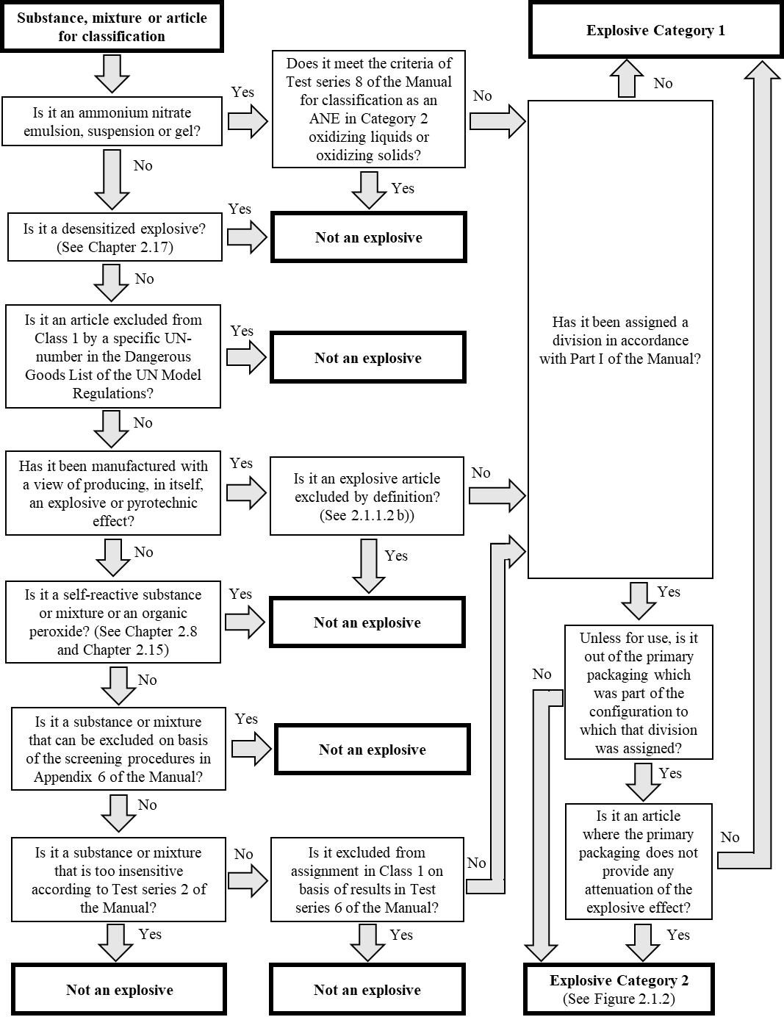

Figure 2.1.2: Procedure for assignment of a sub-category to explosives in Category 2

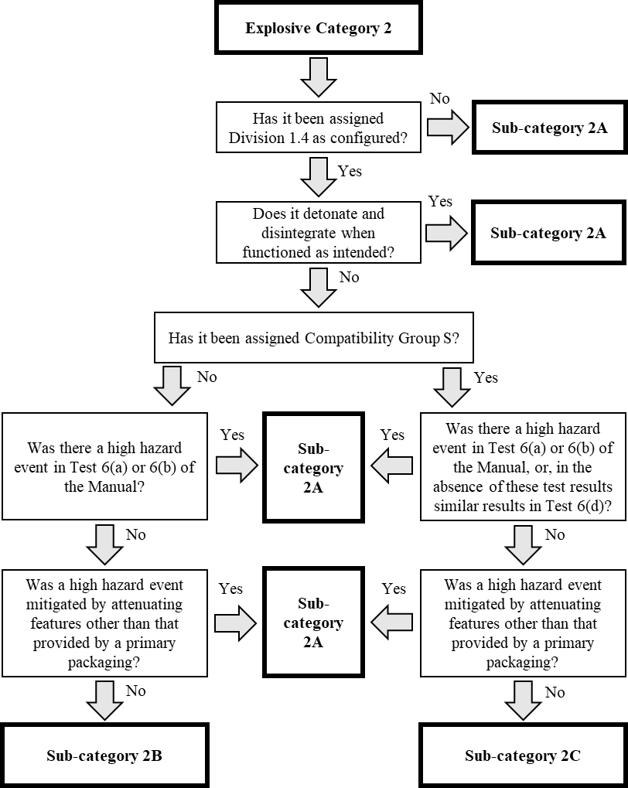

Annex II
Main changes of the draft new Chapter 2.1 (as in annex I) as compared to the current Chapter 2.1

Section in new Chapter 2.1 | Corresponding section in current Chapter 2.1 | Main changes
2.1.1.1 | 2.1.1.1 | Definition of “pyrotechnic article” deleted as it is obsolete and does not occur in the corresponding parts of the UN Model Regulations or the Manual of Tests and Criteria.  Definition of “primary packaging” introduced as it is needed for applying the criteria.
2.1.1.2 | 2.1.1.2 | Exclusions listed in sub-section 2.1.1.2.2 to clarify the scope of the hazard class, which is intended to be the same as the current scope in practice.  Exemption for substances in the R&D phase placed in a note. Note that the amount to which this exclusion can be applied is indicated as “XX” as it still needs to be discussed and determined.
2.1.1.3 | None | Section to further explain the intended application of the classification system.
2.1.2.1 | None | Section to introduce the two main categories of the new system.
2.1.2.2 | 2.1.2.1 | Division 1.4 Compatibility Group S added as a new separate entry, and minor amendments made to bring descriptions of divisions 1.5 and 1.6 in line with those in the UN Model Regulations and the Manual of Tests and Criteria.
2.1.2.3 | None | Section to introduce the three sub-categories within Category 2 of the system.
2.1.3 | 2.1.3 | Hazard communication elements table for the classifications of the system. Note that some elements are denoted “TDB” (to be determined).  Existing note amended to cover also intentional explosives that escape the hazard class, and to point to specifically to section 2.3 of the SDS as well as allow information in its section 10 instead of 9.
2.1.4.1 | None | Sub-section explaining the principles of GHS explosives classification.
2.1.4.2 | None | Sub-section describing the hazard levels of the sub-categories in words.
2.1.4.3 | 2.1.4.1 | Decision logic flowcharts for the system.

Annex III
Alternative (merged) layout of the criteria of a new GHS Chapter 2.1
Category | Sub-category | Criteria
1 | Not applicable | Explosive substances, mixtures and articles which:  - have not been assigned a division in accordance with Part I of the Manual of Tests and Criteria and which:  - have been manufactured with the view of producing an explosive or pyrotechnic effect; or  - are substances or mixtures which show positive effects when tested in test series 2 of the Manual of Tests and Criteria  or  - are out of the primary packaging which was part of the configuration to which a division was assigned in accordance with Part I of the Manual of Tests and Criteria, unless they are explosive articles where the primary packaging does not provide any attenuation of the explosive effect.*
2 | 2A | Explosive substances, mixtures, and articles which:  - have been assigned division 1.1, 1.2, 1.3, 1.5, or 1.6 in accordance with Part I of the Manual of Tests and Criteria; or  - have been assigned division division 1.4 in accordance with Part I of the Manual of Tests and Criteria and are not meeting the criteria for Sub-category 2B or 2C; or  - have been assigned sub-category 2A based on additional data or considerations that supersede the criteria for sub-category 2B or 2C**
 | 2B | Explosive substances, mixtures and articles which have been assigned division 1.4 in accordance with Part I of the Manual of Tests and Criteria and a compatibility group other than S, and which:  - do not detonate and disintegrate when functioned as intended; and  - exhibit no high hazard event*** in Test Series 6(a) or 6(b) of the Manual of Tests and Criteria; and  - do not require attenuating features, other than that which may be provided by a primary packaging, to mitigate a high hazard event.***
 | 2C | Explosive substances, mixtures and articles which have been assigned to Division 1.4 in accordance with Part I of the Manual of Tests and Criteria and Compatibility Group S, and which:  - do not detonate and disintegrate when functioned as intended; and  - exhibit no high hazard event*** in Test Series 6(a) or 6(b), or in the absence of these test results, similar results in Test 6(d) of the Manual of Tests and Criteria; and  - do not require attenuating features, other than that which may be provided by a primary packaging, to mitigate a high hazard event.***
* Explosives in Category 2 that are removed from their primary packaging for use, remain classified in Category 2. Use comprises preparation and intentional functioning, including removal from the primary packaging for functioning or installation or deployment in readiness for functioning.
** The manufacturer, supplier or competent authority may assign sub-category 2A on basis of data or considerations indicating that the explosive represents a high hazard even if it meets the technical criteria for sub-category 2B or 2C.
*** A high hazard event is exhibited when performing Test Series 6(a) or 6(b), according to the Manual of Tests and Criteria, by
(a) a significant change in the witness plate shape, such as perforation, gouge or substantial dent/bowing; or
(b) instantaneous scattering of most of the confining material.
_____________

Informal document INF.3 (56th session) of the SCETDG, which points to this working document of the SCEGHS.
As the EWG is not convening during the 56th session of the SCETDG, these documents are submitted to the SCETDG for information only, as the SCETDG is the focal point for the GHS physical hazards.
Examples of the classifications 2A – 2C are shown in INF.18 to the 36th session of the SCEGHS (Informal document INF.24 (54th session of the SCETDG). Note, however, that the criteria for Sub-category 2B and 2C have since then been amended to exclude explosives that detonate and disintegrate from these classifications.
While the division currently is not displayed clearly on the GHS label, it can be derived from the current hazard statements since they are different for each of the divisions, see section 2.1.3 of the current Chapter 2.1.
As in informal document INF.43 Rev. 1 (36th session) of the SCEGHS.
See informal document INF.19 (36th session) of the SCEGHS (informal document INF.29 (54th session of the SCETDG) for an elaborate discussion on this.
See informal document INF.8 (37th session) of the SCEGHS (informal document INF.19 (55th session of the SCETDG).

