Proposal for Supplement 5 to the 02 series of amendments to Regulation No. 129
Submitted by the expert from Spain
The text reproduced below was prepared by the expert from Spain on behalf of the Technical Services Group (TSG) on Regulation No. 129. The modifications to the current text of Regulation are marked in bold for new or strikethrough for deleted characters. It supersedes ECE/TRANS/WP.29/GRSP/2018/21 distributed at the sixty-third session of GRSP (ECE/TRANS/WP.29/GRSP/63, para 33)
I. Proposal
Paragraph 6.6.4.4.1.1., amend to read:
"6.6.4.4.1.1. Forward facing Enhanced Child Restraint Systems
Head excursion: No part of the head of the dummy shall pass beyond the planes BA, DA and DE as defined in Figure 1 below. However the head of the dummy may pass beyond the DE plane, if there is part of the child restraint structure, i.e. head pad or backrest, behind the head of the dummy, at the point the head passes the DE plane."

This shall be judged up to 300 ms or the moment that the dummy has come to a definitive standstill whatever occurs first.
Except for booster seats when testing using Q10 dummy where:
(a) The value in relation to the DA plane is 840 mm; and
(b) The value in relation to the BA plane is 550 mm; and
(c) The rebound phase is not considered for the assessment of the plane DA and DE.

6.6.4.4.1.1.1. Where a test is conducted in accordance with paragraph 6.6.4.1.6.2. or paragraph 6.6.4.1.8.2 above, a tolerance of +10 per cent shall beapplicable to the head excursion value distance between Cr point andplane AB.

Figure 1
Arrangement for testing a forward-facing device
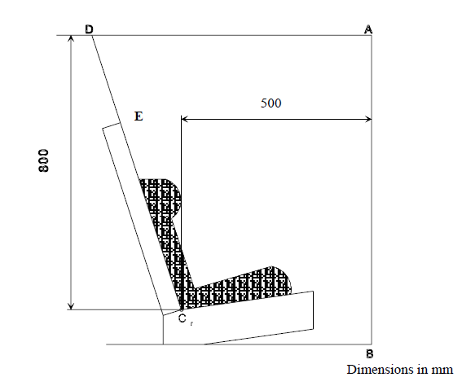
II. Justification
1. The assessment of the DE plane only applies to rearward facing Child Restraint Systems (CRS) in UN Regulation No. 44. The DE plane assessment remains relevant for rearward facing child restraints in UN Regulation No. 129.
2. For forward facing child restraints, there is often structure of the child restraint, (either head pad or backrest) behind the head of the dummy at the point the DE plane is passed. The energy absorption properties of this structure will have been tested using the test method described in UN Regulation No. 129. Therefore this structure would provide protection to the child’s head.
3. It is therefore not necessary to assess the DE plane for forward facing child restraints that maintain structure of the child restraint behind the head of the dummy.

