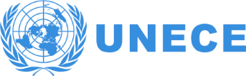 | 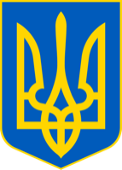 | 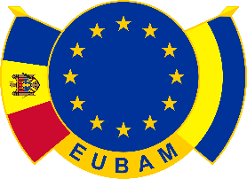 | 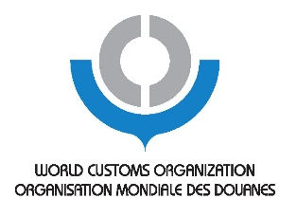

International Seminar on Trade Facilitation and the Single Window
organized by the United Nations Economic Commission for Europe (UNECE) and the Government of Ukraine, in cooperation with the EU Border Assistance Mission to Moldova and Ukraine (EUBAM), the European Commission and the World Customs Organization

Step-by-Step Establishment of a National Single Window and Data Harmonization in Ukraine in Compliance with International and EU Standards

Agenda

University of the State Fiscal Service of Ukraine,
town of Irpen, 08200
Universitetska St. 31

20-21 October 2016
Kiev

Draft 15

DAY ONE

09:00 - 09:30 Registration
09:30 – 10:00 Opening and welcome address:
Government of Ukraine, UNECE, EUBAM, etc.

10:00 – 13:00 Session I: Concept of National Single Window and Pilot Projects in Ukraine
Moderator: UNECE

Current stage of trade facilitation reforms and readiness for a national Single Window mechanism
Representative of the Government Fiscal Service of Ukraine (t.b.c.)

The Single Window concept: the concept, prerequisites and existing tools and standards supporting implementation
Tejo Kosuma, World Customs Organization
Jean-Luc Delcourt and Zahouani Saadaoui, DG TAXUD, European Commission
Mario Apostolov, Regional Adviser, UNECE

11:15 - 11:30 – Coffee break

Pilot projects for the establishment of a Single Window in Ukraine
- National project for data exchange among regulatory agencies
Moskalenko Alexander Petrovich, Deputy Director of the Department of taxation, customs policy, Ministry of Finance of Ukraine
- Port Community System in Odessa (PPL 33-35)
Alexey Orlov, Representative of the Port Community System
- Maritime Single Window in Ukraine (reflecting EU Directive 2010/65)
Dmitry Yakimenkov, SE “Ukrainian Sea Ports Administration”
- Single Window project for Customs clearance in Odessa.
Odessa Customs, State Fiscal Service of Ukraine (t.b.c.)
Discussion

13:00 - 14:00 – Lunch Break

14:00 – 17:00 Session II: Single Window, International Standards and the Need for Step-by-Step Planning
- International standards and Single Window implementation
Tejo Kosuma, World Customs Organization (WCO)
- The EU Customs Single Window current implementation and future plans in the European Union
Zahouani Saadaoui, European Commission, DG TAXUD
- Step-by-Step planning for a National Single Window
Mario Apostolov, Regional Adviser, UNECE
- The Port Community System as a pilot project step in building the national Single Window
Alexander Fedorov, Representative of the Port Community System
- The need to establish a common vision for building a Single Window in Ukraine.
Vladimir Pisar, Trade facilitation specialist, EUBAM
- Single Window PLUS – Coordination Platform: The vision for building Single Window in Poland
Beata Dubiańska, Customs Procedures Specialist, EUBAM

15:00 - 15:15 – Coffee break

Stakeholders views:
- State Fiscal Service of Ukraine (Customs): Miroslav Vasilyevich Prodan and/or Alexey Leonidovich Vasilenko
- Ministry of Economic Development and Trade
- Ministry of Infrastructure
- Ministry of Agriculture
- Other Ministries
- Business Community (business representatives)
Panel discussion on the main items for a national plan for a Single Window

DAY TWO

9:00 – 13:00 Session III: Data Harmonization
Moderator: t.b.c

- Introduction to data harmonization, UNCEFACT Recommendation 34
Mario Apostolov, Regional Advisor, UNECE
- Introduction to the WCO Data Model
Tejo Kosuma, WCO
- The EU Customs Data Model – possibilities for implementation in Ukraine
Jean-Luc Delcourt, DG TAXUD, European Commission
- Data Harmonization in the Single Window context
Michael Dill, GEFEG mbH, Germany (t.b.c.)
- Formats and models; data harmonization in different Single Window prototypes
Dmitry Yakimenkov, SE “Ukrainian Sea Ports Administration”

Practical exercise

Discussion

13:00 - 13:45 Closing Session - Organizational issues and recommendations

For more information, please contact: Mario Apostolov, Regional Adviser UNECE Trade, tel.: +41 22-9171134, е-mail: mario.apostolov@unece.org

