ECE/TRADE/C/WP.7/GE.1/2009/INF.30

Specialized Section on Standardization of Fresh Fruit and Vegetables

Fifty-sixth session
Geneva, 2 - 4 November 2009
Items 4(j) of the provisional agenda

REVISION OF UNECE STANDARDS

Lettuces, Curled-leaved endives and Broad-leaved (Batavian) endives

This note contains the Spanish proposals regarding the amendment of the UNECE Standard for Lettuces, Curled-leaved endives and Broad-leaved (Batavian) endives.
Spanish proposal to amend the UNECE Standard FFV-22 of Lettuces, Curled-leaved endives and Broad-leaved (Batavian) endives.

Spain would like to propose the following amendment of the UNECE Standard FFV-22 concerning the marketing and commercial quality control of Lettuces, Curled-leaved endives and Broad-leaved (Batavian) endives, in relation to the sizing requirements.

The intention of the proposed amendment is to adapt the standard to the trade and, to be precise, to include in the standard the new presentations of the “Little gem” type lettuce that are already being marketed.

The “Little gem” is a type of Romaine lettuce, whose size and weight is approximately between 1/3 and ¼ the size of the normal one. Nowadays this produce is widely commercialized in consumer packages of three, four and six units and it is very much appreciated and more and more consumed because of its shape, tenderness and size (each unit represents a single serving size).

The issue is that these little lettuces, being well formed and completely developed, do not fit the minimum size established in the standard which is of 100 g. At the end of this document you will find some photos.

The sizing table, as it stands in the sizing provisions of the current standard, is as follows:

“Size is determined by the weight of one unit.
A. Minimum weight
The minimum weight for Classes I and II is:

 | Open grown | Grown under protection
Head lettuces (excluding crisphead and “Iceberg” type lettuces) and Cos or romaine lettuces (excluding “Little gem” type lettuces) | 150 g | 100 g
Crisphead and “Iceberg” type lettuces | 300 g | 200 g
Leaf lettuces and “Little gem” type lettuces | 100 g | 100 g
Curled-leaved endives and broad-leaved endives | 200 g | 150 g”

The proposal from Spain would be to delete the minimum weight for all the types of lettuces (that is to say delete the section “A. Minimum size” of the provisions concerning sizing), leaving in the standard the uniformity requirements (section “B. Uniformity” of the provisions concerning sizing). This proposal would permit to trade any type of “mini lettuce”.

Madrid, August 2009.
A consumers’ package containing 6 Little gem lettuces:

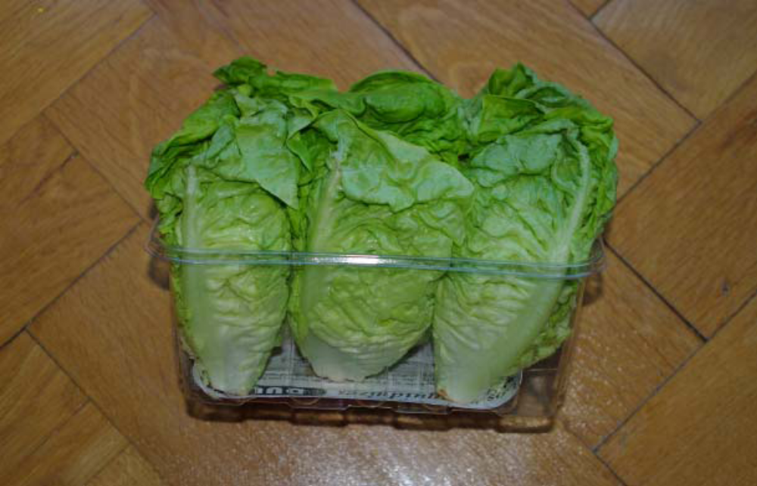

The same consumers’ Packaged from an up-side view:
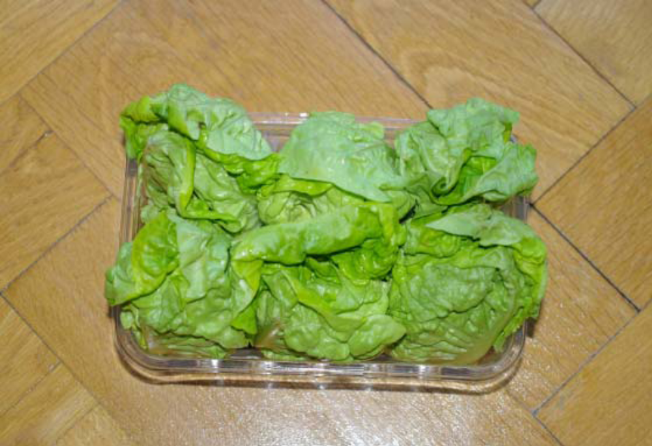

Two Little gem lettuces in a consumers’ package of three:
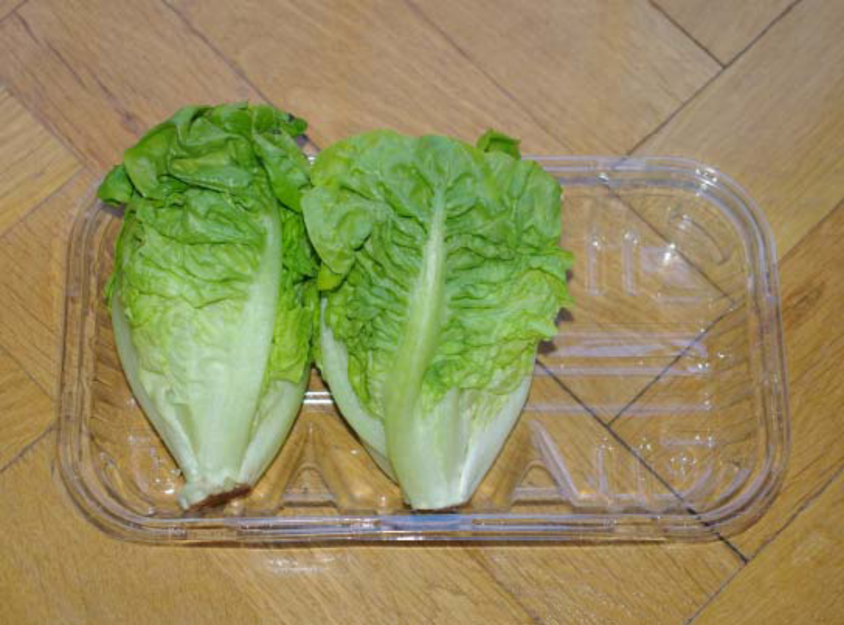
The different sizes of a Roman lettuce and two Little gem lettuces:


