Informal document. N. 9
(28th GRSP 27 November-1 December
agenda item 2.3.)

Doubts regarding Reg17.07 annex 9:

- In some vehicles, the luggage compartment length is so reduced that is impossible to place the type 1 load test specified in item 1 of Reg ECE17.07 Annex 9. As example, vehicles as Smart, or 3 rows Ford Galaxy.

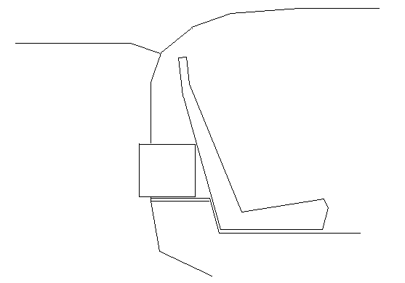
- Item 2.1.1.6 specify that seats are excluded if type 1 load test may not be placed behind them.

Could this item be interpreted in such a way that a vehicle with a really reduced luggage compartment may be approved without the test specified in that Annex 9?

