ECONOMIC COMMISSION FOR EUROPE

INLAND TRANSPORT COMMITTEE

Working Party on the Construction of Vehicles

REVISED PROPOSAL FOR DRAFT 04 SERIES OF AMENDMENTS TO
REGULATION No.44
(CHILD RESTRAINT SYSTEMS)

Transmitted by the French Delegation
This amendment has been prepared to introduce in Regulation n°44 the new anchorage system standard for child restraint systems (CRS) prepared by the International Organization for Standardization (ISO).
The International Standard ISO 13216-1:1999 establishes an anchorage system composed of universal anchorage to be located in vehicle and universal attachment to be located on ISOFIX child restraint systems.
Following modifications of Regulation n°44 are suggested, in which,
(1) “ISOFIX” will be used as a qualificative adjective in order to simplify the modification redaction and to allow child restraint system users to be able to identify ISOFIX restraints without any doubt,
[(2) words copied from the International Standard ISO 13216-1:1999 will be written in italics,]
(3) words removed from the original text of Regulation n°44 will be written [between brackets and crossed out],
(4) words added to the original text will be written in bold types

- In paragraph 2. DEFINITIONS, insert new paragraphs to read :
“2.14.2. ISOFIX anchorage means one of two (2) 6 mm diameter rigid round horizontal bars, extending from vehicle or seat structure to accept and restraint a child restraint system with ISOFIX attachments.”
“2.28. ISOFIX attachment means one of two (2) connections, fulfilling the requirement of paragraph 6.3.2. of this Regulation, extending from the ISOFIX child restraint system structure, and compatible with an ISOFIX anchorage.”
“2.29. ISOFIX child restraint system means an ISOFIX child restraint system intended to be attached to ISOFIX anchorage.”
“2.30. Seat bight means the area close to the intersection of the surfaces of the vehicle seat cushion and the seat back.”
“2.31. Vehicle seat fixture (VSF) means a fixture, complying to dimensions shown in figures 0a and 0b, used by a child restraint manufacturer to determine the appropriate dimensions of an ISOFIX child restraint system and the location of its ISOFIX attachments .”
Fig 0a

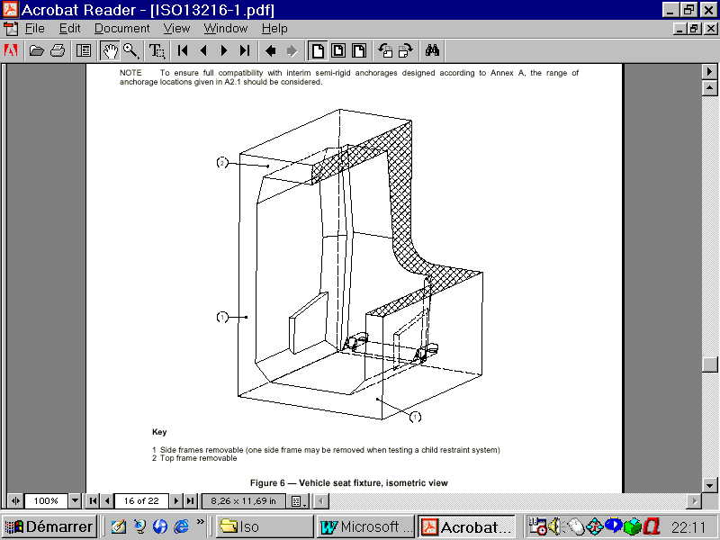

Fig; 0b Dimensions in mm

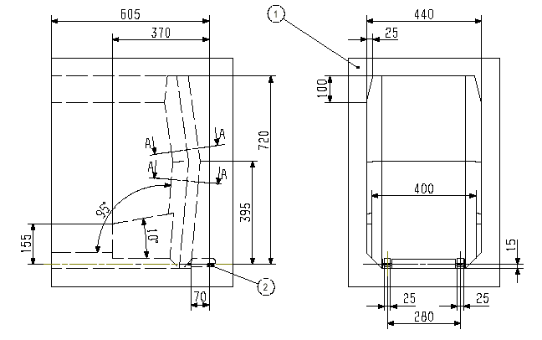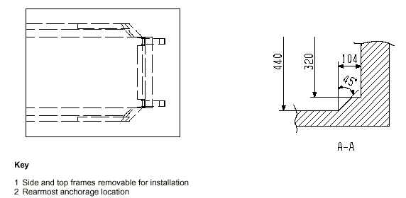

- Amend paragraph 6. GENERAL SPECIFICATIONS to read :
“6.1.3.1. For the “universal” and “restricted” categories, [only] by means of an adult safety-belt (with or without a retractor) meeting the requirements of Regulation n°16 (or equivalent) fitted to anchorages meeting the requirements of Regulation n°14 (or equivalent) and / or by means of ISOFIX attachments meeting the requirements of this Regulation fitted to ISOFIX anchorages meeting the requirements of Regulation n°14.”
“6.1.8. In the case of child restraint system of the “universal” category, the main load-bearing point, if any, between the child restraint and the adult safety-belt shall not be less than 150 mm from the Cr axis when measured with the child restraint on the dynamic test bench.”
“6.1.9. [The maximum length of adult belt which may be used to secure a “universal” category child restraint] If the adult belt is required to secure a “universal” category child restraint, its maximum length to be used on the dynamic test bench is defined in annex 13 to this Regulation.
To check compliance with this requirement, ……(no change) .….. remaining on the spool.”
- In paragraph 6. GENERAL SPECIFICATIONS, insert a new paragraph to read :
“6.3. ISOFIX restraint specifications
6.3.1. Dimensions
The maximum lateral, downward, and rearward dimensions for the child restraint system and the locations of the anchorages with which its attachments must engage are defined for the child restraint system manufacturer by the Vehicle Seat Fixture (VSF) defined by paragraph 2.3.1. of this Regulation.
6.3.2. Attachments
6.3.2.1. Type
Attachments to anchorages may be according to examples shown in Figure 0c, or other appropriate designs that are part of a rigid mechanism having provision for adjustment, the nature of which is determined by the child restraint system manufacturer.
Figure 0c Dimensions in mm
6.3.2.2. Dimensions
Dimensions for the portion of the child restraint system connector that engages the anchorage bar must not exceed the maximum dimensions given by the envelope in Figure 0d
Figure 0d Dimensions in mm
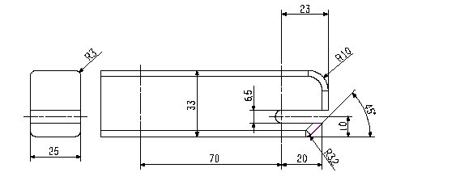
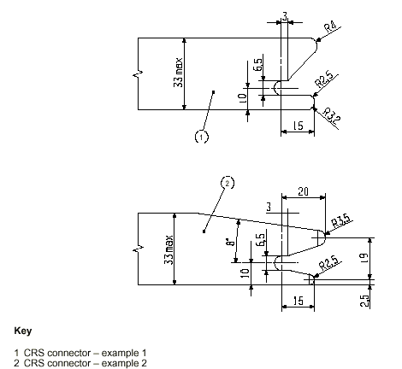
6.3.2.3. Partial latching indication
The CRS shall incorporate means by which there is a clear indication that all attachments are fully latched. The indication means may be audible, tactile or visual or a combination of two or more. It must be detectable under all normal lighting conditions.
6.3.3. Adjustment provisions
The ISOFIX attachments, or the ISOFIX child restraint system itself, shall be adjustable to accommodate the range of anchorage locations described in Regulation n°14.
- In paragraph 7. PARTICULAR SPECIFICATIONS, insert a new paragraph to read :
“7.2.6. ISOFIX attachment specifications
“ISOFIX attachments” and latching indicators shall be capable of withstanding repeated operation and shall, before the dynamic test prescribed in paragraph 8.1.3., undergo a test comprising [ 2000 + or – 5 ] opening and closing cycles under normal conditions of use.”
NB : the above proposal is very close to paragraph 7.2.1.7. relative to buckle dynamic test.
- In paragraph 14. INSTRUCTIONS, insert a new paragraph to read :
“14.2.11. For an “ISOFIX child restraint system” the following label shall be clearly visible at the point of sale without removing the packing :
NB : the above proposal is very close to the UK proposal TRANS WP29 GRSP 1997-12

NOTICE

1. This is an ISOFIX CHILD RESTRAINT SYSTEM. It is approved to Regulation n°44-xx serie of amendments for general use in vehicles fitted with ISOFIX anchorages.
2. It will fit all vehicles with seating positions approved as ISOFIX seating positions (as detailed in the vehicle handbook).”

- In Annex 6. DESCRIPTION OF TROLLEY, appendix 3, amend paragraph 1 to read :
"1. The anchorages shall be positioned as shown in the figures 1,2 and 3 below."

- Amend paragraphs 2.1 and 2.2 to read :
" 2.1. For child restraint [approved for use with] using lap belts, points A and B;
2.2. For child restraint [approved for use with] using lap and diagonal belts, points A, BO and C."

- Insert a new paragraph to read :
" 2.3. For child restraints using ISOFIX attachment, points H₁ and H₂.

- Amend paragraphs 3 and 4 to read :
" 3. Anchorages A, B and/or H₁ H₂ and D shall be used (…. no change….) upper anchorage.
4. Anchorages A, B and/or H₁ H₂, E and F shall be used (…. no change….) upper anchorages."

- Amend paragraph 8 to read :
For testing of child restraints in the "universal" and "restricted" categories, a standard retractor belt, as specified in annex 13, and/or an ISOFIX anchorage, shall be fitted to the test seat."

- Insert a third figure to see :

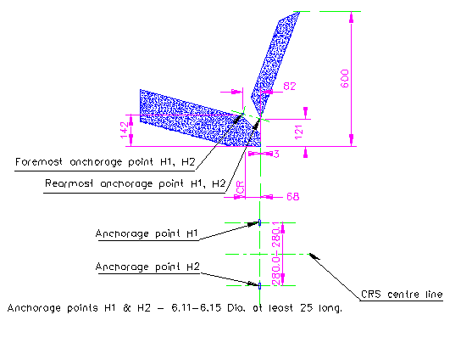

- In Annex 21. DYNAMIC CRASH TEST INSTALLATION, amend the picture to see :

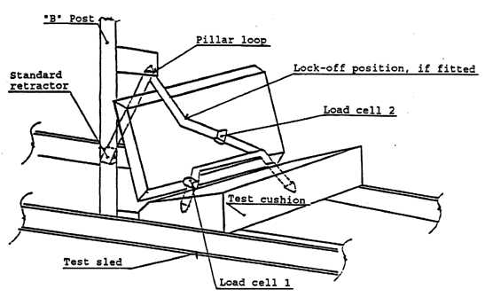
ISOFIX seat bight anchorages
- Amend paragraph 1.2.3 to read :

"1.2.3. Extract all webbing from the retractor spool and allow the tension in the belt between the retractor and pillar loop to drop to the retractor tension. The spool shall be locked before the dynamic test. [Conduct the dynamic crash test.]"

- Insert a new paragraph to read:
“1.3. ISOFIX attachment
For an ISOFIX restraint with adjustable position seat bight ISOFix anchorages. Attach the unladen child restraint onto the seat bight anchorages, H1 and H2 in the appropriate test position. Allow the child restraint latches to pull the unladened child restraint towards the seat bight. Apply an additional force of 135 ± 15 N in the horizontal reference plane of the child restraint in the direction of the seat bight to overcome frictional forces between the child restraint and the seat cushion, assisting the self-tensioning effects of the latch mechanism. Place appropriate test dummy in child restraint when the child restraint has been so adjusted.

- In the note, amend paragraph 1 to read :

"1. Installation is conducted after fitting the manikin into the restraint for paragraphs 1.1 and 1.2.

