Annex 8I

Over-temperature protection

1. PURPOSE

The purpose of this test is to verify the performance of the protective measures of the REESS against internal overheating during the operation, even under the single failure of the cooling function, if available. In the case that no specific protection measures are necessary to prevent the REESS from reaching an unsafe state due to internal over-temperature, this safe operation must be demonstrated.

2. INSTALLATIONS

2.1. The following test may be conducted with the complete REESS (maybe as a complete vehicle) or with related subsystems of the REESS including the cells and their electrical connections (see Annex 8 for requirements of the subsystems). In order to facilitate the test, necessary alteration of the REESS component may be implemented subject to the agreement between the manufacturer and the technical service to the extent that such alteration will not influence to the results of this test.

2.2. If the REESS is equipped with any active cooling function and can be operated even under certain single failure of such function, a manipulated failure, that will not inhibit the operation of REESS, shall be implemented on the TESTED-DEVICE. The method of the manipulated failure shall be determined by the manufacturer and the technical service so as to cause the greatest effect on the temperature increase of the REESS.

2.3. The temperature of the TESTED-DEVICE shall be continuously measured in the proximity of the cells during the test in order to monitor the transition of the temperature. [The manufacturer and testing service shall agree on the location of [the /at least three] temperature sensors and their placements shall be chosen so as to reflect the location where the gradient of the internal temperature of the REESS is the slowest.]

[2.4. At the discretion of manufacturer with agreement of the technical service, an alternative verification procedure that demonstrate the performance of the over-temperature protection as described in paragraph 1 may be applied.]

3. PROCEDURES

3.1. At the beginning of the test, all [internal and external] protection devices which affect the function of the TESTED-DEVICE and are relevant for the outcome of the test shall be operational, except for the manipulated failure implemented in accordance with paragraph 2.2.

3.2. During the test, the TESTED-DEVICE shall be continuously charged and discharged by a steady current that will increase the temperature of cells as rapidly as possible within the range of normal operation as defined by the manufacturer.

3.3. The TESTED-DEVICE shall be placed in a convective oven or climatic chamber (hereby called “test chamber”). The temperature of the test chamber shall be gradually increased until it reaches the ambient temperature determined in accordance with the paragraph 3.3.1 or 3.3.2 below as applicable, and then the maintained [equal to or higher than that temperature] until the end of the test.

3.3.1 In case the REESS is equipped with the protective measures against internal overheating, the ambient temperature shall be increased the temperature defined by the manufacturer as the operation threshold of such protective measures, in order to allow the temperature of the TESTED-DEVICE will increase to that threshold due to its operation according to paragraph 3.2.

3.3.2 In case the REESS is not equipped with any specific measures against internal over-heating, the ambient temperature shall be increased to [(Proposal A) [XX] °C, which represents the realistically high ambient temperature for use of the REESS on the vehicle. (Proposal B) the maximum operative temperature plus a temperature margin of [XX] °C.]

3.4. The end of test: The test will end when one of the followings is observed:
a) the TESTED-DEVICE inhibits and/or limits the charge and/or discharge to prevent the temperature increase.
b) the temperature of the TESTED-DEVICE is stabilised, which means that the temperature varies by a gradient of less than [4°C through 1 hour].
c) any failure against the acceptance criteria prescribed in [Paragraph 6.9.2.1.]

- - - - - -

<Explanation>

Basic concept of this test is to increase the temperature by charge-discharge operation (within normal mode of operation) with aid of the high ambient temperature and to confirm whether the protection measures (e.g. inhibit/limit the charge-discharge, emergency cooling, etc.) will work under such condition without causing the safety hazards.
If the system allows operation under single failure of cooling function, test shall be conducted with manipulated failure. If system does not have active cooling function nor inhibit its operation under failure of cooling, the test shall be conducted without failure.(para.2.2)

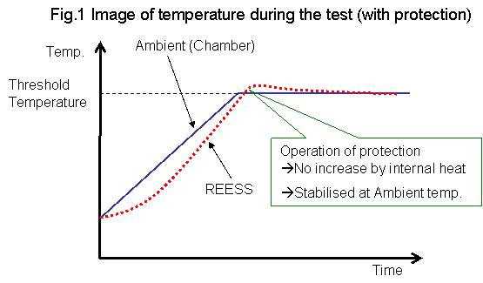

There is a possibility where no protection will be provided, for example, the heat created by the charge-discharge operation will not be enough to cause any failure of the system. In this case, the verification is needed whether or not the temperature of the system would not become the level that causes the safety hazards under realistic environment of the vehicle use.
Since the most of the expert involved in the sub-group do not intend to design the system with this approach, it was difficult to determine the appropriate temperature of the test ambient. (para.3.3.2)
Fig.2 below is an example of the temperature profile assumed under the Proposal A of para.3.3.2.
