Informal document No. 
(81st GRSG, Oct. 8-11, 2001
Agenda Item 8.1)
Transmitted by United States

Test Report of FMVSS No. 201 Free-Motion Headform (49 CFR 572 Subpart L)
Used in Headform Test of ECE Reg. 43

A series of free-motion headform (FMH) tests was conducted on polycarbonate plastic samples to provide data for GRSG in considering the U.S. headform as an alternative impact device in the headform impact test of plastic panes contained in the ECE Regulation 43. The FMH is a Hybrid III head, weighing 4.5 kg (10 lbs.), modified for use as a free-motion impactor. The headform was instrumented with a triaxial accelerometer array located at the center of gravity. The accelerometers used were Endevco=s model 7264-2000 units. Headform acceleration data was collected as a function of time in accordance with SAE Recommended Practice J211.

Twenty-four polycarbonate samples were purchased from a regional plastic supplier. The samples were cut by the supplier to a length of 1100 mm and a width of 500 mm. Twelve pieces had a nominal thickness of 4.76 mm (3/16") and twelve had a thickness of 6.35 mm (1/4"). The test support frame used was supplied by the Visteon Glass Plant in Nashville, TN.

Test Setup
The polycarbonate samples were kept in an environmentally controlled lab at least 4 hours prior to testing. The exact temperature and humidity were not recorded. The protective plastic covering was removed from individual polycarbonate pieces and then cleaned with a mild cleaning solution. The test piece was then fixed between the upper and lower halves of the support frame and secured by applying a torque of 30 Nm to the bolts. The geometric center of each piece was found and the area of impact was ensured to be within 40 mm of this center in accordance to ECE 43.
It was determined that the direction of force imparted on the headform by the test piece should be at the center of the forehead, just above the bridge of the nose. After positioning the impactor perpendicular to the plane of the test piece, it could be seen that contact would be made by other features on the face of the headform during dynamic testing. To avoid interference, the impactor was rotated 5 degrees backwards (See figure 1). Subsequent trial testing revealed that this shallow angle allowed for the rebounding headform to strike the impactor fixture, causing damage to the fixture and accelerometer data cables. Therefore, the impactor was rotated an additional 16 degrees (see figure 1).

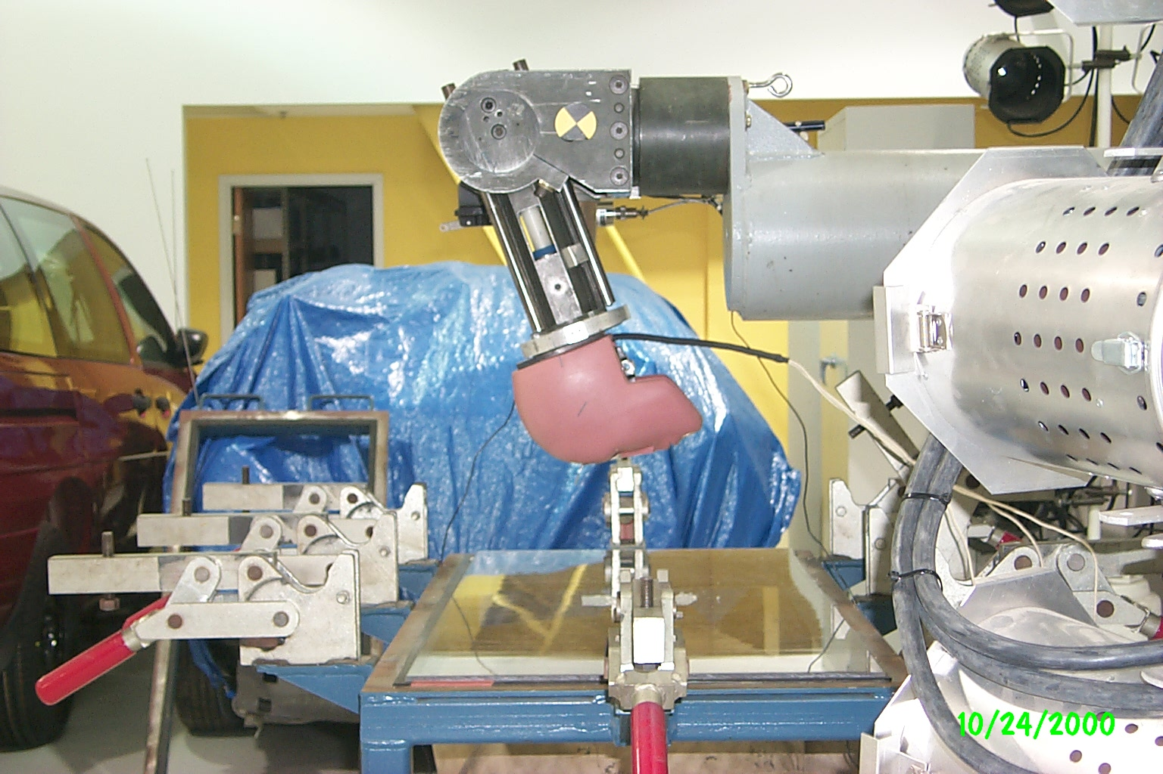
Figure 1 -- Impact Angle of 21 degrees

Although the headform did not rebound into the impactor, a plastic shroud was positioned around the test piece to prevent the headform from bouncing away and stretching the data cables. As a result, the headform struck the test piece multiple times after the initial impact.

Equivalent impact velocities for drop heights of 1.5 m and 3.0 m were computed to be 5.42 m/s (12.1 mph) and 7.67 m/s (17.2 mph) respectively. Table 1 list the test configurations and computed HIC values ( 36 and 15 ms).

Table 1 B HIC Values for Rigid Plastic Glazing
Test No. | Impact Speed/Equiv. Drop Height | Thickness | HIC (36 ms) | HIC (15 ms) | Comments
RGP3_01 | 17.26 MPH/ 3.0 Meters | 3/16 " | 872 | 872
RGP3_02 | 17.41 MPH/ 3.0 Meters | 3/16 " | 817 | 817
RGP3_03 | 17.32 MPH/ 3.0 Meters | 3/16 " | 839 | 839
RGP3_04 | 17.07 MPH/ 3.0 Meters | 3/16 " | 918 | 918
RGP3_05 | 16.92 MPH/ 3.0 Meters | 3/16 " | 918 | 918
RGP3_06 | 16.82 MPH/ 3.0 Meters | 3/16 " | 884 | 884
RGP3_07 | 17.12 MPH/ 3.0 Meters | 1/4 " | 893 | 893
RGP3_08 | 17.14 MPH/ 3.0 Meters | 1/4 " | 876 | 876
RGP3_09 | 17.17 MPH/ 3.0 Meters | 1/4 " | 849 | 849
RGP3_10 | 17.01 MPH/ 3.0 Meters | 1/4 " | 873 | 873
RGP3_11a | 16.41 MPH/ 3.0 Meters | 1/4 " | 780 | 780 | Table was not anchored to floor correctly
RGP3_11b | 17.04 MPH/ 3.0 Meters | 1/4 " | 924 | 924 | Used same plastic piece as previous test
RGP3_11c | 17.02 MPH/ 3.0 Meters | 1/4 " | 959 | 959 | Used same plastic piece as previous test
RGP3_12 | 16.86 MPH/ 3.0 Meters | 1/4 " | 845 | 845
RGP15_01 | 12.15 MPH/ 1.5 Meters | 3/16 " | 288 | 288
RGP15_02 | 11.81 MPH/ 1.5 Meters | 3/16 " | 291 | 291
RGP15_03 | 11.71 MPH/ 1.5 Meters | 3/16 " | 298 | 298
RGP15_04 | 11.84 MPH/ 1.5 Meters | 3/16 " | 303 | 303
RGP15_05 | 11.96 MPH/ 1.5 Meters | 3/16 " | 297 | 297
RGP15_06 | 11.72 MPH/ 1.5 Meters | 3/16 " | 326 | 326
RGP15_07 | 11.75 MPH/ 1.5 Meters | 1/4 " | 310 | 310
RGP15_08 | 12.03 MPH/ 1.5 Meters | 1/4 " | 319 | 319
RGP15_09 | 12.11 MPH/ 1.5 Meters | 1/4 " | 279 | 279
RGP15_10 | 12.09 MPH/ 1.5 Meters | 1/4 " | 291 | 291
RGP15_11 | 12.03 MPH/ 1.5 Meters | 1/4 " | 290 | 290
RGP15_12 | 12.18 MPH/ 1.5 Meters | 1/4 " | 313 | 313
RGP15_13 | 16.80 MPH/ 3.0 Meters | 1/4 " | 885 | 885 | Used same plastic piece as previous test

